2019 - 2022

NHS Borders Workforce Plan




Contents reflecting the 6 Step Workforce Planning Methodology
- Defining the Plan
- Mapping Service Change
- Defining the Required Workforce
- Understanding Workforce Availability
- Action Plan
- Implementation

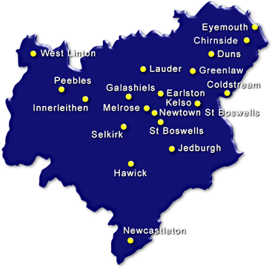

Contents
 |  |  |  | Page No
1 | Defining the Plan | 1.1 | Introduction | 4
 |  | 1.2 | Purpose | 4
 |  | 1.3 | Scope | 4-6
 |  | 1.4 | Ownership | 6
2 | Service Change | 2.1 | Drivers for Change | 7-10
 |  | 2.2 | Public Health Profile | 10
 |  | 2.3 | Financial Context | 11
 |  | 2.4 | Local Workforce Conference | 12
3 | Defining the Required Workforce | 3.1 | Changing Workforce | 13-14
 |  | 3.2 | Integration | 14
 |  | 3.3 | Workforce Information | 14-15
 |  | 3.4 | Current Workforce Planning  3.4.1 Shifting the Balance of Care/Keeping People at Home  3.4.2 Hospital Admission  3.4.3 Patient Flow  3.4.4 Women & Children’s Health  3.4.5 Mental Health  3.4.6 Learning Disabilities  3.4.7 Specialist roles  3.4.8 Healthcare Sciences  3.4.9 Other Therapeutic  3.4.10 Estates & Facilities  3.4.11 Information Management & Technology | 15  16-17  17-18  18  19-20  20-21  21  21-22  23  23  23  23-24
4 | Workforce Capability | 4.1 | Workforce Demographics | 25-30
 | Available Workforce | 4.2 | Skill Mix Changes | 31-32
 |  | 4.3 | Recruitment Monitoring & Vacancy Rates | 33-34
 |  | 4.4 | Employability/Youth Employment Strategy | 35
 |  | 4.5 | EU Withdrawal | 35
 |  | 4.6 | Full-time and Part-time Split | 36-37
 |  | 4.7 | Permanent & Fixed-Term Contracts | 38
 |  | 4.8 | Sickness Absence | 39-41
 |  | 4.9 | Staff Turnover | 42-46
5 | Action Plan |  | Action Plan | 47-50
6 | Implementation |  | Implementation of Action Plan

Step 1 – Defining the Plan

  - Introduction

Why is a Workforce Plan Required?

Workforce Planning is a statutory requirement that was established in NHS Scotland in 2005 with HDL (2005)52. CEL 32 (2011) refreshes this guidance and provides a nationally recognised framework to develop our Local Workforce Plan.

This workforce plan will support us to achieve our Clinical Strategy, 2020 Vision and annual operational plan. The Local Workforce Plan aims to support services to develop structures that deliver the right thing, first time, every time by the right person and will ensure that workforce implications are considered when redesigning services.

We recognise that the majority of Workforce Planning takes place at an operational level and this organisational Workforce Plan provides an overview of the direction for NHS Borders in terms of Workforce Planning.

The profile of the Borders population presents demographic challenges for NHS Borders, and this plan highlights the importance of progressing Workforce Planning locally, regionally and nationally over the coming years. It is forecast that 1 in 4 people born now will live to be over 100 years old.

  - Purpose

The purpose of the Local Workforce Plan is to highlight organisational priorities and demonstrate practical examples of how Workforce Planning is being progressed across NHS Borders. It is essential that NHS Borders continue to facilitate a more joined up approach to Workforce Planning ensuring all relevant stakeholders (internally and externally are involved).

Our Local Workforce Plans will support our Clinical Strategy and outline how we can work differently because of these changes. Our Clinical Strategy recognises that NHS Borders benefits from a dedicated workforce which is committed to providing the highest quality services for our patients. However our workforce itself is becoming older and we need to plan now how we will address this demographic challenge.

  - Scope

The population of the Scottish Borders in 2018 was 115,270, which is an increase of 8.7% in the 20 years from 1998 to 2018. This is the 12th highest percentage change out of the 32 council areas in Scotland and compares with a rise of 7.1% over the same period for the whole of Scotland.

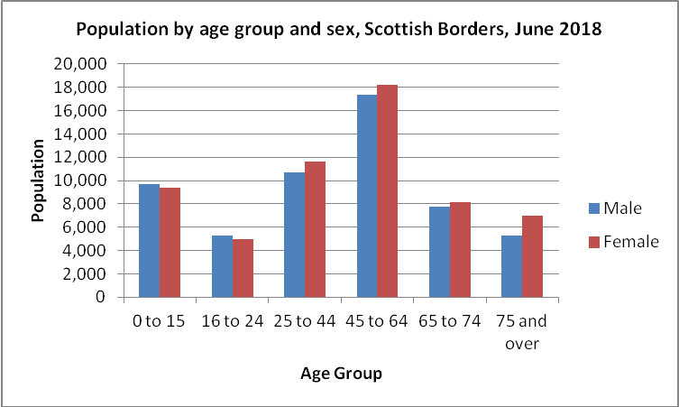
Chart 1: Estimated Population of Scottish Borders by age and sex – June 2018

Between 2016 and 2026, the 16 to 24 age group is projected to see the largest percentage decrease (a reduction of 8.4%), but more alarmingly, the 75 and over age group is projected to increase by 33.5%.

The chart below shows the percentage change in population in Scottish Borders and Scotland, 2016-2026 (2016-based projections). This shows that the population under 65 will continue to shrink and the over 65 age group will grow, with the over 75 age group expanding most.

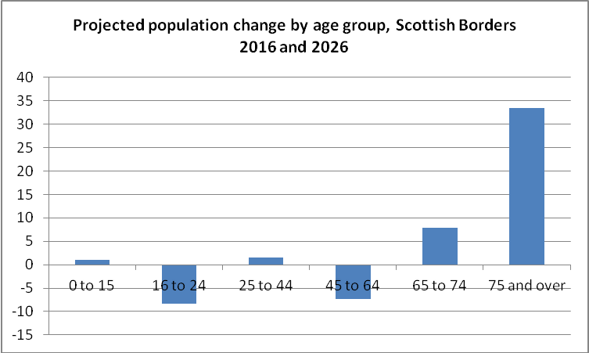
Chart 2: Percentage projected change in population, 2016-2026

This will have a significant impact on our services as there will be a rise in people with multiple and complex long term conditions increasing the demand on NHS Borders. Workforce Planning is essential to ensure a proactive approach to delivering care effectively in this changing demographic environment.

The next chart shows the net migration of people into and from the Scottish Borders in the year 2016-17. This shows encouraging growth in the 30-44 age group in particular. Overall net migration in the year 2016-17 was 7.1% in the Scottish Borders, compared to a Scotland-wide average of 4.4%.
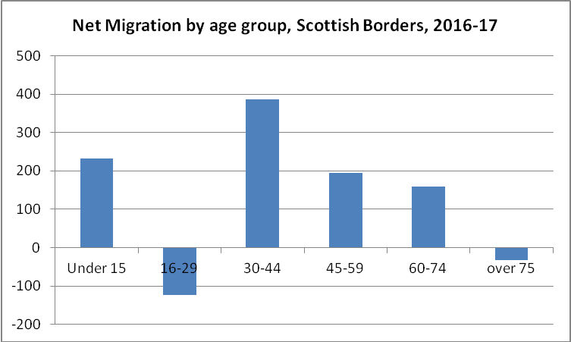
Chart 3: Net Migration by age group, 2016-17

2015 saw the re-introduction of the Borders railway which was closed in 1969. As HM Queen Elizabeth said at the opening ceremony, "The Borders railway brings so much promise for sharing and invigorating this most beautiful countryside as a place to work, live and enjoy.” An independent study published in March 2019 highlighted the positive impact this has made on the community it serves, attracting people to live, work and visit the route.

  - Ownership
Partnership Working and Governance

Our Local Workforce Plan is created in partnership with staff and their representatives. This includes our joint Local Workforce Conference, discussion and agreement at Area Partnership Forum, engagement with services using accepted methodologies for workforce planning, and workload measurement ensuring a consistent framework applies for the development of the future workforce.

A Partnership Subgroup will review the draft Local Workforce Plan and support the development of the final version, following which a final version will be considered for approval by the Staff Governance Committee.

Step 2 – Mapping Service Change

2.1 Drivers for Change

National Clinical Strategy

The National Clinical Strategy sets out the case for:

- planning and delivering integrated primary care services, like GP practices and community hospitals, around the needs of local communities
- restructuring how our hospitals can best serve the people of Scotland
- making sure the care provided in NHS Scotland is the right care for an individual, that it works, and that it is sustainable
- changing the way the NHS works through new technology

NHS Borders Clinical Strategy

The Clinical Strategy sets out a framework to support NHS Borders to continue to provide a high standard of healthcare in a challenging financial environment, when demand for healthcare is increasing. It aims to ensure that NHS Borders services should be patient-centred, safe, high quality and efficient and opportunities to trial innovative models, including moving away from our current traditional bed based system should be embraced.

The 7 Key Principles of the Clinical Strategy are outlined below:

- Services will be Safe, Effective and High Quality
- Services will be Person-Centred and Seamless
- Health Improvement and Prevention will be as important as treatment of illness
- Services will be delivered as close to home as possible
- Admission to hospital will only happen when necessary, and will be brief and smooth
- We are committed to working in Partnership with staff, communities and other organisations to deliver the best outcomes for the people we serve
- Services will be delivered efficiently, within available means

These principles support the NHS Borders 2020 Vision which was developed in response to the national vision for NHS Scotland.

National Health and Social Care Integrated Workforce Plan

The National Health and Social Care Workforce Plan was published in three Parts between June 2017 and April 2018. The plan includes a number of recommendations that, when delivered, will bring about improvements in workforce planning. Part 1 of the workforce plan focused on the acute NHS and was published in June 2017. Part 2, covering workforce planning in social care, was published jointly with COSLA in December 2017. Part 3 of the National Health and Social Care Workforce Plan was published on Monday 30 April 2018, setting out a strategy to recruit new and retain existing GPs, along with plans for the wider primary care workforce.

The National Health and Social Care Integrated Workforce Plan is being finalised and will be published jointly with COSLA later in 2019, with annual iterations thereafter.

Primary Care Improvement Plan

Six nationally agreed priorities have been agreed, which are evidence-based, for transformative service redesign in Primary Care in Scotland over a three year planned transition period between 2018 and 2022. These are:

- Vaccination services
- Pharmacotherapy services
- Community Treatment & Care Services (CT&CS)
- Urgent Care (Advanced Nurse and AHP Practitioners)
- Additional professional roles: MSK Physiotherapy; Community Clinical Mental Health Professionals (OT, psychology and nursing); Community Link Worker’s (CLW’s) GP’s will retain the lead professional role in these areas in their capacity as EMG’s

The aim of the Primary Care transformation is to ensure that every patient is seen by the right professional suited to their needs at the right time whilst ensuring efficiency and value for money. Practices will work in ‘clusters’ across identified locations. Investment will be required to ensure that there are staff with the correct skills and experience/qualifications available in each location with funding for education and development of staff roles being key.

Due to the implementation of the new GP Contract over the next 3 years, there will be significant changes to how services are delivered within Health Centres. The Primary Care partnership is currently undertaking their own workforce review in order to plan for the needs generated by this transformation programme. Although work is underway on this details of this are not yet clear, but are likely to include the development of Advanced Nurse and AHP Practitioner roles and possibly Band 4 roles to support the anticipated multi-disciplinary teams within Health Centres.

Mental Health Strategy

Key ambitions from the Mental Health Strategy (2017-2027) include:

- Prevention and early intervention
- Access to treatment, and joined up accessible services
- The physical wellbeing of people with mental health problems
- Rights, information use, and planning

In the last decade mental health services have changed dramatically and this strategy sets out 40 initial actions to better join up our services, to refocus these and to deliver them when they are needed.

Some of the actions which impact most on NHS/Social Care include:

- Increasing the mental health workforce nationally with 800 additional mental health workers including nursing and AHP roles in our hospitals, GP surgeries, prisons and police stations
- Improving support for preventative and less intensive services (tiers 1 and 2CAMHS) to tackle issues earlier
- Testing and evaluating the most effective and sustainable models of supporting mental health in primary care.

Annual Operational Plan (AOP)

The Annual Operational Plan replaces the need for a Local Delivery Plan. This highlights the expectations that NHS Borders is to meet during the financial year, including delivery and regular performance management of the standards. A draft AOP for 2019/20 was submitted to the Scottish Government on 2 April 2019. Following feedback the plan, with any amendments, will be brought forward to a future Board meeting for approval. A key step in finalising the AOP for consideration by the Board will be engagement with the Area Clinical Forum and the Area Partnership Forum.

Health & Care (Staffing) (Scotland) Bill

As a result of the Health & Care (Staffing) (Scotland) Bill there will be an increasing emphasis on the measurement of workload to assess for workforce planning and Health Improvement Scotland (HIS) will have responsibility for scrutiny of Health Boards’ compliance with any legislation and statutory guidance in relation to safe and effective staffing across NHS Scotland. The Common Staffing Method will be used across all Health Boards to help calculate the staffing requirements. NHS Borders have used the workload tools to support decision making around Nursing and Midwifery workforce for some time, but there will be an increased emphasis on identifying risks, and outlining how we will mitigate these in the context of recruitment or retention challenges. Where there may be investment required this will be against a backdrop of financial constraints and efficiency savings that need to be managed by NHS Borders.

A diagram of the Common Staffing Method is shown below showing the existing triangulation processes that we are familiar with, the additional requirements and the overall aim of staffing that is appropriate to provide safe, high quality care.

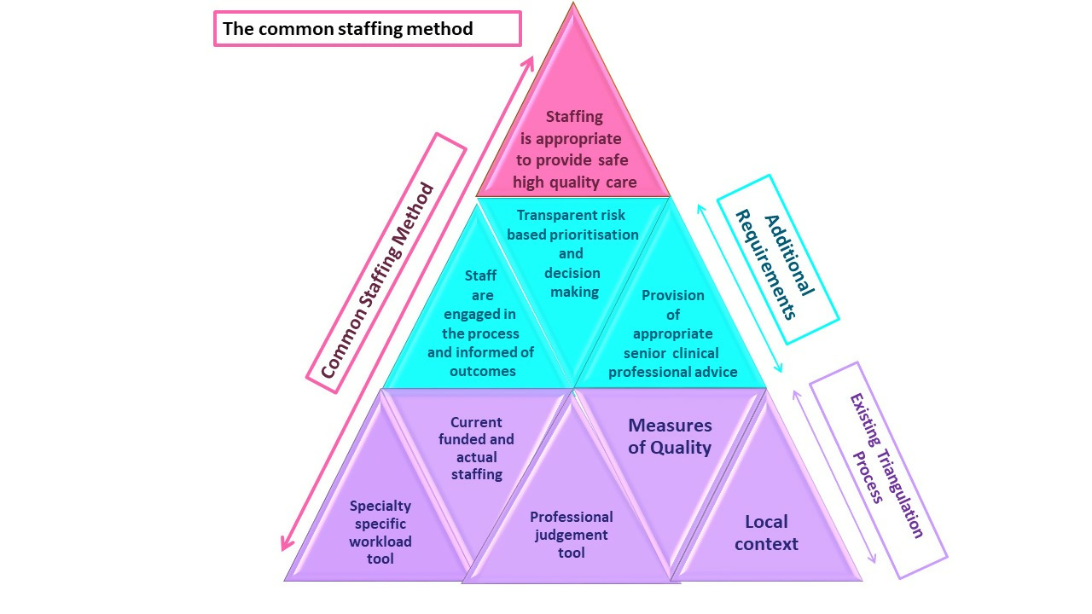
Nursing & Midwifery Workload Tools

Over the last year NHS Borders has utilised the nationally developed Workload and Workforce Planning Tools to inform service redesign across a variety of specialties. All Ward Areas have recently implemented a workforce establishment review and Adult Inpatient and Professional Judgement tools have been used to inform redesigned skill mix. As part of our Nursing & Midwifery Workforce Planning, there is scheduled follow up time aligned to the dates the workload tools are run, to ensure that appropriate analysis is conducted against findings. This includes clinical discussions which will inform the requirement for a business case if seeking additional staff, or reallocation of resources if the tools show an oversupply in a particular area. A robust system of feedback and discussion of findings and analysis of workload tool results is being established to ensure that there is transparency around decision making and prioritisation and to encourage staff engagement in the process which will move onto a statutory footing with the passage of The Health & Care (Staffing) (Scotland) Bill.

Although there is currently no recognised AHP Workload Tool, the Health & Care (Staffing) (Scotland) Bill includes an action to develop multi-disciplinary tools that will support workforce planning. The Specialist Nurse Tool would be the most appropriate fit and is being considered for use in the interim.

2.2 Public Health Profile

The Scottish Borders has more people aged 65 and older than Scotland as a whole, having 24% of the population in this bracket, as opposed to 18% in Scotland. By 2040 it is estimated that 34% of the Scottish Borders population will be over 65, compared to 25% of the overall Scotland population, with nearly 6% being over 85, compared to a Scotland average of just over 4%.

Life expectancy for men is shown as averaging 78.1 years, although this varies from 74.7 to 83.6 depending on locality. For women it is 82 years, again varying dramatically from 79.1 to 89.5 depending on area.

Scottish Borders is a rural area, with nearly half (47%) of the population in 2016 living in rural areas.

Within the Scottish Borders the likelihood of developing Type 2 diabetes has tended to be higher than the Scottish average, having increased from 3.5% in 2005 to 5.5% in 2015. The prevalence increases with age, and 15% of over 65s in the Borders had the condition in 2016. Diabetes can have a significant impact on quality of life and is a largely preventable condition strongly associated with obesity and being overweight. During 2013-16 most adults in the Borders were overweight (68%) including almost a third who were obese. The rate of overweight and obesity is slightly higher than Scotland overall, but not significantly.

In June 2018 the Scottish Government and COSLA agreed and published Scotland’s Public Health priorities using a whole system approach focused on prevention and early intervention. The AHP Active and Independent Living Programme (AILP) was identified as one of the Scottish Government deliverables on public health in the National Health and Social Care Delivery Plan. AILP was subsequently launched in April 2017 with its vision to support the people of Scotland to live active, independent healthy lives by supporting them with their personal outcomes. Locally we are using this programme to deliver transformation in care from AHP services particularly in relation to prevention, re-ablement, rehabilitation and restoration.

2.3 Financial Context

The Local Workforce Plan is closely aligned with our Annual Operational Plan and both consider the financial context when planning for our future workforce. 60% of costs to NHS Borders are related to staffing costs, and in response to the challenging financial environment NHS Borders has recently approved a financial plan for 2019/20, which, despite forecasting significant savings, still retains an in-year financial gap of £9.3m, therefore it is key that we consider more efficient ways of working. Detailed planning and preparation is underway to achieve the identified savings, however it is recognised that this does not fully meet the challenging level of efficiency required of £21.7m.

The Financial Turnaround Programme is designed to support us to deliver comprehensive and sustained financial improvement and change across NHS Borders that will:

- Deliver a one year financial plan with sustainable savings identified to a value of at least £12.4m, agreed by the Clinical Leadership and NHS Borders Board
- Produce a three year plan aimed at achieving a financially sustainable position which will achieve a further reduction in overall expenditure by £21.7m
- Improve services to ensure continuous safe, effective, person centred and affordable patient care

NHS Borders is currently working on Phase one of Financial Turnaround which is focused on the Financial Improvement Programme (FIP), which requires a minimum of £8.3m of recurring savings (4% of budget).

A Programme Management Office (PMO) has been set up to support the delivery of identified savings and is working across 12 distinct work streams:

- Financial awareness
- Demand Management and Pathways
- Financial grip and control: discretionary spend
- Workforce: Frontline Medical
- Workforce: Frontline Nursing
- Workforce: Other Staffing
- Finance: (Non-Pay)
- Estates and Facilities
- Medicines and Prescribing
- Productivity and Efficiency
- Income and Service Level Agreements
- Transformation

A Communication and Engagement Planning Stage will be part of all Efficiency Projects that are progressed, during which Stakeholders are informed of what changes are planned, why they are happening and how they can contribute to the decision making process. . A 55wte reduction in workforce across a variety of staff group has been identified, and committed to in mandates so far through the work streams above. Where Efficiency Projects impact on staff, the Board's agreed Organisational Change Policies are applied as appropriate

2.4 Local Workforce Conference

The key theme of our Local Workforce Conference on 8 March 2019 was ‘Helping to Mould the Future” and was organised by a sub group of the Workforce Group and sponsored by the Area Partnership Forum (APF) and Area Clinical Forum (ACF).

The Chair gave a very open and moving welcome in his last year and reflected on the great performance of NHS Borders and how NHS Borders staff contributes to this so well. Dave Caesar, Head of Leadership and Talent Management within the Scottish Government was our guest speaker and shared his experiences of large scale service transformation and linked this to a compassionate leadership approach which was very thought provoking and entertaining. Staff were encouraged to find out more about project lift to support their future learning and development, and Joanne Rafferty (Principal Lead: Leadership & Talent NHS Education for Scotland) also attended and spoke to staff about Project Lift during the networking session.

A presentation about Partnership Working in NHS Borders, reminded us of the partnership model, opportunities to get involved through Local Partnership Forums and described how effective partnership will help to deliver the Staff Governance Standard. This linked into our theme for the day, which was to investigate how our staff could help to mould the future and 3 interactive workshops followed focussing on:

- Staff governance standards
- Simplifying workforce planning
- iMatter

The outcomes of these workshops feed into our 3 Year Local Workforce Plan highlighting the importance placed on engaging our workforce and the significant workforce challenges ahead.

Jackie Balkan (Regional Workforce Planning) gave her reflections on the day as our final speaker, and linked this to NHS Borders participation in regional working with lots of positive messages about how well NHS Borders are regarded in the region.

The conference attracted 70 attendees from across NHS Borders, and we encouraged managers who had signed up to bring along one of their colleagues. This worked very well, and introduced lots of staff to the conference for the first time.

Step 3 – Defining the required Workforce

3.1 Changing Workforce
NHS Borders Workforce is changing and revised and new roles are being explored to meet predicted service need. Our commitment to role development, new and advanced roles and life-long learning of our staff is key as we can no longer rely on increasing staff numbers and traditional roles.

In a rapidly moving healthcare environment the workforce is facing major challenges around changing demographics, higher expectations of health, advancements in technology, improving quality and new ways of delivering care. Meeting these challenges will require new approaches to multi-professional learning and workforce planning. Health and Social care professions are dependent on each other and there is evidence of a shift towards more collaborative working.

Change is not easy; however, with careful attention to role design, team-working and effective change management, the potential benefits are significant. Reshaping the workforce can deliver benefits for patients through more patient-focused care and improved health outcomes. It can deliver benefits for staff through more rewarding roles and enhanced career pathways. It can deliver benefits for NHS organisations through greater efficiencies and helping to address potential workforce gaps.

Current training pipeline

Future staff mix
Numbers,
roles,
skills

Current staff mix
Numbers,
roles,
skills
Skill flexibility
Role substitution
Role delegation

Skill development
Role enhancement
Role enlargement

New roles

NHS Borders are currently using Role Development to “grow our own” from existing staff. Nurses from the community teams are developing roles as Community Nurses and Health Visitors and are currently working to support the education of Health Care Support Workers (HCSW) to enter the degree programme in second year.

For the past 2 years NHS Borders has carried persistent Registered Nurse (RN) vacancies despite active recruitment strategies, whilst recruitment and retention of Band 2 /3 staff has remained consistently unproblematic. The Assistant Practitioner project aims to develop 10 existing experienced Band 2 /3 HCSWs into new Band 4 Assistant Practitioner roles. Implementation of this new Assistant Practitioner Band 4 role aims to replace Band 5 registered nursing vacancies within agreed health service areas. Staff are currently in training completing their SCQF Level 8 education so no post changes have yet occurred. Active engagement and conversations are taking place regarding the culture shift required to facilitate introduction of this new role. It is anticipated through the development of Band 2 /3 workforce into Band 4 Assistant Practitioner roles we will have more success recruiting and retaining staff which in turn will stabilise the nursing workforce, decrease the number of Band 5 gaps thus reducing the requirement for agency spend. The Assistant Practitioner would be able to take on some duties historically carried out by registered nurses. This will support the change of skill mix within the clinical areas to happen.

There are also currently 10 HCSWs across NHS Borders undertaking Open University courses with 4 of them qualifying as Registered Nurses (RN) this year. A further cohort of 3 HCSWs will commence this training in September 2019. This is a good way to ‘grow our own’ Registered Nurses, and encourages retention, as we ask staff to commit to a retention period after registration is achieved. Within AHP services 2 AHPs are undertaking SVQ3 to support their development within the career framework. This supports the national framework for AHPs (Calderdale Framework).

Over the last year there has also been collaboration between NHS Borders and Queen Margaret University to develop a Nursing Leadership Academy for NHSB (NLAB). All Senior Charge Nurses (SCN) have had the opportunity to participate in the programme to develop and enhance leadership skills at local level and there are now plans to roll out the programme to all Band 6 clinical leaders in the organisation.

Scottish Universities are supporting an additional 33% of physiotherapy places for the next 3 years to meet additional workforce demands and there will be consideration of this being expanded to include wider AHP staff groups. There are also a range of development opportunities for AHPs, including exploring new routes to advanced clinical practice, health research etc and, as the 3rd biggest professional group, have a major part to play in the future sustainability of the NHS.

3.2 Integration

NHS Borders Local Workforce Plan will read across to the Health & Social Care Partnership Plan (H&SCP) once developed, which will further focus on the detail around community changes and GPS Contract work. The deadline for boards to develop a joint H&SCP workforce plan is March 2020, and Workforce Planning representatives from NHS Borders, Scottish Borders Council, independent and third sectors have had initial discussions to progress this work. The AHP Active & Independent Living Programme dovetails into the aims of the H&SC Delivery Plan and there has recently been Joint OT visioning around joining H&SC services leading to a more streamlined service.

3.3 Workforce Information

Turas Data Intelligence Platform

The Turas data intelligence platform was launched by NHS Education Scotland, (NES), on 1 April 2019. The launch of the platform represents the delivery of a key recommendation in the National Health and Social Care Workforce Plan and supports a whole-system approach required for workforce planning in future. This digital tool brings together core workforce datasets across health and social care. This will help workforce planners to maximise their data analysis capabilities, and to build better knowledge and intelligence about the health and social care workforce in an integrated environment. Phase 1 of this project has consolidated workforce data into one central repository. Two further phases of this work will concentrate on: modelling data around the needs of workforce planners and providing predictive analytics about the shape and nature of the future health and social care workforce. This will greatly support us to make informed workforce planning decisions in the future within NHS Borders, jointly with SBC, and across the east region in coming years.

The AHP component of the TURAS platform has been delayed in its launch and our local Practice Education Lead (PEL) will support staff once this feature is available to ensure that staff gain the optimum benefits from this system.

3.4 Current Workforce Planning
The main workforce challenges currently facing the NHS Borders nursing and midwifery workforce are recruitment and retention of registered nursing staff (particularly within some specialist areas), an ageing workforce with approximately 475 members of registered nursing staff aged over 50 years, and a trend for high bank and agency usage in some clinical areas which is consistent with NHS Scotland. Some local challenges include the rural location, transport, and fewer opportunities for career progression. Our recruitment strategies have been extended to include radio adverts, targeting university and return to practice students, and the use of social media to promote the Borders as a great place to live and work.

The service areas where we have had most difficulty recruiting registered nursing staff are Theatres (particularly Anaesthetics), Health Visitors to meet required increased numbers associated with new pathways, and Community Hospitals. To address the recruitment difficulties in Community Hospitals we have offered candidates a permanent contract (with an initial period in a Community Hospital if it’s a fixed term post then moving to a vacancy in BGH) but these have not been attractive – with candidates preferring to work permanently in one location.

Within AHP services there are a number of staff approaching retirement age and there is need for succession planning. AHP services are often reliant on individuals with specific skills, therefore resilience can be an issue when workforce planning. E.g paediatric dietetics we have 2.0WTE Paediatric Dieticians, if one leaves then immediately staffing resource is reduced by 50% and specialist skills lost.
Individual AHPs services have their own bank to help increase resilience.

Pre-emptive employment is also used as a mechanism to recruit permanent registered nursing staff in advance of vacancies coming up in the knowledge that posts continue to become vacant due to staff moves, retirements, maternity leave etc. The aim is to have a steady supply of nurses to reduce/eliminate the vacancy factor and ensure that service provision can be maintained by an adequately developed and supported nursing workforce.

A significant proportion of the registered nursing staff we have attracted over recent years are newly qualified, and whilst it is encouraging that staff wish to commence their careers in the Borders, it does create a pressure which can’t be underestimated for Senior Charge Nurses in terms of training, mentorship and support where a high number start in one area.

NHS Borders currently have 16 Advanced Nurse Practitioners and a further 9 in training. It is anticipated we will be considering further posts, aligned with the needs of the service, in Medical Assessment, Unscheduled Care, Paediatrics, Emergency Care, Mental Health and Primary Care, including GP practices with the implementation of the Primary Care Improvement Plan. AHP Services currently have 6 Advanced Physiotherapist positions with more in development and 1 podiatrist and working towards advanced roles in dietetics. We are also considering advanced Mental Health roles within Primary Care. Physician Associates (PA), defined as “a healthcare professional who is trained to the medical model and who works as part of a medical team to provide holistic care”, are healthcare professionals with a generalist medical education who work alongside doctors, physicians GPs and surgeons to provide medical care as an integral part of the multi-disciplinary team. PA’s are considered a potential solution to recruitment challenges across the medical workforce, across Lothian, Fife and Borders and a plan to adopt the Grampian model which has successfully introduced PA’s across a variety of specialties is being progressed across the region which will see trainees complete placements across the region over the next two years.

3.4.1 Shifting the Balance of Care / Keeping People at Home

It is anticipated that there will be changes in the delivery of services, both inpatient and day care services, offering more complex care to both areas over the next 2 to 3 years. The age profile of the workforce is a challenge, with a number of retirements anticipated, and there have been particular difficulties recruiting RNs in community hospitals. An opportunity to raise the profile and ease recruitment might arise from increasing the scope of the community/day hospitals to include more acute care e.g infusions, blood transfusions, nurse led clinics. Further changes to the work undertaken in Community Hospitals and Day Hospitals/Clinics are anticipated as a result of the transformation work being undertaken in Primary Care with potentially greater need for development of ANP and Advanced AHP posts with independent prescribing supporting a possible restructuring of bed complements and reduced medical cover. There is the potential for reviewing skill mix to include Band 4 Assistant Practitioner roles.
In District Nursing new methods of delivering community care within multidisciplinary teams are being considered. Hospital to Home, and changes to residential and nursing care homes has already lead to impacts on the workforce requirements in other areas where staff have been recruited from.

New community models are emerging through the Transformation Programme, to include broader professional involvement for example of Physiotherapy, OT, Dietetics, SLT, psychology Pharmacy and Social Workers as part of MDTs

The new GP Contract has required additional AHP resource to be placed into Community Health Centres. First Contact MSK Physiotherapy Practitioners have been recruited and will start in post this spring/early summer. There is the potential for a further 4 First Contact Practitioners next year. In the longer term, it is hoped that additional Occupational Therapists and Physiotherapists can be deployed in community settings, reducing the requirement in hospital environments. Significant AHP investment is required within Community Services to support shifting the balance of care to the community. There is also a need to draw on other assets within local communities with greater partnership working with social care and 3rd sector colleagues. Example is Borders weight management team (formally Specialist Weight Management team) working in partnership with Live Borders to deliver Tier 2 weight for management for prevention of Type 2 Diabetes. This is part of the East Partnership Early Adoption for Diabetes Prevention.

The addition of these First Contact Practitioner posts however, is resulting in a shortage of general physiotherapist posts as staff seek promotion, and, in turn this will result in a further need for additional recruitment of newly qualified physiotherapists. There will also be a high proportion of training/development needs as staff move into promoted positions. These new, local opportunities within the workforce however should result in reduced turnover and increased ease of recruitment, and a proposed increase in student placements to NHS Borders from 2019 should help to facilitate this. The Scottish Government expects HEI’s to support an additional 1/3 university places over the next 3 years and further Advanced Practitioner roles are also being explored.

Major Trauma Network Programme is being launched across Scotland. The South East of Scotland Major Trauma Network will see the creation of a Major Trauma Centre for Adults at Royal Infirmary of Edinburgh (RIE) and for Paediatrics at Royal Hospital for Children and Young People (RHCP). The MTC will be supported by 3 x Trauma Units (Fife Victoria Hospital, Borders General Hospital & Forth Valley Royal Hospital) and a Local Emergency Hospital (St John's).

Based on STAG data, it is estimated that 600 adult patients and 30-40 paediatric patients will be admitted under the Major Trauma Service. With the implementation of a Major Trauma Centre at the RIE, due to go live in 2021/22, the pathway for major trauma patients will include care provided by a specialist Major Trauma Service, which includes, earlier, hyper-acute rehabilitation services. Major trauma patients will be admitted to a specialist Major Trauma Ward either directly from the Emergency Department or as a step down from Critical Care. Local leadership will support the development of rehabilitation pathways for major trauma patients that bridge acute, hyper-acute and community. Seeking appointment of additional posts funded by the Programme. Major Trauma Rehabilitation Coordinators will develop local pathways to support early repatriation of patients whilst ensuring access to appropriate rehabilitation services linking with Health and Social Care partnerships where indicated

3.4.2 Hospital Admission

Given the challenges of maintaining GP delivered Primary Care Out of Hours due to a shortage of GPs, additional nursing posts are vital to maintain front line services across NHS Borders. This service supports HEAT T10 plus Shifting the Balance of Care by maintaining patients within their own homes. In Primary Care Out of Hours, Unscheduled Care Nurses have replaced some GP hours in the interest of long term sustainability and this will become an ongoing trend, as attendances have doubled over the last 2 years.

Within the Emergency Department utilising triage protocols has enabled Emergency Nurse Practitioners (ENP) to be trained to appropriate competence levels to augment the medical contribution to the Emergency Department. We expect the number of ENP’s to increase and enhance the overnight cover provided by medical staff currently. Advanced Practitioners in MSK Physiotherapy are addressing GP shortages and non-clinical Advanced Orthopaedic Trauma Practitioners are also supporting a reduction in flow to surgery.

Medical Assessment Unit (MAU) have experienced particular difficulties in recruitment and retention. There is a recognised requirement for role expansion e.g. further ANP posts are required in medical as well as encouraging HCSWs to undertake a Band 4 development programme across the division. There are currently 2 HCSWs undertaking Pre Registration Programmes with the Open University and there will be continuing commitment to supporting staff through this development programme as a way of ‘growing our own’ staff nurses.

Through the Transformational Programme developing Frailty Unit within BGH, focussed rapid multi-disciplinary assessments/interventions avoid lengthy admissions and promote early supported discharge

The AAU/Ambulatory care area has grown in success and now sees up to 15 GP referrals daily as well as up to 15 Ambulatory Care patients. This has lead to a requirement to consider staffing levels and space capacity, with some ambulatory care services being moved to available capacity within the Day Hospital.

Within Planned Care there is a need for investment into training of staff in specialist skills e.g. gynaecology, urology, orthopaedics to allow for safe staff rotation as well as potential development of ANP posts.

Consideration is being given to the development of a combined assessment and ambulatory care unit or gynae/surgical inpatient ward and combined assessment unit, with the option to up skill staff to advanced practice roles.

NHS Borders has found recruitment of staff with anaesthetic/OPD experience difficult with a high level of training required for newly recruited staff. Succession planning is required to ensure sustainability of services, as 40% of theatre and DPU staff can retire within the next 5 years.

Role development to Associate Practitioner level (B4) in theatre is currently ongoing with plans to develop surgical assistant posts over next 3-5 years. There is also an increasing emphasis on short stay surgery and there is potential for improved integration of theatres, recovery and ITU with staff rotation. Currently plans are in place for most DPU work to move to main theatres and there is a potential to extend the working day for physiotherapists to support a reduction in inpatient day surgery.

3.4.3 Patient Flow

The site and capacity team hold responsibility for the management of patient flow across acute services and to community. The senior nurse in the site and capacity team is responsible for responding to and for initial co-ordination of any event which may occur on the site in line with the Scottish Government 6 Essential Actions.
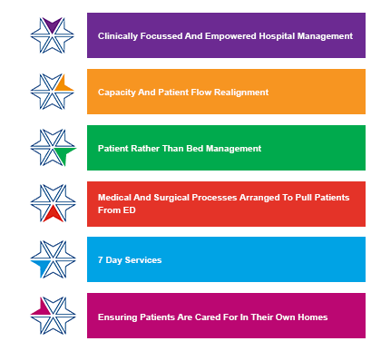
The new Hospital to Home service has supported patients to become more independent at home as their care requirement reduces and is mainly provided for up to 6 weeks either after hospital discharge or prevention of admission. It included a pilot of AHP services being provided in this environment in the Central Locality. This has been extremely beneficial and shows admissions and attendances being significantly reduced and it is therefore hoped that, despite financial constraints, it can be rolled out through all localities. The plan includes the Hospital at Home Healthcare Support Workers having a more Generic Clinical Support Worker role which would include some re-enablement under AHP instruction to achieve the greatest benefit from the investment in AHPs in this setting. Additional OT and Physio capacity is required to support rehab in the community.

3.4.4 Women and Children’s Health

The national Best Start programme aims to ensure that expectant mothers experience more continuity, with a dedicated midwife assigned all the way through pregnancy and birth. There may be an increased number of midwives will be required to support this programme over the next 3-5year roll out with hospital midwives requiring training on child protection for Best Start; and up-skilling of community midwives for intrapartum work will be necessary.

There is a likelihood of 50% of community midwives retiring over next 5 years as well as some senior hospital midwives and assisted birth practitioners.

ANP roles and Band 4 maternity care assistants are being developed. There is also a requirement for more ‘non medical prescribing’ training for midwives. A full training needs analysis is required, with a requirement for supervised/supportive practice for NQPs (preceptorship), clinical skills training and training on Badgernet.

NICE have conducted a national review that recommends non-surgical supervised 3 months pelvic floor exercises to prevent incontinence/prolapse which will require an increase in physiotherapy workload within the bladder and bowel team.

Health Visiting (HV) have also undergone significant change with the introduction of the new Universal HV pathway, which also requires significantly higher numbers of clinical staff to be trained/recruited. NHS Borders has committed to training between 2-4 Health Visitors per year which has been supported by Scottish Government funding. An additional HV Practice Teacher has also been secured and recruitment to this post is underway. There is an also an ageing demographic within the HV workforce with a large percentage over 50 years, and as HVs have Special Class status they can retire at 55 without a financial penalty.

In School Nursing NHS Borders is awaiting government guidance about the numbers required to meet the needs of the new pathway which may include developments in terms of changes to the GP contract and the proposed immunisation Transformation Programme.

Recruitment to Advanced Paediatric Nurse Practitioners (APNP) / Advanced Neonatal Nurse Practitioner (ANNP) level is difficult and the new hospital at RIE may further impact on recruitment and retention for NHS Borders as many staff will be attracted to work in the new specialist hospital. This is compounded by insufficient numbers of children’s nurses being trained nationally. We also anticipate that some staff nurses are likely to move to HV training, with the recent re-banding of all health visitors nationally making this an attractive opportunity for career progression at a much earlier stage in their development.

Supervision of NQPs and the development of HCSW role has been difficult, therefore rotational posts are being considered throughout the unit.

Ready to Act was developed and issued in 2016, in response to the Children and young people Scotland Act (2014). Ready to Act offers directions for AHPs working in Children and Young Peoples Services to transform service delivery, with a national approach to consistency. AHP’s are acutely involved in a number of National directives, for example physiotherapists leading on Cerebral Palsy Integrated Pathway (CPIPS) so no-longer a need for routine reviews with paediatricians. Another example is dieticians/paediatricians no-longer need to routinely review infants with cow’s milk allergy as new pathways/training/helpline developed by dieticians to support a health visitor led service. At a more local level there is considerable collaborative working across health and social care, including the Emerging Literacy Project with SBC, Child Healthy Weight Standards. NHS Borders is an early implementer site and additional workforce resource is expected. We also have an Early Years Assessment Team, consisting of Physio, OT, SLT and consultant paediatrician who offer a single point of assessment for children aged 0-5, demonstrating challenges in two or more areas.

3.4.5 Mental Health

A number of initiatives are likely to impact Mental Health Services in the next few years including: MH strategy 2017-27; Access to Psychological Therapy, CAMHs initiatives; an anticipated greater involvement in Primary Care; Excellence in Care; and locally there is a focus on the MH Transformation Programme which is reshaping work of Community Mental Health Teams, Liaison service, crisis service and inpatient dementia units.

Redesign of Dementia Services within NHS Borders
The Health and Social Care Integration Joint Board recently approved a proposal to redesign dementia services in the Scottish Borders. In order to enhance the care of people living with dementia the redesign will involve investing in appropriate community resources and as a result reducing the number of dementia inpatient beds, currently located within Cauldshiels and Melburn Lodge wards on the Borders General Hospital campus.

The redesign proposal is part of ongoing work from the Health and Social Care Partnership working with Scottish Borders Council and NHS Borders within the context of an overarching mental health transformation strategy to consider how we best care for the growing number of people with dementia, recognising that in many cases, hospital settings is not what is best for them.

This redesign follows local reviews of dementia care, and is in line with recommendations arising from the ‘Transforming Specialist Dementia Hospital Care’ report which recommends that 50 per cent of acute hospital beds for dementia patients should be transferred to more appropriate provision within the community. The reduction of dementia inpatient beds and reinvestment in appropriate community resources in Borders represents a positive shift in the balance of care for medicine of the elderly.

In addition, exploration of further integration of Mental Health services is being considered, potentially to include Mental Health Older Adults Service (MHOAS) and Child and Adolescent Mental Health Service (CAMHS). Also being considered is possibly a review of Mental Health Rehabilitation services, looking at closer alignment with Community Mental Health Teams (CMHT).

The development of an Advanced Nurse Practitioner role in CAMHS is being explored, although waiting times pressures are a major consideration in timing of role development, and generally CAMHS nursing posts can be particularly difficult to recruit to. Shift patterns are being reviewed with consideration of CMHT workforce balance and also training needs analysis is being undertaken to promote opportunities for learning. The CAMHS occupational Therapy integrated with the Paediatric Occupational Therapy Team in April 2019, to form the Children & Young Peoples Occupational Therapy Service. The purpose of the integration was to offer a broader skill mix of staff to the children requiring specialist input as well as reducing waiting times and looking to develop a more sustainable and equitable service.

Recruitment is challenging due to a single intake for student nurses which leads to national shortages and few Registered Mental Health Nurse (RMN) students from the Borders area. There are increasing retention problems, mostly owing to the age profile of the workforce, with 46% of RMNs and 62% of HCSWs in the 50+ age range. More flexible contracts are being considered to support retirees to return on fewer hours. There is a potential to develop more Associate Practitioner roles, growing our own nurses by encouraging support workers to consider Open University.

Psychology

The NHS Borders psychology service has a mixture of consultant clinical psychologists, highly specialist clinical psychologists, Clinical Associates In Applied Psychology and Assistant Psychologists. Psychology has the remit of the overall governance of the delivery of psychological therapies which also includes the remit of training, supervision and consultation. Services are provided within the CMHT, BAS, LD MHOAS and CAMHS and discussions are underway to establish a clinical health psychology service as well as offer psychological therapy within primary care. Psychology within NHS Borders is under resourced compared to other NHS Boards in Scotland and there are gaps in service provision for example rehabilitation, inpatient, neuropsychology, and inpatient.
3.4.6 Learning Disabilities Service

There is a national shortage of LD nurses and it is difficult to recruit experienced staff within the Borders. MH & CAHMS have also been recruiting LD nurses which have impacted on their availability further.

People with learning disabilities are living longer, leading to increased numbers with increased health needs, which has resulted in the need for consistent reviews of service and how posts are utilised. Although staff have specialist skills, there is also requirement for them to work generically due to small numbers, and consideration is being given to potential integration of health and social care staff.

We anticipate a need for succession planning for Autism, Forensic and Epilepsy services. A new ANP post is being developed, and plans are being made for a Challenging Behaviour Unit in Borders with a Positive Behaviour Support Nurse requirement to support this development. There is also scope for wider multi-disciplinary team working in this area.

3.4.7 Specialist Role

The majority of specialist nurses in NHS Borders are aged 50+ with a number of retirements anticipated within the next 3-5years. Succession planning is particularly difficult due to small numbers and this creates a potential need for more generalist nurses with specialist interests to allow for cross cover. It is difficult to recruit experienced specialist nurses and AHPs both locally and nationally and we recognise the requirement to grow our own, but this brings significant challenge in terms of training, development and supervision. The career pathway to specialist nursing needs to be actively promoted locally with development of a specialist forum, focussed recruitment drives with clear guidance or resource allocated to Specialist Nurse and AHP development.

Endoscopy
NHS Borders is working towards providing a nurse led endoscopy service. As part of service redesign a new role of Extended Scope Practitioner was introduced to manage emergency cases which are repatriated back to Borders following surgery in Lothian. This is a specialist nurse role with additional training to review patients usually seen by a doctor. Succession planning which may include further training and development of the current workforce and/or recruitment at specialist level will be required.

As part of the regional initiative on enhancing Endoscopy capacity there has been an expansion of the nursing workforce (the modernised Oliver Eade Suite) at both registered and non-registered levels.

Oncology

The haematology service had been reliant on locums for several years which highlighted the risks inherent with a small service in relation to patient care. These centred around:

- Continuity of care for patients
- Responsibility and accountability for care
- Ensuring investigations are appropriate, timely and followed through
- Timely assessment by a specialist during unscheduled care episodes
- Adherence to local and regional policy

In response to the above, a Macmillan Haematology Advanced Nurse Practitioner (ANP) role was introduced to integrate with the Consultant Haematologists to provide a robust team approach to care, utilising skills of the specialist team in the most appropriate way.

Many of the Clinical Nurse Specialists (CNS) are also undertaking advanced practice roles to impact on patient demand and improve patient experience. There are currently 5 non medical prescribers within cancer services and another due to start the course in September. Within the breast service a band 6 CNS has been employed to support release of the band 7 to allow the development of a nurse led result clinic. This is on a temporary basis for one year and is under evaluation, however early signs are that this is a safe, effective and acceptable model of care for patients which releases Consultant Surgeon time. It also supports succession planning within the breast care team.

As the management and treatment for cancer continues to advance it has resulted not only in increased survival but also in an increasing number of patients attending acute units for unscheduled care. Provision of optimal care to this complex patient group in the absence of specialist oncology input presents a key challenge. Options to address the best use of current resource within the cancer services budget have been considered and an opportunity identified to remodel resources to facilitate delivery of an acute oncology service which would support this patient group as well as address service developments in central venous access management and succession planning for the Nurse Consultant role. Macmillan Cancer Support have agreed to support this development which introduces a Band 4 Project Support / PA to work alongside the Nurse Consultant which releases her to have a defined clinical remit as well as having dedicated time to concentrate on the strategic and leadership functions within the role. It is hoped this service can be progressed if ongoing financial resourcing can be agreed.

Within the chemotherapy day unit the role of the assistant practitioner is embedded and further developments for this role are being explored e.g. subcutaneous injections and single person checking of blood products.

Dialysis
Due to repatriation of Renal activity there has been expansion of the Renal Nursing Workforce. The overall redesign has led to patients with renal insufficiency being treated locally instead of travelling to Edinburgh for treatment. Spaces are often used for holiday dialysis patients. There are possible future staff development opportunities within the renal directorate involving secondment to RIE.

    - Healthcare Sciences

Following the redesign of the service in the laboratories in 2014, there have been challenges with recruitment and retention. There has been a trend for our Band 5 trainees moving to Band 6 posts elsewhere in Scotland due to a lack of opportunity for development to Band 6 locally. Other Scottish NHS Boards have automatic progression to Band 6 Section 21 training posts when Band 5 registration portfolio is complete, whilst staff in NHS Borders can’t progress until a Band 6 post becomes vacant although they can work towards their specialist portfolio whilst awaiting this opportunity. In addition, out of hours rotas add to the recruitment challenges, due to smaller numbers in the rota compared to larger boards, requiring NHS Borders staff to work out of hours more frequently. Although 2 additional posts have been added to the out of hours rota, the benefits of this are restricted due to staff being in training, then moving to other boards soon after they are experienced enough to join the rota. Succession planning to Senior posts progresses.

3.4.9 Other Therapeutic Services

The Pharmacy Department is the largest department in the Other Therapeutic Services staff group, and is another service implementing major change due to the new GMS contract and the need to establish a Pharmacotherapy Service.

The Primary Care Improvement Plan requires an increase in numbers of both pharmacists and technicians working in primary care. Whilst some additional posts have already been recruited to, additional capacity needs to be built in during the current year, with 2 additional Pharmacists and 2 further Pre-Registration Pharmacy Technicians planned. Further recruitment will be necessary next year to recruit student technicians and pharmacists in an effort to “grow our own” to both replace existing staff who are retiring and increase the numbers of staff in line with the primary care improvement plan. Qualified pharmacy technicians are difficult to recruit, therefore we will need to manage this growth carefully so we don’t deplete staff in secondary care, and rotational posts are being considered as a potential way forward.

3.4.10 Estates & Facilities

Estates are currently developing a Workforce Plan using the 6 step methodology to ensure a safe, efficient and sustainable service in the coming years. It will consider how the department can manage service pressures alongside compliance, finance and business pressures in a changing financial and technological environment. One of the objectives is to have a clear skills matrix based on role and individual to help map out career progression opportunities, and support successful recruitment and retention of skilled staff. Within General Service a new portering system will be introduced which will improve the way work is allocated across the department.

3.4.11 Information Management & Technology (IM&T)

IM&T are carrying out an exercise to design a new Target Operating Model as part of the Road to Digital Transformation Plan. During the early phases of this exercise a shift in resource type, not necessarily numbers will be required which would involve development and training of existing employees.

There has already been substantial recruitment as part of the Road to Digital Transformation Programme which has seen the recruitment of numbers of technical and project staff to deliver this programme, to secure data, secure the environment, mitigate risk and deliver enabling technology to the organisation. These roles have been a mix of permanent and fixed term arrangements, funded primarily by the programme.

IM&T have moved the organisation to a more modern infrastructure and training and development has been supplied and delivered as part of the programme, but going forward technical training & development should be factored in to the technology roadmap. This has been difficult in previous years due to the financial pressures.

IM&T have seen some staff securing positions outside the organisation which allows the opportunity to recruit new people, however recruiting short term or permanent employees with the right levels of skills can be challenging due to location and salary challenges in comparison to major cities and commercial sector organisations.

Health Records intend to implement casenote scanning over the next 3 years, which will result in a significant change to the work of the section. Casenotes will increasingly not be required to be pulled, tracked and filed which should result in a 30% reduction in workload. Recently the department has become overly dependent on bank staff and fixed term contracts, meaning these staff often look for their next position as their training progresses. At time of implementation of this system, training in casenote scanning will become essential, and time-consuming until rolled out.

There is a general move towards a ‘Once for Scotland’ approach for Information Governance, with exploratory discussions ongoing with NHS Lothian and NHS Fife. Provisioning for Cyber Security is a growing area to be addressed and it is estimated that an additional 1.0 WTE is required, focussing on Technical Cyber Security. In addition, Data Protection Officers services for Borders GP Practices have yet to be detailed and finalised, and, with GDPR/DPA 2019, GDPR Practitioners are in high demand.

Step 4 – Workforce Capability – Available Workforce

4.1 Workforce Demographics
This section helps us to understand the available workforce and our current staffing. We know that 20% of all jobs in the Scottish Borders are public sector health jobs.

The charts following illustrate NHS Borders workforce as at 31 March 2019.

This chart shows all staff of NHS Borders split to show the proportion of the total staff in each Job Family. This illustrates clearly the fact that the Nursing/Midwifery staff make up the largest numbers of staff, being 45.5% of the whole of NHS Borders workforce. Of these 71% are Registered Nurses/Midwives.

Chart 4: All staff split into Job Families by WTE (This includes Doctors in Training contracted to work for but not employed by NHSB)

The following Workforce Tree Chart shows all NHS Borders staff in Agenda for Change payscales by Band. It shows Band 5 as the largest band, as many registered nurses, midwives, AHPs, etc fall into this category, with gradually reducing numbers at higher bands.

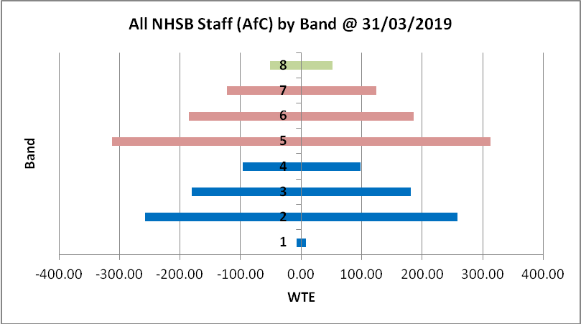
Chart 5: Workforce Tree for all NHS Borders Agenda for Change Staff broken down by Band

The following chart shows all NHS Borders Staff, including Senior Managers and Medical & Dental staff by Band. This includes all Doctors in Training contracted to work for NHSB but not directly employed by NHSB as most Doctors in Training are now employed by NES.

Chart 6: All staff by band by WTE

Age Profiles

The charts below help us to understand the age profile of our workforce. The average age across the workforce at 31 March 2019 was 46.26, which is up from 45.73 in the previous year, showing that increasing retirement ages may be starting to have an impact.

This chart shows the age profile of all NHS Borders Staff, comparing 2018 and 2019. It shows a slight increase in numbers of staff in their 30s, but overall reductions in staff numbers up to 50, and increasing numbers of staff over the age of 50, demonstrating our ageing workforce.

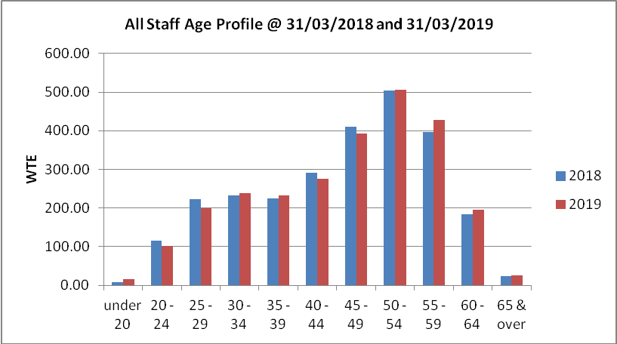
Chart 7: Age Profile of all staff 2018 & 2019

The next chart shows the age profile of all staff as a bar chart and shows the Nursing/Midwifery, AHP and Medical & Dental staff groups as line charts for comparison purposes. You will note that the Nursing/Midwifery chart, as the largest staff group, follows much the same line as the total staff, that is a high proportion of staff over 45, whereas both AHP and Medical & Dental show overall a younger workforce, suggesting successful recruitment of newly qualified staff. It should be noted that Training Grade Doctors are not included in Medical & Dental.

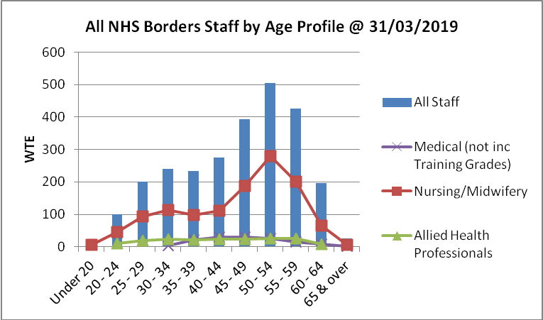
Chart 8: Age profiles of all staff, broken down to show Nursing/Midwifery, AHP & Medical/Dental

The following chart shows the percentages of staff under the age of 40, under the age of 50 and over 55, comparing 2018 and 2019. It shows that nearly 30% of staff are under 40, a very slight fall from 2018 but on a par with 2016. It also shows that 56% of staff are under 50 years old, again a fall from 58% in 2018, with 26% of staff being over 55, up from 24% in 2018. This is concerning, but may simply reflect the way in which the increasing state pension age will affect workforce ages going forward.

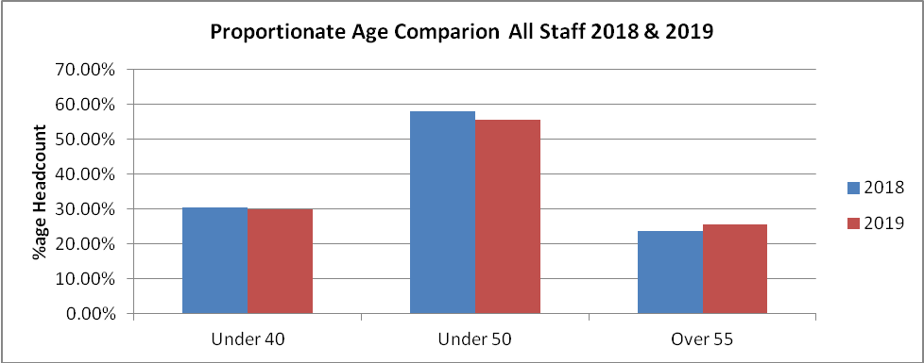
Chart 9: Proportionate Age Comparison of all Staff

The next chart shows the average age in each Job Family compared to 2018. You will see that overall average ages are rising with only a few exceptions in Other Therapeutic and also in Dental Support.

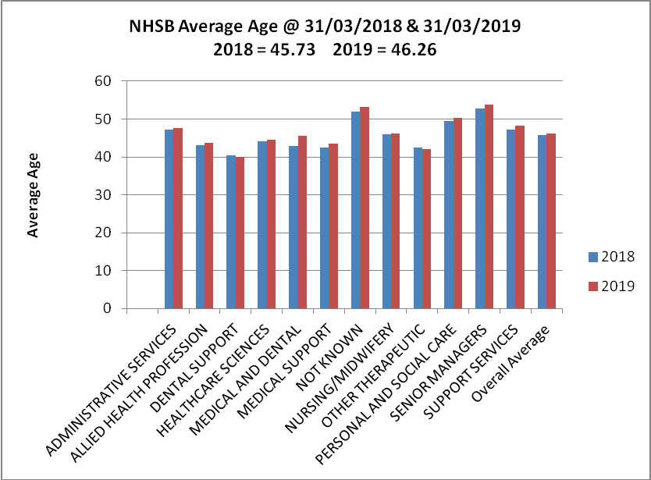
Chart 10: Average Age of all Staff for 2018 and 2019 broken down by Job Family (Does not include training grade M&D)

The chart below shows the gender split in each Job Family. It shows clearly that our workforce is predominantly female. It does however show that Medical & Dental and Support Services have a more mixed gender staff. With a predominantly female workforce, with a high proportion in the older age categories, positive work is being progressed on the impact of the menopause on working life to support retention of staff.

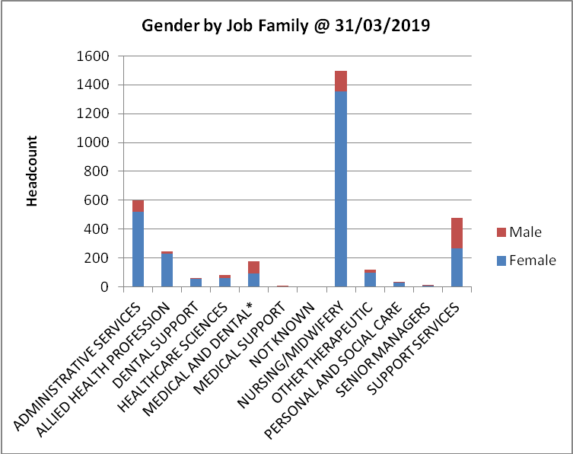
Chart 11: Gender split in Job Families (Headcount)

4.2 Skill Mix Changes
This Christmas Tree chart illustrates the distribution of changes to the workforce between 1 April 2018 and 31 March 2019 by Band. It shows that Band 2 has risen by 41.97 WTE and Band 5 has fallen by 37.29, whilst Band 7 has also risen by 46.86 WTE. Overall there has been an increase of 43.29 WTE. The most significant increase is at Band 7 level, which includes a national re-banding of 22.8 WTE Health Visitors from Band 6 to Band 7.

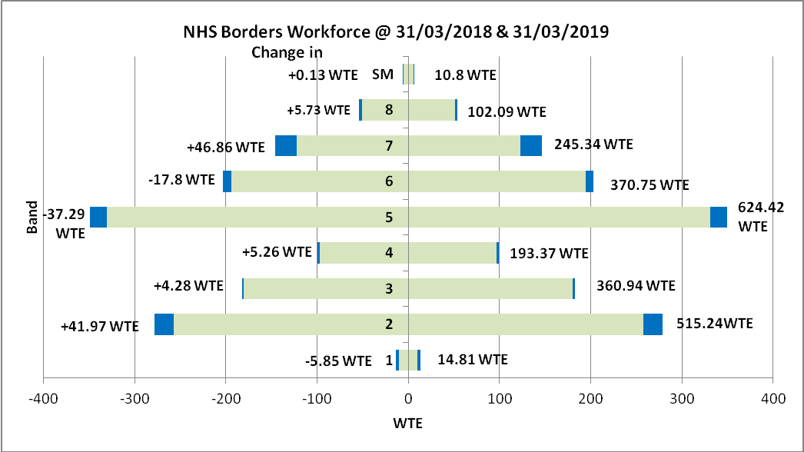

Total Workforce
@31/03/2018=2394.47WTE
@31/03/2019=2437.76WTE
Increase=43.29WTE
Current

This data is taken from Payroll figures and may not correlate with ISD figures.
Chart 12: Changes in Workforce by Band between 2018 and 2019

The chart below illustrates the changes detailed in the table above.

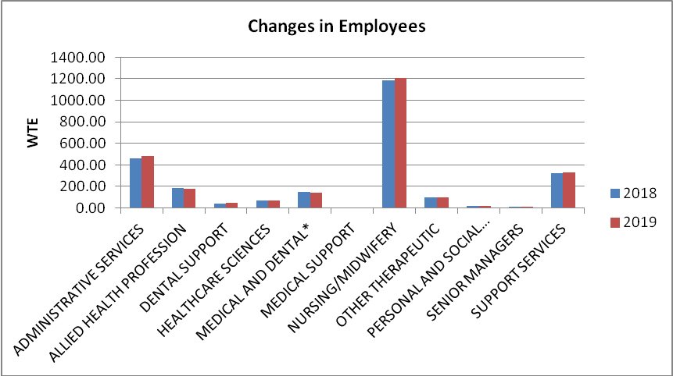
*Medical & Dental does not include doctors in training due to changes in their employment
Chart 13: Changes in Workforce by Job Family between 2018 and 2019

The next chart shows the percentage change in the whole time equivalent in each Staff Group in the year
2018-19. It shows increases in most staff groups, with Personal & Social Care showing an increase of over 8%, but it should be noted that this is a very small group of staff therefore high percentage changes can relate to just one or two staff. It also shows reductions in Allied Health Professions and Medical & Dental. Our reduction of 4.4% in AHP staff is inconsistent with national trends where there has been an increase of 6% in response to national strategies which recognise an increasing role for AHP’s as part of multi-disciplinary teams. The Medical & Dental figures may have been artificially skewed by the way in which trainee doctors are employed having changed throughout NHS Scotland within the last financial year.

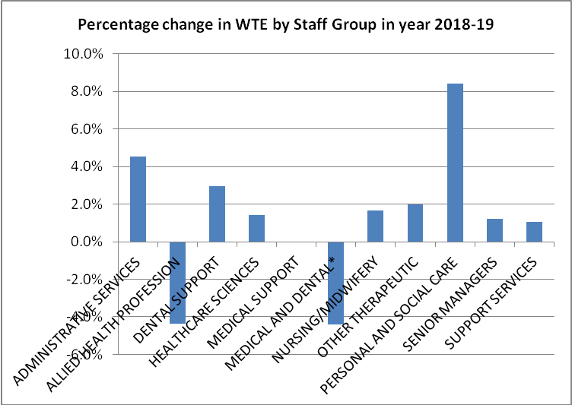
Chart 14: Percentage change in WTE by Job Family between 2018 and 2019
4.3 Recruitment Monitoring and Vacancy Rates

Vacancy control

Our workforce is our greatest asset and also our single largest area of cost, with 60% of the money that NHS Borders spends annually being related to staffing costs.

On an annual basis approximately 137 individual employees will choose to leave their posts and, given our financial position, we need to ensure that we maximise the potential opportunity this presents to make changes and when appropriate reduce our costs on an annual basis.

A revised vacancy control process has been developed and tested by the Unscheduled Care Service and has now been rolled out across NHS Borders so every area of the organisation will deal with vacancies in a fair and equitable way. Local Vacancy Control Panels will be held on a monthly basis. This process places additional scrutiny on the rationale behind filling vacant posts and presents challenges to the recruiting manager such as whether an alternative skill mix has been considered for the role or whether the role could safely be carried out in fewer hours.

The only exception to this is Band 5 registered nursing posts, due to the national shortage of registered nurses as we are currently experiencing 30 vacancies which have permanent funding.

Vacancy Trends

Nursing and Midwifery vacancies in NHS Borders overall are rising, which is also the case throughout NHS Scotland. In the period 31 December 2017 to 31 December 2018, NHS Borders Nursing/Midwifery vacancies increased by 3%. This has resulted in an increased focus throughout the organisation on recruitment. Recruitment Events have been organised and NHS Borders are employing staff pre-emptively, so that they are through all pre-employment checks and ready to start as soon as vacancies arise. In addition there has been a focus on encouraging Nurses/Midwives who are in the final stages of their course and awaiting their PIN, allowing them to start initially in Band 4, and move to Band 5 as soon as PINs are awarded. In addition Return to Practice opportunities have been increased to support Nurses and Midwifes who have left Nursing or Midwifery to be supported to come back to the profession.

This chart shows the number of vacancies filled within the year, showing the length of time from Interview Date to Start Date, broken down by Staff Group. It shows that the majority of posts (65%) are filled in under 8 weeks. The number of vacancies recruited to has risen by over 20% from the previous year. This chart does not include unfilled posts, nor does it count posts which are re-advertised.

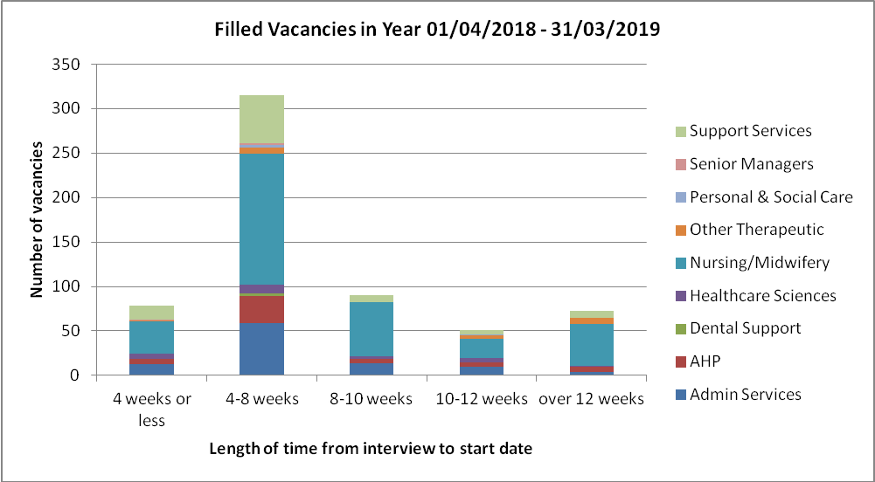
Chart 15: Number of Filled Vacancies showing length of time from Interview date to Start date

4.4 Employability/Youth Employment Strategy

The NHS Youth Employment strategic framework 2021 set out the following priorities for NHS Boards:

- Establish an infrastructure in our Board to support youth employment, including an executive sponsor and a named person / team with responsibility in this area
- Promote NHSScotland careers and career pathways, to attract and inspire young people into our service
- Increase the number of young people employed and retained in our Board
- Embed youth employability and the range of apprenticeships in our Board, including support for those furthest from the job market
- Develop young people in our service through support networks and activities, and use multigenerational working to support and mentor our young people
- Include statements about youth employment in our local and regional workforce plans, reinforcing our Board’s social responsibility as an employer

NHS Borders are already involved in promoting careers to young people and are currently hosting Modern Apprenticeships (MA) in the following areas: Painter, 2 x Dental Nurses, Plaster Room Technician, HR, and Work & Wellbeing are also recruiting an MA. Other initiatives that support youth employment and employability include: Prince’s Trust Programme, Train to Gain, S3 Work Experience, attending Developing the Young Workforce events, and Project Search which supports young people with a learning disability or autism into work.

4.5 EU Withdrawal

The outcome of the referendum on the United Kingdom's membership of the European Union will change the status of all non-UK EU/EEA nationals living in the UK. This has caused significant concern and distress for a considerable number of NHS staff who are directly or indirectly affected by these changes. NHS Borders ran a staff survey in December 2018 and the response indicated that we had 50 EU nationals in our staff from 16 different nations in a wide variety of posts. This is 1.5% of the workforce, a significantly lower percentage than other health boards.

We are supporting our staff by directing them to discuss their concerns with their manager, or alternatively a confidential contact in the HR Team.

A Home Office technical notice on services published on 12 October 2018 dealt with Mutual Recognition of Professional Qualifications MRPQ (Doctors, Nurses, Dental Practitioners, Midwives and Pharmacists) in the event of a No Deal Brexit”. In short EU/EEA professionals already established in the UK will not be affected and their qualifications/registration will remain valid.

The EU Settlement Scheme allows EU citizens to apply for the UK immigration status they need to continue to live and work in the UK. Any EU citizen who applies must prove their identity, show that they reside in the UK, and declare any criminal convictions, before they can be assigned either pre-settled or settled status. This process is free and we have encouraged all EU staff members, and their families, to apply, if they have not already done so,

4.6 Full-time and Part-time Split

The following chart shows the split between full time and part time for each Job Family. It shows that Medical Support staff are 100% full time staff, although this is a very small staff group. Personal and Social Care and Support Services staff show the highest levels of part-time workers. Whilst nearly 70% of Nursing and Midwifery staff are shown as part-time, it should be noted that approximately 25% of these are working 34.5 hours or more (up to but not including full-time) to fit current rosters.

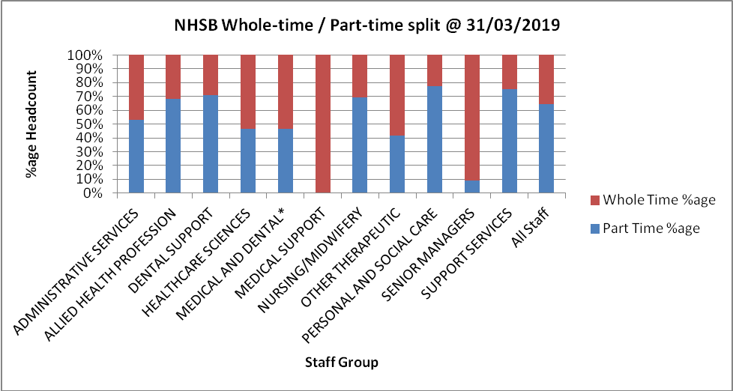
Chart 16: Whole Time / Part Time split by Job Family - %age WTE

The next chart shows the average whole time equivalent for staff, comparing 2018 and 2019. It shows that overall the average WTE is just under 0.8 and this is the same as 2018.

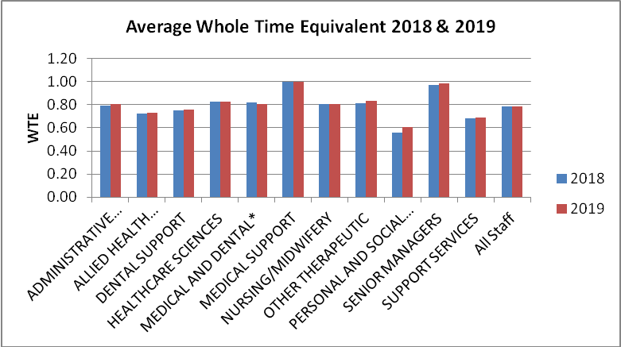
Chart 17: Average Whole Time Equivalent @ 2018 and 2019

The following charts show the gender split for all staff, by showing the full-time/part-time split for female staff and also for male staff.

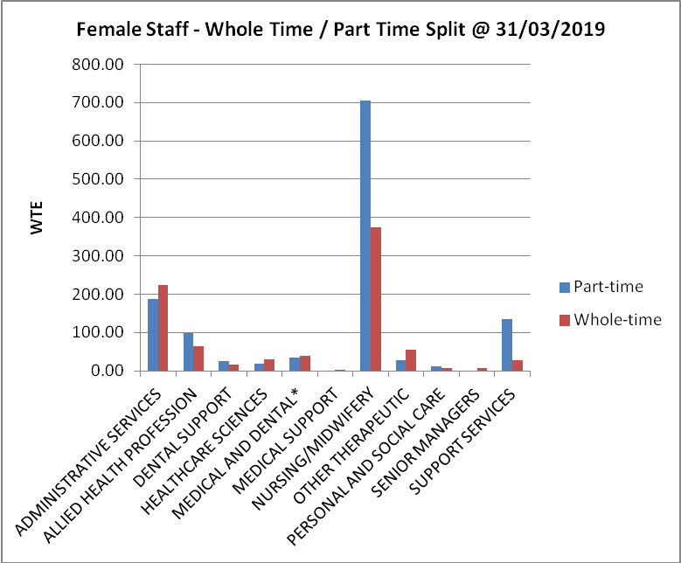
Chart 18: Female Staff – Whole time / Part time split

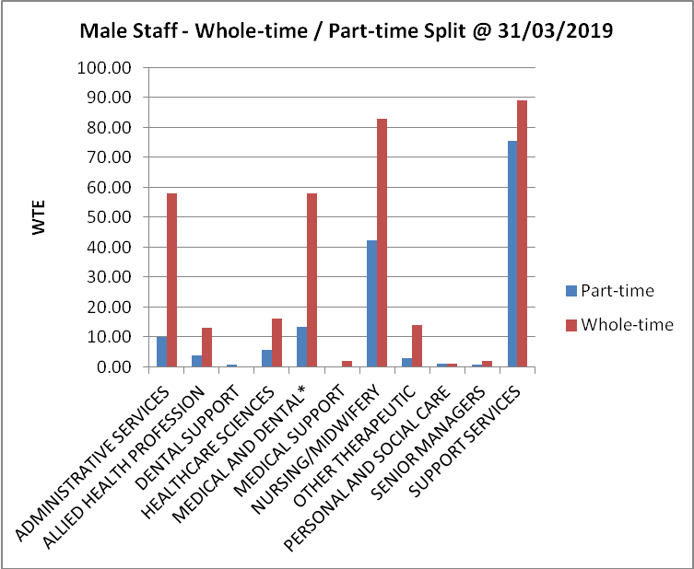
Chart 19: Male Staff – Whole time / Part time split
4.7 Permanent and Fixed Term Contracts (FTC)

This section highlights the proportion of staff who are on Fixed Term Contracts (FTC). Overall the percentage of staff on FTCs has fallen from 8% at 31 March 2018 to 6% at 31 March 2019. The most common reasons for positions being temporary as opposed to permanent is where they are to cover Maternity or long term Sick Leave, or where national funding is only available on a fixed term basis, for example for a specific project.

The following chart shows the percentage of each staff group in permanent and fixed term. Other Therapeutic has the highest percentage at 20% and this is mostly due to short term financial arrangements, combined with a number of training positions.

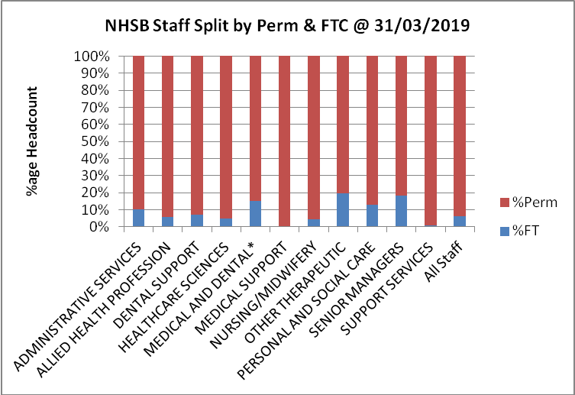
Chart 20: Permanent and Fixed Term Contracts by Job Family - %age Headcount

4.7 Sickness Absence

In 2018/19 NHS Borders had a cumulative (April 2018 – March 2019) Sickness Absence rate of 5.28%. This is a 0.05% increase from the March 2018 rate of 5.23%. The cumulative rate for NHS Scotland is 5.39%.

The month on month Sickness Absence rate for NHS Borders is illustrated in the chart below.

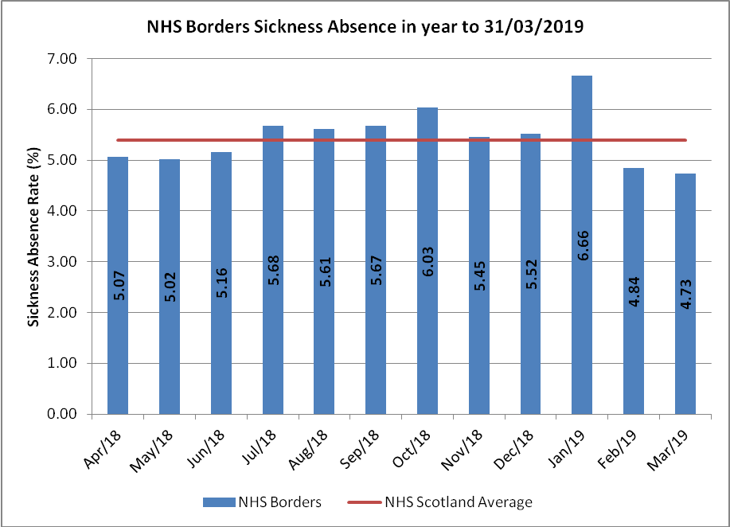
Chart 21: Sickness Absence in year to 31/03/2019
Data is taken from monthly absence reports which excludes staff on Maternity/Paternity leave so will be slightly higher than ISD.

The month on month Sickness Absence rate for NHS Borders split by Clinical Board is illustrated in the chart below. It should be noted that the Learning Disabilities Service (LDS) is a small group of staff, hence the spike below.

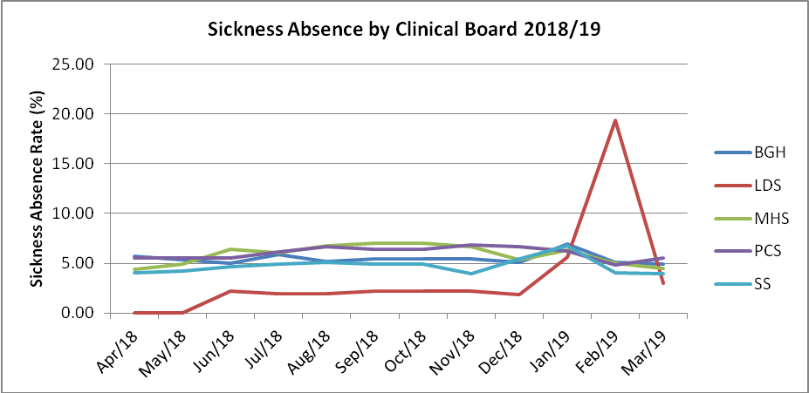
Chart 22: Sickness Absence by Clinical Board for year 2018/19

The following chart shows that there is an above average Sickness Absence rate in both Nursing/Midwifery and Support Services.

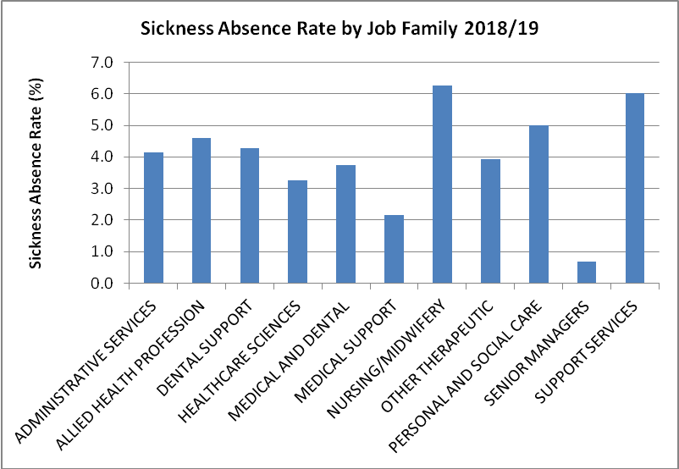
Chart 23: Sickness Absence by Job Family for year 2018/19

The following chart shows that, as expected, staff over 55 years of age are more likely to suffer from Sickness Absence. The overall percentage for under 55 is 5%, compared to a percentage of 6.1% for those aged 55 and over.

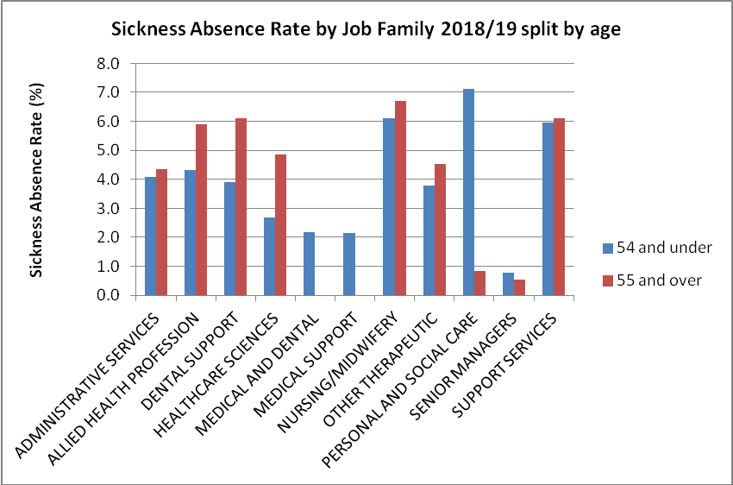
Chart 24: Sickness Absence by Job Family, split by Age for year 2018/19

The following chart shows the overall Sickness Absence reasons. The main issues, where we know a reason, remain musculo-skeletal problems (21%) and mental wellbeing issues (30%).

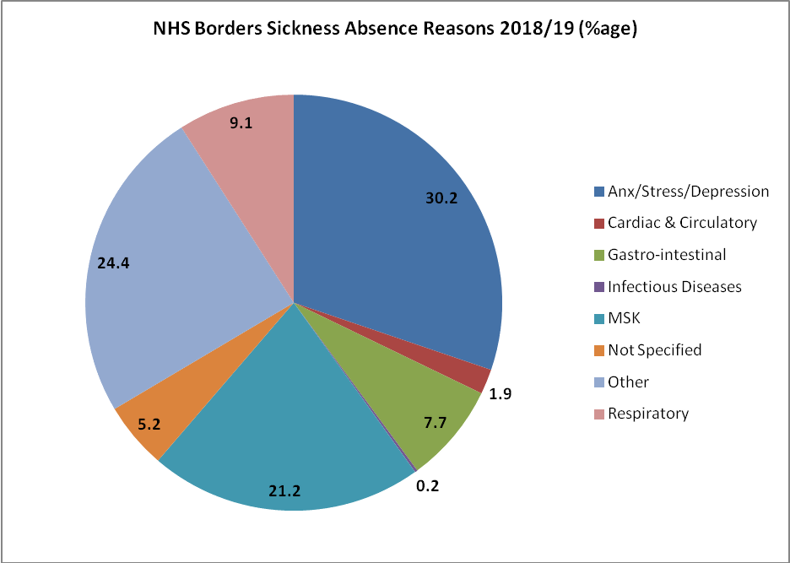
Chart 25: Reasons for Sickness Absence 2018/19
4.9 Staff Turnover

This chart illustrates that the turnover rate for NHS Borders for the year 2018-2019 was 11.33%, substantially higher than in the year 2017-18 which was 9.3%. Whilst some turnover supports succession planning, this is overall higher than might be expected, but may be partly explained by our ageing workforce.

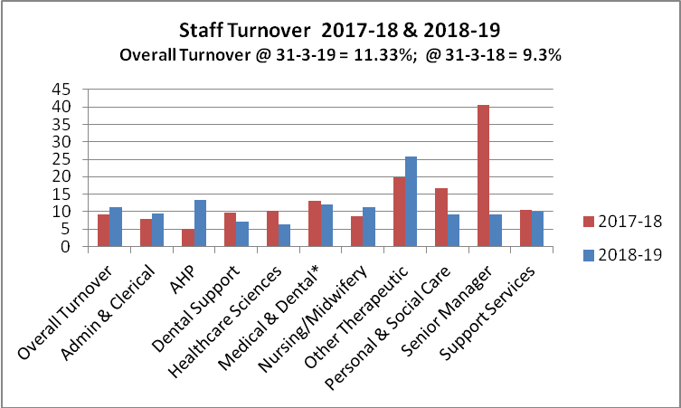
Chart 26: Staff Turnover during years 2017-18 & 2018-19*Excludes Medical Training Grades

The age profile of leavers and their reasons for leaving have been illustrated in the charts following, showing 30% of leavers were aged over 55, and 21.6% of leavers left on account of retirement.

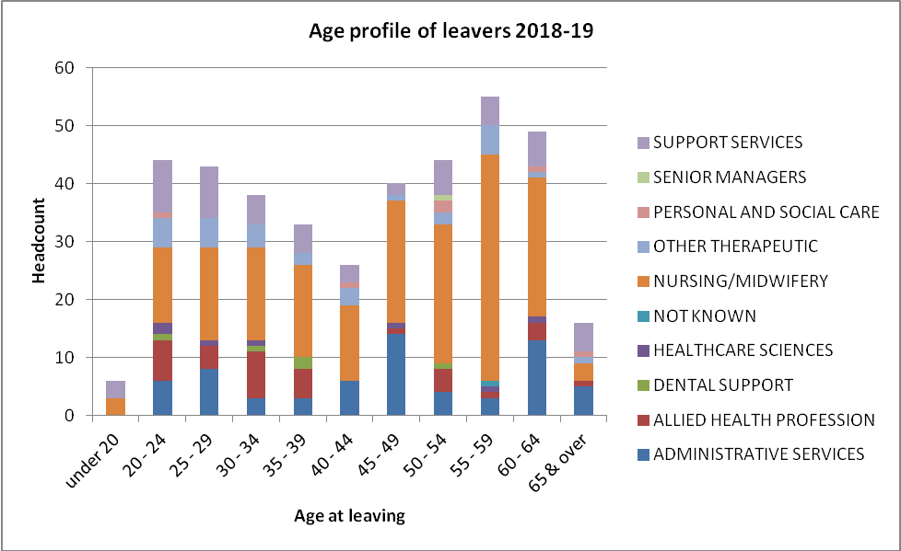
Chart 27: Age at leaving date of leavers in year 2018-19

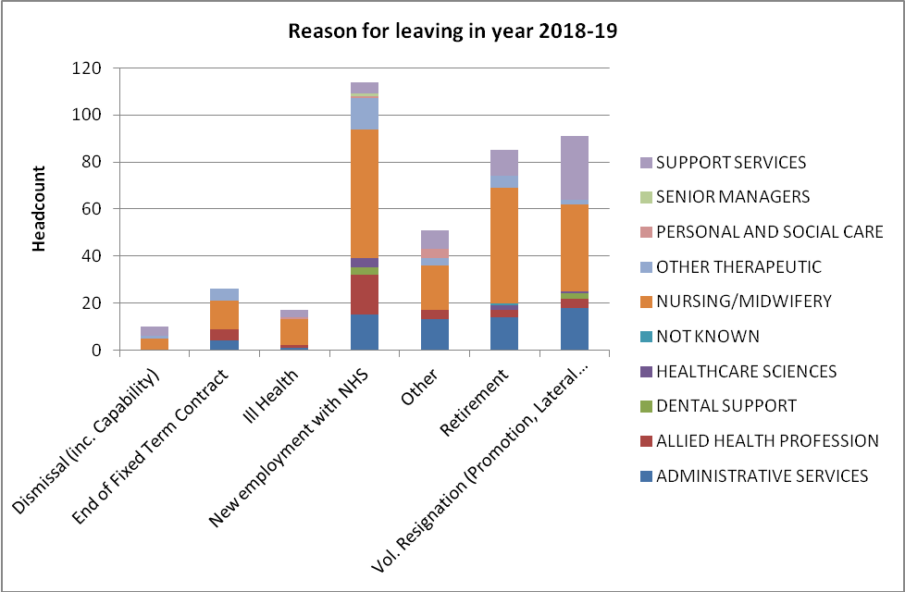
Chart 28: Reason for leaving in year 2018-19

The chart below gives the Workforce Stability Index by Job Family @ 31 March 2018 and 31 March 2019. Overall the stability index remains the same at 0.88, although there are some slight differences in some Staff Groups. Stability index is measured at a point in time, rather than over the preceding year as for turnover. It takes the number of employees who have 1 year’s service or more and divides by the total number of employees, measuring the settled level of the workforce.

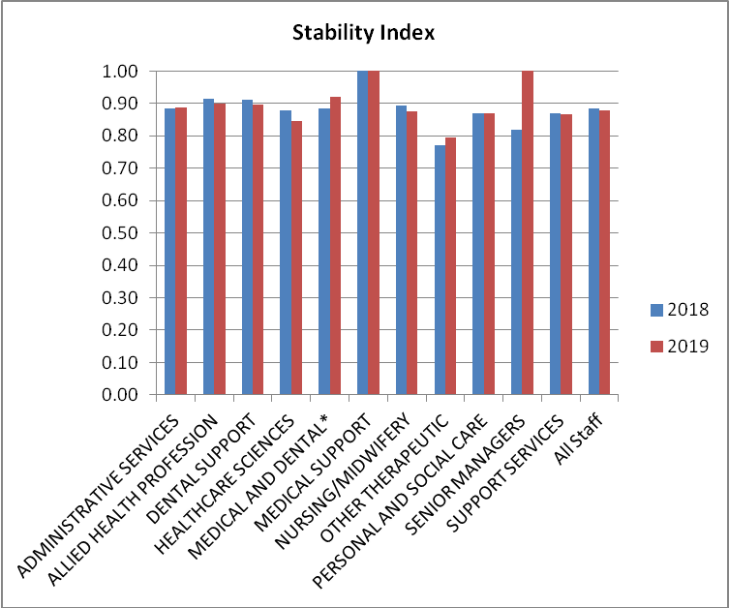
Chart 29: Stability Index

The following charts give age profile and reasons for leaving specifically for the Nursing & Midwifery staff group. 35% of Nurses/Midwives who left in the year were aged 55 and over, and 26% of those who left retired.

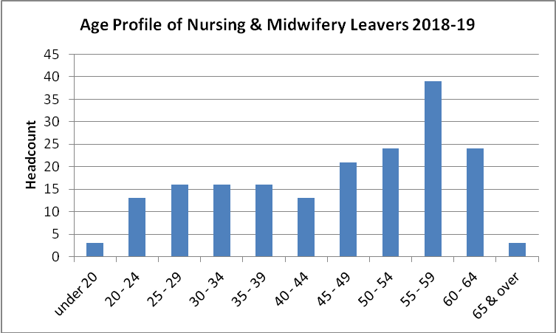
Chart 30: Age profile of Nursing/Midwifery Staff Group Leavers in year 2018/19

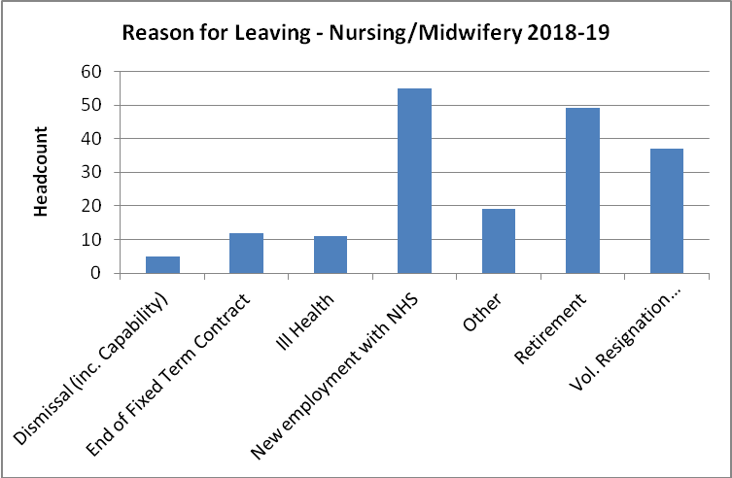
Chart 31: Reason for leaving of Nursing/Midwifery Staff Group Leavers in year 2018/19

The next chart shows the length of service of all leavers in NHS Borders at their leaving date in the year 2018-19. 60% of leavers had 5 years service or less when they left.

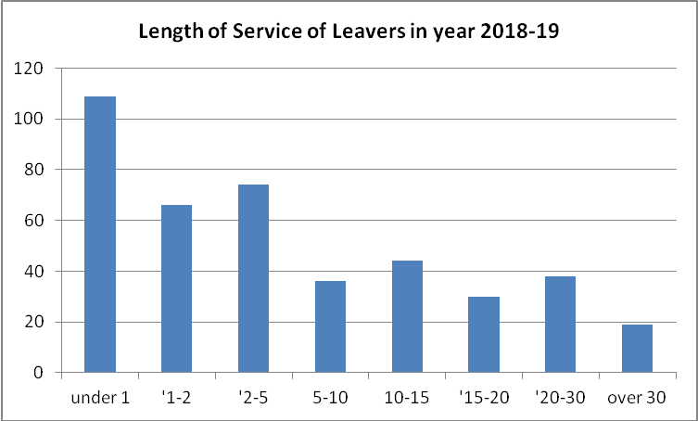
Chart 32: Length of service of all leavers in year 2018-19

The following chart shows the length of service of all Nursing/Midwifery leavers at their leaving date in the year 2018-19. 55% of all NM leavers had 5 years service or less when they left.

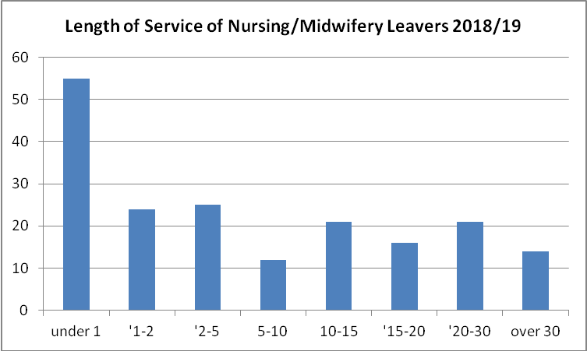
Chart 33: Length of service of all Nursing/Midwifery leavers in year 2018-19

Action Plan  The following actions will be progressed over the 3 year period with updates on progress monitored at the Workforce Group. | Action | Leads | Timescale | Evidenced by | Outcome Measure
1 | Progress Actions from the Recruitment & Retention Strategy for NHS Borders to ensure continuity of service and reduced long term vacancies. Focus on target groups where we are experiencing difficulties recruiting including:  - Consultants, Salaried GPs and other medical and dental posts,  - Registered Nursing and Midwifery Staff | Medical Director, Nursing & Midwifery, HR and Finance Leads. | Medium to Long Term | - Lower number of concurrent vacancies  - Success in recruitment to high priority specialties  - Viable workforce and succession plan for key Medical & Dental and Nursing & Midwifery posts | - Sustainable Workforce – maintained patient safety  - Reduction in supplementary spend  - NHS Borders follows effective procedures when recruiting staff and carries out appropriate qualifications, skills and training, references and background checks.  - NHS Borders is confident that staff delivering care are suitably trained and use their learning to ensure care is safe, effective and person-centred
2 | Support staff to work longer, utilising Retirement Policy and changing cultural attitudes, to make flexible working part of normal career development. Establish a Returning Process to assist with this | WD&P/ Work & Wellbeing | Medium to Long Term | - Higher proportion of staff who choose to stay at work longer or return after retirement leading to increased numbers of experienced staff | - Stable, happy workforce leading to better patient care
3 | Monitor Turnover rates/trends to inform projections of future recruitment requirements and succession planning – ensure feedback from exit interviews is considered/acted upon where necessary | WD&P/Finance Leads | Medium Term | - Up to date trajectory matching projections with actual leavers/starters.  - Intelligence around why staff leave the organisation | - Reliable data to inform succession planning
4 | Promote NHS Borders as an organisation that supports Return to Practice across relevant staff groups e.g. Nursing & Midwifery, AHP Services etc. | Nursing & Midwifery | Short Term | - Improved response rates to Recruitment Adverts  Reputation as a Board who supports staff to return to practice | - Higher Proportion of Vacancies filled by experienced registered nurses/ AHPs (on successful completion of RTP) leading to high quality of patient care.
5 | Support the introduction of the Health and Social care staffing bill, including the use of Nursing and Midwifery Workload Tools, when taking forward Workforce reviews, and communicate outcomes to relevant groups within agreed timescales, ensure appropriate risk escalation processes in place. | Nursing & Midwifery/ WD&P | Medium Term | - Up to date information on outcomes of Service Reviews  - Clear escalation/risk assessment following workforce review  - High quality data/scrutiny | - Assurance around workforce numbers ensuring safe patient services  - Reduction in supplementary spend due to up to date funded establishments.  - Appropriate scrutiny following workforce reviews
6 | Ensure the wider organisation is aware of the corporate values and monitor the feedback of recruits who have been recruited via a values-based process | Workforce Leads/Line Managers | Long Term | - No of Staff Trained and familiar with Behavioural Framework  - IMatter employee engagement scores | - NHS Borders has effective leadership and governance and promotes an organisational culture committed to continuous improvement and shared learning.
7 | Monitor uptake and impact of iMatter | BET | Long Term | - iMatter response rates  - Employee Engagement scores  - Percentage of action plans completed | - Staff experiences and feedback are used to inform and shape improvements in the delivery of care.  - Engaged workforce  - Reduced turnover
8 | Develop joint H&SC Workforce Plan with SBC, third and independent sectors. | NHS Borders and SBC WD&P Leads | Medium to Long Term | - Improved understanding of Workforce Issues across organisational boundaries | - Shared Workforce Information and Methodologies  - Intelligence to support the introduction of the Primary Care Improvement Plan.
9 | Ensure workforce issues and risks identified in the Workforce Plan are recorded on the Risk Register and monitored appropriately | WD&P / Identified Leads | Short Term | - Clear understanding and monitoring of key Workforce issues and risks | - Reduction/mitigation of identified workforce risks and potential negative impact on patient care
10 | Ensure the workforce implications of financial turnaround projects are considered and provide joined up feedback to inform effective decision-making | WD&P/Identified Leads | Short Term | - Workforce implications of projects are considered in a central forum, and feedback provided to leads where there may be an impact on another project, e.g. competing for same staff, potential recruitment challenges etc | - A planned approach to managing workforce changes based on wider knowledge of all service changes with a workforce impact leading to a more settled workforce.
11 | Support the introduction of improved Workforce Information tools including Tableau dashboard reporting and the local implementation of the data intelligence tool. | WD&P/Core Data Group |  | - Validated information to inform decision making from the Data intelligence tool  - Improved access to Workforce Data through Tableau Reporting resulting in better informed managers in relation to their workforce stats. | - Evidence based population, workforce and health trend data leading to more accurate information to base decisions on and increased ability to project future changes etc

