NHS Grampian

SECTION 1
JOB IDENTIFICATION | Must be completed
Job Title: | Fertility Preservation Nurse Consultant
Department(s): | Aberdeen Centre for Reproductive Medicine (ACRM)
Location: | Aberdeen Maternity Hospital, moving to Baird Family Hospital
Hours: | 37.5 hours per weeks
Grade: | Band 8A
Salary: | £49,480 - £53,414 per annum
Contract: | Temporary

SECTION 2
Job Purpose

Background
The Aberdeen Centre for Reproductive Medicine (ACRM) is the sole referral centre for Reproductive Medicine Services in NHS Grampian (NHSG). ACRM operates a Quality Management System (QMS) ISO 9001 to deliver secondary fertility services for Aberdeen city and shire, Orkney and Shetland whilst providing tertiary referral services for the entire North East of Scotland. The ACRM also accepts private referrals.

Currently, a six day/week out-patient service is provided by nursing/midwifery staff ranging from pre-pregnancy advice to an extensive range of fertility investigations and specialist treatments. The team also manage programmes of care as part of in-vitro fertilisation treatment which includes: frozen embryo replacement, egg donation, donor insemination and egg, semen and embryo cryo-storage, super-ovulation, intra-uterine insemination and ovulation induction.

The ACRM also provides specialist clinical services: Fertility Preservation for young people diagnosed with cancer and non-malignant conditions with the potential to impact on future fertility; Transgender; Recurrent Miscarriage and Endocrinology clinics. The ACRM works in close collaboration with the TYA CNS team and Oncology/Haematology departments, to provide counselling, storage and treatment options for patients receiving chemo/radiotherapy which impair fertility potential. There are approximately 100 referrals each year with the numbers ever increasing.
Job Purpose:
To provide specialist holistic care to patients of reproductive age and partners/close family who attend ACRM for consideration of fertility preservation. To provide counselling and education for patients in this context to enhance the quality of life experience, through in-depth knowledge of oncology and other medical treatments and their impact on future fertility.
To co-ordinate patient care from referral through investigation, medical and nurse led consultations, screening, result giving, cycle planning and treatment.
To provide emotional support to patients at all times whilst remaining sensitive to their needs and assisting them in coming to terms with the eventual outcome.

Organisational Chart (Please identify this post clearly in the structure – as a minimum show 2 levels above and 2 levels below (where relevant).

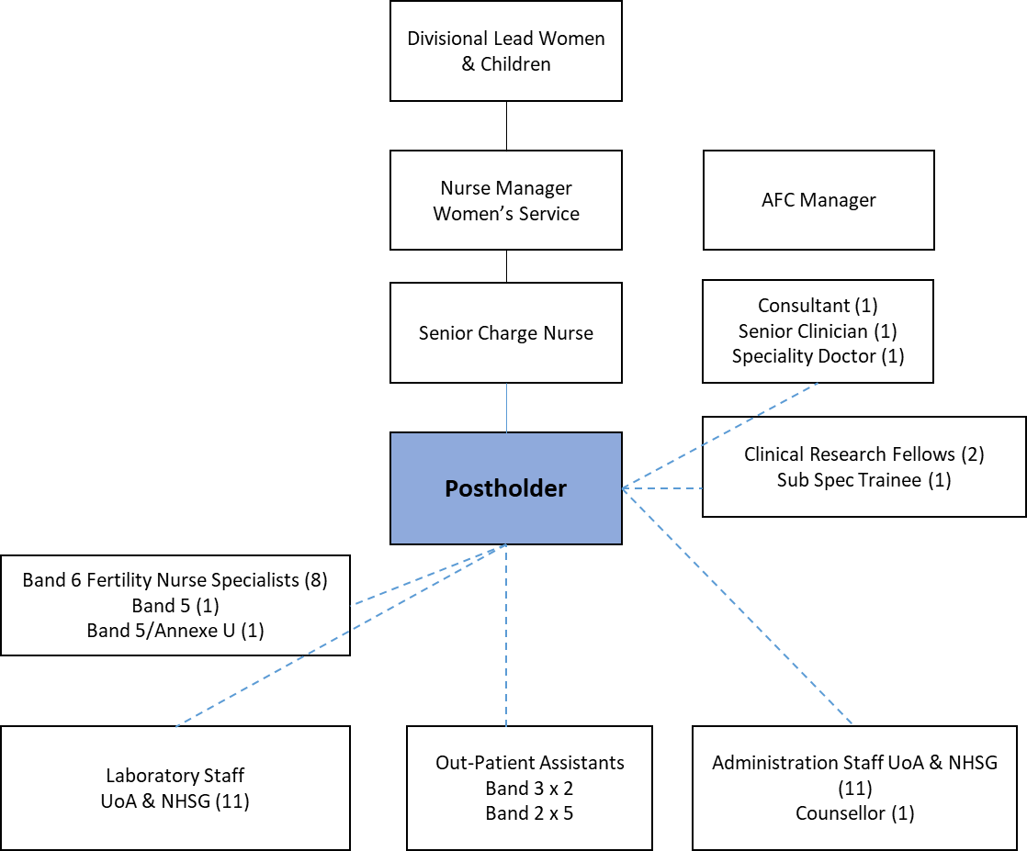

Please refer to appendix B(i) for definitions

1 | Communication and relationship skills  Provide and receive complex, sensitivie information; barriers to understanding/ Provide and receive highly complex, sensitive or contentious information; barriers to understaning; Present complex, sensitive or contentious information to large groups  Level 5a  Infertility associated with cancer and other non-malignant conditions can have a significant psychological impact for patients and survivors, necessitating appropriate fertility‐related psychological support. Consultations are carried out with patients (individuals and couples) exploring fertility preservation and its implications, obtaining informed consent, performing screening tests, planning treatments, providing instruction on administration of drugs (for self-administration) and follow up consultations.  Required to utilise counselling skills on a regular basis; for issues surrounding cancer or non-malignant diagnosis and treatment, imparting bad news where treatment has been cancelled or unsuccessful. There is also the requirement to consider and discuss the fate of stored gametes (eggs & sperm) and embryos in the event of death.  Ability to discuss highly sensitive issues in relation to screening tests (ie., blood borne virus screening and semen analysis), and requirement for donated gametes (ie., donor sperm, eggs or embryos) in addition to surrogacy arrangements. Requirement to communicate complex information regarding fertility preservation in the presence of pre-existing medical conditions. The Fertility Nurse Specialist would be required to have knowledge of the specific health needs in relation to gender dysphoria or gender reassignment, realignment or confirmation in addition to individuals living with psychosexual issues.  The post holder will also liaise closely and communicate at specialist level with the Independent Counsellor, TYA CNS, Oncology, Haematology, Psychology, Early Pregnancy Endocrinology and Gynaecology services in the context of treatment planning and emotional support. Therefore the post holder must possess effective communication skills and participate in cross boundary working.
2 | Knowledge, training and experience  Highly developed specialist knowledge underpinned by theory and experience  Level 7  Masters level education  Current Nursing and Midwifery Council Registration  Three years minimum post registration experience in either women’s health, oncology, haematology of general medical nursing  Knowledge base with regards to speciality advantageous  Annual competency in clinical skills in accordance with NMC, Quality Management & HFEA standards of assessment, together with evidence of professional development relating to fertility OR one of the following specialities: oncology, haematology, general medicine or endocrinology and medicines management  Fertility Preservation Nurse Specialists must hold, or be working towards a nationally recognised ultrasound qualification, which includes competency in early pregnancy assessment (British Fertility Society or Higher Academic Institution)  Working knowledge of the NMC Code, NHSG policies and procedures and HFEA Code of Practice.  Determine care provision through best available evidence (local and national standards, policies and guidelines)  Recognised counselling skills certificate essential  Competency in venepuncture essential  Competency in speculum examination desirable  Current Good Clinical Practice (GCP) and Ethics in Research Certificates desirable  Evidence of well established written and verbal communication skills and the ability to communicate effectively within a wide range of audiences (colleagues; presentation skills; teaching & mentoring skills)  Evidence of proven decision-making skills
3 | Analytical and judgemental skills  Complex facts or situations requiring analysis, interpretation, comparison of a range of options  Level 4  Receiving direct referrals from Oncology, Haematology and Medical Colleagues  Consultations with patients (individuals and/or couples) exploring options, detailed explantation of role of the HFEA and legislation around informed consent and legal parenthood; carrying out initial assessment and suitability for fertility presrvation and exploring proposed treatments and their implications  In cases of adolescent referral, consultations with patient and parent/guardian  Responsible for Interpretation of laboratory results in accordance with with Standard Operating Procedures (SOPs) investigations and monitoring programmes of care and discussing deviation from normal range with patients/medical staff (where appropropriate)  Freedom to make judgements following analysis and interpretation of results in accordance with defined SOPs and deciding treatment options based on individual circumstances  The post holder will be required to exercise judgement in identifying and assessing complex needs of patients diagnosed with cancer and other non-malignant conditions and transgender arrangements, whilst remaining focused throughout the process
4 | Planning and organisational skills  Plan and organise complex activities or programmes, requiring formulation, adjustmaent  Level 3  Responsible for monitoring individual patient response to treatment through ultrasound and serum assay assessment, communicating findings via MDT discussion and documentation of medical records within defined protocols. However, there is scope for the postholder to exercise autonomy and freedom to amend management plan.  Freedom to coordinate care from referral to liaison with other services (ie., oncology; haematology; endocrine and counselling services).  In the absence of the SCN freedom to plan workload  Within the Organisation the postholder must meet with external auditors from British Standard Institute for ISO 9001:2012 standard and the HFEA regarding the Fertility Preservation service to ensure compliance with legislation and quality standards
5 | Physical Skills  Physical skills obtained through practice/ Highly developed physical skills, accuracy important, manipulation of fine tools, materials  Level 3b  Competency in venepuncture  Competency in using monitoring equipment used during surgical procedure of egg collection, suction pump, oxygen saturation and Dynamap BP recording  Daily IT data input (NHSG PMS/Trak and specialist software packages (electronic patient records capable of transmitting sensitive data to the HFEA) and providing statistical data for monthly KPI meeting  Manual record keeping must be maintained to an NHSG, professional and the HFEA required standard  High level Keyboard, IT skills in Excel, Word, NHS No Delays packages & Powerpoint essential  Email communications used widely throughout the Centre
6 | Responsibilities for patient/client care  Develop specialised programmes of care/ care packages; Provide highly specialised advice concerning care  Level 6ac  Responsible for provision of specialist clinical services - venepuncture, trans-vaginal & abdominal ultrasound, intra-uterine insemination, trial of embryo transfer and embryo transfer.  Responsible for evaluating individual needs, and planning programmes of care within specified protocols (involving a multidisciplinary team). Freedon and autonomy for coordinating care throughout treatment programme and contribution to review/follow up process.  Responsible for dispensing pharmaceutical products required for treatment, and advising patients in self-administration (in accordance with working knowledge of medicines management SOP). Also responsible for provision of specialist knowledge and health promotion throughout treatment programmes  Responsible for the provision of highly specialised advice concerning the care and treatment options in relation to the HFEA CoP which meet individual patient need and implications counselling  Responsible for providing the opportunity for individuals and couples to explore feelings, coping strategies and relationship issues from investigation through treatment programmes of care  Responsible for the monitoring, assessment and care of female patients (under conscious sedation) for egg collection procedure  Participation in research studies, undertaking surveys and audits  Competency in the delivery of high standard, quality and evidence based nursing care  Proactive participation in health promotion in accordance with NHS funding criteria, whilst facilitating patient engagement in the planning and delivery of care
7 | Responsibilities for policy and service development implementation  Propose policy or service changes, impact beyond own area  Level 2 Variation  Supports the Senior Charge Nurse (SCN) in the delivery of safe and effective quality care, whilst contributing toward the future development of the Fertility Preservation service  Participation in development (and annual review) of Standard Operating Procedures (SOP’s), Guidelines and Patient Information in accordance with Quality Management Systems & Fertility Preservation  Demonstrates a positive attitude to changes in clinical practice in response to evidence  Demonstrates knowledge and proficiency in implementing NHS Grampian local policies and procedures  Ensures written communications are accurate, appropriate and accurately recorded in accordance with the NMC Code of Practice  Conversant and compliant with NMC, NHS Grampian and University of Aberdeen (policy and guidance) and HFEA Code of Practice  Participates in future service redesign in accordance with local and national priorities. The postholder actively provides feedback from local/national conferences & networking opportunities
8 | Responsibilities for financial and physical resources  Personal duty of care in relation to equipment, resources/ Miantin stock control; authorised signatory, small payments  Level 2bcde  Responsible (authorised signatory) for weekly data input and submission (SSTS) for payroll purposes  Maintain safety of patients, visitors and staff by managing the clinical area in accordance with the Health and Safety at Work Act and NHSG/ACRM risk management strategies  Manages efficiency and economy in the use of supplies and an awareness of stock control systems. Responsible for ensuring adequate stock of medicinal products used in programmes of care, and liasing with finance in the context of weekly orders  Responsible for the safe handling of complex equipment (ie.,specialist ultrasound systems)
9 | Responsibilities for human resources  Professional/ clinical supervisor; Provide training in own discipline/ Teach/ deliver specialist training.  Level 2a  SSTS (designated signatory for payroll purposes) at approver level  The post holder will be required to participate in interview and orientation processes for new members of staff  Supervision/mentoring of less experienced or more junior members of staff (Band 5/Band 5 Annexe U and junior medical staff)
10 | Responsibilities for information resources  Record personally generated information  Level 2ab Variation  Use of specialist IT software for data input relating to programmes of care and from which statistical information (outputs) generated. The package is also used to complete and communicate electronically, legal forms required by the HFEA from which, national statistics generated. The postholder is required to have a working knowledge of the Quality Management System (QMS) to access patient information, SOP’s and Good Practice Guidelines.  Responsible for IT data input; fertility preservations cycles  Knowledge of IT systems; Excel (spreadsheets), Word (reports and patient information sheets), Powerpoint (presentation purposes, both locally and nationally)  Email and electronic calendar systems used widely within the Centre (including daily safety briefing)
11 | Responsibilities for research and development  Regularly undertake R&D activity; clinical trials; equipment testing, adaptaion/ R&D activities as major job requirement  Level 2a  The ACRM is active in audit, fixed protocol and qualitative research, together with Randomised Control Trials (RCT’s); all of which the post holder is expected to participate
12 | Freedom to act  Broad occupational policies  Level 4  The post holder must always work within the NMC Code of Professional Conduct.  Whilst the SCN has direct line management responsibility for this post, the postholder is responsible for analysing and prioritising personal caseload.  Workload is managed autonomously rather than supervised and guided by defined protocols and procedures. Therefore the post holder will be required to exercise initiative and be able to make competent, evidence based and rational decisions, whilst remaining focused on individualised patient care.  Freedom to report diagnostic results in pelvic ultrasound: fibroids; polyps; ovarian cysts (complex and simple); endometrial hyperplasia etc.).  Freedom to exercise clinical judgement within defined programmes of care and whilst observing patient’s condition; reporting any changes to medical colleagues in the event of unpredictable situations requiring multidisciplinary collaboration  Freedom to schedule invasive procedures within defined protocols  Freedom to provide clinical expertise/advice to colleagues in primary and secondary care in the context of referral and treatment planning which requires knowledge of oncology and medical treatment coordination
13 | Physical effort  Combination of sitting, standing, walking/ Occational moderate effort for several short periods  Level 2ad  There a frequent requirement for physical activity/effort to undertake ultrasound sessions 3x4 hour per week. Scan procedures last between 15-30 mins.  Manual handling skills will be required to move/operate ultrasound equipment within cramped environment.  Manual handling skills will be required to move patients who have been sedated for procedures.  The postholder will be required to assist medical colleagues during out patient procedures; egg collections  Keyboard skills and dexterity (functions of ultrasound/manipulation of fine tools) are also required.  Daily check and documentation of First Line equipment (oxygen cyclinder/suction unit) to ensure working order of flowmeter and delivery of O2, together with working order of suction unit, and turned off on completion.  Weekly check, documentation of 2nd line (Resuscitation equipment) and re-stocking where required
14 | Mental effort  Frequent concentration; work pattern predictable  Level 2a  The working environment can be emotive, due to the nature of the specialty (oncology; transgender; infertility). Although there are scheduled clinic/scan lists and procedures scheduled throughout the working week, patients may self-refer with unexpected outcomes (ie., ovarian hyperstimulation) requiring immediate medical management  The postholder is responsible for consultations with patients (couples or individuals), to explain screening and consent process, treatment scheduling and self-administration of medication  Therefore excellent organisational skills are required to prioritise care, analyse results and deal with emotional situations as they arise.  Concentration is required to coordinate fertility preservation cycle with oncology/endocrinology/medical treatment programmes of care
15 | Emotional effort  Occasional distressing or emotional circumstances/ Frequent distressing or emtionsal circumstances; Occastional highly distressing or emotional circumstances  Level 3b  Overall, the post is emotionally demanding in the context of interaction with patients/partners.  The post holder will be expected to deal with frequent episodes of stress and crises; grief, anger and loss in addition to the unique and sensitive needs of transgender patients. Therefore a certificate in counselling skills is essential to provide emotional support to this unique patient group  The post holder will demonstrate sensitivity in discussing intimate sexual, relationship and psychosexual issues in the context of patient anxiety and investigation/treatment pathways  Imparting bad news and dealing with negative emotions whilst remaining sensitive and empathetic to patient needs is challenging  There is an increasing requirement to consult with young people recently diagnosed with cancer or considering gender re-assignment. Therefore, an understanding of how fertility might be impaired, together with the psychosocial aspects of childhood, adolescent and adult cancer and transgender management require appropriate experience in counselling skills and fertility  Frequent autonomous judgement is required to analyse and interpret ultrasound findings and advise on future management plan  Addressing the potential of involuntary childlessness with individuals/couples is another challenging aspect of the post  There is an increasing requirement to consult with patients - whose first language is not English, therefore understanding and implementing care, which acknowledges and respects individual cultural beliefs is challenging (in particular when discussing intimate sexual and relationship issues)
16 | Working conditions  Frequent unpleasant conditions/ Occasional/ Frequent highly unpleasant conditions  Level 4b  There is frequent exposure to bodily fluids (including blood-borne virus positive patients) whilst performing invasive procedures: venepuncture, trans-vaginal egg collection, handling semen samples and embryo transfer

PERSON SPECIFICATION
The Person Specification should meet the demands of the job and comply with current legislation. Setting unnecessary standards may, for example, unfairly discriminate against one sex, the disabled or minority racial groups. Applicants should be assessed in relation to their ability to meet the real requirements of the job as laid down in the job description. Shortlisted candidates MUST possess all the essential components as detailed below.

POST/GRADE: Fertility Preservation Nurse Consultant

LOCATION/HOSPITALS: Aberdeen Centre of Reproductive Medicine.

WARD/DEPARTMENT: Aberdeen Maternity Hospital

ATTRIBUTES | ESSENTIAL | DESIRABLE
Qualifications | - First level degree supplemented by specialist knowledge/training/ experience to master's level or equivalent. | - Leadership qualification/training  - Quality Improvement Training  - Post registration qualification related to Fertility Nursing  - Counseling qualification
Experience | - Substantial experience in fertility nursing  - Experience of leading/managing highly complex situations which require analyses and development of plans to achieve resolution.  - Evidence of anticipating problems, proposing and implementing solutions.  - Experience in developing policies, procedures and guidelines and leading and implementing change  - Evidence of teaching multi-professional staff | - Experience of working with colleagues at a national/international level  - Experience of working with oncology and/or gender identity specialities  - Demonstrate expert clinical and professional practice developed through experience and theoretical knowledge.  - Demonstrate experience in service improvement
Special Aptitudes /  Abilities | - Excellent organisational skills and show the ability to plan, organise and facilitate learning.  - Must have a calm mature approach to the workload with the ability to problem solve and give solutions to multi system problems | - Has proven track record of facilitation and coaching skills. Must show evidence of leaderships skills and their appropriate use
Disposition | - Excellent communication skills. Ability to plan, evaluate and deliver own workload.  - Shows the ability to work under pressure and meets both local and national deadlines/targets.  - Must have a mature balanced approach to workload
Physical Requirements | - Good health record
Particular Requirements of the Post | - Must be flexible and responsive at short notice.

