INFORMATION PACK FOR THE POST OF

CONSULTANT interventional RADIOLOGISTS (x2 posts):-

(OTHER SUB-SPECIALITY INTERESTS will be considered x 2 posts)

NHS Grampian

THE TEN THINGS YOU NEED TO KNOW!

- This vacancy for Radiologist Consultants is to support our growing Department in NHS Grampian in the North East of Scotland with posts in Aberdeen Royal Infirmary and Dr Grays Hospital in Elgin.
- This post can be full time or part time, with a flexible approach to job planning.
- Aberdeen is a great place to work and live and NHS Grampian is thriving.
- The Radiology Department in NHS Grampian is undergoing a major investment; you will be part of this exciting journey.
- This post is important as it will underpin and support a wide range of other specialities in NHS Grampian.
- The scope of work is broad and there are lots of opportunities for developing your skill set, both clinically and as a leader.
- You will be teaching and encouraging our trainees to develop their careers.
- The team in Aberdeen are warm and friendly and this is a great opportunity for you to be part of a strong team who are dedicated to high quality patient care.
- Opportunities for strengthening research; making links with international academic institutions for collaborative working.
- National & international applicants welcome and will be supported in relocation.

Aberdeen is a lively, cosmopolitan city located in the North East of Scotland. In the city there are beautiful parks and gardens and a superb beach just a short walk from the centre. Aberdeen city and surrounding towns boast fantastic museums, galleries; bars and restaurants as well as variety of shopping in both shopping centres and unique family run businesses. There are a wide range of annual festivals in Aberdeen and Aberdeenshire from food and drink, wide range of music and arts festivals and festivals celebrating local culture and traditions. There are excellent and varied schools within the city and Aberdeenshire with a great range of housing to suit all tastes. There are strong public transport links and the Aberdeen Western Peripheral Route (AWPR) has significantly improved commuting when it opened early 2019.
Aberdeen – a great place to work and live
Aberdeen is a gateway to explore natural landscapes from the north east coastline to beautiful Royal Deeside and the stunning Cairngorms National Park. Aberdeen is made famous by the castle and whisky trails across the region, and there are a wide range of outdoor leisure activities on offer such as hill walking, water sports and skiing. There are over 50 golf courses and great salmon fishing rivers.
The city has been the energy capital of Europe since the 1970’s and is the hub of the UK’s energy industry. As a result there is a high quality of living and low unemployment.
Aberdeen's international airport is served by a number of major carriers providing an extensive network of routes throughout the UK, direct to Europe and worldwide through major hubs. There are good road and rail connections to the major Scottish cities of Edinburgh, Glasgow and Inverness.

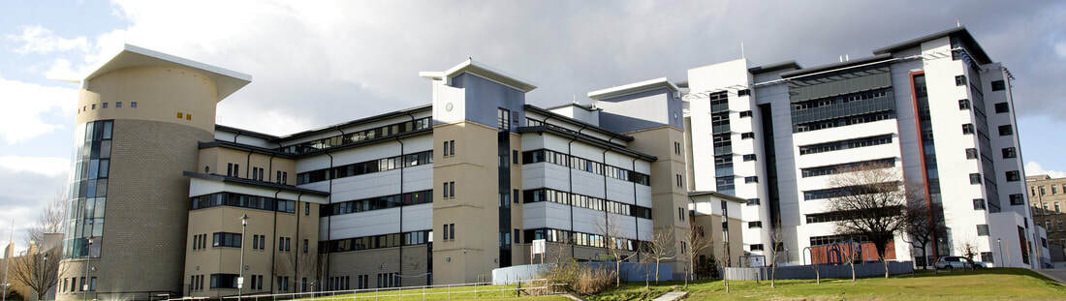

NHS Grampian – thriving and dynamic
NHS Grampian is one of 10 principal Health Boards in Scotland. It provides healthcare services to approximately 600,000 people living in Grampian and additional provision to 50,000 people living in Orkney and Shetland. The organisation employs around 17,000 staff.

A period of significant investment and modernisation began in 2013 with the opening of the Matthew Hay building, bringing emergency and urgent care services together into one building. NHS Grampian Board has recently approved plans for two new buildings on the Foresterhill site, the Baird Family Hospital and The ANCHOR Centre investing £120 million. The Baird Family Hospital will bring together maternity, gynaecology and breast services while The ANCHOR Centre will provide outpatient and day-patient treatment for patients with cancer and blood disorders.

NHS Grampian has a status as the Major Trauma Centre for the North East of Scotland. There is also significant investment expected to improve elective care with a new building and increase in workforce. This is a very exciting time for Radiology as all these strategic local and national drivers will bring investment to the Radiology department which will improve services for our patients. In particular we are keen to develop the IR service in line with contemporary strategic drivers to provide the best service we can for our patients.

The Acute Sector brings together all acute services under a single management structure. The sector is made up of 5 divisions (Medicine, Surgery, Women and Children, Clinical Support Services and Dr Gray’s Hospital) each managed by a Divisional Management Team. Radiology sits within Clinical Support Services.

Clinical Support Services
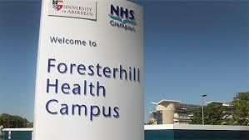
The Clinical Support Services (CSS) Directorate has responsibility for all radiology, nuclear medicine, medical physics, laboratories, oncology, haematology, radiotherapy and pharmacy. The Divisional General Manager is Vanessa Sandison (v.sandison@nhs.net), the Divisional Clinical Director is Dr Hugh Bishop (hughbishop@nhs.net) and the Divisional Nurse Lead is Mrs Yvonne Wright (Yvonne.wright2@nhs.net).

NHS Grampian Radiology Department

Radiology services are structured on a modality basis with Clinical Service Directors reporting to the Unit Clinical Director, Dr Dympna McAteer (d.mcateer@nhs.net) and the Unit Operational Manager, Mrs Grace Ball (grace.ball@nhs.net).

There is imaging across the Grampian Region, in Aberdeen hospitals, as well as community hospitals and Dr Gray’s Hospital in Elgin.

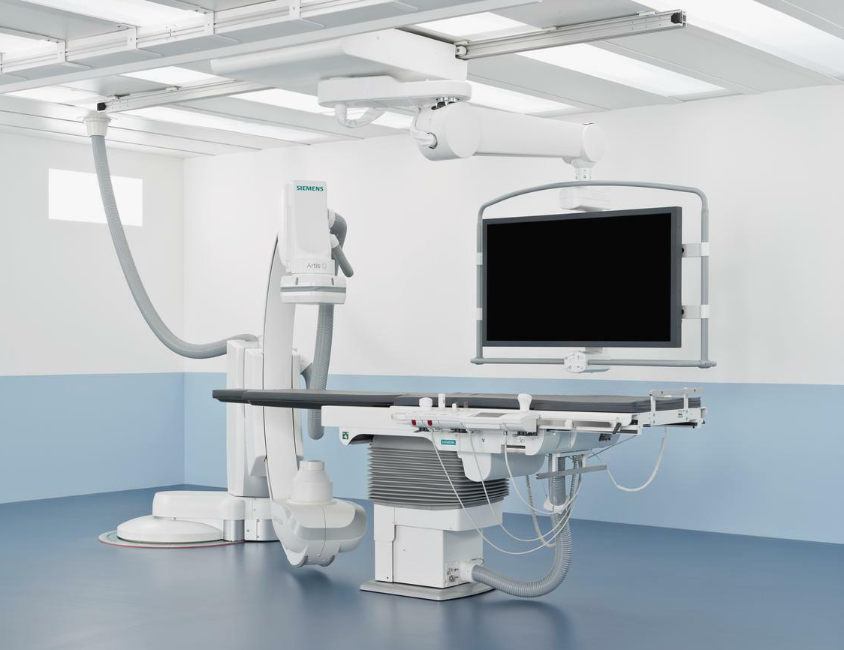
Aberdeen

The Interventional Radiology suite is presently developing an IR suite with two Siemens Artis Q angiographic units. This circa £2M+ redesigned department will have recovery space and a day ward to facilitate efficient and effective patient flow.

The main radiology department is based at Aberdeen Royal Infirmary on the Foresterhill site. This department has a CT Suite with a 128 slice Siemens Somatom Definition and a dual energy GE Discovery 750. Emergency and urgent cases are imaged on a 64 Slice GE Optima 660 located in the Matthew Hay Emergency Care Centre. The main department also has a Siemens 1.5T Advanto MRI unit and access to sessions on a Philips 3T University MR scanner, which has recently been replaced.

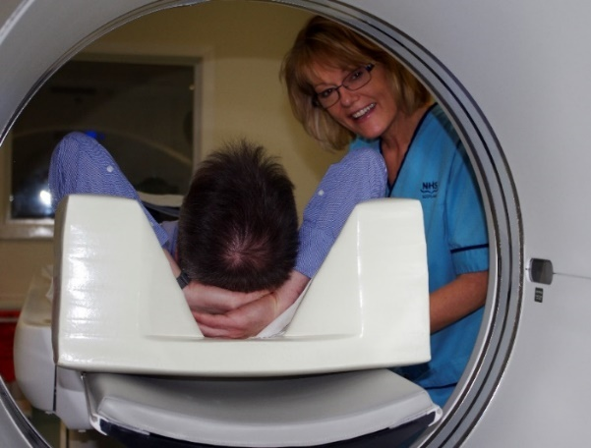
Nuclear medicine has a long and illustrious history in Aberdeen with numerous world and national firsts in terms of service innovations and academic achievements. The department performs around 8500 examinations a year and is equip with 2 SPECT gamma cameras and 1 SPECT/CT, PET/CT system, a full isotope laboratory and will be commissioning in Q1 2020 and new PETtrace 660 cyclotron, which includes a Zn target to produce 68Ga. The department has a full radio pharmacy facility and a GMP standard PET laboratory, with 9 hot cells. The department is well supported by Scientific and Technical staff, both clinical and academic and has an extensive research portfolio.
Currently, there are two Hologic mammography rooms within the Radiology department with tomosynthesis and vacuum biopsy services. The separate breast screening centre is fully equipped and has a comprehensive quality assurance and educational programme. The Breast MRI service also provides MRI guided biopsy along with family history screening.

Aberdeen Royal Infirmary is a teaching hospital. NHSG Radiology have a well-established and successful teaching programme for trainees. We also have strong links to Aberdeen University and Robert Gordons University, encouraging links to other UK and European academic settings for collaborative research. There is a strong audit and research component to the department for all members of staff which is shared and learned from.

The department is fully integrated with Carestream RIS/PACS/electronic requesting and uses a Soliton Voice Recognition System across all sites.

Elgin
The fully digital radiology department at Dr Gray’s Hospital in Elgin provides comprehensive plain imaging, Ultrasound, Fluoroscopy and a newly installed 160-slice Canon Aquilion Prime SP CT, (with full subtraction suite, cardiac and colon packages, and dedicated multi-user thin client post-processing Vitrea workstation). In addition a new MRI service is planned for 2020 / 21 as part of the elective care investment.

Ultrasound service at Dr. Gray’s is provided on 2 x Toshiba Aplio 500 with advanced software including Shearwave Elastography, SMI Doppler and Contrast package (CHI). A fully integrated Fuji AcSelerate digital system (x2) have Tomosynthesis capability. Moray also provides plain imaging services on a part time basis in Forres, Dufftown, Keith and Buckie. The department is fully integrated to the Scottish National PACS system (Carestream Vue PACS) with a local RIS (Carestream) and electronic requesting (TrakCare) and reporting uses Soliton Reporting+ with full voice recognition available across all sites in NHS Grampian and also linked to NHS Orkney and NHS Shetland.

Local reporting radiographers undertake appendicular radiographs and Sonographers who perform and report general and Doppler ultrasound independently. NHS Grampian is also part of the first regional project to fully link all boards to a single reporting platform using Soliton Share+. The north region is to link up NHS Grampian, Highland and Tayside.

Patient care

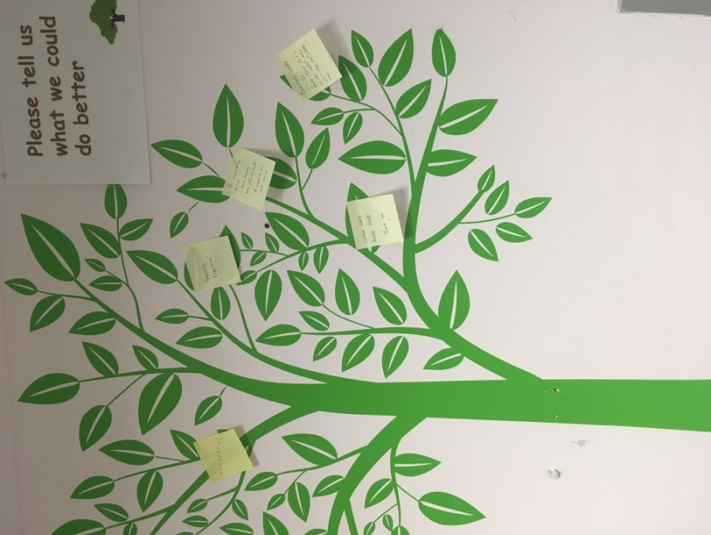
The multidisciplinary team in NHS Grampian Radiology Department are very patient-centric. Our teams make all efforts to ensure that patients feel comfortable and confident when having any imaging or procedures done, ensuring their care and dignity. We undertake patient satisfaction audits which help with any service redesign and we respect the rights and responsibilities our patients have, underpinned by person-centred values.

We take all patient feedback seriously and consistently act on complaints and compliments, both within our department, but also through our Divisional Clinical Governance Group. This enables a drive towards service quality and improvement. This approach to our service provision is attractive to people who also carry these values and we are keen to appoint such individuals into our team.

Future plans for NHS Grampian Radiology
The Executive Team in Radiology are very ambitious. There is a common understanding that Radiology is at the heart of the hospital and as such we have a constant drive for further investment across all our staffing disciplines and capital. The major capital investment for a new Baird Family Hospital and ANCHOR centre for Oncology and Haematology will improve patient care and augment the imaging service for patients. NHS Grampian are also pursuing major capital investment through the Elective Care Programme and this will increase the imaging with additional MRI, CT and improved x-ray facilities. In addition, the Interventional Radiology suite is being updated with state of the art equipment and departmental redesign with replacement plans to follow for all modalities.

Often there are non-recurring funding streams and we provide business cases and applications for such funding, capitalising on any opportunity to promote quality improvement.

Value-based care for our patients and staff requires collaboration across all our modalities and work streams. We work closely with our eHealth and Health Intelligence colleagues to interrogate our data and activity, producing evidence for increased funding applications, future projections, working on the capacity gap, workflow efficiencies and avoidance of service creep. We also value the contributions from our collective workforce and encourage participation in our strategic planning via the modality groups and participatory events.

A workforce plan is also in development in order to enhance our retention and recruitment plans. Staff development is a key driver for improving services, and all staff are encouraged to engage with the weekly CPD lecture programme and are also given time and space to pursue their own learning.


A consortium between NHS Grampian, Aberdeen University and other partners was successful in the funding competition – Creating a network of digital pathology, imaging and AI centres. The iCAIRD (Industrial Centre for Artificial Intelligence Research in Digital Diagnostics) project initiated in autumn 2018 to develop infrastructure to apply AI in digital diagnostics, pathology and radiology built upon existing national initiatives. This is a significant project which NHS Grampian are committed to, with contribution from members of the Radiology department.

Department representation around the Scottish Radiology Transformation Programme for local, regional and national developments ensures NHS Grampian are part of the decision making process.

The future plans for the radiology department are developed in conjunction with staff and underpinned by service need and evidence in order to provide the best imaging service for our patients.

Potential candidates will be encouraged to identify areas within the department where they can lead and develop, acting as a conduit between contemporary thinking and local good practice.

Consultant Staff in Radiology based in Elgin

Dr R Hamdy  rafik.hamdy@nhs.net | Dr Gray’s Clincal Lead Radiologist. General Radiology (including CT colonopgrahy), Musculoskeletal Radiology, Paediatric (Cranial and Spine US).  Based at Dr Gray’s Hospital.
Dr S Wilkie  struan.wilkie@nhs.net | NHS Grampian Clinical Lead for Radiology IT. General Radiology (including Trauma). Non-vascular intervention (Biopsy, drainage, MSK), Chest, Cardiac Radiology  NHS Grampian cross- site (based Dr Gray’s with clinical sessions at Aberdeen Royal Infirmary)
Dr S Forbat  sforbat@nhs.net | General Radiology, Breast Radiology  Cross- board NHS Grampian and NHS Highland working

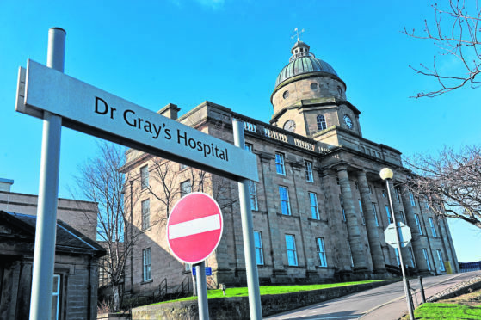

Based at Aberdeen Royal Infirmary

Dr D McAteer Unit Clinical Director
d.mcateer@nhs.net US Modality Lead
Gastrointestinal and Head and Neck Radiology

Prof A Murray Roland Sutton Professor of Radiology
a.d.murray@abdn.ac.uk Director of Aberdeen Biomedical Imaging Centre
Neuroradiology and Nuclear Medicine

Prof A Denison Dean of Postgraduate Medicine at NHS Education for Scotland
alan.denison@abdn.ac.uk University of Aberdeen.
Chest Radiology and PET.

Dr L Narayanan Training Programme Director
leelanarayanan@nhs.net Neuro and GI Radiology

Dr S Olson MRI Service Director Lead
shona.olson@nhs.net Neuroradiology, haematology

Dr G Lip Clinical Director North of Scotland Breast Screening
geraldlip@nhs.net Breast and Head and Neck Radiology

Dr E Ramage Postgraduate Advisor
emma.ramage@nhs.net Gastrointestinal and Gynaecology Radiology

Dr S Arcot Ragupathy CT Clinical Service Director Lead
sarcotragupathy@nhs.net Breast and Uroradiology

Dr S Wilkie Radiology IT Clinical Lead
struan.wilkie@nhs.net Cardiac Radiology

Dr I Paraskevopoulos Interventional Radiology Clinical Lead
ioannis.paraskevopoulos@nhs.net

Dr M Ashcroft Interventional Radiology
Dr F Caswell Chest and Oncology
Dr S Debios-Marshall Chest, cardiac
Dr M Ghandi Urology, Gastrointestinal, haematology
Dr D Greiskalna Breast Radiology
Dr D Morgan Paediatric Radiology
Dr R Mitchell-Hay Gastrointestinal and hepatobiliary Radiology
Dr N Muhammad Gowdh Breast and Gynaecological Radiology
Dr A Nandakumar Breast and Uroradiology
Dr A Neelakantan Neuro and Head and Neck Radiology
Dr A Rana Neuroradiology
Dr D Reynolds Musculoskeletal Radiology
Dr N Rose Musculoskeletal Radiology
Dr L Saraswat Gastrointestinal Radiology
Dr B Sethi Paediatric Radiology
Dr S Walker Paediatric Radiology
Dr B Winter Musculoskeletal Radiology
Dr A W Yong Neuro and Head and Neck Radiology

Research and University Links
Aberdeen Royal Infirmary is a teaching hospital. NHSG Radiology have a well-established and successful teaching programme for trainees. We have strong links to Aberdeen University and Robert Gordons University, encouraging links to other UK and European academic settings for collaborative research. There is a strong audit and research component to the department for all members of staff which is shared and learned from.

The University of Aberdeen was founded in 1495 and has over 14,000 full-time matriculated students. The University is a world-class research-led centre of learning and teaching excellence and is ranked in the top 100 Universities worldwide, and 4th overall in Scotland in the Times/Sunday Times “Good University Guide”.

Aberdeen has a long and distinguished history of imaging excellence and the Aberdeen Biomedical Imaging centre is undertakes high quality hypothesis driven research in imaging. Significant investment by the University and funding bodies has allowed the creation of an impressive imaging infrastructure with modern MRI facilities, PET-CT cyclotron and radiochemistry laboratories. The strong scientific team is solely dedicated to the creation of new imaging technologies such as PEDRI, fast field cycling MRI, ultra-low field MRI and hand held PET.

The Aberdeen Biomedical Imaging Centre (ABIC) collaborates with the community of life scientists both nationally and internationally and is a member of SINASPE - the Scottish Imaging Network – A platform for Scientific Excellence. The ABIC facilities and imaging experts are located on the Foresterhill site within the acute NHS hospital and this facilitates clinical imaging research and involvement in clinical trials using imaging biomarkers. Research dedicated 3T MRI facilities, pre-clinical MRI and pre-clinical PET CT facilities are available and ABIC staff work closely with those in the Kosterlitz Centre for Therapeutics who are developing novel PET tracers.

The University of Aberdeen’s School of Medicine, Medical Sciences and Nutrition is co-located on the Foresterhill Health Campus with NHS Grampian. There are state of the art research, teaching and learning facilities provided in the Suttie Centre, Aberdeen Dental Education Centre, the Institute of Medical Sciences and the Rowett Institute of Nutrition and Health.

Imaging has a rich presence in the medical undergraduate curriculum, and there are extensive opportunities to contribute to the education of tomorrow’s doctors, from admissions to examining in Finals. The appointee will be awarded honorary status which provides multiple benefits (see http://www.abdn.ac.uk/staffnet/working-here/honorary-status-2973.php). The undergraduate teaching dean (Professor Denison) is a radiologist and would be pleased to discuss opportunities.
For more information about the University, including the Strategic Plan, please visit http://www.abdn.ac.uk/about.

The Robert Gordon University has earned wide recognition for its pragmatic approach to higher education both in Scotland and internationally. For generations it has produced qualified professionals across a broad spectrum of careers in the arts, management, engineering, sciences, pharmacy, health and the professions allied to medicine. Around 5,800 students study almost 100 full-time and part-time courses at undergraduate, post-experience and postgraduate levels. There is an established Radiographer training programme. The University also offers a successful Radiographer reporting course in line with developing a robust Radiographer reporting resource as described in the 2012 AHP National Delivery Plan, and the NSS Radiology Transformation Programme.

The University is actively involved in applied research in a variety of fields and many short course programmes are being formulated to meet the growing needs of the community, culture and economy. http://www.rgu.ac.uk/

At present NHS Grampian Radiology Department are carrying a number of vacancies and are keen to recruit talented Radiologists wishing to take a post and join our team, both in Aberdeen and Elgin. We appreciate that in the current climate Radiologists have a range of options where to work and live. However, we are a forward thinking dynamic department and carefully design our posts with the intention to attract motivated individuals to complement and enhance existing services. We are looking to strengthen the range of imaging and future resilience.
Description of post/s
Our posts are advertised as a 10 PA position, although applicants wishing to work part time, or take EPAs are welcomed and would be the subject of detailed job planning discussions. EPAs are described as additional activity, are separate from the main contract and variable at 3 month notice period from either employee of employer.

Any out of hour’s activity will be undertaken on the basis of the terms and conditions set out in the new consultant contract (Scotland):
- The Aberdeen General Radiology on-call rota is currently 1:20, but under review and provides emergency cover across Grampian, Elgin and Shetland. General Radiologists also have the benefit of participating in the rota covering departmental monthly visits to NHS Orkney and Shetland (approx 2 trips per consultant per year / 18 months). Review of weekend working processes are also underway as part of future planning.
- The Elgin rota is 1:4.8 with Radiologists covering up until 9pm.
- The IR rota is 1:5 with opportunities to pick up additional shifts at locum rate.

All candidates will be expected to contribute to the workload within their respective departments. The successful candidate will have opportunities to be part of strategic discussions in planning the future vision for Radiology, NHS Grampian.

The appointee will be expected to participate in teaching, clinical audit and continuing professional development and contribute to service development and management.

Clinical Commitments

Job plans will be discussed individually but an indication on the bases of a 10PA contract will usually be based around:

3 Radiology Sessions in your Specialist Area
1 Flexible radiology session/prospective cover
1/ 2 MDT sessions
1 on call session
1/2 general reporting sessions
2 SPA sessions

This contract would be negotiable for candidates who wish to work part time.

NHS GRAMPIAN

PERSON SPECIFICATION
The Person Specification should meet the demands of the job and comply with current legislation. Setting unnecessary standards may, for example, unfairly discriminate against one sex, the disabled or minority racial groups. Applicants should be assessed in relation to their ability to meet the real requirements of the job as laid down in the job description. Shortlisted candidates MUST possess all the essential components as detailed below.

POST/GRADE: Consultant Radiologist with a Specialist Interest
LOCATION/HOSPITALS: Aberdeen Royal Infirmary and/or Dr Grays Hospital, Elgin
WARD/DEPARTMENT: Radiology

Requirements |  | Essential | Desirable
Qualifications/Training | Full Registration with the General Medical Council, a licence to practice, and be eligible for inclusion in the GMC speciality Register. | Yes
 | Those trained in the UK should have evidence of higher specialist leading to CCT in Clinical Radiology or eligibility within 6 months of confirmed entry from date of interview. | Yes
 | Non-UK applicants must demonstrate equivalent training | Yes
Ability/Knowledge | Ability to perform as an independent Clinical Consultant | Yes
Experience | Broad Experience in body cross sectional imaging including drainage procedures to permit participation in On-call services | Yes
Experience | Experience of audit and research | Yes
Experience | IR subspecialty interest should have experience in vascular and non vascular interventional procedures as well as CTA reporting. | Yes
Teaching | Experience in post graduate teaching |  | Yes
Special Aptitude and Abilities | Ability to work flexibly to meet the needs of the service  Patient focussed | Yes
Disposition | Team player, works with integrity  Patient-centred | Yes
Physical requirements | Good general health | Yes
Management Ability | Working knowledge or understanding of the NHS systems and current developments  Ability to develop and lead new areas of service development | Yes  Yes

* GMC Requirements:
- GMC accredited Primary Medical Qualification (PMQ)
- English language knowledge –
  - PMQ delivered in English
  - IELTS, PLAB 1 or PLAB 2
  - References from previous English-language employers covering 2 years.
  - Written offer and English Language Form from Responsible Offer of Designated Body
- Proof of identity
- Certificate(s) of Good Standing
- Activities over the past 5 years.
- Declaration of Fitness to Practice
- English-translated documents
- Payment of GMC fee

MODEL JOB PLAN FORMAT
a) Consultant Contract Details

Name: |  |  |  | Specialty: Clinical Radiology / Interventional Radiology
Principal Place of Work: ARI and or Dr Grays
Contract : | Full Time |  |  | Honorary | PAs __10_____ | EPA _______
Availability Supplement: |  |  | 3% | Level 1 |  | (Delete as appt )
OOH at Premium Rate worked : 4 hours
Managerially Accountable to: Unit Clinical Director
Responsible for : |  | Diagnostic Radiology with a special interest

b) Timetable of activities which have a specific location and time

NB: A detailed Job Plan will be agreed with the successful candidate at the time of the appointment, taking account of the experience, skills and interests of the candidate and how they can best be used within the Consultant team.

DAY | HOSPITAL/ LOCATION | TYPE OF WORK | DCC | SPA
Monday  From / To  0900-1300  1300-1700 | Hospital base  Hospital base | DCC Specialist session  DCC Specialist session | 4  4
Tuesday  From / To  0900 – 1500  1500 – 1700 | Hospital base  Hospital base | MDT and specialist prep  SPA | 6 | 2
Wednesday  From / To  0900 - 1300  1300 – 1500  1500-1700 | Hospital base  Hospital base  Hospital base | DCC Specialist session  Flexible specialist session  SPA | 4  2 | 2
Thursday  From / To  0900-1300  1300-1700 | Hospital base  Off site | SPA  Duty on-call hours | 4 | 4
Friday  From / To  0900 - 1300  1300 - 1700 | Hospital base  Hospital base | Reporting / vetting  DCC Specialist session | 4  4
Saturday
From / To

Sunday
From / To

NHS GRAMPIAN

CONSULTANT RADIOLOGIST

CONDITIONS OF APPOINTMENT

1. The appointment will be made by the Board on the recommendation of an Advisory Appointments Committee, constituted in terms of the National Health Service (Appointment of Consultants) (Scotland) Regulations, 1993 - NHS Circular 1993 No 994 (S.140) which will include University representatives. Any person suitably qualified and experienced who is unable for personal reasons to work full-time, will be eligible to be considered for the post.

2. (a) The whole-time salary, exclusive of any distinction award, will be a starting salary of £80,653 - £107,170 progression of salary is related to experience.
Appendix 8 of the contract sets out the code of conduct for private practice which applies to all interested parties. In general consultants will be free to undertake private practice as long as this is undertaken out with the agreed job plan and employers are informed, in writing, of private commitments. While employers have discretion to allow some private practice to be undertaken alongside a consultant’s NHS duties, such provisions of private service should not prejudice the interests of NHS patients or disrupt NHS services.

(b) Job plans must be agreed in association with the appropriate General Manager and Clinical Managers; for signature on behalf of the Chief Operating Officer. Changes will be discussed and agreed by these officers and yourself in line with Clinical Grouping service needs and changes in service requirements as well as at annual review.

3. The person appointed will be expected to take part in undergraduate and postgraduate teaching programmes. You will therefore be awarded appropriate Aberdeen University Honorary Status.

4. Consultants are expected to undertake research and development in their own field and to link with the University research areas.

5. Day to day arrangements for undertaking the specified duties of the post will be made in consultation with the Head of Service, other consultants in the department and with the Board.

6. The person appointed will have a continuing responsibility for the care of patients in his or her charge and will undertake the administrative duties associated with the care of his or her patients and an appropriate share in the running of the clinical department.

7. The person appointed will act as an adviser to the Board in Radiology.

8. The person appointed will be expected to undertake domiciliary consultations as may be required by the Board.

9. The person appointed will be expected to undertake advisory ("pastoral") visits to hospitals in the Area.

10. You may exceptionally be required to undertake duties at other hospitals in the Grampian Area or other Health Board areas and at hospitals in Orkney, Shetland and elsewhere for which service agreements would be arranged.

11. The person appointed may undertake the diagnosis and treatment of patients occupying accommodation made available under Sections 57(1), 57(2) and 58 of the National Health Service (Scotland) Act 1978 at the above hospitals insofar as the patients have not made private arrangements for such treatment.

12 The Board, in partnership with the BMA Local Negotiating Committee has a study leave policy for all Career Grade Medical and Dental staff Policy available on request from the Human Resources Department.

13. The appointment will be superannuable if the person appointed so chooses. He or she will be subject to the regulations of the National Health Service Superannuation Scheme and the remuneration will be subject to deduction of contributions accordingly, unless he or she opts out of the Scheme.

14. The private residence of the person appointed should not normally be more than 10 miles by road from their principal place of work unless otherwise agreed locally. They must be contactable by phone.

15. NHS Grampian is legally liable for the negligent acts or omissions of employees in the course of their NHS employment. Medical staff are however advised to ensure that they have defence cover for activities not covered by the Board’s indemnity.

16. The officer appointed will be required to be registered on the General Medical Council’s Specialist Register.

17. As a result of guidance issued by the Scottish Office on "Protecting Health Care Workers and Patients from Hepatitis B" NHS Grampian is required to:-

Ensure health care workers who may be at risk of acquiring hepatitis B from a patient are protected by immunisation.

Protect patients against the risk of acquiring hepatitis B from an infected health care worker. Due to the nature of this post, any offer of appointment will be conditional upon the successful applicant either:-

- Undergoing a process of screening/immunisation/monitoring in accordance with the Board's Policy and Procedure, or

- Producing acceptable documentary evidence that he/she is not an infective risk to others.

In the event that he/she is an infective risk to others or if he/she fails to comply with the above requirements, the conditional offer of appointment will be withdrawn.

As a condition of his/her subsequent employment in this post he/she is also required to undergo further immunisation and monitoring at the intervals specified by the Board's Occupational Health Service in order to boost/maintain his/her level of immunity. Should he/she become hepatitis B e antigen positive and therefore an infective risk to others at any stage in the future the appointment will be subject to review in accordance with the Board's agreed Procedure for dealing with such situations where the postholder is involved in "Exposure Prone Procedures". This review may result in the postholder having to alter his/her clinical exposure to remove risk to patients and others. In circumstances where this is not a practical option, it will be necessary to provide industrial compensation for this prescribed industrial disease prior to the postholder leaving the Board's employment.

18. The appointment is made subject to satisfactory fitness for employment. The candidate will therefore be required to complete a pre-employment health screening questionnaire and may/will subsequently be required to attend for health screening.

19. Termination of the appointment is subject to three months' notice on either side.
The Board is required to instigate a check to be made with the Disclosure Scotland Office for any convictions recorded before an offer of appointment can be made (rehabilitation of Offenders Act 1974 amended 1985 and 1986) and (Disclosure of Criminal Convictions of NHS Staff with Substantial Access to Children 1989).

NOTES TO CANDIDATES

Canvassing in connection with appointments is not permitted but this does not debar candidates who wish from visiting the hospitals concerned.

Further information can be obtained and an appointment to view the Department arranged by contacting Dr Dympna McAteer, Unit Clinical Director on 01224 552176 (d.mcateer@nhs.net), or Mrs Grace Ball, Unit Operational Manager for Radiology on 01224 553517 (grace.ball@nhs.net). Further information is also available from:

Dr Hugh Bishop Dr N Fluck
Divisional Clinical Director Medical Director
Clinical Support Services NHS Grampian
3rd Floor West Wing, Ashgrove House Summerfield House
Aberdeen Royal Infirmary Eday Road,
Aberdeen Aberdeen

PA Ann-Marie Park Lyndsay Cassie
Direct Line: 01224 553734 Direct Line: 01224 558577

Apply for this post by visiting www.medicaljobs.scot.nhs.uk or the NHS SHOW webpage and search for Ref No quoted above.
Closing date 29 March 2020

NHS Grampian has a process of induction for all newly appointed Consultants. You will have a local department induction and orientation led by your Unit Clinical Director. In addition we believe it important that you have an opportunity to meet with key personnel in NHS Grampian. This allows them to explain their role in the organisation and to discuss key information on the organisation and strategic planning processes we operate. We believe it important that all newly appointed Consultants even if they have previously worked in Grampian should have this opportunity once appointed to a Consultant post. Your Clinical Director along with you will be responsible for ensuring this is undertaken. Heads of Service are supplied with the names of those you should meet.

NHS Grampian are obliged to bring to your notice that the Rehabilitation of Offenders Act 1974 provides for many people who have been convicted of certain criminal offences, the opportunity to have no need to refer to any conviction or circumstances relating to it in the course of daily lives. Certain convictions can, therefore, be regarded as “spent” after the lapse of a period of years under the terms of the Act. The National Health Service employment for which you are applying, however, has been excluded from the provisions of the Act and you are, therefore, required no withhold information about convictions which for other purposes are “spent” under the provisions of the Act. In the event of employment, any failure to disclose such convictions could result in dismissal or disciplinary action by the Board. Any information given, however, will be completely confidential and will be considered only in relation to the post to which this job description refers.

There is a Day Nursing facility for children of staff employed by NHS Grampian in Aberdeen. ‘Little Acorns Day Nursery’ which has been specially designed can accommodate 24 children between the ages of 6 months and 5 years. Please contact the Nursery Manager on (01224) 557828 for further details.

In The Interest Of Health Promotion We Operate a No Smoking Policy

