

Working for NHS Lanarkshire

Clinical Fellow in General Medicine
University Hospital Wishaw
NHS Lanarkshire

Recruitment Pack

Application Closing Date: 23rd July 2025

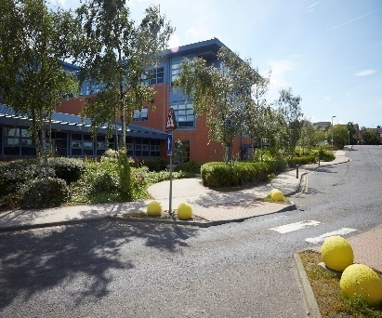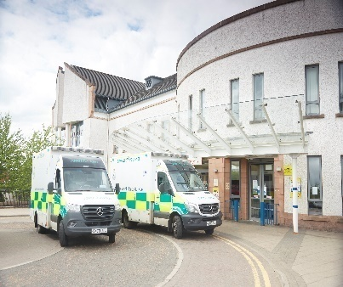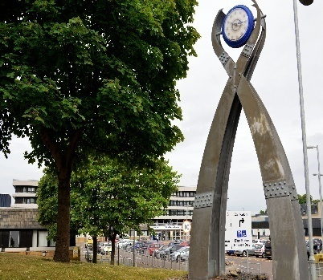

HR Medical & Dental
Law House
Airdrie Road
Carluke
ML8 5EP



Contents

Section |  | Page
Section 1: | How to Apply | 3
Section 2: | Contact Information | 4
Section 3: | Person Specification | 5
Section 4: | The Post | 7
Section 5: | Department Resources | 8
Section 6: | Working for Lanarkshire | 8
Section 7: | Terms and Conditions of Employment | 8

This post requires the post holder to have a PVG Scheme membership/record. If the successful applicant is not a current PVG member for the required regulatory group i.e. child and/or adult, then an application will need to be made to Disclosure Scotland and deemed satisfactory before the successful post holder can commence work.

Section 1: HOW TO APPLY

In order to apply:
Applicants are required to complete an Application Form via the following link: https://apply.jobs.scot.nhs.uk/vacancies.aspx. Please note that you can upload your CV, however this will only be used to pre-populate part of the application form. CV`s are not accepted instead of a completed Application Form. Your CV will not be visible to the panel.

Please complete applications by MIDNIGHT ON THE CLOSING DATE.

You will receive an email acknowledging receipt of your application once submitted.

To find out more about the role and our recruitment process please visit NHS Scotland Recruitment Portal
Recruitment | NHS Lanarkshire (scot.nhs.uk)

Application Process:

The first part of the process is to complete the gateway questions applicable to the role you are applying for. Should you meet the requirements of the gateway questions you will then have the opportunity to complete the full application form, which asks you to complete your top three preferences of location and specialty.

It is important that you demonstrate you meet the eligibility criteria detailed in the person specification on your application.

Shortlisting Process:

Stage 1

Applications will be shortlisted in line with the person specification for the job. If you are successful after this stage you will receive an invite to interview by email.

Stage 2

Interview and Competency Assessment.

Section 2: Contact Information

Prospective applicants are encouraged to make contact with:

Dr Mhairi Sinclair
Clinical Director General Medicine
(Email: Mhairi.Sinclair@lanarkshire.scot.nhs.uk)

Application Queries
If you have any queries regarding the application process please email Iain Crosby at medical.dentalrecruitment@lanarkshire.scot.nhs.uk

NHS Lanarkshire is committed to working towards equal opportunities for all.

Section 3: Person Specification

PERSON PROFILE
Attributes | Essential |  |  | Desirable
Qualifications | MB ChB or equivalent  Full GMC registration with current license to Practice
Training | Completion of Foundation Training |  |  | Further post Foundation training in an appropriate medical discipline
Experience | Completion of Foundation Training  At least six months general medicine with exposure to acute medical problems |  |  | Twelve months general medicine with exposure to acute medical problems
Audit/Research | Understanding of the principles of medical audit.  Evidence of a consistent engagement and contribution to audit or quality improvement. Minimum of annual local involvement.  Awareness of principles of research with an ability to critically analyse medical literature. |  |  | Previous work in quality improvement  Good Clinical Practice accreditation
Publications
Teaching | Demonstrates good clinical teaching skills and attributes.
Knowledge and  Skills | Post registration experience. Further procedures (Foundation competencies). |  |  | Human Factors or Non-technical skills training  Ability to work with databases  Safe data handling
Disposition | Committed to Quality Patient Care.  Able to be understanding of and sensitive to the needs of patients.  Excellent communication skills (verbal and written)  Ability to work under pressure.  Ability to work effectively in a multidisciplinary team.  Responsive to change and innovation, promoting a culture for organisational development.  A flexible approach to duties, which satisfies the needs of the Service in a changing environment.  Ability to demonstrate reflective practice with evidence of regular appraisal with clear Personal Development Plan relating to Continuing Professional and Personal Development.  Good time management and organisation.  Demonstrates commitment and enthusiasm to service delivery. |  |  | Problem solver/diplomat/counsellor.  A natural leader.
Managerial | Knowledge of service provision at a local level.  Awareness of the principles and core practices involved in service management, project management and effective meetings. |  |  | Involvement in service re-design.  Involvement in project delivery.  Formal leadership qualifications.  Evidence of leadership resulting in positive transformation of patient care.
Leadership | Awareness of the principles of team leadership and effective people management.  Commitment to the Values of NHS Lanarkshire:- Fairness, Respect, Quality, Working Together. |  |  | Evidence of role as leader within groups.
Other | Satisfactory medical clearance by NHS Lanarkshire Occupational Health Service.  Satisfactory PVG Check.  Fluent in medical English and evidence of ability to communicate in stressful situations.
If there is any reason why a disabled person should not be considered suitable for this post, please provide details: |  |  | The post requires physical dexterity. Uncorrected visual or hearing defect would be incompatible with the nature of the work.
 |  | Prepared By:- |  | Approved By:-
Name
Designation
Date

Section 4: The Post

The post are based in the department of medicine and care of the elderly and give a good depth of general medical experience.

The trainees bear the devolved responsibility for the day to day care of the inpatients in the ward and will be expected to perform diagnostic and therapeutic procedures, after appropriate tuition where necessary. They will be responsible for overseeing proper and timeous communication with general practitioners and with patients and their relatives.

The trainees will become familiar with the principles of a clinical audit, are expected to participate in audit projects which involve patients for whom they are responsible and will be encouraged to initiate and pursue projects of their own.

Educational activities take place on a hospital wide and a department of medicine basis. For the hospital as a whole there is a weekly hospital meeting, usually an invited speaker on a topical subject. Within the medical division there is weekly protected teaching and a monthly departmental academic half day.

Other activities include MRCP teaching relating to post holders needs.

Section 6: Working for NHS Lanarkshire

For more information on the role please visit NHS Lanarkshire Careers Website

Section 7: Terms and Conditions of Employment

TYPE OF CONTRACT | Fixed Term (until 5th August 2025
GRADE AND SALARY | Clinical Fellow  £45,,504 to £71,550 per annum (pro rata)
HOURS OF WORK | Full Time – 40 hours per week plus out of hours duty
SUPERANNUATION | New entrants to NHS Lanarkshire who are aged sixteen but under seventy five will be enrolled automatically into membership of the NHS Pension Scheme. Should you choose to "opt out" arrangements can be made to do this via: www.sppa.gov.uk
REMOVAL EXPENSES | Assistance with removal and associated expenses may be awarded
EXPENSES OF CANDIDATES FOR APPOINTMENT | NHS candidates who are requested to attend an interview will be given assistance with appropriate travelling expenses. Re-imbursement shall not normally be made to employees who withdraw their application, refuse an offer of appointment. Non NHS employees are not normally awarded travel expenses.
DISCLOSURE SCOTLAND | This post is considered to be in the category of “Regulated Work” and therefore requires a Disclosure Scotland Protection of Vulnerable Groups Scheme (PVG) Membership.
CONFIRMATION OF ELIGIBILITY TO WORK IN THE UK | NHS Lanarkshire are required to check the entitlement to work in the UK of all prospective employees, regardless of nationality or job category. UK Visas & Immigration rules are available at www.bia.homeoffice.gov.uk. Prospective applicants are encouraged to check eligibility in advance of applying for vacancies in NHS Lanarkshire.
MEDICAL NEGLIGENCE | In terms of NHS Circular 1989 (PCS) 32 dealing with Medical Negligence the Health Board does not require you to subscribe to a Medical Defence Organisation. Health Board indemnity will cover only Health Board responsibilities. It may, however, be in your interest to subscribe to a defence organisation in order to ensure you are covered for any work, which does not fall within the scope of the indemnity scheme.
NOTICE | Employment is subject to one month notice on either side.
PRINCIPAL BASE OF WORK | You may be required to work at any of NHS Lanarkshire sites as part of your role. Your base will be clarified for expenses purposes.
REFERENCES | All jobs are only offered subject to receiving two satisfactory references. At least one reference must be from your current/most recent employer or your course tutor if you are currently a student. If you have not been employed or have been out of employment for a considerable period of time, you may give the name of someone who knows you well enough to confirm information given and to comment on your ability to do the job.

