
Theatres, Royal Infirmary of Edinburgh
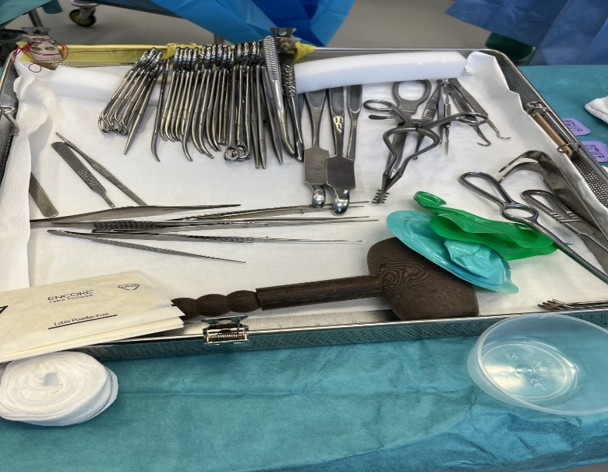
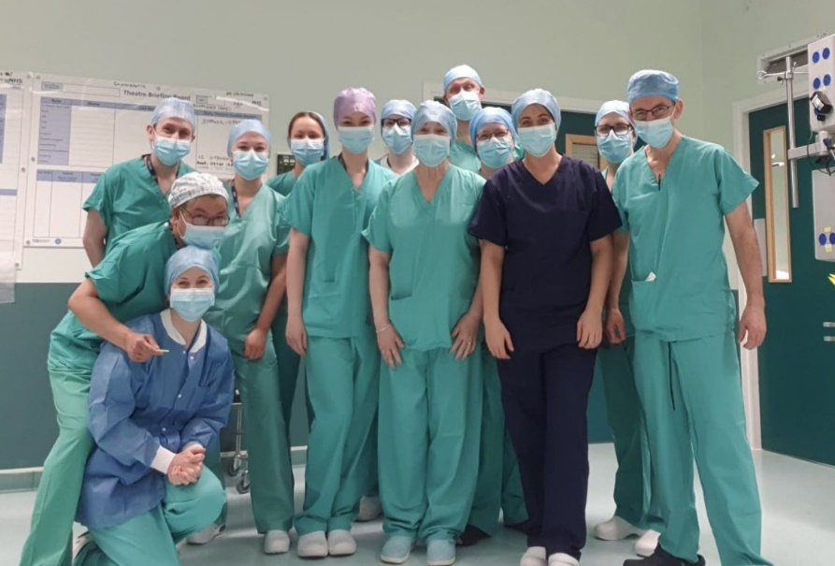
Exciting opportunities are available to join our theatre teams within the Royal Infirmary of Edinburgh. We have multiple Band 3 positions available for people wishing to pursue a career in healthcare, and we are looking for passionate, caring, motivated people to join our highly skilled nursing teams.

What We Can Offer You
We have a range of vacancies for Clinical Support Workers to join our innovative and dynamic Theatre teams at the Royal Infirmary of Edinburgh, providing you with the opportunity to gain a breadth of knowledge and exposure to multiple specialties. We have 28 adult operating theatres at the Royal Infirmary of Edinburgh, split into various specialities, including Obstetrics and Gynaecology, Cardiothoracic, Day Surgery, Transplant and upper hepatobiliary, Emergency and Vascular Theatres, Orthopaedic and Trauma and Neurosurgery Theatres. We may be able to offer flexible working patterns, but there is a requirement to work unsocial hours in most specialities.

We also have unique pathways in career development with a view to becoming a band 5 registered practitioner or a band 4 assistant theatre practitioner and a supportive team with a dedicated Education Lead. Please contact Cath Green, Clinical Lead on 0131 242 3102 for an informal discussion.





