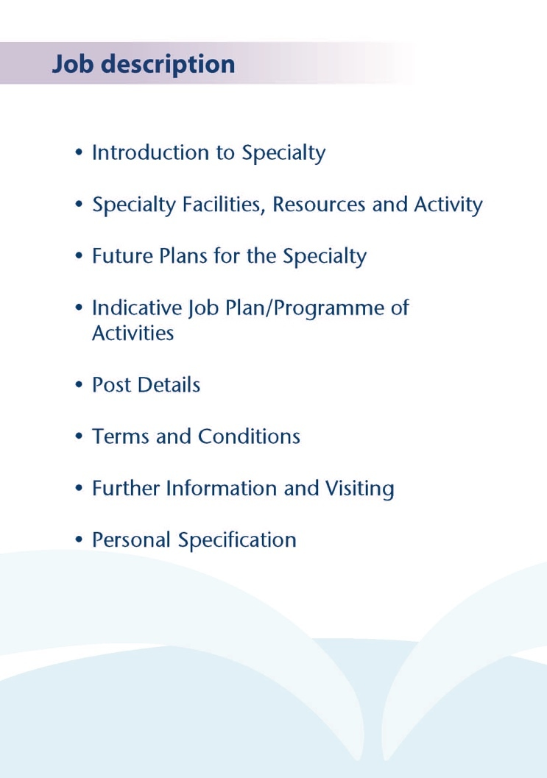



This post in Elderly Mental Health in NHS Ayrshire and Arran benefits from retaining the traditional positive aspects of working with the specialty such as respecting continuity of care, with the post holder working with the Consultant to look after patients from a locality based on GP practice throughout their illness, both as an inpatient and an outpatient and the pleasure of working within established inpatient and community teams. The service also benefits from modernised service models involving Care Home Liaison and Hospital Liaison teams. The Community Mental Health Team for the Elderly provides an excellent service, with nursing, OT and Psychology team members. The locality is partly suburban covering the Southern part of the town of Ayr, along with the smaller rural populations in the south of the county towards Girvan and surrounding villages. The base for the post is in Ailsa Hospital in Ayr, within easy reach of Glasgow. Several Consultant and SAS doctors are based here and as such there is peer support available. The post holder will share a Medical Secretary and a Medical Audio Typist with the two Consultants covering South Ayrshire along with another Specialty Doctor.

Inpatient wards are provided in the purpose build Woodland View facility in Ayrshire Central Hospital, where 15 organic beds (Ward 3) and 15 functional beds (Ward 4) are provided for Elderly Mental Health across Ayrshire and Arran. The post holder would provide ward level care for a small number of patients from the South locality of South Ayrshire who are admitted in Woodland View. They will also provide ward level care for one 12 bedded Organic NHS Complex Clinical Care ward at Ailsa Hospital, all under Consultant Supervision from Dr Luty.



Medical Staff Resources
Consultant Grade:

ADULT
East Locality
Dr Morag Henderson
Dr Aileen Guthrie (CD)
Dr Jon Macklin
Dr Pamela Swift

North Locality
Dr Everett Julyan
Dr Alison MacRae (Acting CD)
Dr Yasmin Nalci
Dr Alex McLean
Dr Eilidh Orr

South Locality
Dr Jacqui Scott (CD)
Dr Tim Johnston
Dr Adrian Nitu

Liaison
Dr Malcolm Cameron (perinatal)
Dr Kim Newlands
Dr Ben Chetcuti (CD)
Dr Julie Langan-Martin

Psychotherapy tutor
Dr Steve Moorhead

Forensic and Inpatient
Dr Dawn Carson (CD Inpatients and Forensic)
Dr Gillian Howieson
Dr Ishbel McFarlane
Dr Shastry

Rehabilitation
Dr Krzysztof Tyczynski

Elderly
Dr Stephanie Cowan
Dr Ian McClung
Dr Gillian Scott
Dr Debbie Brown (DMD)
Dr Mark Luty (CD EMH Community)
Dr Susan Maxwell

CAMHS
Dr Helen Smith (CD)
Dr Tahir Ali

FCAMHS
Dr Craig Marsh

LDS
Dr Claire Hughes (CD)
Dr Omer Rashid
Dr Douglas Paterson

Addictions
Dr Beinn Wilson (CD)
Dr Karthik Kessavalou
Dr Caroline Woolston
Dr Claire Duncan
Dr Rian O’Regan
Dr Mathew Turner

Non Consultant Grade:

The 35 consultant posts are supported by 7 Specialty Grade Doctors, approx.18 junior trainees (FY2/ST1-3) and up to 6 Senior Psychiatric Trainees (ST4-6s)

Admin Support

The post holder will have Medical Secretarial Support share with the other Consultant for South Ayrshire Health and Social Care Partnership.

Education

Woodland View has its own library and training facilities on site for local Postgraduate teaching.

University Hospital Crosshouse and University Hospital Ayr have the Alexander Fleming Education Centre and MacDonald Education Centre, respectively. These facilities have well stocked libraries with good electronic facilities, a lecture theatre with state-of-the-art equipment and meeting rooms.

The post holder will be expected to participate in the local postgraduate psychiatric training programme and to be involved in the teaching of medical undergraduates.



.
The Elderly Mental Health team in NHS Ayrshire and Arran is actively reviewing services to ensure safe and effective care in a climate of increased demand in a financially challenging NHS environment.
The inpatient wards at Woodland View were purpose build in 2016. NHS Complex Clinical Care wards are at Ailsa Hospital have also undergone significant modernisation works in 2020, ensuring they remain an excellent environment in the interim. Easy Ayrshire Community Hospital also houses NHS Complex Clinical Care beds.



The post is a full time permanent Specialty Doctor post which will consist of 10 programmed activities, but it may be adapted to applicants wishing to work 8 or 9 sessions. The nature and timing of activities shown in the timetable are indicative and the precise nature of the duties will be agreed with the successful candidate at a job planning meeting with the Clinical Director. Timetables may be adapted in future to meet the changing needs of the service but any changes would be subject to discussion and job planning.

 | Mon | Tues | Wed | Thur | Fri
am | Community Mental Health Team Meeting / Ward Round Clonbeith | Outpatient Clinic  North Ayr Health Centre | Outpatient clinic  Girvan Community Hospital | SPA time  Eg attendance at Teaching. | Ward work/ clinical admin
pm | Ward Work/  community reviews | Ward Round Ward 4 Woodland View | Clinical Admin/ home visits | Ward Round Ward 3  Woodland View | Community reviews

Proposed Weekly Programme
The above timetable is indicative and subject to amendment through job planning.

Notes on the Programme

Travel: Any travel allocation will be included within the Total Programmed Activities and will be determined by location at which Direct Clinical Care and Supporting Professional Activities are carried out.

On call arrangements: The postholder will not be expected to take part in an on call rota.

Supporting Professional Activities: NHS Ayrshire and Arran recognise the important role Job Planning has in ensuring Specialty Doctors are supported in delivering high quality, safe, sustainable clinical care to patients.
The post holder can expect 1 SPA as a minimum to support job planning, appraisal and revalidation.

Job Plan Review

New appointees will have an interim Job Plan review conducted at 3 months post commencement to review the balance previously agreed. The agreed job plan will include all the Doctor’s professional duties and commitments. Thereafter Job Planning will be carried out annually as part of the Boards Job Planning process.

Special Interest

The post holder may by mutual agreement through job planning pursue relevant professional interests during the post eg special interest in teaching or management.

Private Practice: If the post-holder wishes to undertake any private practice, they are obliged to inform their employer at the time of appointment of their intentions to do so. This should be submitted in writing to the Clinical Director.



The main duties and responsibilities of the Specialty Doctor are:

- Medical input into the Elderly Mental Health Services within NHS Ayrshire and Arran into the South locality of the South Ayrshire Health and Social Care Partnership

- Diagnose, treatment and management of older patients with mental health difficulties within this locality under Consultant Supervision.

- Provide day to day medical input into inpatients admitted to the Woodland View inpatient unit from this locality.

- Provide day to day medical input into the inpatient in Clonbeith Ward at Ailsa, a 12 bedded NHS Complex Clinical Care ward. Cross cover with the specialty doctor for the adjoining Dunure Ward would be expected for leave cover etc.

- Provide twice weekly outpatient clinics for patients from this locality

- Provide medical input to the multidisciplinary team through support, advice and guidance on clinical mental health issues to assure high quality patient interventions.

- To provide support to the care home liaison team in order to, where possible, avoid inappropriate admission to both general hospital and mental health beds.

- Develop effective working relationships with partner organisations

- Maintain compliance with legal requirements covering all aspects of clinical management to support NHS Ayrshire and Arran to meet its statutory requirements in delivering safe, efficient patient services.

- The successful applicant will be encouraged to develop a relevant subspecialty interest, subject to resources and in line with local priorities.



Terms and Conditions of Service are those determined by the Terms and Conditions of Service – Specialty Doctor (Scotland) (2022). The distance that a Doctor can reside from the principal base hospital, where travel time is seen as more important than mileage, is subject to the agreement of the Medical Director.

For further information or to arrange an informal visit please contact Dr Mark Luty Clinical Director on 01292 513981.



POST OF : Specialty Doctor IN OLD AGE PSYCHIATRY

LOCATION : Ailsa Hospital, Ayr

DURATION : Permanent

QUALIFICATIONS:

Attributes | Essential | Desirable
Education and Qualifications: | Full registration with the General Medical Council;  At least four years’ full-time postgraduate experience at least two years of which will be in Psychiatry.  Driving licence and access to a car.  Willingness to seek approval under section 22 of the Mental Health Act. | MRCPsych or equivalent.  MRCGP, MRCP or Diploma in Geriatric medicine, MSc or equivalent  Section 22 Approval under Mental Health (Care and Treatment)(Scotland) Act 2003
Experience:  - Expertise in generalist field  - Expertise in sub-specialty field | Experience of working within an elderly mental health environment.
Team Working | Committed to working effectively within a multi-disciplinary team evidenced with examples
Teaching & Training | Demonstrate evidence of ongoing continuing professional development.  Enthusiastic individual with good interpersonal skills. | Interest in teaching and training in psychiatry.
Research & Publications |  | Participation in research.  Evidence of published research within Psychiatry.

Clinical Governance | Demonstrate knowledge and understanding of Clinical Governance relevant to Mental Health. | Experience of improving the quality (safety and effectiveness) of services or other clinical governance activities.  Evidence of audit cycle completion.
Personal and Interpersonal Skills | Excellent verbal and written communication. | Demonstrate effective multi-disciplinary team working utilising effective contribution of all professionals.

