JOB DESCRIPTION

JOB IDENTIFICATION
Job Title: eESS Support Team Administrator

Responsible to: eESS Support Team Supervisor

Department: HR Systems

Directorate: Human Resources

Operating Division: Corporate

Job Reference: 236449

No of Job Holders: 3

2. JOB PURPOSE
To provide responsive, professional and high quality, customer-focussed IT systemservice to managers and staff across NHS Lothian in relation to the day to day usage of the electronic Employee Support System (eESS).

To act as the first point of contact within the HR Systems team for certain eESS related enquiries from managers, employees and stakeholders internal and external regarding eESS. Using a computerised enquiries management system the post holder will assess the requirements of the enquiry and undertake the necessary action and advice required to satisfactorily conclude the enquiry within a reasonable timeframe.

Responsible for the accurate inputting of new starter details and account distribution for all new staff to NHS Lothian. In addition to this data quality exercise will need to regularly be undertaken by the post holder.

3. DIMENSIONS
- NHS Lothian dimension:

- Staff Numbers: 36k Posts
- Staff headcount: 28k Headcount; 25k Substantive Headcount; 21k wte

- HR Systems supports high volume HR processes annually e.g:

- 4500 Vacancies
- 40000 Applications
- 3400 Appointments

- 79000 training bookings

- 2400 Terminations
- 5400 Change forms

- HR Systems Coverage:

- Development and implemented across 18 sites
- 1500 Manager Users
- 20k+ System Users

The postholder is employed within NHS Lothian and there may be a requirement to work flexibly across Lothian to meet service demands. In particular, regular travel between St John’s Hospital (base location) and Waverley Gate (NHS Lothian HQ) will be required.

4. ORGANISATIONAL POSITION
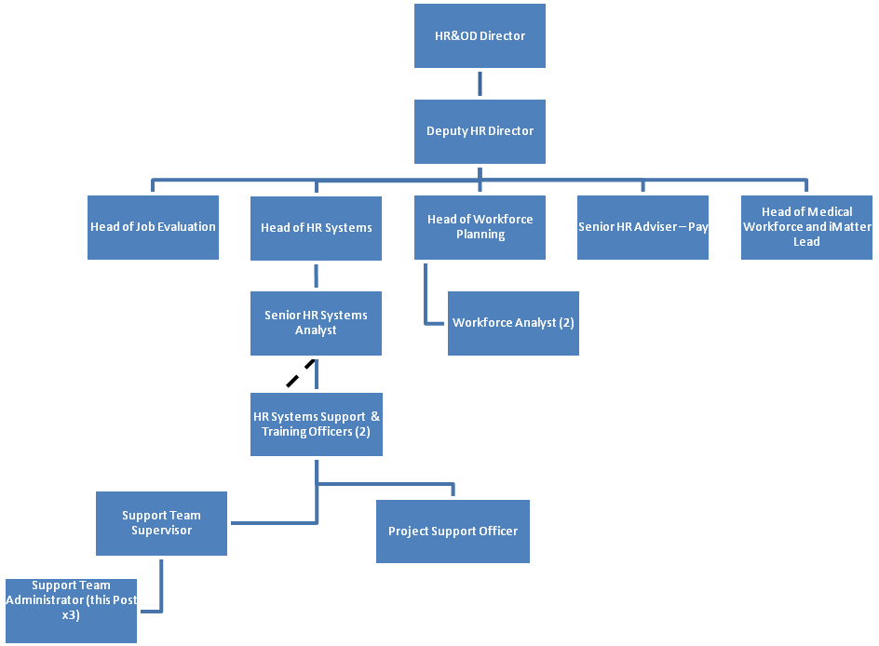

5. ROLE OF DEPARTMENT
The key purpose of the HR Systems function is to implement and maintain the HR Management Information System (HRMIS) Strategy across NHS Lothian to support the wider HR Strategy that in turn supports the achievement of NHS Lothian strategic objectives. The Strategy will also help NHS Lothian deliver other key priorities such as Single System working and the reduction in non-clinical support costs.

Facilitate the transition between Local to National HRMIS systems. Currently the HR Systems are in a transitional phase from our local HR System to the national HR System just after recently implementing the new National Recruitment System.

The HRMIS consists of:
- Core Electronic Staff Record (ESR) containing the full range of personal and post information.
- National Recruitment System - automating all aspects of recruitment administration process
- Fully integrated Training Module - automating all aspects of training administration process
- Employee Relations Case Management Module
- Self Service elements that allows managers to access their employees records and to update records and also enables individuals to access their record and apply on line for jobs and training
- Interface with a number of other systems including SSTS, GMC, SHOW, Tableau and Learnpro

6. KEY RESULT AREAS
- Provide a supportiveInformation support function for the eESS system within NHS Lothian.

- Responsible for the accurate recording of new starter information into eESS.

- Responsible for the creation and safe distribution of accounts to users of eESS.

- First point of contact for certain eESS related queries routed via our helpdesk (electronically and by phone).

- Assess helpdesk tickets & calls, take corrective action, and escalate to supervisor or eESS Operational Team when required.

- Manage the helpdesk system on a daily basis ensure appropriate support team cover at all times.

- Work on a rotational basis with colleagues to ensure appropriate cover in place to manage all business as usual activities as well as helpdesk activities.

- Support managers with completing electronic transactions on eESS.

- Control and review security access rights (Including safe issuing of passwords, housekeeping etc) to ensure no data security breaches.

- Ensure compliance at all times with Data Protection Legislation & Information Governance Principles.

- Maintain general system administration functions e.g. user accounts, updates to hierarchy and positions, updates to roles and responsibilities, setting up proxy access etc.

- Maintain departments attendance database system (SSTS)

- Ensure appropriate IT Governance Documentation and/or approvals are in place for all users.

- Adhere to protocols and procedures, and amend as required, to ensure data is recorded accurately and processes are followed to ensure robust data quality.

- Required to perform business as usual data quality checks on a daily basis as well as ad-hoc data quality checks and fixes.

- Communicate with various NHS colleagues/departments, including payroll, IT staff as well as employees and managers on a range of confidential and sensitive information.

- To support NHS Lothian’s values of quality, teamwork, care and compassion, dignity and respect, and openness, honesty and responsibility through the application of appropriate behaviours and attitudes.

7a. EQUIPMENT AND MACHINERY
The following are examples of equipment which will be used when undertaking the role:

Use of a range of general office equipment on a continual basis, including:
- Personal Computer
- Photocopier (including scanner)
- Telephone

Note: New equipment may be introduced as the organisation and technology develops, however training will be provided.

7b. SYSTEMS
The following are examples of systems which will be used when undertaking the role:

- Regular use of the Internet, Intranet, Outlook email system and Microsoft Office software – Word, Excel, Access, Publisher, Powerpoint
- Established database systems, e.g. contact/mailing database, etc
- IT Systems e.g. HR Systems and Payroll

Note: New systems may be introduced as the organisation and technology develops, however training will be provided.

8. ASSIGNMENT AND REVIEW OF WORK
Work is generated by the eESS Support Team Supervisor or operational HR Systems team, as well as routine helpdesk related activities.

The post holder is required to work autonomously, prioritising work and using initiative in order to achieve the goals set within the agreed timescales.

Performance is reviewed by the eESS Support Team Supervisor against objectives agreed at annual appraisal.

9. DECISIONS AND JUDGEMENTS
The post demands a degree of autonomy and independence with workloads identified by the eESS Support Team Supervisor or eESS Operational Team. The post holder will be required to prioritise their own work based on information made available to them.

The post holder must make decisions regarding issues they are able to deal with and when to refer on to the eESS Support Team Supervisor or eESS Operational Team. In particular they must make decisions regarding information to convey being aware of the confidential and sometimes sensitive nature of the information available to them.

Postholder will be responsible for receiving/processing complex, confidential and sensitive information.

Work is supervised when required and post holder is required to use own judgement and has the freedom to manage and prioritise own element of the workload and the order in which tasks are carried out.

Post holder follows Departmental standards and procedures but has a responsibility to highlight problems and make recommendations/suggestions to improve working practices. Following agreement with management, new protocols will be put into practice by the post holder.

10. MOST CHALLENGING/DIFFICULT PARTS OF THE JOB
Dealing with a high volume of helpdesk calls in a professional and timely manner.

Learning a complex system and processing high volumes of data.

Working flexibly to meeting the demands of the service which continually change, and organisational changes which have a direct impact on workload.

Responding to telephone and electronic enquiries from managers seeking guidance within agreed parameters. Use of influencing skills to ensure managers undertake most appropriate form of action.

11. COMMUNICATIONS AND RELATIONSHIPS
Post holder is required to communicate, establish and maintain good working relationships with various colleagues, departments and services, as well as with managers and employees.

Communication is integral within the eESS Support Team and regular team meetings are held to ensure information is passed on to all team members.

Excellent organisational and communication skills required to gather the relevant, often confidential, information from Managers and employees in relation to the accurate and timely processing of transactions on eESS to ensure these meet payroll deadlines.

Ability to handle all information in a confidential and professional manner and respond to queries with efficiency, tact and diplomacy

12. PHYSICAL, MENTAL, EMOTIONAL AND ENVIRONMENTAL DEMANDS OF THE JOB
Physical:
- Requirement to spend the majority of the working day at a workstation (i.e. sitting in a restricted position) taking telephone enquiries, using PC to respond to e-mails, produce reports and create documents as necessary
- Accurate and high speed keyboard skills and will use a keyboard and mouse for a large proportion of the working day.
- Advanced keyboard skills are required to input/extract information by interrogating various systems

Mental:
- Requirement for prolonged periods of concentration when processing the range of complex transactions.
- Frequent changes in task from answering telephone calls to responding to emails to undertaking transactional/investigative work.
- Having to deal with many tasks simultaneously, such as handling manager queries, resolving transactions conflicts, answering telephone and alternating between screens on PC
- Levels of work are unpredictable with priorities often changing at short notice, creating pressure and stress.

Emotional:
- Required to influence managers who may be unhappy with requests for further information
- To process information/request further information from managers/staff who may have a reluctance to provide it, requires a detailed explanation of why the information is needed, and requires a great deal of tact and diplomacy, which generates stress, emotional and mental fatigue

Environmental:
- Continuous use of a VDU.
- Attending meetings/working across multiple sites.

13. KNOWLEDGE, TRAINING AND EXPERIENCE REQUIRED TO DO THE JOB

Qualifications/experience
Educated to SCQF level 7 e.g. HNC in business administration or systems/other relevant subject and experience in a similar administrative role.

Skills
Proficient in use of Microsoft Office software, e.g. Word, Excel, Access, PowerPoint.
Knowledge of intranet/internet editing software.
Experience of servicing committees as required on an ongoing basis, including minute-taking.
Good keyboard skills.
Ability to work under pressure and meet deadlines.
Effective interpersonal, organisational, communication and decision-making skills.
Ability to work both as part of a team and use own initiative when required.
Experience of engaging and working effectively with colleagues of all disciplines.

14. JOB DESCRIPTION AGREEMENT
A separate job description will need to be signed off by each jobholder to whom the job description applies.  Job Holder’s Signature:  Head of Department Signature: | Date:  Date:

