236407- Consultant Radiologist

Contents
To assist you with your application for the above post, this pack will provide useful information about the post, about NHS Lanarkshire and about Lanarkshire more generally.
- Message from our Associate Medical Director
- Selection Process
- The Post
- Person Specification
- Terms & Conditions
- Management Structure Overview
- Lanarkshire The Place
- Our Vision
- Our Corporate Objectives
- Our Values
- The Board
- Our Health Together
- Monklands Replacement Project
- Net Zero Carob Pathfinder Project
- Scotland's First Digital Hospital
- Health Inequalities
- University Strategic Partnerships
- Living in Lanarkshire
- Useful Websites

Message from Associate Medical Director
Thank you for your interest in the post at NHS Lanarkshire.
We have excellent opportunities for people to progress further in their career, with friendly and supportive colleagues in a multi-disciplinary team.
We are looking for inspiring individuals who can take forward service improvements and work well with others. We support flexible working, interest in non-clinical work (such as research and audit); and if you do have any relevant special interests we would definitely want to support this in any potential candidate for interview.
If you think you have got what it takes, I look forward to receiving your application.
If you have not already done so, you will also want to check out NHS Lanarkshire’s website at https://www.nhslanarkshire.scot.nhs.uk/
Karen Gray
Associate Medical Director
NHS Lanarkshire

Selection Process
The Job Pack and Person Specification is designed to inform potential applicants on the essential and desirable experience and personal attributes which are sought in the appointment of Consultant Radiologist.
Assessment against this will feature throughout the recruitment and selection process for the appointment.
All applications for the job are made through https://apply.jobs.scot.nhs.uk/vacancies.aspx Guidance notes for the completion of the Medical & Dental Application Form are available on the advert. Please note CV’s will not be accepted.
Please follow the link below should you wish any further information on NHS Lanarkshire recruitment https://www.nhslanarkshire.scot.nhs.uk/recruitment/
NHS Lanarkshire are happy to consider requests for this publication to be in another accessible format e.g. large print, braille. Please contact us via either of the undernoted methods, clearly stating which format is required:
For any application queries, please email medical.dentalconsultant@lanarkshire.scot.nhs.uk
Should you require further information regarding this post you can contact the HR Medical & Dental team or make informal enquiries with the department using the contact details below:
Additional Arrangements
Informal enquiries regarding this post will be welcomed by:
- Dr K Gray, Associate Medical Director Access & Diagnostics on 01355 585787
- Dr J Guse, Consultant Radiologist, University Hospital Monklands on 01698 759981
- Dr F Lau, Clinical Lead, University Hospital Hairmyres on 01355 585787
- Dr L Hinksman, Consultant Radiologist, University Hospital Wishaw on 01698 366518

The Post
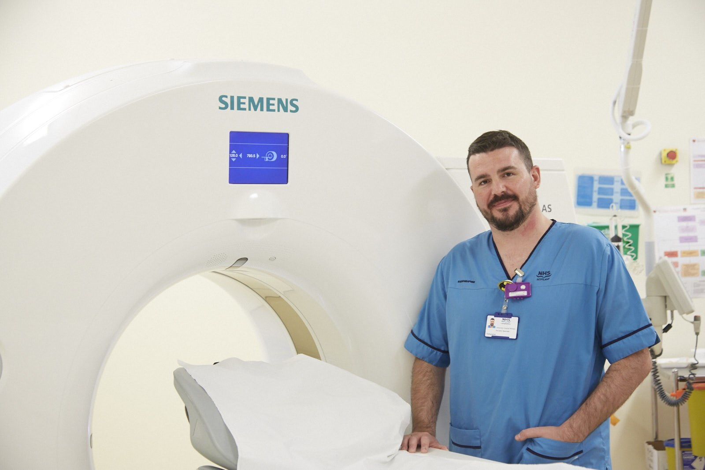
This substantive consultant radiologist post is NHS Lanarkshire wide, with site preference discussed with the successful candidate/s, depending on their specialty interest and service needs but cross site working physically or remotely may be required.
NHS Lanarkshire wishes to expand its radiology workforce to support general radiology but sub specialty interests particularly in MSK, breast, upper GI radiology, neurological and paediatric imaging would be particularly welcomed.
NHS Lanarkshire is a particularly busy Health Board due to its size, location and demographics. There is constant change and expansion in many clinical areas with adoption of a number of national clinical pathways within both Primary and Secondary Care. Clinical care has become more complex with an increasing reliance on imaging earlier and more frequently within many clinical pathways. Access to secondary care is also increasingly unscheduled with many patients presenting in poorer health and with more comorbidities. This is reflected in the growing imaging requirements and complexity within most subspecialty areas. It also means both “elective” and “acute” radiology requires a wide breadth of clinical expertise.
NHS Lanarkshire has met this challenge by developing close team working where our complementary skills are brought together to enable the best possible imaging support for our clinical colleagues. We recognize the need to expand the Radiology service both for out-patients and in-patients as well as support multidisciplinary team meetings for an increasing number of clinical pathways.
Flexible working is encouraged, with, for example, several radiologists choosing to undertake some reporting sessions in the evening. The presence of a single Lanarkshire-wide PACS/RIS also allows radiologists to undertake some reporting at a different site from their base hospital when required or preferred. A home reporting solution is currently being pursued with the anticipation that when this option is available it will be offered to all colleagues to suit the needs of the individual and service.
Regular cancer and non-cancer multi-disciplinary team meetings are held and involvement in at least one of these meetings is required. Multi-disciplinary audit is encouraged and supported.
The job is offered as a full-time post on a 10 PA basis but applications will be considered from those wishing to work less than full-time. EPA’s may be available for both part-time and full-time positions.
Proposals for additional SPA time from applicants is encouraged. In addition to the 1 PA for Non-DCC/SPA activities, the Board is supportive of applications for additional SPA time from individuals with well-developed ideas for improving services who are able to demonstrate a commitment to quality improvement, patient safety (including human factors training), Medical Education, Research & Development, acting as an Appraiser, etc. Applicants who are able to demonstrate a commitment to any of the above or other areas and wishing to commence on more than 1 PA for SPA duties should discuss proposals with the identified Recruitment Lead and/or Service Manager who will consider the request in line with the successful candidate’s professional and service requirements. All requests will be considered and subject to the approval of the final job plan.
The Board has a well-established, bespoke Medical Education and Training Centre with simulation facilities and is developing a faculty for Human Factors training. We have a strong commitment to Patient Safety and Quality Improvement with an increasing number of consultants who are trained Patient Safety Fellows.
General Provisions
You will report to the local Site Lead Clinician with whom you will agree your job plan.
Health and Safety
You are required to comply with NHS Lanarkshire Health and Safety Policies.
Resident Medical Staff and others
The departments are accredited by The Royal College of Radiologists for professional training. They are in the West of Scotland Radiology Training Scheme to train specialty trainees in Diagnostic and Interventional Radiology of varying seniority.
The West of Scotland Radiology Training scheme was awarded a commendation for Innovation in Training at the recent NES Awards
Each department regularly receives very positive feedback with respect to the training offered. Each site offers a variety of sub-specialty training blocks and your involvement would be encouraged. If agreed with the radiology lead, you may be the named Clinical Supervisor or Educational Supervisor for Radiology specialty trainees, including for advice and counseling.
You will share responsibility for training and supervising various groups including medical, nursing, radiography students, Resident Medical staff, Radiology taster weeks as part of your SPA.

The Radiology Service
NHS Lanarkshire has three Radiology Departments - University Hospitals Hairmyres, Wishaw and Monklands. While each is responsible for its own inpatient clinical care, sub-specialty expertise is shared across sites, including patient transfers when required.
The three radiology departments collaborate to provide radiology services, with centralised out-patient booking for all imaging modalities. They are managed under the Associate Medical Director for Access & Diagnostics. Each hospital has a Site Clinical Lead for Radiology. The Deputy Director for Diagnostics is Mrs Alex McGuire, the Diagnostic Services Manager is Mrs Kirsten Lanaghan and they both work closely with the Deputy Diagnostic Services Manager, Mrs Lesley Sharp. The deputy Radiology Service Manager at Hairmyres is Mrs Lisa Turki, Wishaw is Mrs Sara Riddell, Monklands is Mrs Claire Robertson.
Each department is accredited by The Royal College of Radiologists for professional training and are affiliated to the West of Scotland Radiology Training Scheme. This training scheme has been awarded a commendation for innovation in training recently by NHS Education for Scotland (NES). We host specialty trainees in Diagnostic Radiology of varying seniority from the West of Scotland training scheme.
The radiology departments are formally associated with Glasgow Caledonian University for the practical training of B.Sc. Radiography students.
Microsoft TEAMS has been successfully integrated into all MDTs and also widely used for other clinical and management meetings. An onsite radiology department video-conferencing seminar room is available.

IMAGING FACILITIES
The departments provide a wide range of imaging modalities. We have fully digital diagnostic radiography, fluoroscopy and mammography. There is an MRI scanner, 5 ultrasound rooms and 2 CT scanners in each hospital.
The Wishaw MRI scanner was replaced in July 2023 with a Siemens 1.5T Sola system. CT1 Siemens unit was replaced Aug 25. Bone densitometry is performed at University Hospital Wishaw.
Hairmyres has a Philips Azurion IR theatre and a Philips Azurion FlexArm in the Hybrid theatre next door, with a joint control room installed in 2022. The fluoro room has a Siemens Artis Zee with PURE unit installed in December 2024. NHS Lanarkshire outpatient Cardiac CT angiograms are performed here on a Philips Ingenuity scanner. Cone Beam CT at University Hospital Hairmyres.
Monklands’ fluoro room has a Siemens Artis Zee with PURE unit installed in February 2024. A Canon CT scanner was installed in 2023. Nuclear Medicine imaging is at University Hospital Monklands where there is a GE double headed gamma camera with full SPECT capability
PACS
Reporting is done using VUE PACS which integrates with the Scotland wide PACS. Tender for a new RIS is ongoing, with planned installation in 2026. SECTRA PACS is due to replace the current Carestream PACS in 2026, as part of the National Scottish PACS network.
OFFICE ACCOMMODATION
Office accommodation is provided for each Consultant Radiologist either in a single or shared office. Each consultant has access to:
- a lap top with RIS, email and Internet access
- a PACS Diagnostic Workstation with embedded voice recognition software. Current RIS is due to be replaced imminently.

Resources
Department Consultant Radiologist Staffing
Consultants at University Hospital Wishaw
Dr M Mohan
Dr A Shenoy
Dr J Addison
Dr D Steele
Dr C Cadman
Dr L Hinksman
Dr F Harries
Dr A Kovacs
Dr J Angus
Dr S Babar
Dr K Chang
Dr G Magro
Dr M Rashid (starts April 2026)

Consultants at University Hospital Hairmyres (Most also work at other sites in NHSL)
Dr K Gray (AMD for Access & Diagnostics)
Dr F Lau (Also at UHM) Clinical Lead
Dr J Ballantyne (Also at UHM)
Dr N Mathias (Also at UHM)
Prof C Chew
Dr A Kamalasanan (Also at UHW)
Dr M C Chin
Dr R Munir
Dr M Ismail
Dr S Hasan (Also at UHM)
Dr G Sundar (Also at UHM)
Dr D Fraser (Also at UHM)
Dr B Hamilton
Dr C Primrose (starts May 2026)
Dr A Forrester (Locum)
Dr M Strauss (Locum) (Also at UHW)
Dr S Sethumadhavan
Dr I Cameron (Visiting part-time IR)

Consultants at University Hospital Monklands
Dr J Guse
Dr S Khan
Dr A Paddon
Dr E Owens
Dr L Smart
Dr U Nachtrab
Dr P Garnett
Dr M Ahmad
Dr K Mitchell
Dr A Vohra
Dr R Rueben
Dr J Dreisbach
Dr S Patek
Dr K Nwafor
Dr Y See
Dr I Ahmed
Dr C Bilsland
Dr M Rymazewska (Locum)

Radiology Specialist Trainees on rotation from the West of Scotland Training Scheme. 1-5 per site

Secretarial Support:
Secretaries 2 WTE per site

Duties & Responsibilities
The main duties and responsibilities of your post include:

- Provisions of a general radiology service dependent on the needs of the hospital and primary care division.
- Provision of cover for colleagues during annual, study or short-term sickness leave (currently 2 weeks).
- Participation in the supervision, training and management of resident medical staff.
- Management responsibility where appropriate as agreed with the site clinical director.
- Participation in staff appraisal process.
- Participation in internal or external quality assurance programmes.
- Participation in clinical audit.
- Participation in undergraduate and postgraduate teaching programmes, SPA allocation is provided for this.
- Compliance with Royal College of Radiologists’ recommendations on continuing Medical Education.
- Work on behalf of NHSL or services provided by other agencies, e.g. Scottish Prison Service.
Radiology is a consultant-based service. Some functions have been delegated to other staff but the overall responsibility for all services remains with the consultants. The managerial head of each department is a consultant radiologist who has responsibility for the operational management of the department and its services.
Clinical duties are rostered to balance the specialty interests of individual consultants and the needs of the service. This may require working across sites within Lanarkshire to deliver clinical care for a subspecialty interest. This activity may be carried out remotely or in person depending on the nature of the activity, the needs of the service and preferences of the individual.
A Rota details the day-to-day responsibilities of consultants. This will be as stable as possible and provides the basis for individual consultant job plans but is sufficiently flexible to support the needs of the department and maintain a safe service in NHS Lanarkshire as a whole.
Out of necessity it is altered to prospectively cover the absence of colleagues from displaced rest period post on call, annual leave, study leave, short periods of medical or other unplanned leave (currently 2 weeks).
The ‘core’ Rota will include all direct clinical care and supporting professional activities of the consultant staff. Individual weekly rotas will also include any extra-programmed activities as contracted separately.
Consultants will be available within the radiology department during most of the programmed activities that involve direct clinical care. Home working is being implemented and once established will be offered to consultant radiologists who wishes to do this as part of their job plan. There is some flexibility with respect to the location for supporting professional activities (SPA) with this being governed by the nature of the activity. This will be agreed between the individual and their Clinical Lead.
Working Hours:
The routine working hours of the departments are Monday - Friday, 9am – 5pm, when a comprehensive in and out patient service is provided. Some radiologists choose, with the agreement of their site clinical lead to undertake some of their reporting sessions in the evening, rather than during the normal working day.
Out-of-Hours (OOH) Rota:
Weekend daytime OOH diagnostic radiology service is covered by Consultants on the OOH rota, with displaced time off given the following week.
This arrangement has proved successful in providing 7-day access to Radiology for the hospitals while maintaining radiologists’ wellbeing. This is in addition to the statutory leave entitlement.
The overnight OOH diagnostic radiology service is outsourced (currently Night Hawk – Medica). A local Consultant Radiologist covers as a second on call for major incidents or during IT connection failure to the outsourcing company. This is compensated by additional on-call availability supplement, determined according to OOH Rota frequency.
Work Programme
As required under Section 3 of the Terms and Conditions of Service, the duties and responsibilities are supported by a job plan and work programme detailed as follows:
Job Planning/Programmed Activities
The job plan will be dependent on the successful candidate’s subspecialty training and interests. A minimum of 1 SPA will be included in the job plan but please refer to the guidance above under the general description of the post.
On taking up post a Job Plan will be agreed between the person appointed and the Clinical Director/Associate Medical Director. This job plan is subject to review at least once a year by the post holder and the Clinical Director/Clinical Lead as noted in the terms and conditions.
The procedures set out in the ‘Terms & Conditions of Service’ must be followed if it is not possible to agree a job plan, either initially or at an annual review.
The timetable is indicative and subject to negotiation with the Clinical Director/Associate Medical Director.
The core 10 PA working week will be based on 9 PA’s of Direct Clinical Care (DCC) duties and 1 PA of SPA time for a full-time post-holder. The indicative weekly timetable included in the work programme shows likely PA’s within the 10 PA post and indicated the location where each activity will be undertaken and the type of work involved.

Fixed Commitments
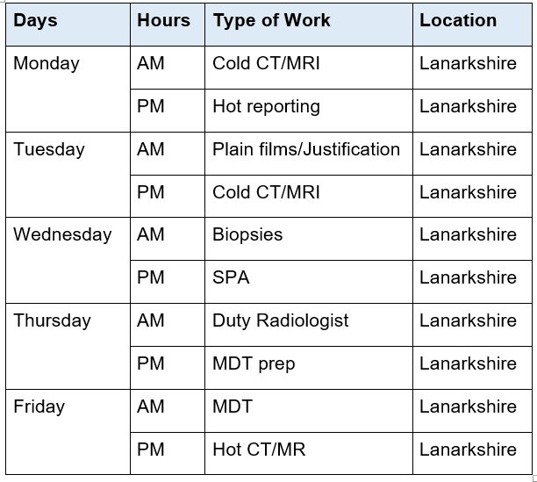
In addition, other activities not occurring at fixed times.
- MDT preparation.
- Discussing management/investigation of patients with colleagues in primary and secondary care services.
- Vetting electronic referrals (daily).

Working within Radiology in Lanarkshire
The successful applicant will work closely with their local and Lanarkshire-wide radiology colleagues. This allows each colleague to be part of a smaller local team while accessing a large variety of regional cases to develop their subspecialty interest. Though site based, each colleague is appointed as an NHS Lanarkshire Consultant and cross-site working is integral to our role to deliver subspecialty expertise across the health board and regional network.
As a result, a position in Lanarkshire allows an interesting and challenging clinical practice with ample opportunity to develop one’s professional interests. Close working relationships within and between departments allows us to support each other and when developing a subspecialty interest, colleagues are available to support this. Study leave is readily available and reasonable expenses paid.
The relatively small local hospital site encourages close working relationships across specialties through day-to-day work and also when you join multidisciplinary clinical teams.
In conclusion a position within any one of the three University Hospital sites in Lanarkshire will be a particularly rewarding one, allowing you to develop professionally as well as the opportunity to make a genuine difference to the care of our patients.

Activity figures from 2024/25
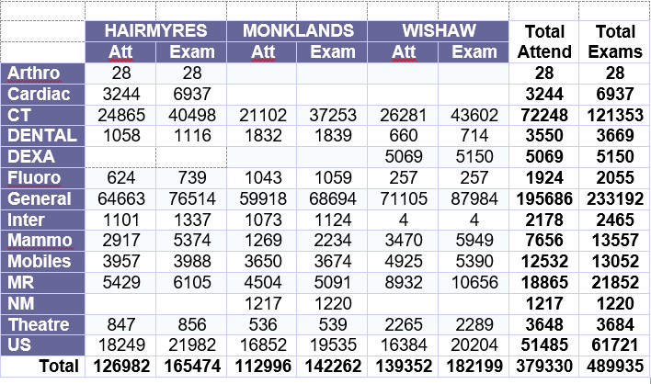

Audit and Research
The successful candidate will be expected to participate in Quality Improvement and audit processes and there is an active clinical audit department available to assist. NHS Lanarkshire is ambitious to build a portfolio of research projects backed by enthusiastic and dynamic individuals. It has an active Research and Development department and would welcome discussion regarding a potential research interest.

Continuing Professional Development
Study leave is available within the terms and conditions of service with the approval of the Clinical Director/Clinical Lead. The appointee will be required to fulfill such demands for continuing professional development as the Royal College of Radiologists (or other relevant bodies) may make.

Honorary Academic Status
The University of Glasgow enjoys close links with NHS Lanarkshire, and our medical students benefit greatly from the excellent educational opportunities provided by the board in both primary and secondary care. Those who are or who will be significantly involved in teaching our students, or in any other activity which involves a significant contribution to teaching, research or scholarship within the University are eligible to apply for honorary status at the University of Glasgow.
Applications can be made via the Hospital Sub-dean and then to the appropriate academic department within the University.

Person Specification
QUALIFICATIONS:
ESSENTIAL CRITERIA
- MBChB or equivalent.
- FRCR (or equivalent)
- Current full registration with GMC with a licence to practice.
- Inclusion on GMC’s Specialist Register or within 6 months of CCT or CESR (CP) at interview.
DESIRABLE CRITERIA:
- Higher Degree or other Diploma.
- Further educational certificates, diploma.
- Other e.g. ALS Provider.
TRAINING:
ESSENTIAL CRITERIA
- In possession of CCT or CESR at the time of interview or in an established training programme and within six months of CCT (i.e. pending exam).
DESIRABLE CRITERIA
- Training at ST/SPR level in communication, teaching or management.
- Experience within UK training establishments.
EXPERIENCE:
ESSENTIAL CRITERIA
- Recent and relevant clinical experience and competency in Radiology with wide general experience.
- Recent and relevant experience and personal qualities to work in a busy unit dealing with the high turnover of planned and unscheduled admissions.
- Ability to supervise the clinical work of doctors in training and relevant staff in other disciplines.
- Confident with indirect supervision of varying grades of doctors in training.
- Experience of Independently reporting Chest imaging and performing Non-Vascular Interventional Radiology are essential.
DESIRABLE CRITERIA
- Well-developed subspecialty interest.
- Administrative / Management experience.
- Previous experience in developing / improving NHS Services or equivalent.
AUDIT/RESEARCH:
ESSENTIAL CRITERIA
- Understanding of the principles of medical audit.
- Evidence of contribution to audit at least at local level.
- Awareness of principles of research with an ability to analyse critically medical literature.
DESIRABLE CRITERIA
- Experience and interest in audit of radiology practice and experience of design of audit.
- Research within Radiology or other clinical specialty.
- Involved in design of research relevant to Radiology.
PUBLICATIONS:
ESSENTIAL CRITERIA
- Presentations relevant to the practice of Radiology.
DESIRABLE CRITERIA
- Previous publications relevant to the practice of Radiology.
- Presentations at national meetings relevant to the practice of Radiology.
TEACHING:
ESSENTIAL CRITERIA
- Previous involvement in the delivery of undergraduate or postgraduate teaching.
- Experience of providing supervision and or mentorship.
DESIRABLE CRITERIA
- Interest in and commitment to teaching and training.
- Experience of providing problem-based teaching.
- Experience of organising teaching programmes.
- Formal training in educational/clinical supervision
KNOWLEDGE & SKILLS:
ESSENTIAL CRITERIA
- Broad based knowledge and skills in diagnosis and clinical management within the Specialty and encompassing most sub-disciplines.
DESIRABLE CRITERIA
- Further educational certificates, diploma’s, etc
- Good IT Skills
MANAGERIAL:
ESSENTIAL CRITERIA
- Knowledge of service provision at a local level.
- Awareness of the principles and core practices involved in service management, project management and effective meetings.
DESIRABLE CRITERIA
- Involvement in service re-design.
- Involvement in project delivery.
- Involvement in NHS-related meetings.
LEADERSHIP:
ESSENTIAL CRITERIA
- Awareness of the principles of team leadership and effective people management.
- Commitment to the Values of NHS Lanarkshire: Care and Compassion, Dignity and Respect Openness, Honesty and Responsibility, and Quality and Teamwork.
DESIRABLE CRITERIA
- Evidence of role as leader within groups.
DISPOSITION:
ESSENTIAL CRITERIA
- Committed to Quality Patient Care.
- Able to be understanding of and sensitive to the needs of patients.
- Excellent communication skills (verbal and written)
- High fluency in medical English and evidence of ability to communicate in stressful situations.
- Ability to work under pressure.
- Ability to work effectively in a multidisciplinary team.
- Responsive to change and innovation, promoting a culture for organisational development.
- A flexible approach to duties, which satisfies the needs of the Service in a changing environment.
- Ability to demonstrate reflective practice with evidence of regular appraisal with clear Personal Development Plan relating to Continuing Professional and Personal Development.
- Good time management and organisation.
- Demonstrates commitment and enthusiasm to service delivery.
DESIRABLE CRITERIA
- Problem solver/diplomat/counsellor.
- A natural leader.
OTHER:
ESSENTIAL CRITERIA
- Fluent in medical English and evidence of ability to communicate in stressful situations.
DESIRABLE CRITERIA
- Preference to work in a District General Hospital as a general radiologist while helping to deliver a subspecialist service locally.
- Current full driving licence.
- Good IT Skills

Terms & Conditions
a. This appointment is offered on the Terms and Conditions of the Consultant Contract.
Additional NHS Lanarkshire Policies which support the Contract are listed below and are available on request:
- Non-Direct Clinical Care Activities
- Fee-Paying Work in the New Consultant Contract
- On-Call Availability and Payment of Supplement
- Generic Objectives
- Resident On-Call Duties
- Waiting List/Additional Sessions
- Job Plan Review
b. On 1st April 2015 a new NHS Pension scheme (NHS 2015) was introduced. If you are joining the NHS Pension Scheme for the first time you will be in the 2015 scheme and your normal pension age (NPA) will be equal to your state pension age (SPA). If you have re-joined the scheme after a break of five years or more, you will be a member of the NHS 2015 scheme. All new employees commencing employment will automatically become a member of the pension scheme. Further information on the scheme, protection and/or members guides are available at www.sppa.gov.uk. Alternatively contact an advisor of The Scottish Public Pensions Agency (SPPA) Tel: 01896 893000.
c. The employment is subject to 3 months’ notice on either side subject always to the appeal and other provisions of paragraphs 10.4 & 10.5 of the Terms and Conditions of Service of Hospital Medical and Dental Staff and Doctors in Public Health and the Community Health Service Consultant Grade.
d. The successful candidate must be contactable throughout any on-call period. NHS Lanarkshire will provide the facility for this.
e. The successful candidate, if not already employed by the NHS Lanarkshire, will be required to complete a medical questionnaire to obtain medical clearance from the Occupational Health Physician.
f. The successful candidate will be required to complete a Disclosure Scotland PVG (Protecting Vulnerable Groups Scheme) form. An e mail link will be sent to the successful candidate for completion. No approach will be made without written permission of the successful applicant who will be asked to sign and complete a disclosure PVG application, giving authorisation for the check to be undertaken. If you are a non EEA National and are currently based out with the UK a Country of Origin check/criminal records certificate will also be required from each country in which you have resided continuously or cumulatively for 12 months or more in the last 10 years.
g. NHS Lanarkshire does not negotiate salary placements. On commencement the salary will be in line with paragraph 5.1 of the terms and conditions of the new consultant contract. Appointees start on the scale minimum except in the circumstances of paragraphs 5.1.2 – 5.1.7 of the terms and conditions of service.
h. From 1st April 2025 the starting salary for the post is £111,430 per annum (based on 10 Programmed Activities per week). The successful candidate’s total salary will be dependent on his/her previous service history. Remuneration for any extra programmed activities will be dependent upon the job plan agreed at the time of appointment.
i. Dependent upon present place of residence, NHS Lanarkshire may require the successful candidate to undertake to move home to a distance acceptable to NHS Lanarkshire, normally within 10 miles of the base Hospital, in which case removal expenses will be payable in accordance with NHS Lanarkshire Policy. In some cases, however, a residence more than 10 miles distant from the base hospital will be acceptable and in this case removal expenses will be subject to the prior approval of the Associate Medical Director for such a residence. The position will be made clear to the successful candidate on application.

Management Structure Overview
The supporting operational and clinical management structures are focused on enhancing patient safety, quality improvement and local delivery at hospital level, with visibility of clinical leadership and support for individual professional accountability. Our Medical Managers will provide professional leadership to medical staff, ensuring that they are effectively developed, organised, integrated and managed to support the strategic aims of each Division and meet the needs of the patient
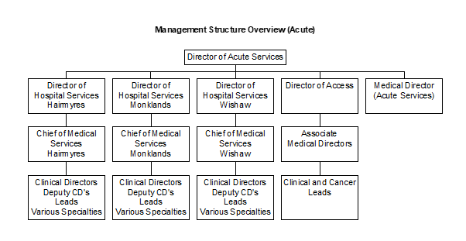

Lanarkshire - The Place
NHS Lanarkshire is the third largest health system in Scotland with around 15,400 staff and a baseline recurring budget of £1.7bn, serving a community of circa 652,000 people through:
- Three acute hospitals - University Hospital Hairmyres, University Hospital Monklands and University Hospital Wishaw
- Around 94 GP Practices
- Spans two local authority areas - North Lanarkshire Council and South Lanarkshire Council with two Integration Joint Boards, North Lanarkshire IJB and South Lanarkshire IJB. NHS Lanarkshire and North and South Lanarkshire Councils formed the North and South Lanarkshire University Health and Social Care Partnerships to develop a wide range of community facing health improvement, health and social care services with locality-based planning and delivery. The Partnerships include a range of community health and social care services, community hospitals (mainly for long term conditions and continuing care for older people), as well as a wide range of services for patients with mental health problems and learning disabilities. Services also include GP Practices providing many primary and community care services throughout Lanarkshire.
https://hscnl.org.uk/
https://www.slhscp.org.uk/
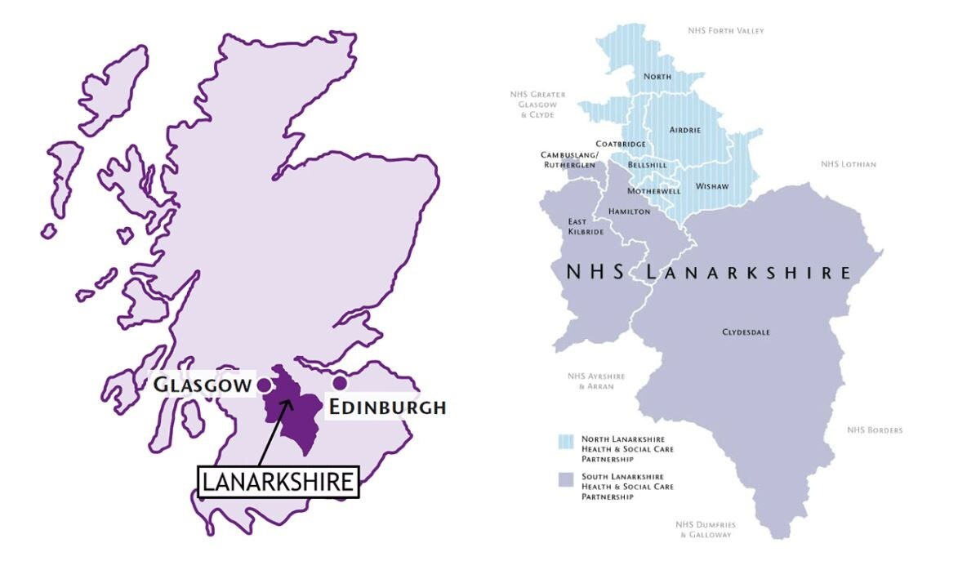
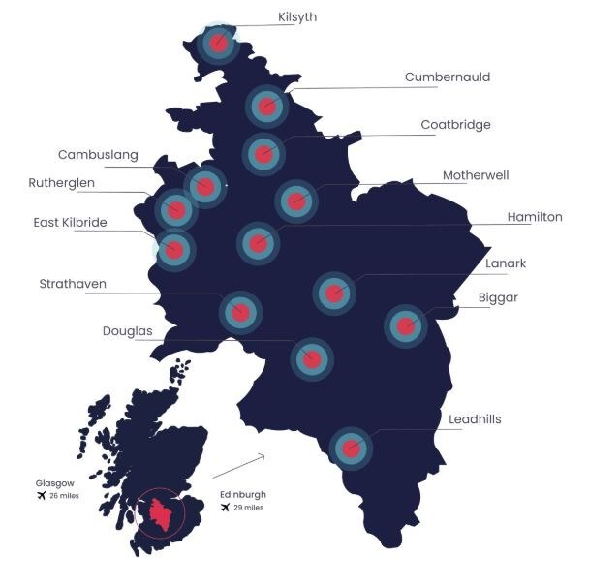

Our Vision
To enable healthier, longer lives by delivering compassionate, innovative, sustainable and high-quality health and care services that empower people and reduce inequalities.
Workforce - We will work with our staff and trade union colleagues to ensure that NHS Lanarkshire is a great place to work, with a positive and inclusive culture; that our staff are treated fairly with dignity and respect; and that our teams have opportunities to grow and develop.
Access & Services - We will work with our communities to ensure that NHS Lanarkshire enables them to readily access effective, timely and responsive supports and services; that our patients are treated fairly with dignity and respect; and that local people have increasing agency over their health.
Innovation & Quality - We will design and drive the transformation of our and services, prioritising safety, quality improvement and innovation so as to deliver effective and affordable care for the benefit of our communities.
Finance & Delivery - We will ensure that we deliver best value for our patients through the effective use of budgets and operating within the funding available to us; and that our governance mechanisms provide robust assurance that we are prioritising our resources effectively and responsibly to secure the most health benefit for our communities.

Corporate Objectives
The Board’s Corporate Objectives for 2025/26 have been approved.
Please see link below:
https://www.nhslanarkshire.scot.nhs.uk/download/corporate-objectives/
Link to the Annual Delivery Plan
https://www.nhslanarkshire.scot.nhs.uk/download/2024-may-29-board-papers/

Our Values

Everyone Matters: 2020 workforce vision published in June 2013 sets out the vision for the workforce and the values that are shared across NHS Scotland.
The Health and Social Care: national workforce strategy published in March 2022 sets out the vision for the health and social care workforce. It supports the tripartite ambition of recovery, growth and transformation of the workforce and the actions to achieve the vision and ambition.
Link to the Health and Social Care: National Workforce Strategy
https://www.gov.scot/publications/national-workforce-strategy-health-social-care/pages/2/

The Board
Lanarkshire NHS Board (the Board) is a strategic body, accountable to the Scottish Government Health and Social Care Directorate and to Scottish Ministers for the functions and performance of NHS Lanarkshire. The Board consists of the Chair, Non-Executive Directors (who are publicly appointed by the Scottish Ministers), Stakeholder Non- Executive Directors including the Employee Director, Area Clinical Forum Chair, representatives of North and South Lanarkshire Councils and Executive Directors.
The NHS Board’s role is to improve the health and wellbeing of the people of Lanarkshire through robust, accountable and corporate governance systems. The Board’s role is to set strategic aims, hold the executives to account for the delivery of those aims, determine the level of risk the Board is willing to accept, influence the organisation’s culture and engage with stakeholders on the stewardship of public money and the priorities of the Board.
Composition of the Board:
Non-Executive Directors
- Chair
- 11 Non-Executive Lay Members (including 1 Whistleblowing Champion)
- Chair - Area Clinical Forum
- 2 Local Authority Elected Members - 1 from North Lanarkshire Council and 1 from South Lanarkshire Council
Executive Directors:
- Chief Executive
- Director of Public Health and Health Policy
- Executive Director for Monklands replacement & PFI Contracts
- Interim Director of Property and Sustainability
- Executive Medical Director
- Executive Director of Nursing, Midwifery & Allied Health Professions
- Interim Director of Finance
NHS Lanarkshire also has three Deputy Chief Executives with a portfolio of responsibilities in addition to their substantive roles. These are:
Deputy Chief Executive – Finance, Performance and Risk.
Deputy Chief Executive – Strategy, Transformation and Reform. Currently held by the Director of Planning, Property and Performance.
Deputy Chief Executive – Corporate, Governance and Culture. Currently held by the Director of Human Resources.

Our Health Together: Living our best lives in Lanarkshire
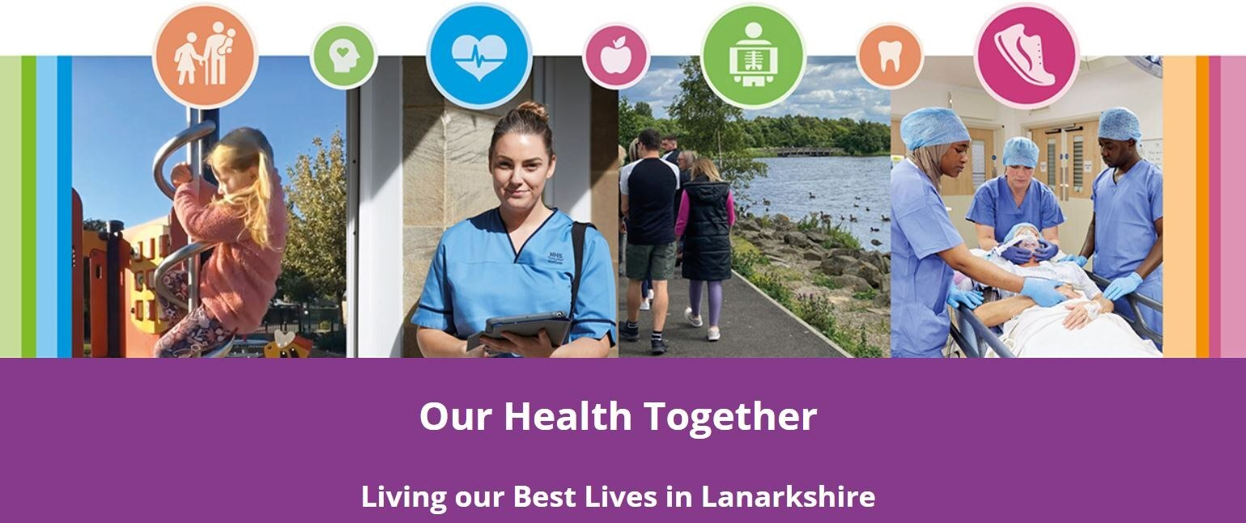
Our new healthcare strategy, ‘Our Health Together - Living Our Best Lives in Lanarkshire’ is a route map that starts us on a journey to deliver positive change. We will work with our staff, communities and partners to explore together how we can reform to deliver sustainable, affordable services that provide person centred high quality care. We have already started this process, and our communities and staff were involved in a far reaching engagement process during 2023 where we sought to understand what matters to people who use our services, or staff and the wider community.
A lot has changed since we published our previous strategy, ‘Achieving Excellence,’ in 2017. The pandemic and cost of living crisis` impact has been greatest on our most vulnerable groups. To deliver a better patient experience, we must transform our models of care, improve performance and ensure we make best use of resources to achieve best value. This includes taking action to promote good health. We have identified 4 priority areas of focus - Urgent and Emergency Care, Planned Care (including outpatients and surgery), Mental Health and Primary Care (which includes general practice).
The exciting development to replace the University Hospital Monklands provides opportunities to explore ideas for innovation and service redesign. Adopting new approaches for health care provision across our whole system will deliver a better experience for our patients and service users.
Link to NHS Lanarkshire strategy:
https://www.nhslanarkshire.scot.nhs.uk/our-health-together/

Monklands Replacement Project
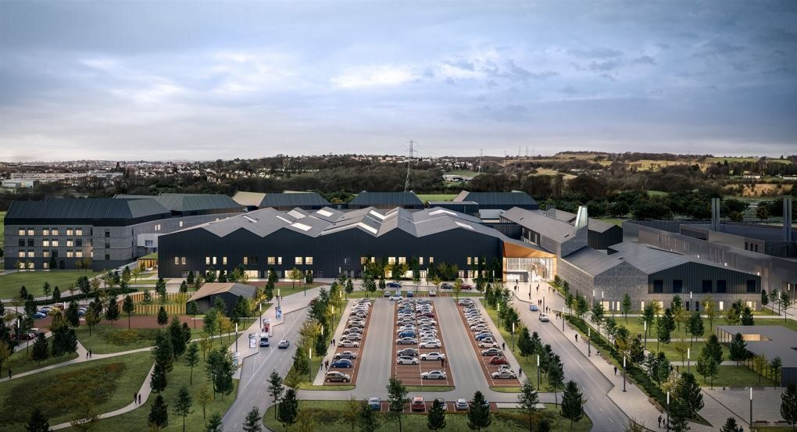
The Monklands Replacement Project (MRP) is NHS Lanarkshire’s exciting and positive vision for University Hospital Monklands and the local and wider community it serves, proposing a major investment in Lanarkshire’s hospital estate by rebuilding the hospital on a new site. NHS Lanarkshire has now purchased the 161.5 acre site for the state-of-the-art facility at Wester Moffat, Airdrie.
The existing Monklands Hospital is now more than forty years old and will struggle to adapt to the rapidly changing needs of the future healthcare environment and its associated infrastructure. This project will deliver a new acute hospital in circa 2031 to meet these challenges.
The new, state-of-the-art University Hospital Monklands will support the required clinical model to meet the objectives set out in NHS Lanarkshire’s healthcare strategy, Our Health Together which has the ambition to: shift care away from inpatient treatment to day case, day treatment, outpatient and community care; develop pan-Lanarkshire hospital centres of excellence; and support the healthcare needs of the wider West of Scotland
The key investment objectives for the MRP that were set out in the Initial Agreement and remain central to the project are to:
- Improve person-centred services
- Improve the safety of patient care
- Improve clinical effectiveness and enhancing patient experience and clinical outcomes
- Improve the quality of the physical environment
- Provide flexible and adaptable facilities across the healthcare system
The new hospital will have over 470 beds within a new acute hospital extending over approximately 100,000m2. The clinical requirements are based on a requirement for 100% single rooms and include a range of departments necessary for a major acute hospital such as theatres, emergency department, endoscopy, infectious diseases, critical care, outpatients, renal, radiotherapy, and imaging. At a cost in the 100’s of millions of pounds, the new Monklands hospital will be the largest infrastructure project in Scotland when under construction. As part of this, NHS Lanarkshire are required to work with a number of external Parties to provide assurance, including the newly formed NHS Scotland Assure.
The Outline Business Case was approved by Scottish Government in July 2023 and we are now progressing to submit the Full Business Case in 2025.

Net Zero Carbon Pathfinder Project
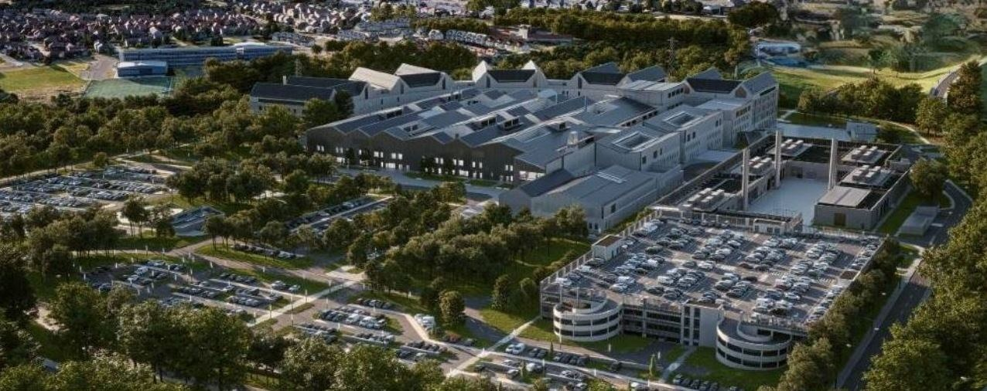
The Energy Efficient Scotland Routemap requires public sector buildings to be zero carbon by 2050 and the Scottish Government has also called a Climate Emergency, committing to become a net zero carbon economy by 2045. The Net Zero Carbon Public Sector Buildings (NZCPSB) standard (“the Standard”) is a new voluntary standard which has been developed by Scottish Government to support the Public Sector in setting ambitious targets to achieve net zero outcomes for new buildings and major refurbishments.
The Standard supports a challenging, credible path to net zero carbon materials and energy supplies for all non-domestic buildings. By 2045, projects that adopt the Standard will achieve zero embodied carbon during construction and subsequently the whole life of projects, including operational energy. The Monklands Replacement Project has been selected as a pathfinder project for the new standard which has resulted in the requirement for an all-electric hospital. This demands innovative solutions and a substantial energy centre to accommodate all of the required technology.

Scotland’s First Digital Hospital
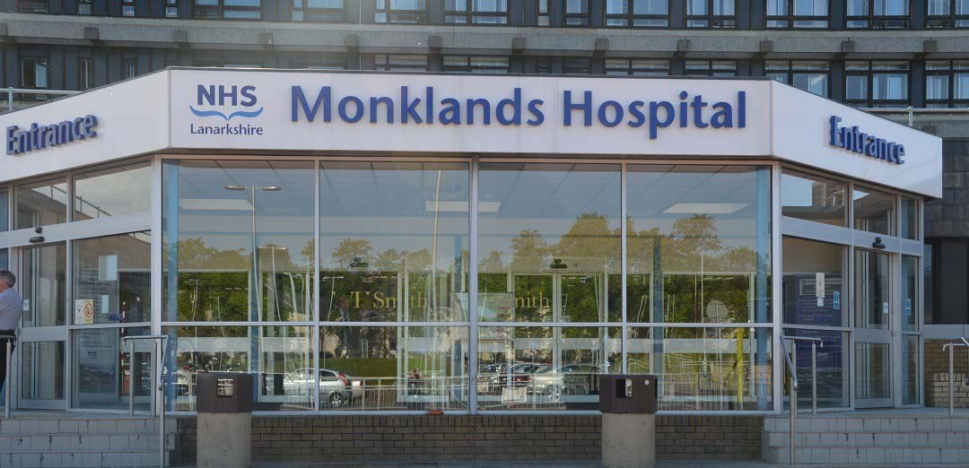
The construction of a new Monklands Hospital has also created the opportunity and ambition for the new Monklands University Hospital to be Scotland’s first digital hospital, directly benefitting its local community of patients, staff and visitors. Technology will be used to allow patients to access care advice and to navigate their way through the hospital easily and intuitively. The new hospital will ensure safer, better patient care and value for staff and for patients through the use of digital technology and real time information to support an efficient and effective patient journey. The hospital will have new digital systems to support patients and their clinical teams.
For further information, please visit to https://www.monklands.org/

Health Inequalities
The Board is committed to addressing health inequalities throughout Lanarkshire and, working with our Community Planning Partners, there will be a renewed focus on improving the exacerbated socioeconomic and health inequality challenges faced by Lanarkshire since the pandemic.
The Board has adopted a ‘place based approach’ to regenerate what will be the vacant Monklands Hospital site, and the work we are taking forward with Strathclyde University and Professor Sir Harry Burns will form part of our wider triple lens strategic approach to tacking health inequalities in Lanarkshire.

University Strategic Partnerships

NHS Lanarkshire has entered into strategic partnerships with
- Glasgow Caledonian University in 2017 (and renewed in 2023)
- The University of the West of Scotland in 2018.
- Strathclyde University in 2019.
- University of Glasgow in 2025.
This resulted in the Board gaining university status for all three hospitals and both health and social care partnerships.

Living in Lanarkshire

Within the UK, Lanarkshire is situated in the heart of Scotland's central belt, the area offers an ideal combination of tranquil parks and market towns, with something for everyone.
Centrally located between Glasgow (c. 20 minutes) and Edinburgh (c. 40 minutes) you can easily commute or, should you wish to relocate, you can choose either a substantial Lanarkshire town or a more relaxed rural location and still have the attractions of two major cities on your doorstep. The county offers accessible links to major cities with easy access to major motorway/rail routes and international airports allowing you to travel across Scotland, the UK and beyond.
There are many attractions within Lanarkshire, including:
- New Lanark World Heritage Site
- Antonine Wall World Heritage Site
- The Falls of Clyde
- Summerlee -The Museum of Scottish Industrial Life
- The National Museum of Rural Life
- Strathclyde Country Park
- Scottish Wildlife Reserves on the shores of the River Clyde
- Various Museums, Galleries, Castles, Heritage Centres
- Numerous country parks

Schools
The majority of Glasgow's independent schools are located just outside the city centre. https://www.mytopschools.co.uk/private-schools-glasgow/
St Aloysius’ College https://www.staloysius.org/
Hutchisons’ Grammar School https://www.hutchesons.org/
Hamilton College https://www.hamiltoncollege.co.uk/
To find more information about living and working in Scotland please visit:
www.visitlanarkshire.com
www.visitscotland.com/destinations-maps/glasgow-clyde-valley/
www.southlanarkshire.gov.uk
www.northlanarkshire.gov.uk
https://www.scotland.org/
https://www.talentscotland.com/
https://moverdb.com/moving-to-glasgow/

Useful Websites
NHS Lanarkshire: https://www.nhslanarkshire.scot.nhs.uk/
Scotland’s Health on the Web (SHOW): www.show.scot.nhs.uk
North Lanarkshire Council Website: www.northlanarkshire.gov.uk
South Lanarkshire Council Website: www.southlanarkshire.gov.uk
Link to the Corporate Objectives: https://www.nhslanarkshire.scot.nhs.uk/download/corporate-objectives/
Link to Monklands Replacement Project: https://www.monklands.org/
Link to our Healthcare Strategy: https://www.nhslanarkshire.scot.nh.uk/our-health-together/

