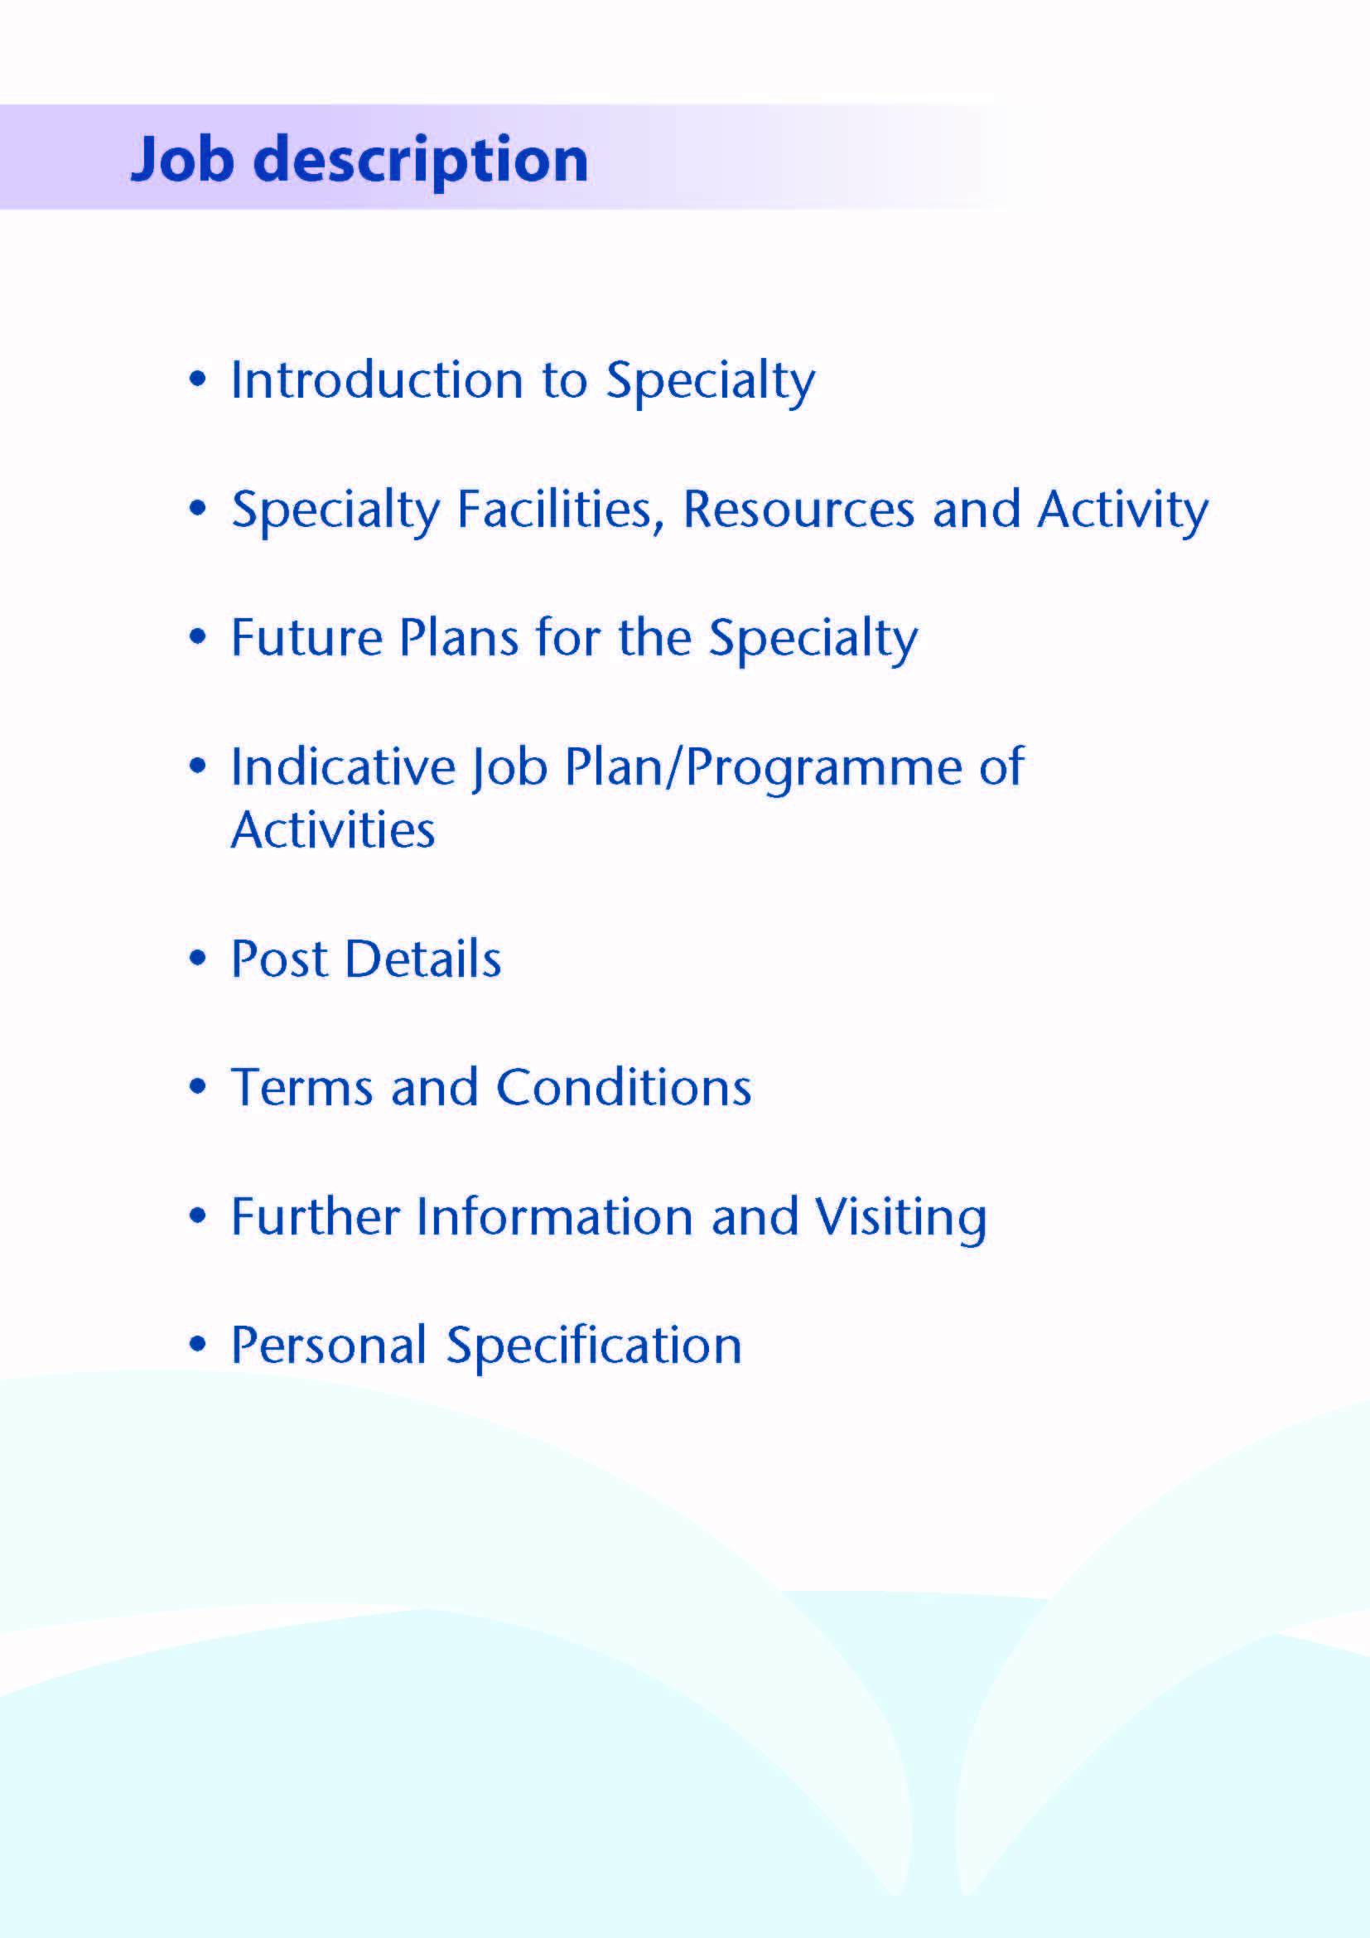



This locum post comprises 10 sessions based mainly in Community Paediatric Services in Ayrshire. They include components of community paediatrics with on-call and hot weeks in acute general paediatrics.

Introduction

The appointee will have a neuro-developmental caseload and will have the opportunity to bring or develop a special interest to supplement those of the team. The appointee will work closely with the established Community Paediatric Team.

The appointee will also take part in the local paediatric ward “hot-weeks” based in University Hospital Crosshouse (UHC).

The appointee will contribute to the consultant on-call rota for acute paediatrics in University Hospital Crosshouse (1:8 prospective cover rota)

About Ayrshire
Situated in the picturesque south west of Scotland on the Firth of Clyde coastline, Ayrshire is a 30 minute drive from Glasgow, Scotland’s largest city, and an easy commute by road or rail to our capital city Edinburgh, making it an ideal location for those who want to enjoy city life but who value the benefits and quality of life offered by living in a more relaxed semi-rural district.

The area boasts all you could ask for, whether you enjoy an active outdoor lifestyle, or take a more laid back approach to life enjoying the culture and heritage of the area, it’s all on your doorstep. There are first class sports and recreational facilities, including 40 quality golf courses, award winning visitor attractions, in addition to a vast array of restaurants and bars.

The isle of Arran, less than an hour’s ferry ride, is known as Scotland in miniature, and provides an ideal “overseas” escape while the Isle of Cumbrae boasts one of Scotland’s premier watersport centres.

The area is supported by excellent road and rail services. National and international flights are available from Glasgow International Airport, and our own local airport in Ayrshire, Glasgow-Prestwick.

All this coupled with excellent housing, quality local authority and private schooling and the excellent transport links, sets Ayrshire in an enviable position when it comes to offering a quality lifestyle for those who choose to live and work in the area.

For more information on what Ayrshire has to offer visit www.AyrshireandArran.com and for information on local authority services including schooling visit, www.south-ayrshire.gov.uk ; www.north-ayrshire.gov.uk and www.east-ayrshire.gov.uk


NHS Ayrshire and Arran has a total population of approximately 380,000 with 72,000 children under the age of 16 years. There are approximately 3,500 deliveries a year.

Facilities

Community Paediatrics and Community Child Health:
The Community Child Health Service is delivered from numerous locations across Ayrshire and Arran. The Child Development Centre (Rainbow House) acts as our hub and is located at Ayrshire Central Hospital (ACH) in Irvine. The Community Paediatric Team, comprising Medical, Nursing, Physiotherapy, Occupational Therapy, Clinical Child Psychology, Speech and Language Therapy and administrative staff, is located within Rainbow House.

Much of the clinical work of the Team is delivered at locations outside Rainbow House. The Child developmental centre assesses and coordinates investigation where there are early developmental difficulties. We support children and young people with an identified intellectual disability who have additional health needs, such as physical impairment or epilepsy. We have strong links with the child psychology service to provide Neuropsychology expertise for assessments. We continue to work with CAMHS to consider the needs of those children and young people whose needs stretch across our two services. The plan for a young person’s forensic unit on site in ACH reinforces this need for joint working.

In addition to neurodevelopmental clinics, specialist paediatric clinics held in Rainbow House include, Epilepsy, Neuromuscular (principally Duchenne MD), Communication Disorders (ASD), Tone Management and Botulinum Toxin Assessment and Review. Recent service development work includes the development of a transition pathway for young people with complex needs and work continues to link this with other agencies. One of our consultant colleagues has also piloted services specifically for children affected by fetal alcohol syndrome. A Functional vision clinic has been piloted and there is a monthly multidisciplinary Audiology clinic with ENT. These two clinics allow us the framework for a sensory impairment service. A sleep clinic is also in development. Each locality is additionally served at present by between one to two paediatric staff grades to provide support for nurseries and schools, liaison with Education and Social Work and special interests include: adoption and fostering and autism assessment. We are looking at ways of improving links with CAMHS and particularly for those children who require input across both services how this is best managed at a service level.

General Paediatrics:
The Paediatric Unit at UHC is responsible for the in-patient and out-patient care of individuals up to their 16th birthday. This is the only site for all paediatric inpatient services in Ayrshire. It comprises an Outpatient Suite with 6 consulting rooms, a 10-bedded Children’s Assessment Unit and an inpatient ward including not only medical paediatrics but also designated paediatric ID and dermatology beds and paediatric surgical specialities (general paediatric surgery, orthopaedics, ENT, dental surgery, plastic surgery and ophthalmology). There are 23 inpatient beds (26 during the winter months), including 4 in a dedicated adolescent facility. The majority of patients for elective surgery in the above specialities are catered for in the Day Surgery Unit (separate from the inpatient facilities).

The Ayr Hospital also has a dedicated Paediatric out-patient suite. In addition, General Paediatric out-patient clinics are held at Ayrshire Central Hospital in Irvine, East Ayrshire Community Hospital in Cumnock, the Davidson Hospital in Girvan, the Brooksby Centre in Largs and the War Memorial Hospital in Lamlash on the Isle of Arran. Most clinics are of a general nature but there are specific epilepsy, cystic fibrosis and diabetes clinics. In addition there are joint clinics in cardiology, endocrinology, epilepsy, gastroenterology, renal, rhueumatology and genetics held in Ayrshire locations with visiting specialists from Yorkhill.

The consultant paediatricians operate a “hot week” system of working in general paediatrics and the appointee will participate in this approximately 1 week in 9). The RCPCH Facing the Future recommendations envisage consultants taking an active role in evening working in leading the team and managing handovers and this is something we are working towards.

Neonatology:
Ayrshire Maternity Unit is the only maternity unit in Ayrshire, catering for approximately 3,500 deliveries per annum. There is a 20 cot Neonatal Unit with 5 designated intensive care cots and a 4-bedded transitional care area in the postnatal ward. The Neonatal Unit provides level 3 neonatal intensive care and has facilities to provide ventilation, and management of sick and premature infants. There are close links with Glasgow Neonatal centres as per the national “best start initiative”. There are no facilities for neonatal surgery locally. There are currently five consultants in post who cover the neonatal unit.

Community Paediatric links with the Neonatal Unit include in-reach with joint consultation for families, with colleagues from the Neonatal Unit, in the perinatal and neonatal period. The appointee will not have any acute or on-call responsibilities in the neonatal unit.

Education:
Trainees and students
Undergraduates from Glasgow and Dundee Universities come to Ayrshire for paediatric blocks. Foundation Year 2 doctors come for 4 month blocks of paediatrics and General Practice Specialty Trainees in their 2nd year of training come for 6 month blocks of training. West of Scotland Specialty Trainees come to Ayrshire at various stages of their training for periods of up to one year on our middle grade rota and join Community Clinics.
Medical Education and Continued Professional Development
Our department has an active timetable of educational activities which all medical staff are expected to take part in. This includes monthly departmental CME meetings, monthly peer review (including child protection peer review), weekly SIM training and weekly neonatal and general teaching meeting for junior an middle-grade staff.

Medical Staff Resources

Consultants
Community Paediatricians

Dr N. Cordeiro (Clinical Lead Community and Neurodisability/Epilepsy)
Dr Mona Rahim (Clinical lead Child Protection and Neurodisability)
Dr Sarah Brown (LAAC/Fetal Alcohol Syndrome/Neurodisability)
Dr Gemma Duffy (Clinical lead A&F and LAAC/ Neurodisability/ Child Protection)
Dr Judith Brown (Neurodisability)
Dr Ruth Addison (LAAC/ Neurodisability / Child Protection)

General Paediatricians
Dr C Morrison (Cardiology/Epilepsy, Associate Medical Director)
Dr L Armstrong (Gastroenterology)
Dr S Williamson (Clinical Director/ Endocrine/Diabetes)
Dr C Findlay (Diabetes/Epilepsy)
Dr B Oates (Rheumatology/ Nephrology/ Allergy)
Dr N Connel (Respiratory/Allergy)
Dr A Yacoub (Diabetes/ Child Protection)

Neonatologists
Dr S Kinmond (Clinical Lead, Neonates)
Dr T Adams (Respiratory/Neonates)
Dr J Staines (Endocrine/Cardiology/Neonates)
Dr R Sunderesan (Neonates)
Dr A Ansary (Neonates)

Associate Specialist:
Dr F Barnes (Neonates)

Speciality Doctors:
Dr S Coy (General Paediatrics/ Palliative Care)
Dr J Siddique (Neonates)
Dr A Vijayan (Community)
Dr G Lui (Community/Autism)
Dr C Owens (Neonates /General)

Middle Grade training posts: currently 12,

GPST 2 level posts: 6,

Fy2: 7
Activity

Figures for outpatient appointments in Community Paediatrics (2019)

Area and Clinic Type | New | Review | Locality totals
South Ayrshire New | 183 | 465 | 648
North Ayrshire New | 204 | 777 | 981
East Ayrshire New | 198 | 623 | 821



Various challenges face our service at present.
During the COVID pandemic we re-configured the paediatrics area in UHC, reducing the space used for out-patients and increasing the number of single rooms for acute admissions. Our current work now involves telephone and video consultations alongside a reduced number of face-to-face appointments in the clinics. This affects both out general paediatric clinics and community paediatric clinics. We have increased our liaison with GPs to provide support and advice for them to prevent unnecessary admissions or referrals. As we come out of the pandemic we expect some of these practices will continue.
We anticipate a steady reduction in middle grade posts over the next few years and are planning to cope with this using a combination of strategies including development of more nurse practitioners and specialist nurses as well as changes in consultant working patterns.
We also face challenges with future proofing a service to cope in the longer term with retirements and the ongoing reorganisation of children’s services. We would anticipate further amalgamation of traditionally community based and acute services in terms of providing a single well-coordinated service to meet all the health care needs of the children of Ayrshire.

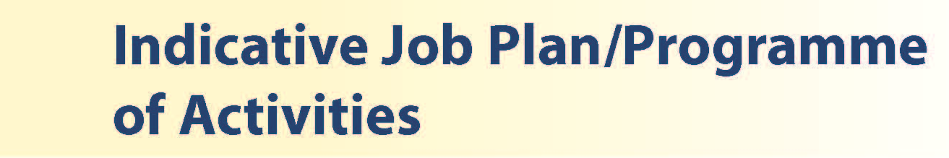

The post consists of hot-weeks, cold weeks and out of hours working.

Cold Weeks
These will comprise the majority of weeks of work, with a 9-5 timetable Monday to Friday with one day off. During this week, the post holder will be based in Rainbow House Child Development Centre. An example timetable is shown below

DAY | HOSPITAL/ LOCATION | ACTIVITY | TOTAL HOURS PER ACTIVITY INCLUDING TRAVEL TIME
Monday  9am-1pm  1pm -5pm | Rainbow House  Rainbow House | Clinic  Admin | 4 DCC  4 DCC
Tuesday  9am-1pm  1pm -5pm | Rainbow House  Rainbow House | Clinic  SPA | 4 DCC  4 SPA
Wednesday  9am –1pm  1pm – 5pm | Rainbow House  Rainbow House | RH Admin  RH MDT discussion | 4 DCC  4 DCC
Thursday  9am – 1pm  1pm – 5pm | Day OFF | Day OFF
Friday  9am – 1pm  1pm– 5pm | Rainbow House  Rainbow House | Clinic  Admin | 4 DCC  4 DCC
Out of Hours and on-call | Crosshouse Hosptial | 2 hours admin, 6 h clinical reviews | 8 DCC
TOTALS |  |  | DCC | SPA
TOTALS |  |  | 36 | 4

Hot Weeks

Hot weeks are based in general paediatrics, University Hospital Crosshouse and entirely devoted to clinical work and includes supervision of students and trainees, from 9am to 5pm Monday to Friday. No routine clinics will be held during hot weeks. the frequency of hot weeks is 6 per year (approx. once every 9 weeks). In general the appointee will be encouraged if possible to cover the whole hot week (10 sessions), compensating by taking time off in lieu the week before or after. 2 consultants are on hot week duties each day. One is “first on”, covering the in-patient ward (ward round etc), reviewing referrals and supervising trainees. The other is “second-on”, covering the urgent clinic, assessment area and acute child protection referrals.

SPA activities and fixed commitments on “hot weeks” (one week in eight):
DAY | HOSPITAL/ LOCATION | ACTIVITY | HOURS PER ACTIVITY INC TRAVEL
FROM / TO | HOSPITAL/ LOCATION | ACTIVITY | HOURS PER ACTIVITY INC TRAVEL
Monday
a.m. | Crosshouse Hospital | Ward round children’s wards / rapid access clinic | 4DCC
p.m. | Crosshouse Hospital | Hot week on call for wards – acute reviews, parent consultations, referral vetting, GP calls etc. Acute child protection / CME | 3DCC  1SPA
Tuesday
a.m. | Crosshouse Hospital | Ward round children’s wards | 4DCC
p.m. | Crosshouse Hospital | Hot week on call for wards – acute reviews, parent consultations, referral vetting, GP calls etc. Acute child protection. Medical Student teaching | 3DCC  1SPA
Wednesday
a.m. | Crosshouse Hospital | Ward round children’s wards / rapid access clinic | 4DCC
p.m. | Crosshouse Hospital | Hot week on call for wards – acute reviews, parent consultations, referral vetting, GP calls etc. Acute child protection | 4DCC
Thursday
a.m. | Crosshouse Hospital | Ward round children’s wards / rapid access clinic | 4DCC
p.m. | Crosshouse Hospital | Hot week on call for wards – acute reviews, parent consultations, referral vetting, GP calls etc. Acute child protection. SIM training | 3DCC  1SPA
Friday
a.m. | Crosshouse Hospital | 0900-0930 junior doctor teaching  Ward round children’s wards | 1 SPA junior doctor teaching / audit meeting  3DCC
p.m. | Crosshouse Hospital | Hot week on call for wards – acute reviews, parent consultations, referral vetting, GP calls etc. Acute child protection | 4DCC
total |  |  | 36 hrs DCC  4 hrs SPA

On-Call and out-of-hours
On-call for acute paediatrics (Out of hours and weekends) contributes 2 PAs per week to the total of 10 sessions. This includes 2 extra hours of admin per week in the on-call period. This allows a day off each week.

The basic on call rota is 1:11 (1:8 with prospective cover) and the post attracts a 5% on-call supplement. The on-call consultant must be immediately available for telephone advice or to attend the hospital when advice and support are necessary. Junior cover is provided by separate teams for general paediatrics and neonatology. On call Consultants are available for assessment of acute injury where Non-Accidental Injury is suspected out of hours if this cannot, or is not suitable, for allocation the following day. There is no separate Child Protection on-call rota out of hours.

Medical Education and Continued Professional Development
Our department has an active timetable of educational activities which all medical staff are expected to take part in. This includes monthly departmental CME meetings, monthly peer review (including child protection peer review), weekly SIM training and weekly neonatal and general teaching meeting for junior an middle-grade staff.

Notes on the Programme

Patient Administration. This activity covers the management of individual patients including Out Patient administration, results reporting, letters/’phone calls to parents, carers, GPs and members of the wider multidisciplinary team involved in the patients’ care.

On call arrangements

Travel: Any travel allocation will be included within the Total Programmed Activities and will be determined by location at which Direct Clinical Care and Supporting Professional Activities are carried out.

Supporting Professional Activities: NHS Ayrshire and Arran recognise the important role Job Planning has in ensuring consultants are supported in delivering high quality, safe, sustainable clinical care to patients. It is therefore important to ensure there is an adequate balance between direct clinical care activities and activities which support both the personal and professional development of the consultant workforce and facilitates agreed contribution to activities including:

- Under and post graduate teaching/training
- Clinical Governance
- Quality and Patient Safety
- Research and Innovation
- Service management and planning
- Work with professional bodies
1 session of SPA is the default for job plans for new consultant appointments. On appointment additional SPA time may be negotiated for specific additional activities, such as guideline development and simulation training, acceptable to the candidate and desirable by the Board.

There may be a requirement to vary the DCC outlined in the indicative timetable below when the final balance of DCC and SPA is subsequently agreed. There may also be opportunities to contract for Extra Programmed activities Opportunities subject to service requirements and in accordance with national terms and conditions of service.

If the post-holder will be responsible for the formal training and supervision of post-graduates and under-graduates, a suitable additional allocation of SPA time will be made in accordance with national guidance.

The total programme is 10 Pas.

Job Plan Review

New appointees will discuss the indicative job plan with the Clinical Director, prior to commencement and will at that time review the balance of activities. Where it is possible to agree a revisions to the indicative plan in advance of commencement this will be acted upon. In any event however, there must be an interim Job Plan review conducted at 3 months post commencement to agree and finalise the Job Plan. The consultant at time of induction should ask for an interim review date to be scheduled. The agreed job plan will include all the consultant’s professional duties and commitments, including agreed Supporting Professional Activities. Thereafter Job Planning will be carried out annually as part of the Boards Job Planning process.

Private Practice: If the post-holder wishes to undertake any private practice, they are obliged to inform their employer at the time of appointment of their intentions to do so. This should be submitted in writing to the Clinical Director. The conduct of private practice will be in accordance with the Consultant Contract (Scotland) Terms and Conditions.

The post-holder shall be free to undertake private practice without approval provided such work is undertaken outside the time agreed in the job plan for programmed activities. (Refer Section 6 of the New Consultant Contract).



- The post-holder will be accountable to the Clinical Director for Paediatrics and Child Health, Dr Scott Williamson, who will agree the Job Plan.
- The post-holder will be expected to work with local managers and professional colleagues in the efficient running of services and will share with Consultant colleagues in providing the medical contribution to management. Subject to the provisions of the Terms and Conditions of Service, they are expected to observe the Directorate’s agreed policies and procedures, drawn up in consultation with the profession on clinical matters, and to follow the standing orders and financial instructions of NHS Ayrshire & Arran.
- In particular, where the postholder formally manages employees of NHS Ayrshire and Arran, the postholder will be expected to follow the local Board and National Employment and Personnel Policies and Procedures.
- The postholder is required to comply with the Organisation's Health and Safety Policies.

Resources

The staff resources of the department are listed elsewhere. The postholder will have access to such general administrative support as is required for the discharge of his/her duties and responsibilities. This will include the provision of adequate secretarial and clerical support and the availability of accommodation, equipment etc.

The postholder will receive support from such other professional staff as are employed within the Directorate and are deployed to his/her area of patient care.
The postholder will be provided with necessary personal devices to enable the fulfilment of their duties and responsibilities.

Duties and Responsibilities

The main duties and responsibilities of the post include:

- The new appointee will be responsible, with consultant colleagues, for the care and management of children in Ayrshire who require secondary level care.
- Responsibilities for carrying out teaching, accreditation and examination duties as required, and for contributing to undergraduate and postgraduate medical education. The postholder will be expected to comply with College recommendations on Continuing Medical Education.
- The postholder will be required to comply with Organisational Policies on Clinical Governance.
- Responsible for consultant level medical management of acute admissions to general paediatrics when on “Hot weeks” and when on-call.
- Contribution to the child protection assessments out of hours
- The successful applicant will be encouraged to develop a relevant sub-specialty interest, subject to resources and local priorities.
- Requirements to participate in the clinical improvement process and in continuing medical education
- Managerial, including budgetary, responsibilities (where appropriate).

Annual Appraisal & Job Planning

The postholder will also be required to participate in annual appraisal. Job planning is linked closely with, but is separate from, the agreed appraisal scheme for consultants. The job plan review will take into account the outcome of the appraisal discussion and reflect the agreed personal development plan.

Summary

The successful applicant will join a friendly, hard-working team striving to provide excellent care and to develop services in a purpose-built Unit with a relaxed and supportive ethos.



The Terms and Conditions of Service are those determined by the Terms and Conditions of the New Consultant Grade (Scotland) as amended from time to time. The distance that a consultant can reside from the principal base hospital, where travel time is seen as more important than mileage, is subject to the agreement of the Executive Medical Director, but it is usually anticipated that a journey that takes no more than 30 minutes for any emergency situation would be acceptable.

Please come to visit us and have a look about. Applicants wishing further information about the post are invited to contact Dr Nuno Cordeiro, or Dr Scott Williamson, with whom visiting arrangements can also be made.

The last date for application is Friday 9th April 2021 (noon).



Post of: Consultant Community Paediatrics
Location: Rainbow House, Ayrshire Central Hospital, Irvine

Qualifications:
Essential | Desirable

Full GMC Registration with current Licence to Practice
CCT in Paediatrics or be within 6 months of anticipated award of a CCT/CESR at the time of  interview for the post. | Inclusion on the GMC Specialist Register  Sub specialty training leading to CCT in Community Child Health
Membership of Royal College of Paediatrics and Child Health or equivalent
 | APLS or equivalent paediatric resuscitation certificate

Skills/Knowledge/Competence
Requirements | Essential | Desirable
Experience:  - Expertise in Generalist field  - Expertise in sub-specialty field | - Comprehensive knowledge of paediatrics  - Relevant training in the assessment of child development and multiagency working in community paediatrics  - Ability to communicate effectively with children of all ages and their families and with all levels of staff  - Ability to work efficiently and timeously  - Experience of child protection | - IT literacy
Experience in General and Acute Paediatrics | - Competence and experience in general and acute paediatrics  - Willingness to take part in consultant on-call rota for acute paediatrics
Team Working | - Ability to lead others and think strategically  - Effective Team Player
Development | - Evidence of relevant Continuing Professional Development  - Evidence of satisfactory compliance with appraisal requirements
Teaching & Training | - Ability to deliver high quality teaching to medical students, junior medical staff and colleagues in other health professions | - Interest in and knowledge of advances in medical education and training.
Research & Publications |  | - Evidence of publications of a high standard relating to specialty
Clinical Audit | - Evidence of interest and experience in medical audit or clinical improvement projects
Management and Administration | - Ability to lead a clinical team  - Commitment to effective departmental management  - Proven organisational skills | - Proven management experience  - Understanding of resource management and quality assurance.
Personal and Interpersonal Skills | - A willingness to accept flexibility to meet the changing needs of the NHS in Scotland  - Effective communicator and negotiator  - Demonstrate effective leadership  - A willingness to develop special interests which conform to the needs of NHS Ayrshire and Arran  - Ability to operate on a variety of different levels | - Knowledge of recent changes in the NHS in Scotland

