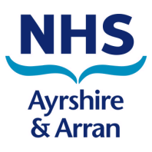
Working for NHS Ayrshire & Arran

Clinical Development Fellows

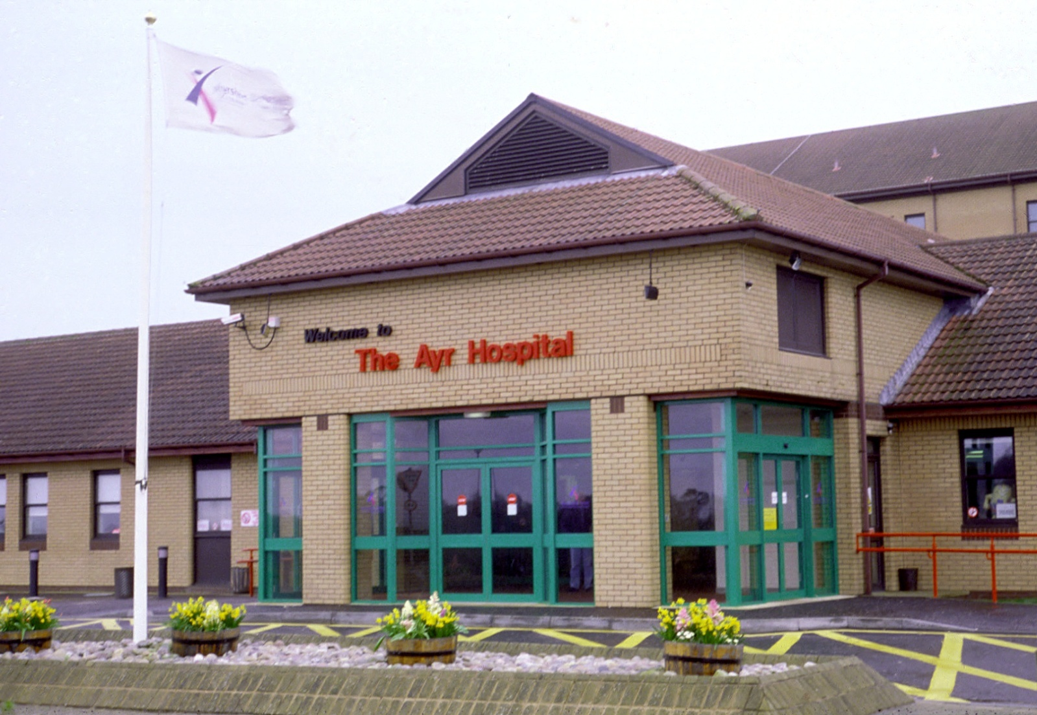
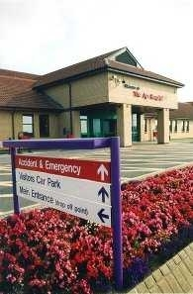

Person Specification: Clinical Development Fellow
Post Reference Number:

The Posts: Clinical Development Fellows (Medicine, University Hospital Ayr/University Hospital Crosshouse)

The aim of these posts is to provide development opportunity for the post-holders, building on their existing Foundation or Core level training, while supporting key service areas in relation to provision of in and out of hours clinical care by a medical and multi-professional workforce. Post-holders can therefore expect in addition to gaining specialty based development, including clinic and procedural experience, to provide a contribution to the specialty rotas.

Post Summary:
Working with the Director of Medical Education (DME) for NHS Ayrshire and Arran, the Assistant DMEs, Clinical Director and Directorate Management team, these posts will provide successful applicants with the opportunity to experience in medical specialties prior to committing to a programme of training through Core or Specialty training application.
These posts will offer successful applicants the opportunity to experience clinical practice and through this develop skills and competencies in a safe and supervised environment as one aspect of overall CV development.
The post holders will be encouraged and fully supported to participate in service development projects, with an expectation that this will lead to a poster or oral presentation at a national conference relevant to the area of improvement work.
Clinical development, will be combined with directed activity linked to an area of mutual professional interest including clinical teaching, quality improvement and safety, medical informatics or management and leadership development.

Main Duties and Responsibilities

The exact format of each post will be agreed with the successful applicant, the Clinical Director(s) of the base specialty(s) and the Director or Assistant Director of Medical Education. The following general principles will apply to all posts.

The posts will be up to an average of 44 hours per week and each Clinical Development Fellow will contribute approximately:

- 20 – 24 hrs of supervised clinical activity linked to a specialty of choice under the mentorship of an appropriately trained supervisor
- 12 – 16 hours average commitment to out of hours clinical activity such as acute medical receiving, hospital at night, hospital at weekend or specialty cover
- 8 hrs for personal and professional development (PPD)

PDP will be tailored towards the career aspirations of the post-holder but may include some or all of the following components:

- Clinical Teaching skills through contribution to our successful undergraduate clinical teaching programme, development opportunities with University of Glasgow Medical School and sponsorship of online or workshop based teaching skills development
- Clinical simulation teaching and development supported by the Consultant Lead for Clinical Simulation and the Resuscitation Skills department

- Management and leadership skills development through NHS Ayrshire and Arran Organisational Development and Leadership programmes and in conjunction with NES LaMP (Leadership and Management programme)
- Research and quality improvement skills development and activity linked to safety and quality improvement in NHS Ayrshire and Arran; facilitated by a Scottish Patient Safety Fellow and by a new Ayrshire and Arran Chief Resident programme
- Medical informatics development linked to current e-health strategies

Funding for PDP

Up to £1,250 per annum pro rata will be made available to successful applicants to support funding of development activities agreed with the Clinical Supervisor / Personal and Professional Development Mentor. This may include a combination of internal and external courses or workshops, online or distance learning and attendance where appropriate at national conferences relevant to the career aims of the post-holder. NHS Ayrshire and Arran reserve the right to reclaim a proportion of the PDP funding should an appointee terminate their contract early.

Communication and Working Relationships

The post-holders are expected to engage in good communication and working relationships with a wide range of staff including:

- Supervising consultants and supervising staff from medical, clinical and AHP backgrounds
- Named Clinical Supervisor and mentor for personal and professional development
- Clinical Director of the parent acute care specialty who will act as immediate line manager and is responsible for clinical governance arrangements
- Director and Assistant Directors of Medical Education who are responsible for overall organisation of post including educational governance arrangements
- Colleagues in training posts at Foundation, Core and Specialty level including the Hospital based Chief Residents

Base

The post-holder will be based University Hospital Ayr or University Hospital Crosshouse. In collaborative agreement with Clinical Directors and the DME/Assistant DMEs post-holders will rotate through 3 medical specialties during a 12 month appointment (extendable by mutual agreement).

Annual leave

Annual leave is in accordance with the nationally agreed level for the grade of applicant.

Salary

£33,884- £53,280 per annum dependant on equivalent experience. The posts will also attract a pay supplement of 50% to reflect commitment to out of hours. The banding supplement is fixed. These are non-training posts and New Deal provisions will not apply. The posts will however comply with EWTD limits on hours of work and rest.

Medical Clearance

The offer of appointment is subject to the post holder undergoing relevant clearances and health checks.

Qualifications and Experience

The post holder must (at the time of commencement of employment) have full registration with the GMC and a license to practice. Applicants will also at time of appointment have recently completed a UK based Foundation Programme or have evidence of equivalent foundation competencies.

Job Revision

This job description should be regarded only as a guide to the duties required and not definitive or restrictive in any way. It may be reviewed in the light of changing circumstances following consultation with the post holders. This job description does not form part of the contract of employment.

Training Approval

These posts are not recognised for training but have been designed to support future employment status including developing CVs to support application for Core or Specialty training and are built on sound educational governance principles.

Appointment

The appointment will be on a fulltime basis and will be offered on a 6 or 12 month basis, dependant on candidate preference and will be subject to satisfactory on-going appraisal within role.

Potential Posts
These are replacement posts providing a wide range of sub-specialty options for clinical development within medicine. The construct of the posts will be agreed between the successful applicant, the Clinical Director and the Director and/or Assistant Director of Medical Education. Dependent on the career aspirations of the successful applicant options may include a 6 month clinical development fellowship in a single specialty area extendable to 12 months which could include two distinct 6 month clinical attachments in separate clinical areas (e.g. emergency medicine with acute medicine).

Selection Factors |  | Criteria
QUALIFICATIONS & TRAINING | Essential | - Successful completion of UK Foundation Programme by August 2018.  - Full registration with GMC at time of appointment and a current licence to practice.
 | Desirable | - Distinctions, prizes or honours during undergraduate training.  - Postgraduate examination success, evidence of research/audit and evidence of teaching involvement at undergraduate or postgraduate level.
EXPERIENCE,  KNOWLEDGE,  COMPETENCIES & SKILLS | Essential | - Successful completion of UK Foundation training and portfolio evidence of Foundation Level competencies.  - Demonstrates understanding of basic principles of audit, clinical risk management and evidence based practice.
 | Desirable | - Clinical skills and competencies beyond Foundation requirements in an acute care medical setting.  - Enthusiastic in teaching including evidence of contributing to teaching and learning of others. Experience of simulation based training.  - Evidence of active participation in audit or research. Evidence of participation in risk management.
PERSONAL CHARACTERISTICS AND OTHER | Essential | - Capacity to operate effectively under pressure and remain objective in highly emotive/pressurised situations.  - Awareness of own limitations and when to ask for help  - Capacity to communicate sensitively and effectively with others  - Able to discuss treatment options with patients in a way they can understand  - Excellent written and verbal communication skills  - Capacity to bring a range of approaches to problem solving; analytical and flexible approach to problems  - Excellent situational awareness with capacity to monitor and anticipate situations that may change rapidly  - Demonstration of effective judgement and decision-making skills  - Capacity to manage time and prioritise workload, balance urgent and important demands, follow instructions  - Understands importance and impact of information systems  - Understands the importance of team work  - Demonstrates respect for rights of all and awareness of ethical principles, safety, confidentiality and consent
 | Desirable | - Motivated and able to work unsupervised as well as within a small team with appropriate guidance

Contact Information

Prospective applicants are encouraged to make contact with:

Dr Claire Gilroy
Doctor to Doctor Recruitment Lead
Emergency Medicine Department
University Hospital Ayr
Tel: 01563 827 964

Or

Dr Kati Carroll
Consultant in Acute Medicine
University Hospital Crosshouse
Tel 01563

Working for NHS Ayrshire and Arran

NHS Ayrshire & Arran recognises that our staff are vital to delivering our purpose, values and commitments and to achieving our strategic objectives. Our aim is to create an organisation where people want to work and strive to deliver excellence each day; where staff wellbeing and personal resilience are supported; where careers are interesting and developed; where staff are encouraged to reach their full potential; and where staff feel their contribution is recognised and valued.
We pride ourselves on improving health and providing a comprehensive range of high quality, safe, effective and person-centred health services. Our strategic direction is based on continuous improvement and services that are centred on the patient or service user.
Over the years we have invested in modern community and hospital facilities, and our highly trained and qualified staff provide health care to almost 400,000 people. More than 9,000 staff work in our hospitals - two University Hospitals at Ayr and Crosshouse near Kilmarnock, Ayrshire Central Hospital in Irvine and Biggart Hospital in Prestwick- almost 1,300 beds. They are committed to providing the highest standards of patient care to the people of Ayrshire and Arran.
Our two University Hospitals provide a wide range of acute services including Accident and Emergency, Anaesthesia, Breast Screening services, Cardiology, Care of the Elderly, Clinical Haematology, Dermatology, General Medicine, General Surgery, Plastic Surgery, Gynaecology, Intensive Care/High Dependency Unit, Maternity and Neonate Services, Oral and Maxillofacial Surgery, Oncology, Ophthalmology, Orthopaedics, Paediatrics, Pharmacy, Radiology, Renal Medicine, Urology, Sexual Health, Neurology and Vascular Surgery.
University Hospital Ayr lies on the southern outskirts of Ayr on the Dalmellington (A713) Road, It is a District General Hospital providing medical and surgical services on an inpatient, day case and outpatient basis. It is the main Accident and Emergency service for South Ayrshire. It provides a number of Ayrshire-wide services including Vascular Surgery, Ophthalmology and Audiology.
University Hospital Crosshouse is situated two miles from Kilmarnock town centre. It is a large District General Hospital providing a wide range of services, including paediatric inpatient services. It is also home to the national Cochlear Implant Service. It is the main Accident and Emergency Centre for North Ayrshire. The UNICEF-accredited Ayrshire Maternity Unit is also based at University Hospital Crosshouse.
The Location

Situated in the South West of Scotland on the Firth of Clyde, Ayrshire is a scenic area with 80 miles of varied coastline. We are ideally placed, offering easy access to Glasgow, the national motorway network via the M77 and ferry services to West Coast Islands. There are excellent rail and bus links to Glasgow and elsewhere. Glasgow and Prestwick International airports are close by, providing access to the rest of the UK and beyond.

Ayrshire offers a variety of living environments. There are three main towns, Kilmarnock, Irvine and Ayr, which provide plentiful shopping and leisure amenities and affordable housing. There are also many picturesque villages close to the hospital which offer a more relaxed rural environment. Nearby coastal Troon is a popular place to live. There are high quality state and private schools.

The area offers a wide variety of leisure opportunities. There are over 50 quality golf courses, including Turnberry and Royal Troon, the latter being the venue for the 2016 Open Golf Championship. There is access to sailing on the West Coast and islands. There are several fine beaches and abundant pleasant countryside for walking and cycling (see below). There are many good restaurants, country inns and hotels in the area, with quality seafood a speciality.

The ferry port of Ardrossan, which is a twenty minute drive from Crosshouse Hospital, is the departure site for the regular CalMac ferries to the Isle of Arran, a 55 minute crossing. This picturesque island is a popular weekend and holiday destination for walking, cycling, golfing and relaxing in beautiful surroundings. There are also ferries to Kintyre from Ardrossan and to Cumbrae from Largs.

Take a walk along the coast, find out more about our National Bard or taste a drop of whisky
and see how it's made - there are plenty of great things to do in Ayrshire & Arran, here are just a few of them:
- Culzean Castle & Country Park
- Dundonald Castle
- Dean Castle & Country Park
- Brodick Castle & Country Park
- Kelburn Castle & Country Estate
- Burns Monument Centre / Birthplace Museum / Burns Cottage / Souter Johnnies
- Cottage
- Crossraguel Abbey
- Dumfries House
- Vikingar
- The Isle of Arran Distillery & Visitor Centre
- The Scottish Maritime Museum
- Ayr Race Course
- Heads of Ayr Farm Park
- Dark Sky Observatory
- Walking – Ayrshire Coastal Path, The River Ayr Way, Ayr Gorge, The Smugglers Trail,
- Goat Fell
- Cycling -National Cycling Network Routes – 7, N73 / Mountain Bike Trails
- Regional Sports Facilities
- Scottish Wildlife Reserves
- Various Museums and Heritage Centres

For a more city-based lifestyle many staff choose to commute to Kilmarnock from the southern fringes of Glasgow and neighbouring East Renfrewshire. From these areas the hospital is a pleasant, approximately 30 minute motorway drive. This is usually relatively quiet against the busier traffic flow direction. South Glasgow and East Renfrewshire offer high quality housing, education and leisure facilities. There is easy access by road and public transport to Glasgow city centre, with all its cultural, shopping and sporting attractions. East Renfrewshire has the top-performing state schools in Scotland.

Terms and Conditions of Employment

For an overview of the terms and conditions visit http://www.msg.scot.nhs.uk/pay/medical

TYPE OF CONTRACT | Fixed Term (6 -12 months)
GRADE AND SALARY | £33,884- £53,280 per annum  You will also receive an amount equivalent to a banding payment. Should rotations be re-banded this amount will not change as New Deal does not apply to these roles
HOURS OF WORK | Full Time – up to 48 hours depending on on-call commitment
SUPERANNUATION | New entrants to NHS Ayrshire and Arran who are aged sixteen but under seventy five will be enrolled automatically into membership of the NHS Pension Scheme. Should you choose to "opt out" arrangements can be made to do this via: www.sppa.gov.uk
REMOVAL EXPENSES | Assistance with removal and associated expenses may be awarded
EXPENSES OF CANDIDATES FOR APPOINTMENT | NHS candidates who are requested to attend an interview will be given assistance with appropriate travelling expenses. Re-imbursement shall not normally be made to employees who withdraw their application, refuse an offer of appointment. Non NHS employees are not normally awarded travel expenses.
TOBACCO POLICY | NHS Ayrshire and Arran operates a No Smoking Policy in all premises and grounds.
DISCLOSURE SCOTLAND | This post is considered to be in the category of “Regulated Work” and therefore requires a Disclosure Scotland Protection of Vulnerable Groups Scheme (PVG) Membership.
CONFIRMATION OF ELIGIBILITY TO WORK IN THE UK | NHS Ayrshire and Arran has a legal obligation to ensure that it’s employees, both EEA and non EEA nationals, are legally entitled to work in the United Kingdom. Before any person can commence employment within NHS Ayrshire and Arran they will need to provide documentation to prove that they are eligible to work in the UK. Non EEA nationals will be required to show evidence that either Entry Clearance or Leave to Remain in the UK has been granted for the work which they are applying to do. Where an individual is subject to immigration control under no circumstances will they be allowed to commence until right to work in the UK has been verified.
REHABILITATION OF OFFENDERS ACT 1974 | The rehabilitation of Offenders act 1974 allows people who have been convicted of certain criminal offences to regard their convictions as “spent” after the lapse of a period of years. However, due to the nature of work for which you are applying this post is exempt from the provisions of Section 4 of the Rehabilitation of Offenders Act 1974 by virtue of the Rehabilitation of Offenders Act 1974 (Exceptions Orders 1975 and 1986). Therefore, applicants are required to disclose information about convictions which for other purposes are “spent” under the provision of the act in the event of employment, failure to disclose such convictions could result in dismissal or disciplinary action by NHS Ayrshire and Arran. Any information given will be completely confidential.
MEDICAL NEGLIGENCE | In terms of NHS Circular 1989 (PCS) 32 dealing with Medical Negligence the Health Board does not require you to subscribe to a Medical Defence Organisation. Health Board indemnity will cover only Health Board responsibilities. It may, however, be in your interest to subscribe to a defence organisation in order to ensure you are covered for any work, which does not fall within the scope of the indemnity scheme.
NOTICE | Employment is subject to one month notice on either side, subject to appeal against dismissal.
PRINCIPAL BASE OF WORK | You may be required to work at either of NHS Ayrshire and Arran acute hospital sites as part of your role.
SOCIAL MEDIDA POLICY | You are required to adhere to NHS Ayrshire and Arran’s Social Media Policy, which highlights the importance of confidentiality, professionalism and acceptable behaviours when using social media. It sets out the organisation’s expectations to safeguard staff in their use of social media.

References
All jobs are only offered following receipt of two satisfactory written references. At least one reference must be from your current/most recent employer. If you have not been employed or have been out of employment for a considerable period of time, you may give the name of someone who knows you well enough to confirm information given and to comment on your ability to do the job.

