
NHS Grampian

Job Description

SECTION 1

OB IDENTIFICATION
Job Title: | Domestic Assistant
Department(s): | Domestics
Location: | Turriff Hospital
Hours: | 25 hours per week
Grade: | Band 2
Salary: | £18,786 - £20,812 pro rata per annum
Contract: | Fixed Term – until 31.03.2022
Job Reference: | KJ057988
- JOB PURPOSE

Working closely with ward staff to provide a high standard of domestic service to patients, staff and visitors within Wards and Departments.

To undertake catering related duties to hospital wards and departments where necessary.

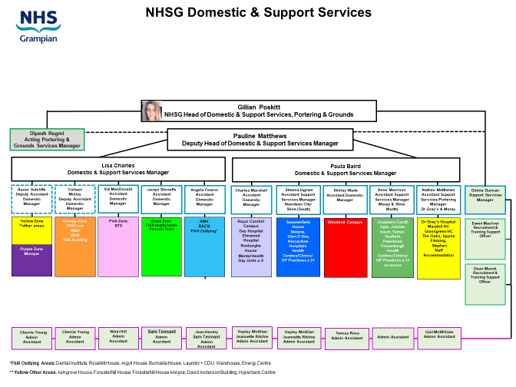

4. SCOPE AND RANGE

Provision of a Cleaning Service within Wards and Departments in an Acute Hospital setting, whilst working closely with ward/department staff to ensure high quality service provision. There will be a requirement to undertake some catering related duties e.g. (Dishwashing, Distribution of water jugs for patients, Assist Nursing Staff to distribute patient’s meals and beverages).

5. MAIN DUTIES/RESPONSIBILITIES

- Responsible for cleaning all the floors, furniture, fixtures, fittings, glassware, high and low level surfaces, sanitary areas within Clinical and Non-Clinical Areas these duties will be carried out inline with NHSG Policies and local operational procedures and Work Schedules.
- Responsible for ensuring the safe disposal/packaging of waste as per NHSG policy for example Clinical Waste, Household Waste.
- Provision where applicable of a range of catering related duties e.g. making toast, setting up and distributing patient meals and beverages, assisting with the plating of patient meals within the main kitchen.
- Within Residential Accommodation responsible for changing and making up of beds on residents departure.
- Movement of Furniture/Equipment is subject to Risk Assessment by Supervisor to enable effective access for periodic cleaning.
- Reporting details of faults and failures of electrical equipment /fabric of the building to
Supervisor or Ward Manager.
- Responsible for maintaining adequate stocks of cleaning materials and consumables and requesting further supplies from supervisor.
- Responsible for ensuring building security measures are undertaken for example locking doors, securing windows.
- Responsible for the completion of records/log sheets and personal signing in/out sheets.
- Responsible for safe/secure/hygienic storage of various stocks at ward / department level egg cleaning chemicals, consumables, dry / refrigerated food stuffs and equipment.
- Responsible, where applicable for the changing of curtains/bed screens.
- Responsible for the routine cleaning of all domestic equipment.

- SYSTEMS AND EQUIPMENT
The post holder will be required to operate the following equipment.

- Procedures as detailed in the Domestic Services
Operational Procedures Manual
- Tub or cylinder vacuum
- Floor Polishing/Scrubbing Machine
- Carpet Shampooer All equipment to be used
- Dishwashing equipment in accordance with manufacturers
- Toaster instructions and as stated in
- Wet Pick up Suction Drying Machine Domestic Procedure Manual
E.g. Removal of spillages, water.
- Microwave
- Hot water boilers/kettles
- Floor Mopping equipment
- Food Trolleys
- Cages e.g. transporting Linen
- Safety Steps

This list is not exhaustive but indicative of the equipment in use
7. DECISIONS AND JUDGEMENTS
- The post holder will be expected to follow domestic services procedures in accordance with those set down in the Domestic Procedures Manual and work schedules.
- There will be regular supervision whilst on duty; however the post holder will work without direct supervision on occasion.
- The post holder can liaise with Senior Ward Staff /or Assistant Domestic Services Manager (ADSM) at any time.
- Work schedules prepared by the Manager based on National Cleaning Services Specification
Will be adhered to as far as possible.
- The post holder can make decisions as to the order of work at their own discretion to fit in
with ward procedures, priorities and patient needs.

8.COMMUNICATIONS AND RELATIONSHIPS

- The post holder will be in contact with patients, clinical, non-clinical staff, colleagues, members of the public, and Assistant Domestic Services Manager on a regular basis. Face to Face or telephone.
- Domestic Assistants will be expected to coach new staff on cleaning tasks further to the initial training carried out by Supervisor.
- On a regular basis the post holder will develop a close relationship with long stay patients and relatives. Dealing with patient deterioration and bereavement may have an emotional impact on the post holder.
9. PHYSICAL DEMANDS OF THE JOB

The post holder must be physically fit and able to undertake the physical duties of the post.
The Post involves manual handling duties and constant movement and standing for duration of shift e.g. twisting, stretching, bending, kneeling, lifting, pushing and pulling.

- Use and movement of cleaning equipment
- Physically moving furniture whilst cleaning areas e.g. Desks, Chairs.
- Physical movement of Stores e.g. Cleaning chemicals, Paper Disposals by use of cages
and trolleys.
- Physical movement of Waste e.g. Household Waste and Clinical Waste by use of cages
and trolleys.
- Physical movement of Linen e.g. bedding by use of cages and trolleys.
- Physical movement of Meal Trolleys.

10. MOST CHALLENGING/DIFFICULT PARTS OF THE JOB
- Accessing areas for cleaning purposes and completing duties within time-scales whilst maintaining an unobtrusive service.
- Regularly working in obnoxious smelling environment e.g. urine, vomit, excrement and receiving
requests to remove body fluid spillages.
- Removing, handling and reporting discarded sharps e.g. used needles.
- Lack of communication of essential information which effects t
- he completion of duties e.g. Requests for isolation/discharge cleaning.
- Patient choice - having to work around patient’s needs and clinical service provision.
Working in an area with terminal ill/dying and/or aggressive patients.

11. KNOWLEDGE, TRAINING AND EXPERIENCE REQUIRED TO DO THE JOB

Knowledge

Basic Communication skills.
Knowledge of basic cleaning.

Experience

Previous experience desirable.

Training

Able to undertake essential induction training and ongoing training as provided by the organisation e.g. Elementary Food Hygiene, Fire Awareness Training, and Lifting & Handling.

NHS GRAMPIAN - DOMESTIC SERVICES

Domestic Assistant

PERSON SPECIFICATION

Requirements of Post
 | ESSENTIAL | DESIRABLE
Qualifications: | - Basic General Education.  - Literate and numerate – able to complete simple log sheets | - Basic qualification relating to cleaning processes, Health and Safety , Hygiene or Infection Control  - Completion of NHS Scotland Domestic Assistants/Housekeeper workbook
Experience: | - Experience of working with others  - No experience necessary as full training given | - Experience of undertaking cleaning tasks preferably in a healthcare setting  - Have some knowledge of cleaning operations and methods.
Knowledge | - Basic awareness of health and safety issues associated with cleaning | - Show awareness of health, safety and control of infection issues relating to cleaning service  - Knowledge of cleaning tasks preferably in a hospital environment
Interpersonal Skills | - Good communication skills – must be able to understand written and verbal instructions  - Ability to carry out tasks in a methodical manner  - Be able to listen and communicate information effectively  - Be able to take instruction
Technical Skills | - None essential as full training given. | - Have some knowledge of cleaning operations and methods
Personal Attributes | - Have the ability to work as part of a team, or as sole Domestic in some areas  - Be able to use initiative in the work environment  - Must be able to recognise the importance of, and maintain confidentiality at all times  - Be able to present a positive image of the domestic/Support Services department  - Have a friendly attitude towards patients and other service users and display an approachable cooperative manner  - Have the ability to cope working in clinical and non clinical environments  - Be committed to attend work regularly and on time
Physical Requirements | - Must be physically fit, and be able to undertake range of duties in safe and competent manner. This will include walking and standing for most of the shift, bending, stretching, pushing, pulling and lifting, using appropriate aids  - Clean and tidy appearance

