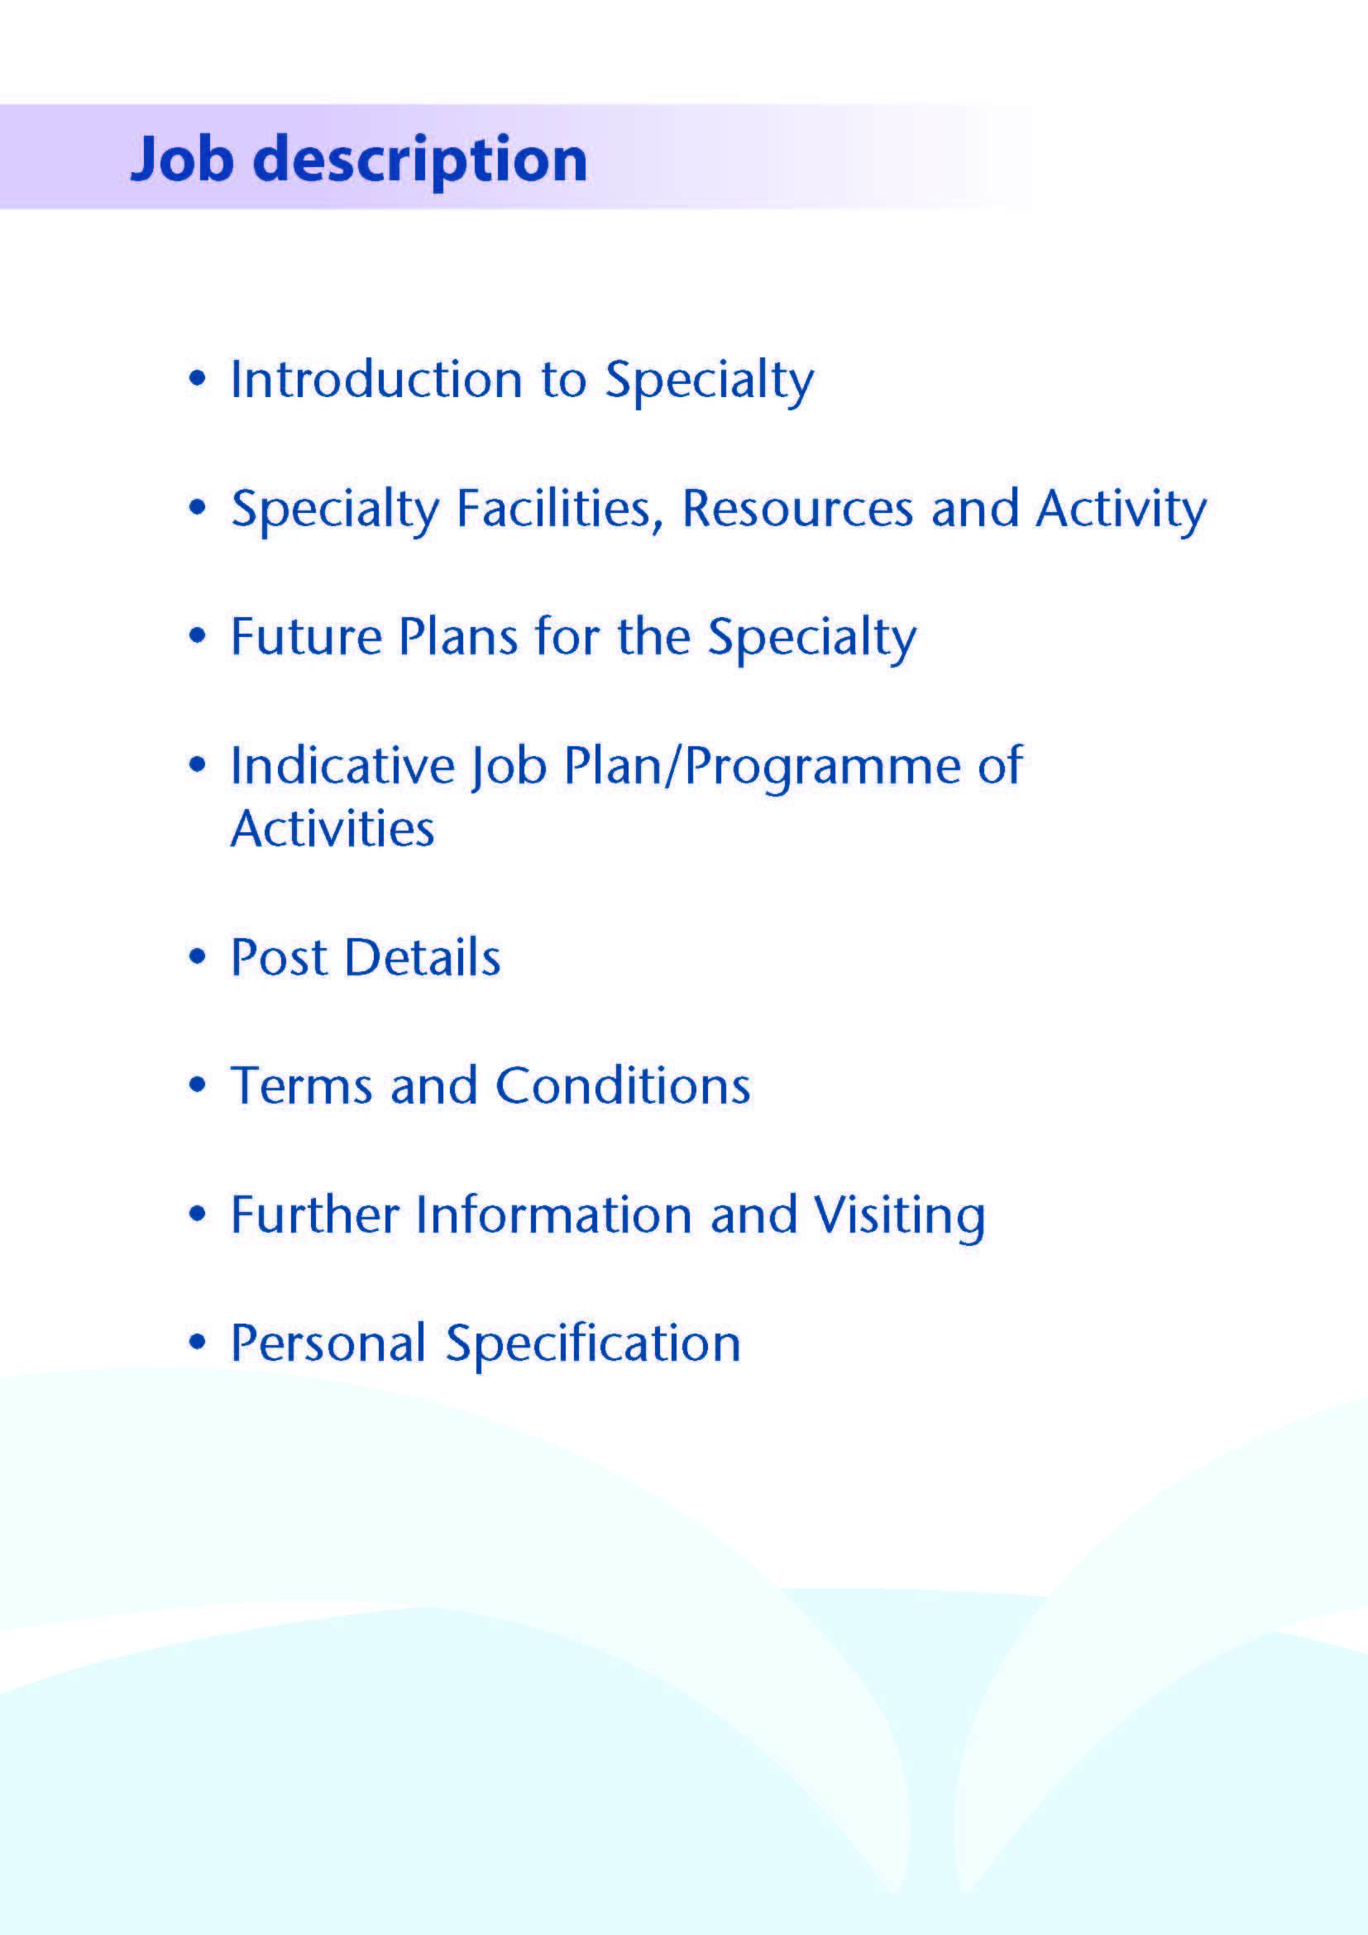



We are seeking an enthusiastic neonatal paediatrician for a full-time Locum replacement post (10 PAs) to support Consultant led services within Neonatology in NHS Ayrshire and Arran.
Neonatal and Acute Paediatric Services are on one site at University Hospital Crosshouse in Kilmarnock, a large and busy District General Hospital.

Introduction

The Neonatal Unit provides “level 2” intensive care – Local Neonatal Unit (LNU). This post contributes to the neonatal consultant rota, involving on-call and hotweek cover, delivering safe, effective, patient-centred care. An Interest in guideline development and clinical audit would be particularly welcome although other specific interests within neonatology or general paediatrics would also be considered. There will also be opportunity to participate in General Paediatric out-patient work with admission rights to General paediatric in-patient beds.

About Ayrshire
Situated in the picturesque south west of Scotland on the Firth of Clyde coastline, Ayrshire is a 30-minute drive from Glasgow, Scotland’s largest city, and an easy commute by road or rail to our capital city Edinburgh, making it an ideal location for those who want to enjoy city life but who value the benefits and quality of life offered by living in a more relaxed semi-rural district.

The area boasts all you could ask for, whether you enjoy an active outdoor lifestyle, or take a more laid-back approach to life enjoying the culture and heritage of the area, it’s all on your doorstep. There are first class sports and recreational facilities, including 40 quality golf courses, award winning visitor attractions, in addition to a vast array of restaurants and bars.

The isle of Arran, less than an hour’s ferry ride, is known as Scotland in miniature, and provides an ideal “overseas” escape while the Isle of Cumbrae boasts one of Scotland’s premier water sport centres.

The area is supported by an excellent road and rail services. National and international flights are available from Glasgow International Airport, and Ayrshire’s own local airport in Glasgow-Prestwick also offers a wide range of air routes to a number of major European cities and holiday destinations abroad.

All this coupled with excellent housing, quality local authority and private schooling and the excellent transport links, sets Ayrshire in an enviable position when it comes to offering a quality lifestyle for those who choose to live and work in the area.

For more information on what Ayrshire has to offer visit www.AyrshireandArran.com and for information on local authority services including schooling visit, www.south-ayrshire.gov.uk ; www.north-ayrshire.gov.uk and www.east-ayrshire.gov.uk


NHS Ayrshire and Arran has a total population of approximately 380,000 with 72,000 children under the age of 16 years. There are approximately 3,000 deliveries a year.

Facilities

Neonatology:

Ayrshire Maternity Unit (AMU) was opened as a new, purpose-built, state-of-the-art facility in 2006. It is the only maternity unit in Ayrshire, catering for almost all the 3,000 deliveries per annum, including high-risk pregnancies, in an obstetric unit with a midwife-led unit alongside. The unit is co-located with University Hospital Crosshouse and is linked by an internal corridor.

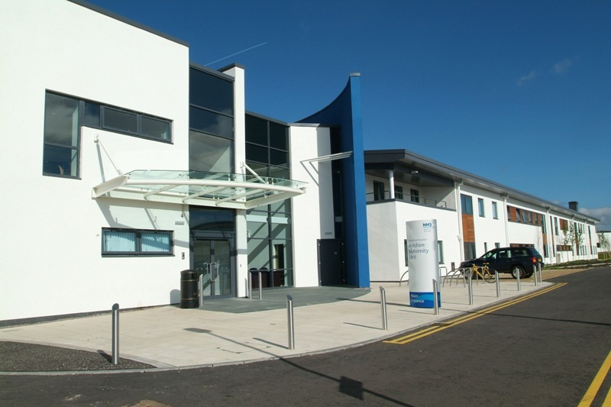

The 20 cot Neonatal Unit provides level 2 unit (Local Neonatal Unit – LNU) and has facilities to provide conventional ventilation, high frequency oscillation and nitric oxide management of neonatal respiratory problems. We care for babies born from 27 weeks gestation, as well as babies requiring therapeutic cooling. .

There are 5 designated intensive care cots, providing approximately 500 intensive care days per annum. There are 4 High Dependency and 11 Special Care cots (the configuration is flexible depending on clinical need). The Neonatal team is also responsible for screening of all infants in the postnatal ward and provides assessment and care for these infants as required.

Full medical intensive care is provided to extremely low birth weight, very preterm infants and ill term babies. Neonates requiring cardiac and surgical intervention are transferred to the Royal Hospital for Children, Glasgow, following stabilization. There is a telemedicine link to Consultant Cardiologists and Paediatric Surgeons at the Royal Hospital for Children in Glasgow.
The Unit is committed to working as part of the West of Scotland Neonatal Managed Clinical Network (MCN). Badgernet software is used throughout the MCN.
The Unit contributes to the Scottish Perinatal Advisory Service and accepts in-utero and ex-utero transfers from other maternity / neonatal units in Scotland.

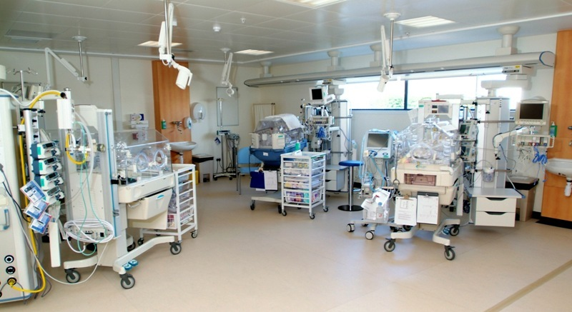

The Unit has excellent relations with colleagues in other specialities; our local ophthalmology colleagues visit regularly for ROP screening and our orthopaedic, maxillofacial and ENT colleagues visit when needed. We are privileged to have regular Genetics clinics on site, provided by a visiting Geneticist from Glasgow who is always happy to visit the Unit on request. We enjoy good relationships with helpful colleagues in specialities such as paediatric neurology and respiratory paediatrics in Glasgow. As a busy District General Hospital, Crosshouse has comprehensive laboratory facilities and these are supported by specialised laboratory services in Glasgow.

There are areas of social deprivation in Ayrshire resulting in significant perinatal morbidity, including a constant throughput of infants suffering Neonatal Abstinence. The Unit has a Neonatal Community Liaison Team to facilitate discharge.

This post is one of five neonatal consultant posts and we also have an Associate Specialist in Neonatology. There are currently 7 Advanced Neonatal Nurse Practitioners (ANNPs) in post, 6 contributing to the junior neonatal rota and one to the middle grade rota with one vacancy currently for a “middle grade” (8B) ANNP. The middle grade rota is staffed mainly by rotational trainees on the West of Scotland paediatric rotation as well as the ANNP and a Specialty Doctor. Junior medical cover is provided by a combination of Foundation Year 2 and General Practice Specialty Trainees and the ANNPs.

Relationships with obstetric colleagues are excellent and we have two obstetric consultant colleagues with an interest in fetal medicine. We have regular meetings to plan perinatal care of women with high-risk pregnancies and their infants, in addition to monthly perinatal morbidity and mortality meetings.

“High Risk” infants are currently followed up at a dedicated Neurodevelopmental Clinic co-ordinated by our Associate Specialist at University Hospital Crosshouse. Other infants requiring follow up are seen not only at the dedicated paediatric out-patient clinic suite within the Paediatric Unit at University Hospital Crosshouse but also at dedicated follow up clinics at University Hospital Ayr and Ayrshire Central Hospital in Irvine. They may also be seen at East Ayrshire Community Hospital in Cumnock, Girvan Community Hospital or the War Memorial Hospital in Lamlash on the Isle of Arran.

General Paediatrics:
The Paediatric Department at Crosshouse Hospital, Kilmarnock is responsible for the in-patient and out-patient care of the section of the population between birth and the 16th birthday. A major reconfiguration of the service took place in 2006, bringing all inpatient services on to one site. The general paediatric unit at Crosshouse Hospital provides co-location of a dedicated Outpatient Suite, a Children’s Assessment Unit and a dedicated inpatient unit including not only medical paediatrics but paediatric ID and dermatology beds and paediatric surgical specialities (general paediatric surgery, orthopaedics, ENT, dental surgery, plastic surgery and ophthalmology). There are 24 inpatient beds, including 4 in a dedicated adolescent facility. The majority of children admitted for elective surgery in the above specialities are catered for in the Day Surgery Unit (separate from the inpatient facilities).

The Ayr Hospital, Ayr also has a dedicated Paediatric out-patient suite. In addition, General Paediatric out-patient clinics are held at Ayrshire Central Hospital in Irvine, at East Ayrshire Community Hospital in Cumnock, at the Girvan Community Hospital in Girvan, at the Brooksby Centre in Largs and at the War Memorial Hospital in Lamlash on the Isle of Arran. Most clinics are of a general nature but there are dedicated clinics for children with cystic fibrosis, diabetes and epilepsy. In addition there are joint clinics in cardiology, endocrinology, epilepsy, gastroenterology, renal, rheumatology and genetics held locally with visiting specialists from Glasgow Children’s Hospital.

The consultant paediatricians operate a “hot week” system of working in general paediatrics. The appointee will not participate in this.

As a busy District General Hospital, Crosshouse has comprehensive laboratory facilities and these are supported by specialised laboratory services in Glasgow.

Community Child Health:
The Community Child Health Service is delivered from numerous locations across Ayrshire and Arran and based at the dedicated Child Development Centre (Rainbow House) at Ayrshire Central Hospital, Irvine. There are 6 consultant community paediatricians based there, supported by nurses, AHPs and 3 SAS grade doctors.

Education:
Undergraduates from Glasgow and Dundee Universities attend Crosshouse for paediatric blocks and self-selected modules throughout the academic year. Foundation Year 2 and General Practice Specialty Trainees spend 50% of their placement in general paediatrics, and 50% in the neonatal unit. Specialty trainees on the West of Scotland paediatric rotation spend blocks of 6 – 12 months at Crosshouse, approx 2 thirds of their time is spent in general paediatrics and a third of their time is spent in Neonatology.

There are weekly educational meetings within the paediatric department, monthly peer review and monthly paediatric CME meetings open to all in Paediatrics and Child Health. We are involved in regular audit and quality improvement initiatives.

APLS courses are held in Crosshouse, as are annual safeguarding courses. and frequent simulation training.

Consultants in the department are involved as RCPCH examiners for the MRCPCH and DCH examinations.

.

Medical Staff Resources

Neonatal Unit Staff Resources
Consultant Staff | Base
Dr Althaf Ansary | Ayrshire Maternity Unit
Dr Jon Staines | Ayrshire Maternity Unit
Dr Tim Adams | Ayrshire Maternity Unit
Dr Raju Sunderesan | Ayrshire Maternity Unit
This post | Ayrshire Maternity Unit
Associate Specialist
Dr Fiona Barnes | Ayrshire Maternity Unit
Specialty Doctors
Dr Jamila Siddique | Ayrshire Maternity Unit
Dr Cara Owens | Ayrshire Maternity Unit

Activity

Most years the Unit admits about 360 infants and provides 500 – 600 “intensive care days.” On average about 36 very low birth weight infants (< 1500g) are admitted each year). Perinatal mortality figures are generally in line with the Scottish average (see Scottish Perinatal and Infant Mortality and Morbidity Reports, www.isdscotland.org).



The unit has been changing recently to accommodate the standards set up after a review of maternity and neonatal services in Scotland. The ethos of this review is family-centred care. We are committed to continuing to provide as comprehensive a service as possible for Ayrshire’s most vulnerable infants, as close to home as possible, working within the West of Scotland Neonatal Managed Clinical Network. We have an active interest in the Safer Patient Scottish Paediatric Programme.

The Unit participates in various multi-centre research projects. We are keen to develop research activity further.

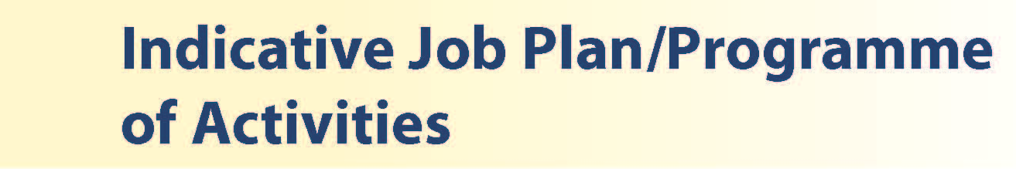

Proposed Weekly Programme

The proposed weekly programme is shown below. Activities with current fixed time commitments will be carried out as detailed in the work programme e.g. clinics. Other DCC and SPA activities are shown with indicative timings within the weekly programme and will be discussed with the appointee.

One week in five will be a “hot week” during which the Consultant will function as “consultant of the week” from 9am till 5pm and have no clinical commitments outwith the Maternity Unit. Commitments that week apart from “hands on” work will include teaching and guideline development as well as patient-related administration.

NOTE: 1 SPA activity is the default for job plans for new consultant appointments. On appointment additional SPA time may be negotiated for specific additional activities, such as guideline development and simulation training, acceptable to the candidate and desirable by the Board.

The total programme is 10PA’s including 1 SPA

An allocation of 2 DCC PAs is included as time off in the non-hot week programme to recognise time commitment associated with the work undertaken when on-call

Provisional Programme for “Hot Weeks”:

SPA activities and fixed commitments on “hot weeks” (one week in five):
DAY | HOSPITAL/ LOCATION | ACTIVITY | HOURS PER ACTIVITY INC TRAVEL
FROM / TO | HOSPITAL/ LOCATION | ACTIVITY | HOURS PER ACTIVITY INC TRAVEL
Monday
a.m. | AMU | Ward round Neonatal Unit | 4DCC
p.m. | AMU | Hot week on call for Neonatal Unit – parent consultations etc. | 4DCC
Tuesday
a.m. | AMU | Neonatal teaching 9.30-10am  Ward round Neonatal Unit | 0.5SPA  3.5DCC
p.m. | AMU | Hot week on call for Neonatal Unit – parent consultations etc. | 4DCC
Wednesday
a.m. | AMU | Ward round Neonatal Unit | 4DCC
p.m. | AMU | Hot week on call for Neonatal Unit  Patient-related admin. | 4DCC
Thursday
a.m. | AMU | Ward round Neonatal Unit | 4DCC
p.m. | AMU | Hot week on call for Neonatal Unit  Patient-related admin.  NNU teaching 3 – 4.30pm | 2.5DCC  1.5SPA
Friday
a.m. | AMU | Ward round Neonatal Unit | 4DCC
p.m. | AMU | Hot week on call for Neonatal Unit  Patient-related admin.  Perinatal meetings 2 – 4pm | 2DCC  2SPA
Saturday |  |  | 36 hrs DCC  4 hrs SPA
Sunday

Provisional Programme for weeks other than “Hot Weeks”:

SPA activities and fixed commitments on “non- hot weeks” (four weeks in five):
DAY | HOSPITAL/ LOCATION | ACTIVITY | HOURS PER ACTIVITY INC TRAVEL
FROM / TO | HOSPITAL/ LOCATION | ACTIVITY | HOURS PER ACTIVITY INC TRAVEL
Monday
a.m. | AMU | Patient related admin | 4DCC
p.m. | AMU Crossshouse | SPA including CME (monthly), Neonatal Protocol Group (monthly), Risk Management meetings (monthly) etc.  Patient realted admin | SPA 3  DCC 1
Tuesday
a.m. |  | Time off in lieu of on call worked | 4DCC
p.m. |  | Time off in lieu of on call worked | 4DCC
Wednesday
a.m. | Ayr (week 1,3,5) | Gen paeds OPC | 4DCC
p.m. | AMU/ AYR | Patient related admin | 4 DCC
Thursday
a.m. | Ayrshire Central Hospital (week 2,4) | Gen Paeds OPC | 4DCC
p.m. | AMU | Patient related admin  Guidelines and protocols, Neonatal Unit teaching | 3 DCC  1SPA
Friday
a.m. | AMU | neonatal special care | 4DCC
p.m. | AMU | neonatal special care  Prinatal meeting (monthly) | 4 DCC
Saturday |  |  | 36 hrs DCC  4 hrs SPA
Sunday

This is indicative only; times and locations of clinics may be subject to change.

Notes on the Programme

Patient Admin. This activity covers the management of individual patients including Out Patient administration, results reporting, letters/’phone calls to parents, carers, GPs and members of the wider multidisciplinary team involved in the patients’ care.

On call arrangements

The basic on call rota is 1:5 (1:4 with prospective cover) and the post attracts an 8% on-call supplement. The on-call consultant must be immediately available for telephone advice or to attend the hospital when advice and support are necessary. The on-call rota is non-resident out of hours. The on-call consultant must be within 30 mins travel of the hospital at all times during the on-call period.
Travel: Any travel allocation will be included within the Total Programmed Activities and will be determined by location at which Direct Clinical Care and Supporting Professional Activities are carried out.

Supporting Professional Activities: NHS Ayrshire and Arran recognise the important role Job Planning has in ensuring consultants are supported in delivering high quality, safe, sustainable clinical care to patients. It is therefore important to ensure there is an adequate balance between direct clinical care activities and activities which support both the personal and professional development of the consultant workforce and facilitates agreed contribution to activities including:

- Under and post graduate teaching/training
- Clinical Governance
- Quality and Patient Safety
- Research and Innovation
- Service management and planning
- Work with professional bodies
1 session of SPA is the default for job plans for new consultant appointments. On appointment additional SPA time may be negotiated for specific additional activities, such as guideline development and simulation training, acceptable to the candidate and desirable by the Board.

There may be a requirement to vary the DCC outlined in the indicative timetable below when the final balance of DCC and SPA is subsequently agreed. There may also be opportunities to contract for Extra Programmed activities Opportunities subject to service requirements and in accordance with national terms and conditions of service.

If the post-holder will be responsible for the formal training and supervision of post-graduates and under-graduates, a suitable additional allocation of SPA time will be made in accordance with national guidance.

The total programme is 10 Pas.

Job Plan Review

New appointees will discuss the indicative job plan with the Clinical Director prior to commencement and will at that time review the balance of activities. Where it is possible to agree any revisions to the indicative plan in advance of commencement this will be acted upon. The agreed job plan will include all the consultant’s professional duties and commitments, including agreed Supporting Professional Activities.

Private Practice: If the post-holder wishes to undertake any private practice, they are obliged to inform their employer at the time of appointment of their intentions to do so. This should be submitted in writing to the Clinical Director. The conduct of private practice will be in accordance with the Consultant Contract (Scotland) Terms and Conditions.

The post-holder shall be free to undertake private practice without approval provided such work is undertaken outside the time agreed in the job plan for programmed activities. (Refer Section 6 of the New Consultant Contract).



The post-holder will be accountable to the Clinical Director for Paediatrics and Child Health, Dr Scott Williamson, who will agree the Job Plan.

The post-holder will be expected to work with local managers and professional colleagues in the efficient running of services and will share with Consultant colleagues in providing the medical contribution to management. Subject to the provisions of the Terms and Conditions of Service, they are expected to observe the Directorate’s agreed policies and procedures, drawn up in consultation with the profession on clinical matters, and to follow the standing orders and financial instructions of NHS Ayrshire & Arran.

In particular, where the postholder formally manages employees of NHS Ayrshire and Arran, the postholder will be expected to follow the local Board and National Employment and Personnel Policies and Procedures.

The postholder is required to comply with the Organisation's Health and Safety Policies.

Resources

The staff resources of the department are listed elsewhere. The postholder will have access to such general administrative support as is required for the discharge of his/her duties and responsibilities.

This will include the provision of adequate secretarial and clerical support and the availability of accommodation, equipment etc.

The postholder will receive support from such other professional staff as are employed within the Directorate and are deployed to his/her area of patient care.

The postholder will be provided with necessary personal devices to enable the fulfilment of their duties and responsibilities.

Duties and Responsibilities

The main duties and responsibilities of the post include:

- The new appointee will be responsible, with consultant colleagues, for the care and management of newborn infants in Ayrshire and for co-ordinating appropriate follow up until such time as a child can be discharged or be transferred to the care of a colleague in Community Child Health or General Paediatrics.
- to the appointee will hold a General Paediatric clinic with admission rights to the General Paediatric ward at Crosshouse.
- Responsibilities for carrying out teaching, accreditation and examination duties as required, and for contributing to undergraduate and postgraduate medical education. The postholder will be expected to comply with College recommendations on Continuing Medical Education.
- The postholder will be required to comply with Organisational Policies on Clinical Governance.
- The successful applicant will be encouraged to participate in research and to develop a relevant sub-specialty interest, subject to resources and local priorities.
- Requirements to participate in medical audit and in continuing medical education
- Managerial, including budgetary, responsibilities (where appropriate).

Summary

The successful applicant will join a friendly, hard-working team striving to provide excellent care and to develop services in a purpose-built Unit with a relaxed and supportive ethos.



The Terms and Conditions of Service are those determined by the Terms and Conditions of the New Consultant Grade (Scotland) as amended from time to time. The distance that a consultant can reside from the principal base hospital, where travel time is seen as more important than mileage, is subject to the agreement of the Executive Medical Director, but it is usually anticipated that a journey that takes no more than 30 minutes for any emergency situation would be acceptable.

Please come to visit us and have a look about. Applicants wishing further information about the post are invited to contact Dr Tim Adams or Dr Scott Williamson, with whom visiting arrangements can also be made.



Post of: Locum Consultant Neonatologist
Location: Ayrshire Maternity Unit, University Hospital Crosshouse, Kilmarnock

Qualifications:
Essential | Desirable

Full GMC Registration with current Licence to Practice
Existing Consultants: Inclusion on the GMC Specialist Register  New Consultants: CCT in Paediatrics or  Neonatology  or be within 6 mths  of anticipated award of a  CCT/CESR at the time of  interview for the post. | Sub specialty training leading to CCT in Neonatal Medicine  SPIN in neonatal medicine
Membership of Royal College of Paediatrics and Child Health or equivalent

Skills/Knowledge/Competence
Requirements | Essential | Desirable
General Experience:  - Expertise in sub-specialty field | - Comprehensive knowledge of, and experience in, Neonatology  - Ability to communicate effectively with parents, families and with all levels of staff.  - Ability to work efficiently and timeously  - Willingness to participate in neonatal rota  - Neonatal sub specialty interest | - IT literacy
Team Working | - Ability to lead others and think strategically  - Effective Team Player
Development | - Evidence of relevant Continuing Professional Development  - Evidence of satisfactory compliance with appraisal requirements
Teaching & Training | - Ability to deliver high quality teaching to medical students, junior medical staff and colleagues in other health professions | - Interest in and knowledge of advances in medical education and training.  - Experience of sim training
Research & Publications |  | - Evidence of publications of a high standard relating to specialty
Clinical Audit and Clinical Improvemenr | - Evidence of interest and experience in medical audit / Clinical improvement projects
Management and Administration | - Ability to lead a clinical team  - Commitment to effective departmental management  - Proven organisational skills | - Proven management experience  - Understanding of resource management and quality assurance.
Personal and Interpersonal Skills | - A willingness to accept flexibility to meet the changing needs of the NHS in Scotland  - Effective communicator and negotiator  - Demonstrate effective leadership  - A willingness to develop special interests which conform to the needs of NHS Ayrshire and Arran  - Ability to operate on a variety of different levels | - Knowledge of recent changes in the NHS in Scotland

