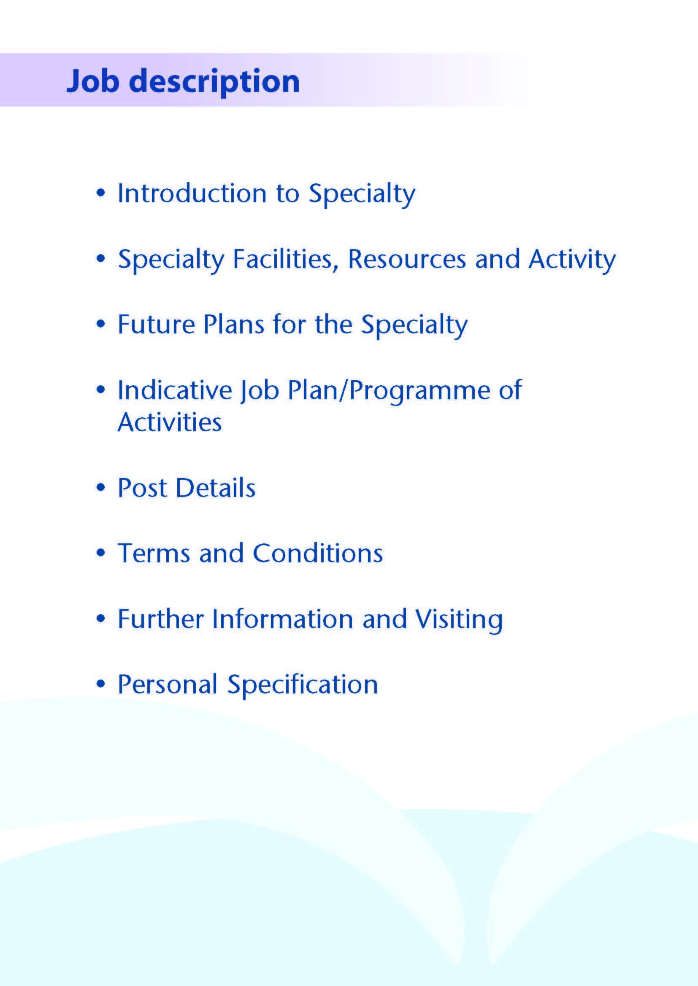



NHS Ayrshire and Arran has invested significantly in mental health service development over recent years following a major strategic review, and this has resulted in the creation of a 24 hour crisis service, expansion of primary care mental health services and new services for eating disorders. All acute psychiatric beds are now sited in our purpose-built inpatient unit, Woodland View, which opened on the Ayrshire Central Hospital campus in Irvine in 2016.

A vacancy has arisen for a dynamic Consultant in General Adult Psychiatry to join our North Ayrshire Community Mental Health Service (NACMHS), and to play a key role in supporting ongoing exciting and innovative developments.

There is one full time (1.0 WTE) post, including opportunities for both community and inpatient responsibilities. The successful candidate will be one of 5.0 WTE Consultants providing input to the multidisciplinary NACMHS based at the Three Towns Resource Centre in Saltcoats, part of the North Ayrshire Health & Social Care Partnership.



Adult inpatient mental health services in Ayrshire are provided within our purpose built community hospital, Woodland View, with general adult (acute), elderly, continuing care, rehabilitation, IPCU and alcohol rehabilitation wards. There is a smaller unit providing elderly and rehabilitative services based on the Ailsa Hospital site in South Ayrshire.

There are three General Adult Community Mental Health Teams (CMHTs) in Ayrshire: North, East and South.

The North Ayrshire CMHT consists of:
5.0 Consultants
3-4 Core/GPST/F2 trainees
1-2 Higher Trainee
1 Nursing Team Leader
8.7 WTE Charge Nurses
11.6 WTE staff nurses
1 WTE Health Assistant
4.4 WTE Occupational Therapy
4.8 WTE Psychologists
9.21 WTE Admin staff

Medical Staff Resources

Consultant Grade:

ADULT

North Locality
Vacancy (this post)
Dr Everett Julyan (North Community Clinical Director)
Dr Alison MacRae
Dr Alex McLean
Dr Eilidh Orr

East Locality
Dr Aileen Guthrie (East Community Clinical Director)
Dr Morag Henderson (Associate Medical Director)
Dr Mike Taylor
Dr Krzysztof Tyczynski

South Locality
Dr Alistair Gibb (Inpatient, Rehabilitation & Forensic Clinical Director)
Dr Tim Johnston
Dr Adrian Nitu
Dr Jacqui Scott (South Community Clinical Director)

Rehabilitation
Dr Millia Begum

Liaison/Perinatal
Dr Malcolm Cameron (Clinical Director)
Dr Ben Chetcuti
Dr Kim Newlands

Psychotherapy
Dr John Prestwich

Forensic/IPCU
Dr Partha Gangopadhyay
Dr Dawn Carson

Elderly
Dr Debbie Browne
Dr Stephanie Cowan
Dr Dominic Gallagher
Dr Mark Luty (Clinical Director)
Dr Susan Maxwell
Dr Joseph Sharkey
Dr Alan Spratt

CAMHS
Dr Vytas Blazys
Dr Helen Smith (Clinical Director)
Dr Ali Tahir

Learning Disability
Dr Claire Hughes (Clinical Director)
Dr Douglas Paterson
Dr Omer Rashid

Addictions
Dr Clare Duncan
Dr Karthik Kessavelou
Dr Beinn Wilson (Clinical Director)
Dr Caroline Woolston

Non-consultant Grade:

The consultant posts are supported by several Speciality Doctors, up to 20 trainees (FY2/GPST/ST1-3) and a varying number of Higher Trainees in Psychiatry (ST4-6)

Administrative Support

Successful applicants will have access to such general administrative support as is required for the discharge of their duties.

Education

Woodland View has its own library and training facilities on site for local postgraduate teaching. Crosshouse and Ayr Hospitals have the Alexander Fleming Education Centre and MacDonald Education Centre, respectively. These host well stocked libraries with good electronic facilities, a lecture theatre with state-of-the-art equipment and meeting rooms.

Successful applicants will be expected to participate in the local postgraduate psychiatric training programme and to be involved in the teaching of medical undergraduates.


A new low secure unit opened on the Woodland View site in January 2017 and Woodland View will host the new national medium secure adolescent unit.

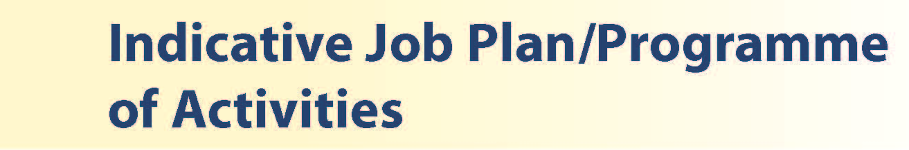

The post will consist of up to 10 programmed activities. The nature and timing of activities shown in the timetables are indicative and the precise nature of the duties will be agreed with the successful candidates at a job planning meeting with the Clinical Director. Timetables will be reviewed to meet the changing needs of the service and post-holder, subject to discussion and job planning. Flexible working is encouraged.

 | Mon | Tues | Wed | Thur | Fri
am | Clinic  (Three Towns) | Admin/CMHT  (Three Towns) | MDT  (Three Towns) | SPA | Ward round  (Woodland View)
pm | Ward reviews  (Woodland View) | Clinic  (Three Towns) | Admin/CMHT (Three Towns) | Admin/CMHT  (Three Towns) | Admin/CMHT (Three Towns)

Proposed Weekly Programme

The proposed weekly programme is illustrated above. Activities with current fixed time commitments will be carried out as detailed in the work programme, e.g. clinics, multidisciplinary meetings (MDT) and on-call, with flexibility as required.

CMHT work can include medical input to the crisis team, urgent individual or joint assessments, home visits, clinic appointments, mental health act work, CPA or AWI work, depending on the dynamic needs of the service.

Other DCC and SPA activities are shown with indicative timings within the weekly programme and will be agreed with the consultant.

The job plan incorporates all the consultant’s professional duties and commitments including agreed Supporting Professional Activities.

Opportunities may exist for Extra Programmed Activities to be undertaken subject to service requirements and in accordance with national terms and conditions of service.

Administration: This activity covers the management of individual patients including outpatient administration, results reporting, letters/phone calls to patients, carers, GPs and members of the wider multidisciplinary team involved in patient care as well as medico-legal documents.

Travel: Any travel allocation will be included within the Total Programmed Activities and will be determined by location at which Direct Clinical Care and Supporting Professional Activities are carried out.

On call arrangements: The successful applicants will be part of the rota, currently 1 in 26. The availability supplement is level 1 (currently 3%).

Supporting professional activities and job plan review

NHS Ayrshire and Arran recognise the important role job planning has in ensuring consultants are supported in delivering high quality, safe, sustainable clinical care to patients. It is important, therefore, to ensure there is an adequate balance between direct clinical care activities and those activities which support both the personal and professional development of the consultant workforce and facilitates agreed contribution to activities including:

- Under- and post-graduate teaching and training
- Clinical Governance
- Quality Improvement and Patient Safety
- Research and innovation
- Service management and planning
- Work with professional bodies
All consultants will have one SPA as a minimum to support job planning, appraisal and revalidation. However, the final balance of SPA and DCC activity will be agreed between the appointee and clinical manager prior to contracts being agreed.

There may be a requirement to vary the DCC outlined in the indicative timetable when the final balance of DCC and SPA is subsequently agreed. There may be opportunities to contract for Extra Programmed Activities subject to service requirements and in accordance with national terms and conditions of service. There may also be opportunities for core or additional subspecialty sessions e.g. Addictions, Forensic, Liaison etc. according to the interests of the successful candidate and needs of the service.

If a post holder will be responsible for the formal training and supervision of post-graduates and undergraduates, a suitable additional allocation of SPA time will be made in accordance with national guidance.

Job plan review: New appointees will have an interim job plan review three months post commencement to review the balance previously agreed. The agreed job plans will include all the consultants’ professional duties and commitments, including agreed Supporting Professional Activities. Thereafter job planning will be carried out annually as part of the Board’s job planning process.

Research: Research is encouraged and supported by an active Research and Development Committee. Appointees will be encouraged to develop research interests associated with their specialist interest.



The main duties and responsibilities of the posts include:

- Providing consultant level leadership and medical input to the service
- Providing consultant level assessment, diagnosis and treatment of new and existing patients presenting to services
- Liaising with mental health colleagues across disciplines and with health and social care partners in support of comprehensive patient care
- Liaising with GPs and third sector agencies
- Acting as RMO for patients subject to mental health legislation
- Undertaking domiciliary visits and emergency assessments where appropriate
- Undertaking Mental Health Act/Adults with Incapacity Act work
- Providing medical input to the North Ayrshire Crisis Resolution Team, with supervision (1 hour per week) on a rotational basis with other consultants
- Participation in the local psychiatric training programme
- Involvement in teaching and supervision of medical students and junior doctors (subject to job plan negotiation)
- Participation in medical audit and continuing professional development
- Compliance with NHS Ayrshire & Arran Clinical Governance policies
- Involvement in appraisal and job planning.
- Participation in the consultant on-call rota, currently 1 in 26



Terms and Conditions of Service are those determined by the Terms and Conditions of the New Consultant Grade (Scotland) as amended from time to time. The distance that a consultant can reside from the principal base hospital, where travel time is seen as more important than mileage, is subject to the agreement of the Medical Director.

For further information or to arrange an informal visit please contact Dr Everett Julyan, Clinical Director, or Dr Alison MacRae, Consultant Psychiatrist, on 01294 470010; or Dr Morag Henderson, Associate Medical Director, on 01294 323514.



POST OF : CONSULTANT IN GENERAL ADULT PSYCHIATRY

LOCATION : NORTH AYRSHIRE CMHT

QUALIFICATIONS:
ESSENTIAL | DESIRABLE

Full GMC Registration (with Licence to Practice)
Existing Consultants: Inclusion on the GMC Specialist
Register for General Adult Psychiatry
.
New Consultants: Be within 6 months of the
anticipated award of CCT/CESR
by the time of interview.
MRCPsych (or equivalent)
Section 22 approval under the Mental Health (Care and Treatment)(Scotland) Act 2003

Full Driving Licence

SKILLS/  KNOWLEDGE/  COMPETENCE | ESSENTIAL | DESIRABLE
General Experience | Broad experience and knowledge in the field of psychiatry | Training in a relevant psychotherapy, e.g. CBT, EMDR, DBT or MBT
 | Ability to communicate effectively with all levels of staff and patients
 | Ability to work efficiently with good time management
 | IT literacy
 | Good record keeping skills
Team Working | Commitment to being an effective team player, establishing and maintaining patient-centred collaborative relationships
 | Ability to recognise value of and develop working relationships with partnership agencies
 | Willingness to contribute to development and clinical leadership of the multidisciplinary partnership
CPD | Evidence of relevant Continuing Professional Development
Teaching and Training | Engagement with teaching and training | Interest in and knowledge of advances in medical education and training
Research and Publications |  | Evidence of publications in peer reviewed journals
Clinical Audit | Participation in regular medical audit
Management and Administration | Proven organisational skills
Personal and Interpersonal Skills | Flexibility to meet the changing needs of the service
 | Effective communicator and negotiator
 | Open and non-confrontational
Professional values and practice | Committed to practicing according to the GMC’s Good Medical Practice, and the RCPsych’s Good Psychiatric Practice

