
NHS Grampian Job Advert
Post Ref No: PS090552 Closing Date: Sunday, 6th March 2021

DR GRAY’S HOSPITAL ELGIN
EMERGENCY PRACTITIONER

EMERGENCY MEDICAL PRACTITIONER (GP)
or
SPECIALITY DOCTOR EMERGENCY MEDICINE



ROLE DETAILS

Title:

EMERGENCY MEDICAL PRACTITIONER (GP) SPECIALITY DOCTOR EMERGENCY MEDICINE

Salary:

Emergency Medical Practitioner (GP) aligned to Salaried GP Scale with associated OOH payments(Entry point dependant on experience)

Speciality Doctor Emergency Medicine aligned to Speciality Doctor Scale- with associated OOH payments (Entry point dependant on experience)

Location: NHS Grampian – Dr Gray’s Emergency Department Responsible To: Lead Consultant, Emergency Department Dr Gray’s Hospital Hours of Duty: Various hours available

Job Description Hours of Work:
The post is flexible and is worked on a rolling 16-week rota incorporating study and annual leave. Due to the nature of the post a proportion, aprox 50:50 split of working time will be “out of hours”, including week-ends. The current shifts are 12 hours.

Background

You will be joining an enthusiastic team who are dedicated to providing a high quality Emergency Care. We have 2 Consultants with an additional 2 posts currently out to advert, an Associate Specialist and Emergency Medical Practitioners along with FY2 & GP trainees plus a substantive Physician’s Associate and a Minor Injuries nurse-led team.

We also participate in the Acute Care Remote and Rural GP Fellowship programme, hosting up to two Fellows annually. Your daytime shifts will ensure you benefit from ongoing supervision and training and you will be supported with local and wider training and development to fulfil the role as needed and part of annual appraisal and PDP.

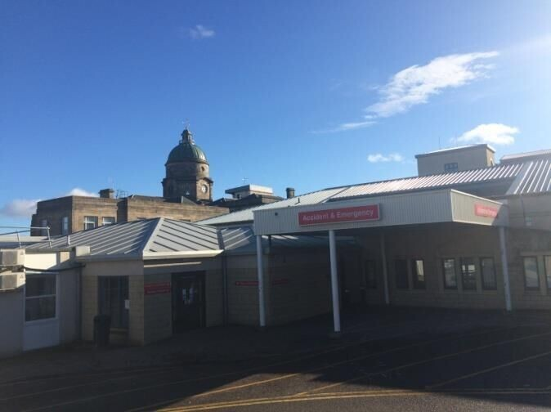

You will work 12hr shifts in a consultant-led department that sees a whole range of emergency patients from Minor Injury presentations to major trauma.

The Emergency Department (ED) at Dr Gray’s Hospital provides a 24 hour Emergency Medicine service dealing with approximately 25,000 new and return attendances per year.

Resuscitation and stabilisation of acutely ill and injured patients of all ages falls within our scope, as well as emergency surgery and transfer where needed for tertiary and intensive care. There are no by-pass protocols in place and we do not fall under the remit of retrieval services, except for paediatric and neonatal intensive care.

A whole range of interventions are undertaken in the department including the latest approaches in trauma management, STEMI and stroke thrombolysis and procedural sedation, including Ketamine sedation for children undergoing painful procedures. Point of care ultrasound is in use and training available. In recent audits Dr Gray’s Hospital ED has scored highly in the provision of analgesia and management of sepsis and is committed to providing exemplary clinical care.

We enjoy excellent professional relationships with the emergency services as well as local military services at RAF Lossiemouth and Kinloss.

Equally important is the reputation for being the social hub of the hospital, with many social events and activities taking place.
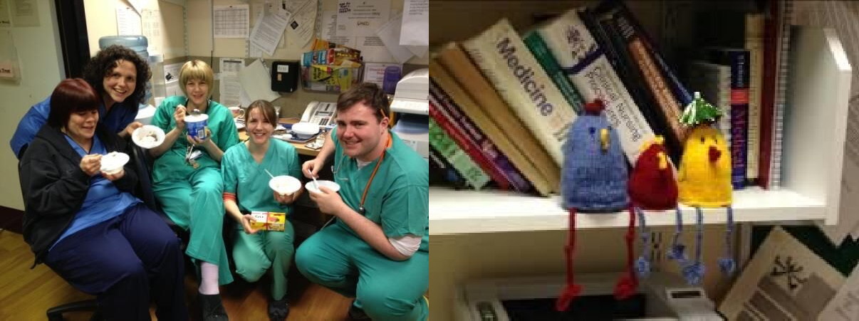

Dr Gray’s Hospital

Dr Gray’s Hospital is situated in Elgin, the county town of Moray, in North-East of Scotland, five miles from the coastal town of Lossiemouth. It is the only centre in Grampian outwith Aberdeen providing a range of acute services.

The current bed compliment of 100 is divided between General Surgery, Orthopaedic, Ophthalmology, General Medicine, Paediatrics, Obstetrics & Gynaecology, Acute Medical Assessment Unit, a Stroke Rehabilitation Ward and a Day Ward. There is also a Consultant Led Psychiatric Service.

The hospital has recently been redeveloped, with modern equipment and user friendly facilities throughout and there is a library and a Postgraduate Medical Centre with 24/7 access and videoconferencing facilities.

Job Purpose

The Emergency Practitioners provide the middle-grade support for the Emergency Department and out of hours are the senior decision maker in the department supported by the consultant on-call. When on duty you will be involved in consultations with the full range of emergency unscheduled care and emerging scheduled urgent care pathways via NHS24.

The Consultant Perspective

Dr Pam Hardy, Lead Consultant in Emergency Care

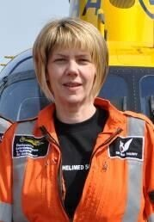
I have been a Consultant for about 20 years now having trained in paediatrics then emergency medicine in and around Sheffield, and moved to Elgin 9 years ago.
I love it here especially the small-hospital atmosphere at Dr Gray’s.
I have been working in pre-hospital care for the last 20 years and still commute 450 miles to fly regularly with the Derbyshire, Leicestershire & Rutland Air Ambulance and catch up with family and friends down there.

I’m involved with pre-hospital care here too via BASICS Scotland and the Moray Immediate Care Scheme and I chair the Royal College of Surgeons of Edinburgh Scottish Regional Faculty of Pre-hospital Care, as well as being involved with the immediate care exams and sub-specialty PHEM development.

I love living here in my little house in the wood, running on the beach and have taken up camping and all sorts of things I never thought I’d do since moving here!

I’m happiest in a helicopter….
And I make good Sticky Toffee Pudding!

Dr Gavin Tunnard


I did my EM training in London along with some time in Australia finishing in 2015. I subsequently worked as a consultant in south east London for 2 years before making a work life decision to move north of the border with my young family.

I have an interest in education and point of care ultrasound and regularly teach on ATLS, level one ultrasound and FRCEM preparatory courses nationally. I am also a journal reviewer for the EJEM.
More recently I have completed BASICS training and I am dipping my toe into PHEM.

Out of work I can be found outdoors with my family enjoying the Moray beaches and countryside.

The EMP Perspective

Dr Catriona Macdonald: Emergency Medical Practitioner (GP)

I have been working as a part-time EMP since 2015 and combine this with my other job as a GP partner in Rinnes Medical Group, Dufftown. I did the Acute Care Remote and Rural GP Fellowship in Moray in 2014 and before that I was completing my GP training in Elgin. I came to Moray as an FY2 and liked it so much that I never left!
The fellowship was a fantastic way to increase my skills in acute care and has given me the confidence to continue with hospital work, alongside being a GP. I was able to develop skills that are transferable between the emergency department and rural GP work and pre-hospital care and I enjoy blurring the boundaries between primary and secondary care. Having two jobs means my working week is always varied and interesting.

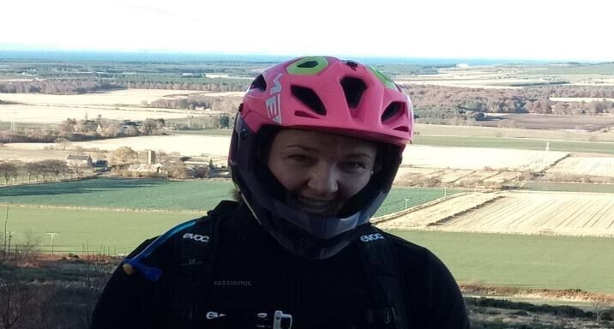

Assignment and Review of Work

Self directed within agreed objectives as set during annual appraisals and Personal Development Plans (PDP’s). Medical indemnity will be provided by NHS Grampian.
For GP practitioners most maintain a portfolio career with some time spent in general practice to facilitate achievement of all aspects of general practice required for revalidation.

Qualifications and /or Experience Specified for the Post

MRCGP / MCEM qualification desirable.

Speciality Doctors to have completed a minimum of 2 years full time postgraduate training in this specialty (or equivalent)

Applicants should ideally have current ALS, ATLS and PLS skills

Local information

Elgin

As county town, Elgin is an administrative centre for the local farming, distilling and fishing industries. Many good schools are within the local area, and private education is available at Gordonstoun School which is 4 miles from Elgin.

The choice of housing is varied – all within easy distance of the hospital and an abundance of rural and coastal locations to choose from.

There is an excellent selection of stores and specialist shops in the town centre of Elgin and nearby Retail Park, providing for most needs, as well as local farm shops and delicatessen.

There is also a good range of restaurants and bars within easy reach with fantastic local fayre and seafood as well as international cuisine.

Local sports and leisure facilities include provision for soccer, rugby, swimming, 10-pin bowling, a cinema and an ice-rink with an endless array of outdoor sporting and leisure facilities across Moray (see below).

The nearest beaches and forest trails are within 10 minutes drive and the ski resorts of Cairngorm and the Lecht are within 1 hours drive.
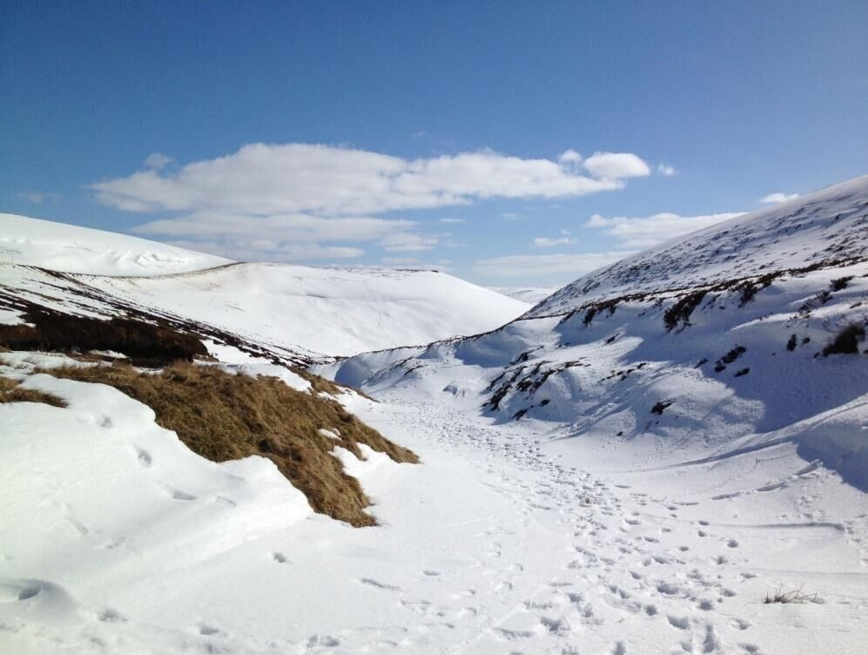

The local rail station links to Aberdeen and Inverness and mainline rail services to Edinburgh and Glasgow.

Aberdeen airport is approximately 90 minutes away, and Inverness 40 minutes, with domestic, island and international flight destinations.

Moray

Moray is a great place to live and work, lying hidden from the main Scottish tourist route between the beautiful coast of the Moray Firth and the mountains of the Highlands and the Cairngorm National Park. Long stretches of unspoiled beaches border the forest trails of Roseisle and Culbin, with picturesque fishing villages and frequent sightings of seals and dolphins along the shores.




Local beaches and forest trails

The Moray Firth boasts a sheltered unique microclimate with lower than average rainfall and the opportunity to experience all four seasons in one day!

Moray is a popular destination for so many outdoor activities including:

  - Sea fishing, and salmon and trout fishing on the River Spey and the River Findhorn
  - 16 golf courses, including a famous championship links course at Lossiemouth

  - Sailing, canoeing, water skiing, open water swimming

Sailing at Findhorn Bay

  - Hill walking, hiking, running

  - Camping, caravanning and hostelling – including some fantastic bothys
  - Horse riding
  - Mountain biking including many designated trails for all abilities
  - Skiing, snowboarding and ice climbing




An icy Coire and T -Sneachda and Ben Nevis

And Moray has the only Malt Whisky Trail in the world...



The stills of Glenlivet distillery and beating the retreat

Further information on NHS Grampian and Dr Gray’s Hospital is available at: http://www.nhsgrampian.co.uk
https://youtu.be/jHFNBb3EVIQ

For an informal discussion feel free to telephone:
Pam Hardy, Lead Consultant in Emergency Care at Dr Gray’s Hospital Tel: 01343 567310
Or email: Pamela.Hardy@nhs.scot

NHS GRAMPIAN PERSON SPECIFICATION
The Person Specification should meet the demands of the job and comply with current legislation. Setting unnecessary standards may, for example, unfairly discriminate against one sex, the disabled or minority racial groups. Applicants should be assessed in relation to their ability to meet the real requirements of the
job as laid down in the job description. Shortlisted candidates MUST possess all the essential components as detailed below.

POST/GRADE: Emergency Medical Practitioner LOCATION/HOSPITALS: Grampian – Dr Gray’s Hospital WARD/DEPARTMENT: Emergency Department
FACTOR | ESSENTIAL | DESIRABLE
QUALIFICATIONS/ TRAINING | - MB ChB  - Successfully completed and evidence of achievement of Foundation and ST3 competencies in line with GMC standards/Good Medical Practice  - Fully registered with licence to practise with GMC  - Successful completion of training in Advance Life Support  - Speciality Doctors to have completed a minimum of 2 years full  time postgraduate training in this specialty (or equivalent) | - MRCGP / MCEM or equivalent  - Other Post Graduate Diplomas  - Completion of other relevant life support and similar courses
EXPERIENCE |  | - Appropriate range of previous experience in Emergency Medicine  •
KNOWLEDGE AND  SKILLS | - Capacity to apply sound clinical knowledge & judgement  - Ability to manage acute situations under pressure and monitor situations that may change rapidly  - Excellent communication skills  - Ability to maintain trust and confidence of patients | - Knowledge of service provision requirements in all clinical disciplines  - Knowledge of current issues affecting general practice  - Evidence of self directed learning
DISPOSITION  e.g. Personal (transferable) skills | - Capacity to communicate effectively at different levels  - Good time management  - Able to work cooperatively with others & work effectively in a multidisciplinary team and supervise  / support junior staff.  - Capacity to achieve a balance between urgent and important  demands. Capacity to organise oneself and prioritise own work. | - Ability to adapt to differing workplaces  - Demonstrate an analytic approach to practice & capacity to bring a range of approaches to solving problems  - Ability to communicate effectively with external agencies and other disciplines
OTHER | - Eligibility to work in the UK  - Computer literate

- Understands the principles of equality and diversity

