 | 
Multi-Media Communications Officer
088854
Job Pack
February 2022

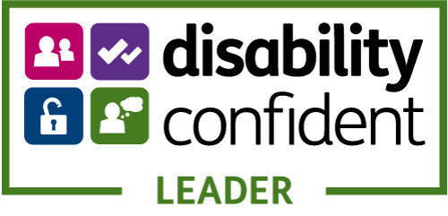
Contents
Welcome to NHS 24 3
Our Organisation 4
Our Structure 5
Communication 6
Our Centres 7
The Role 9
This Opportunity 10
The Job Description 12
Recruitment Process 20

Welcome to NHS 24
Thank you for your interest in this position.
This information pack details information about both NHS 24 and this role. I hope that you find this information useful and it helps inform your decision to apply to come and work with NHS 24.
Now is a great time to be joining NHS 24 as we continue to grow and deliver safe, responsive person centred services to the public of Scotland.
We are proud to employ 1600 staff across our centres in Scotland. As the Director of Workforce, I am committed to ensuring that NHS 24 is a great place to work. Our staff are our greatest asset who deliver high quality safe and effective care to our patients.
I am committed to putting our staff at the centre of everything we do and to working to a common set of values to guide the work we do, the decisions we take and the way we treat each other. Our values are: care and compassion; dignity and respect; openness, honesty and responsibility; and quality and teamwork.
If you would like to be part of our team and feel you have the skills and share our values I would be delighted to hear from you and welcome your application.

Jacqui Hepburn
Director of Workforce, NHS 24
Reference Material
You can find more information about NHS 24 and our services at:
About NHS 24
NHS 24 Services
Key Documentation

Our Organisation
NHS 24 is the national provider of digital and telephone based health and care services for Scotland. We provide people with access to information, care and advice through multiple channels including telephone, web and online.
We work in collaboration with partners, the public and our people to co-design services using technology and a digital first approach to sustainable service development and delivery.
Our Services
Delivery of safe, effective and person centred care to the people of Scotland is the absolute priority for NHS 24. Our services are delivered across a range of channels including telephone, online, web chat, text, email and social media, on a ‘Once for Scotland’ basis to complement the face to face delivery of NHS Scotland’s health and care services. Key services include the telephone triage service 111, our national health and care information service NHS inform, the Mental Health Hub, Breathing Space, NHS Living Life, Care Information Scotland and, more recently, providing an Urgent Care support service to the citizens of Scotland.
Our services are delivered by multi-disciplinary teams, which include a range of clinical and non-clinical skills sets, including nurses, pharmacists, physiotherapists, call handlers (all operate under clinical supervision), health information advisors and mental health counsellors.
As an integral part of the NHS in Scotland, NHS 24 continues to develop, provide, and facilitate an expanding range of multichannel, patient centred, safe and effective digital and telephone based-health and care services.
For example:
- NHS 24 is the national provider of a range of digital and telephone services including 111, NHS inform and Breathing Space.
- Working with partners across the health and care sector, NHS 24 provides health and social care information and access to urgent and out of hours care for people across Scotland via a range of channels including telephone, website and web chat.
- In response to COVID-19, NHS 24 has utilised its national telephony and digital capability to support a national 24/7 COVID-19 pathway, provided through a 24/7 111 service that focuses on COVID patients only in the in hours period and supported by a non-clinical special 0800 helpline and the use of digital assets including NHS inform.
- In the first 11 months of 2019/20 (excluding March 2020 COVID-19 related activity), NHS 24 recorded a call demand of 1.4m calls to 111. In the same period, demand to the new Mental Health Hub service, accessed via 111, was 22,653.
- Throughout 2019/20, visits to NHS inform online averaged 4.4 million per month, however this has grown rapidly during the pandemic to over 2 million visits per week.
- NHS 24 employs a range of staff across its locations, including clinical and non-clinical staff and essential support services staff.

Our Structure

Communications
Communications is a corporate function of NHS 24 and as such covers a wide range of areas – from media relations, staff engagement, marketing, and multi-media production.
It is a full-service function supporting NHS 24 services including the Unscheduled Care Service (111), Scottish Emergency Dental Service, NHS 24 Health Information Services, Breathing Space and Living Life Services.
The Corporate Communications team plays a key role in delivering against NHS 24’s Strategy and annual operating plan. Our role is:
• To increase awareness of NHS 24’s range of multi-channel services
• To support our people and position NHS 24 as an employer of choice
• To protect and enhance NHS 24’s reputation and key role within NHS Scotland
• To support development and delivery of sustainable health services which will improve the health and wellbeing of people across Scotland.
The Communications team manage NHS 24’s reputation with reactive and proactive media relations, social media and strategic engagement. The team uses the full suite of communications channels and assets to increase awareness of NHS 24’s range of services and delivery channels to contribute to the ongoing development of sustainable health and care systems.
✓ Play a key role in the delivery of national health messaging to ensure people across Scotland know when and how to access the right health services for their needs.
✓ Create compelling accessible multi-media content to inform and enable people to look after their health and encourage a digital first approach.
✓ Ensure staff are informed and engaged with service developments.
✓ Measure and evaluate the effectiveness of campaigns, channels and resources to ensure they deliver against NHS 24 and NHS Scotland objectives.
Our Centres
We have seven regional centres, four in the West, two in the East and one in the North of Scotland. We also have a number of local centres.
This post will be based at our Norseman House Centre.
East Regional Centre  Norseman House  2 Ferrymuir  South Queensferry  EH30 9QZ | 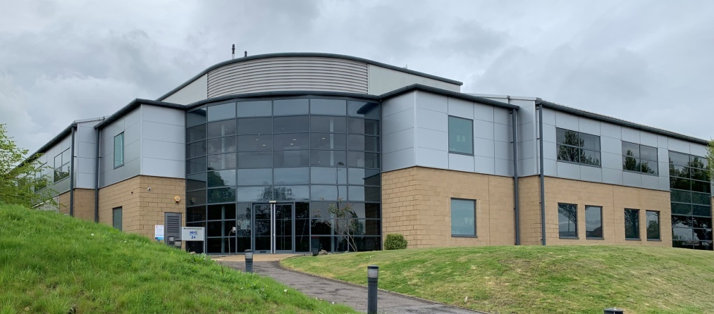
Public Transport
- Rail: South Queensferry Station (Pre-arranged taxi only)
- Bus: No 43, First Edinburgh bus from Waterloo Place.
- Air: Edinburgh Airport.
Road Direction from Edinburgh
- Leave Edinburgh on the A8 (follow Glasgow M8 signs)
- Continue on A8 beyond Airport until you reach a roundabout take 4th exit (signed Forth Rd Bridge)
- Branch right at junction onto A90 (signed Forth Rd Bridge)
- Continue on the A90 to Queensferry
- M9 take Junction 1A Forth Rd Bridge (A90)
- Take right onto Ferrymuir Rd (signed A8000)
- At roundabout, take 1st left into Ferrymuir Business Park (at Burger King) then 1st left at the next mini roundabout with NHS 24 Building being the complex on the left hand side. (Signed NHS 24)
Road Directions from Glasgow
- Follow signs to Edinburgh to join the M8 East
- Branch left M9 junction 2 signed Forth Rd Bridge (A90) & Edinburgh Airport
- M9 take junction 1A Forth Road Bridge (A90)
- Take right onto Ferrymuir Rd (signed A8000)
- At roundabout, take 1st left into Ferrymuir Business Park (at Burger King) then 1st left at the next mini roundabout with NHS 24 Building being the complex on the left hand side. (Signed NHS 24)

The Role –
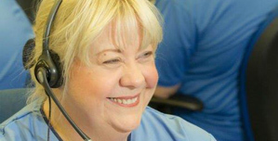
Multi Media Communications Officer

This is an exciting role with a broad scope of creative outputs. The Multimedia Communications Officer will produce content for a range of channels including social media, websites, and internal communications.

The post holder will provide a high quality audio/visual/digital communications service to NHS 24 and its stakeholders. They will have autonomous areas of work and lead in the planning, development and implementation of a range of digital/audio visual communications projects including supporting events, public and media relations, web content and campaigns (local and national). When required the post holder will support the development of multi-media content for NHS 24 websites, social media platforms and for other areas such as internal training materials and where appropriate to support NHS 24 key messages by providing relevant digital content for external use, e.g. by other Health Boards.

They will be required to plan and manage a programme of digital content development in support of a broad range of NHS 24 projects and services. Areas of work will include briefing, commissioning and managing requests for audio visual production, working with external suppliers and external agencies; supporting NHS 24 colleagues of all levels with communication and marketing activities.

Skills
- Educated to degree level in appropriate communications, media or video production or equivalent qualification/experience
- Proven experience of the entire video production journey, including pre-production, filming, editing, audio recording, audio post production and formatting
- Knowledge and interest in digital development and emerging technologies – ability to horizon scan and translate requirements for NHS 24
- Experience of content management systems e.g. Sitecore/SharePoint

This Opportunity
Job Reference: 088857
Position Title: Multi-Media Communications Officer
Hours: 37.5 hours
Location: Norseman House
Band: Band 5
Job Type: Permanent
Salary: £26,104 - £32,915 per annum (pro rata) and enrolment into SPPA pension scheme. Placement on salary scale is dependent on confirmation of previous relevant NHS service.
WHO ARE YOU?
Someone who is passionate about the way audio-visual communications can help us reach our audience and support a sustainable health service.
Creative and self-motivating, you will have ideas about the way audio-visual can help people support their own health and wellbeing, support the delivery of sustainable services.
OUR CENTRES & AVAILABLE HOURS
Successful applicants will be based at Norsemen House our South Queensferry centre. The location and address of this centre is included within this pack. Please note there will be a requirement to travel between centres and other locations as required.
BENEFITS
NHS 24 offers a complete benefits package, with a permanent contract on Band 5 £26,104 - £32,915 per annum (pro rata). Placement on salary scale is dependent on confirmation of previous relevant NHS service.
We also offer you many supportive policies to enhance your employee journey and have a comprehensive Employee Assistance Programme Provider, Cycle to Work Scheme, bursary scheme and a range of learning and development. As an NHS Scotland employee you will be entitled to:
- 35 days annual leave (rising to 41) pro-rata
- development opportunities including study bursaries, e-learning and classroom based courses
- enhanced pay for working public holidays
- enrolment into the Scottish Public Pensions Agency (SPPA) pension scheme
- NHS discounts on goods and services
- HELP, employee support and assistance

INTERESTED?
For an informal discussion, please contact Lisa Dransfield, Deputy Head of Communications on 07796 938 126.

Job Description
Job Title: Multi-Media Communications Officer
Reporting To: Senior Communications Manager
Department(s)/Location: Chief Executive Department
- JOB PURPOSE
The Multimedia Communications Officer will provide specialist technical and production expertise in audio/visual and digital content that will support the Head of Communications in the delivery of NHS 24’s Communications Strategy and implementing key elements of the communication function.
The post holder will provide a high quality audio/visual/digital communications service to NHS 24 and its stakeholders. They will have autonomous areas of work and lead in the planning, development and implementation of a range of digital/audio visual communications projects including supporting events, public and media relations, web content and campaigns (local and national). When required the post holder will support the development of multi-media content for NHS 24 websites, social media platforms and for other areas such as internal training materials and where appropriate to support NHS 24 key messages by providing relevant digital content for external use, e.g. by other Health Boards.
They will be required to plan and manage a programme of digital content development in support of a broad range of NHS 24 projects and services. Areas of work will include briefing, commissioning and managing requests for audio visual production, working with external suppliers and external agencies; supporting NHS 24 colleagues of all levels with communication and marketing activities; having editorial responsibility for the production of high quality internal and external communications audio/visual digital content.
2. ORGANISATIONAL POSITION
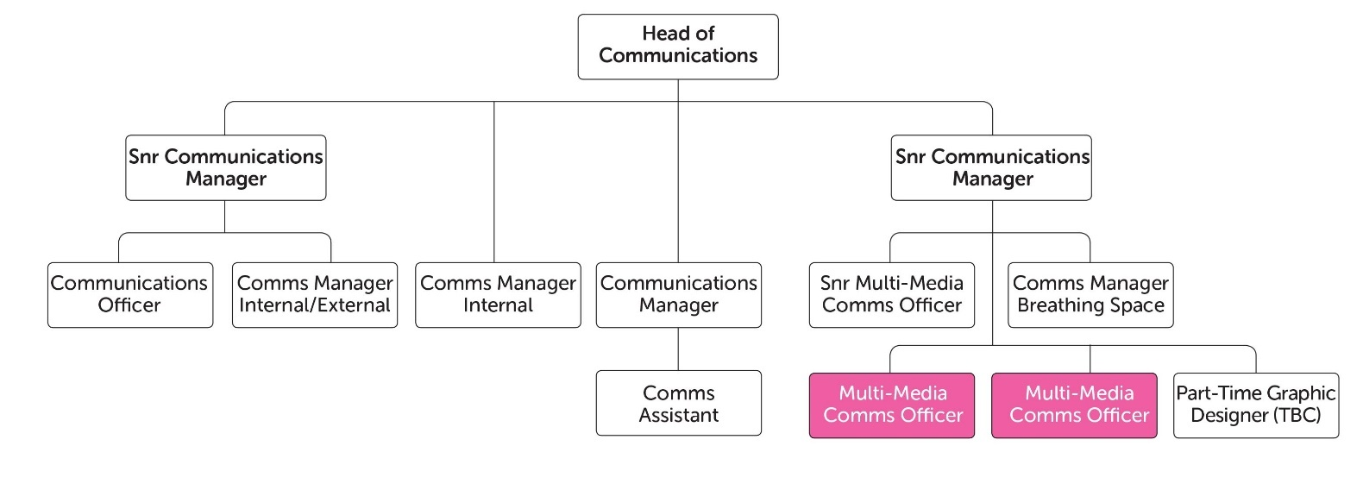
  - SCOPE AND RANGE
NHS 24’s communications function has key strands in its communications strategy: internal communications, marketing and delivery of national health campaigns, media relations, public affairs and social media channels.
NHS 24 is the national provider of digital and telephone based health and care services for Scotland. We provide people with access to information, care and advice through multiple channels including telephone, web and online.
We work in collaboration with partners, the public and our people to co-design services using technology and a digital first approach to sustainable service development and delivery.
NHS 24 is increasingly making use of digital channels of communication both to deliver health and care services, and to engage with the public. The production of high quality digital content is becoming increasingly important to how we deliver services and information.
  - MAIN DUTIES/RESPONSIBILITIES
This post holder will produce multi-media content for NHS 24 services and communications channels. The range of channels for which multi-media content will be required includes but is not limited to web services, events and social networking channels.
This post-holder will also be responsible within the communications team for supporting the development of multi-media content for the intranet as a communications channel and other internal communications channels such as blogs.
Campaign Management
The post-holder will be part of the team delivering multi-media content across a range of projects and platforms, including supporting national marketing campaigns and will be expected to:
- Support the planning and implementation of multi-media content for marketing strategies and campaigns in order that they communicate and influence stakeholder knowledge, behaviour and opinion on existing and emerging services in a positive way;
- Manage the production of audio visual content as part of digital communication projects and when required work with partner NHS Board contacts and the Scottish Government and internal departments;
- Manage, advice and co-ordinate the development of audio visual communication materials, ensuring that the organisation receives high quality service at all times.
- Work with the marketing manager to scope and advise the organisation on the best digital marketing approach for campaigns, web content etc.
- Work alongside and in partnership with multiple stakeholders including health boards, local authorities, patient and public representative organisations and the Scottish Government Health and Social Care Department.
- Report to the Senior Communications Manager, ensuring that they are fully briefed at all times on projects that require digital communications support.
Publications Support
The post-holder is responsible for the effective co-ordination of audio visual content to support NHS 24’s print and online publications and to support the development of audio visual web content for digital services and will be expected to:
- Produce audio visual material for the internal staff magazine Insight, produce engaging content to support the development of a more interactive edition of the magazine, recording stories as required and co-ordinating content in support of the magazine editor;
- Develop clear relations and networks with staff to elicit stories and participation in digital publications;
- Support corporate publications with audio visual content if required such as the annual report, working with relevant colleagues to elicit key information and developing key corporate messages in a digital format;
- When required, train colleagues in the use of audio visual equipment.
- Collaborate with colleagues to develop digital communications standards and guidelines, adapting and monitoring these on a regular basis;
- Assist and train staff in the creation and production of audio visual material;
- Ensure all necessary permissions are in place for the production of digital content for both internal and external stakeholders and patients where required, being sensitive to data protection requirements;
- Monitor, and where possible, ensure the accuracy of digital publications produced by other organisations that refer to NHS 24 and its services;
- Manage all digital/audio visual productions to budget and to timescale, ensuring adherence to Standing Financial Procedures, and using their specialist knowledge ensure efficiency, effectiveness and value for money in its management.
Project Management
The post holder is responsible for the planning and delivery of project management of audio visual content in relation to NHS 24 campaigns, projects and ad hoc initiatives and is therefore expected to:
- Create, lead and co-ordinate audio visual communication plans as part of a project team or group;
- Provide project teams with digital/audio visual communications guidance to meet project objectives and in relation to overall corporate objectives;
- Influence and advise project boards, committees and staff on appropriate digital communications approaches;
- Deliver digital content communications actions efficiently and effectively and be able to adapt those plans as the project and corporate objectives develop to ensure the requirements to produce audio visual content are met for a broad range of projects or initiatives.
Event Support
The post-holder is responsible for the planning and project management of digital content to support and record NHS 24 events including the annual staff conference or achievement awards, Annual Review, VIP visits and open days and is therefore expected to:
- Support project plans and teams for routine events;
- Provide audio visual advertising, promotional and other relevant content to promote events;
- Develop clear relations and networks with staff to elicit participation in the development of digital content events;
- Ensure content produced at events promotes key NHS 24 messages;
Communications Function Support
The post-holder will be part of the communications team and will be expected to support colleagues and cover for some aspects of their roles during both absences and where departmental workload dictates. This arrangement applies to the post holder’s duties when they are unavailable or require support.
The post holder is expected to:
- Plan and project manage the production of digital/audio visual content for ad hoc activities e.g. staff events, audio visual material for senior managers and directors, support for recruitment campaigns, that involve a number and range of participants;
- Deliver relevant presentations internally and externally to key stakeholders;
- Act as an ambassador for NHS 24 with patients, public, external organisations, attending public events and presentations, and where appropriate, the media;
- Be a trained part of NHS 24’s responses to a crisis or major incident, having appropriate training and duties to undertake (e.g. production of internal digital communication to staff such as the intranet);
- Provide training and support to members of staff regarding digital/audio visual communications;
- Be familiar with copyright standards and be able to apply them;
- Deal with general enquiries and requests for information;
- Keep own filing and administrative requirements up-to-date and keeping accurate and accessible electronic files where possible.
Media
The post holder at times may be expected to:
- Work with Communications colleagues to manage audio visual content during media visits, Ministerial or VIP visits and photocalls;
- Produce appropriate and high quality audio visual content working with the media team that can be disseminated in a range of formats to digital and broadcast media across Scotland in accordance with publication deadlines.
Policy/Service Development
- The post holder has discretion to interpret and advise on NHS 24 Communications policies and procedures. In addition the post holder will be expected to lead policy development work in relation to the adoption and development of the organisation’s Multimedia/Digital Communication.
- Develop an annual Digital Communications plan and proactively make recommendations for changes to ensure NHS 24 software applications in relation to digital communication can continue to meet organisational requirements, identifying, proposing and agreeing new developments and processes for the provision of digital communications, with particular emphasis on recommending and progressing digital communication technology changes and changes to related processes where appropriate.
Miscellaneous Duties
The post holder will also be expected to:
- Represent the Head of Communications/Senior Communications Manager where appropriate both internally and externally at events and stakeholder meetings relevant to the digital agenda;
- Carry out his/her duties with due regards to NHS 24’s HR policies;
- Demonstrate duties to new members of staff to the Communications team.
- Be aware of their responsibilities to maintain a safe and healthy environment for staff, visitors and the public which specifically are:
- Responsibility to consider yourself and anyone else who could be affected by the things you do, or don’t do , while at work;
- Responsibility for informing your manager of any health and safety concerns you identify and for completing an adverse event form for any accidents, incidents or near-misses that happen to you or that you are aware of to reduce injuries or loss;
- Ensure that all duties are carried out to the highest possible standard, and in accordance with current quality initiatives within the area of work;
- Respect the confidentiality of all matters that they may learn in the course of their employment and respect the requirements under the Data Protection Act;
- Undertake any other duties which may be required from time to time.
- Given the nature of the post, the post-holder is required to work flexibly to meet the demands of the post. As the post-holder is expected to form part of the crisis or major incident response, out-of-hours calls may be received and unsociable hours worked. This job description will be subject to review in consultation with the post-holder, taking into account the need to balance service provision with other communications functions and activities.
- 5. SYSTEMS AND EQUIPMENT
The post holder will possess skills and experience with the use of a broad range of software applications including Content Management Systems such as Sitecore, SharePoint and other open source solutions as required, but particularly for NHS 24’s intranet.
The post holder will support the management, design and development of digital content for the intranet with particular regard to ensuring that the intranet to allow digital content to be displayed on it – this would be working closely with the internal communications manager, who has overall responsibility for the intranet. Additionally, the post holder will support social media planning and delivery so should have an understanding of social media management tools such as Hootsuite/Sendible
There will be a requirement for the regular use of the full suite of Microsoft Office software including Word, Excel, PowerPoint, Outlook and Access.
The post holder will possess extensive knowledge of multimedia hardware and software necessary for image, video and audio production - this may include:
DSLR cameras, handycams and mobile phones for filming
Non-linear editing packages such as Vegas Pro for post-production
Audio equipment including microphones, pre-amplifiers, field recorders and audio interfaces
Digital audio workstations such as Cakewalk for audio recording and mixing
Image editing packages such as GIMP and/or Canva for image editing and info graphic creation
Image, video and audio formatting standards to make sure media is optimized for each platform
Web tools including cloud storage and file transfer systems
Windows 7 and Windows 10
eExpenses – For inputting expenses online.
Video and teleconferencing systems
- General Equipment – Use of personal computer or laptop, printer, fax machine, telephone, photocopier, scanner, digital camera and audio visual equipment.
- 6. DECISIONS AND JUDGEMENTS
The post-holder must be an experienced multimedia specialist with a proven track record and knowledge of digital communications, audio visual content development for the web, digital public relations and marketing approaches and procedures and be able to advise and make day-to-day decisions on that basis.
The post-holder will be expected to:
- To influence and persuade colleagues, committees, groups internally and externally on appropriate digital marketing approaches;
- The post-holder will be the lead specialist responsible for the effective management of the development of digital audio/visual content across a range of projects and platforms.
- Decide how to run audio visual content projects and respond to sensitive or complex issues;
- Develop digital/audio visual content that is appropriate to the organisation and to brief and work with internal and external stakeholders as required;
- Make recommendations on the best and most cost effective methods of communicating to different audiences through audio visual communication channels;
- Have responsibility for elements of campaign budgets, ensuring that all services are delivered on time and within agreed costs;
- Make day-to-day decisions on the presentation of audio visual information in line with corporate objectives;
- Advise colleagues internally and represent NHS 24’s Communications function externally at a senior level internally and externally;
- Ability to recognise when issues should be escalated to the Head of Communications.
7. COMMUNICATIONS AND RELATIONSHIPS
The role will require extremely good communication and facilitation skills. Contact and discussions will be required at all levels of the organisation to develop good working relationships both internally and externally.
The post holder will be required to be an effective bridge between the business and the technology world, often having to explain the complexity and meaning of technical concepts and thinking in concise non-technical language and translating expressions of business goals into implications for technology.
Internal:
- A high quality of verbal, written and digital communication skills is expected with all internal stakeholders including the Executive Team;
- Ability to work closely with internal stakeholders as part of a project team;
- Able to take responsibility for the creation and delivery of digital content based communication activities;
- Maintain positive working relationships with all colleagues in the Communications department and ensure that the Head of Communications is informed appropriately of activities and issues.
External:
- A high quality of verbal, written and audio visual communication skills is expected with all external stakeholders including the ability to communicate organisational objectives and messages clearly and effectively;
- Represent NHS 24 at national meetings where relevant involving key stakeholders including partner NHS Boards and the Scottish Government;
- Visiting partner NHS Boards to record content for audio/visual productions
- Supporting PPF activities, giving presentations to and meeting with members of the public and other visitors and stakeholders in order to produce relevant digital content for internal and external use;
- Representing NHS 24 on communication groups and committees involving other NHS Scotland or public sector stakeholders;
- Briefing and commissioning agencies and other supplier organisations as required in relation to audio visual content;
- Verbal and written communication contact with members of the press and media from time to time where the dissemination of digital content is involved;
- Guiding, influencing and creating key campaign messages in a digital format;
- Producing audio visual content for external audiences e.g. NHS Scotland board communication channels including social media.
8. PHYSICAL DEMANDS OF THE JOB
Physical
- Maintenance and moving of audio visual equipment as required and transporting between sites and filming locations
- Lifting and moving equipment for exhibition displays and promotional material to various locations for external events.
- Transporting laptop and editing equipment when visiting other NHS 24 sites.
Mental
- The post holder will frequently be required to concentrate for prolonged periods of time to research and produce digital articles, publications, and produce digital marketing plans;
- Ability to deal with interruptions and ad hoc requests for immediate support by work colleagues by email and telephone.
Emotional
- Ability to think clearly and give advice to colleagues and other stakeholders when under pressure to meet deadlines.
- Ability to meet challenges to decisions or advice calmly including dealing with difficult people and situations e.g. public meetings
- Respond to difficult organisational situations.
Working Conditions
- The role necessitates a significant amount of travel both nationally between NHS 24 sites and external venues for meetings and internationally across Europe often via car, plane, or public transport.
- This role is predominantly based at a PC and the post holder is required to spend extended periods of time working with VDU equipment continuously, and works predominantly in an office environment.
- MOST CHALLENGING/DIFFICULT PARTS OF THE JOB
- Working to tight deadlines
- Working between sites and across teams
- Representing views of the organisation
- Supporting a wide programme of work across Scotland with the production of relevant and high quality content.
- Distilling and effectively communicating key organisational decisions in a digital/audio visual format.
The post holder will be required to liaise with managers to capture and understand their business needs and provide recommendations on how this can be achieved. This may require the post holder to communicate highly complex technical information to non-technical experts.
- KNOWLEDGE, TRAINING AND EXPERIENCE REQUIRED TO DO THE JOB
- Educated to degree level in appropriate communications, media or video production or equivalent qualification/experience
- Experience of working on web and digital based developments
- Proven experience of the entire video production journey, including pre-production, filming, editing, audio recording, audio post production and formatting
- Experience of podcast production, including recording, mixing and mastering
- Knowledge and interest in digital development and emerging technologies – ability to horizon scan and translate requirements for NHS 24
- Experience of content management systems e.g. Sitecore/SharePoint
- Experience of the use of web tools, browsers and products to support the management and dissemination of high quality, engaging content across existing and emergent social media sites
- Experience of effective audio visual content management on both local and national campaigns
- Proven relationship management and negotiation skills
- Excellent written, verbal and audio visual communication skills
- Skilled in communicating with external agencies such as NHS Boards, public representative organisations
- Experience of handling and dealing effectively with a wide range of stakeholder enquiries.
- Experience in managing suppliers and delivery to timescales and on budget
- Proficient in a range of IT skills
- Excellent time management
- Enthusiasm, commitment, positive attitude to problem solving
- Ability to act independently and to set and deliver to deadlines

Recruitment Process
The NHS Scotland Everyone Matters 20:20 Workforce Vision outlines the commitment the Scottish Government has in putting people at the centre of everything the NHS in Scotland does. Working to a common set of values will guide the work staff do, the decisions that we take and the way we treat each other. Using a Values Based Approach to recruitment will ensure that NHS 24 staff members not only have the competencies required for the role, but they will live and breathe the values needed, to ensure that patients receive the best possible care, and that all staff are valued and treated well.
We will use a Values Based Approach in our selection process which will consist of the following assessments:
- Application Shortlisting – applications forms received are reviewed and those meeting the role requirements will be invited to a competency based interview.
- Interview / Assessment – these competency based interviews have a focus on NHS 24 Values and the candidate's technical expertise. The interview may also include a role specific test or a presentation topic.
QUERIES:
For any queries in relation to this vacancy, please contact a member of the HR Business Support Team via email at: recruitment24@nhs24.scot.nhs.uk
GENERAL:
Equality & Diversity:
NHS 24 is committed to equality & diversity:
http://www.nhs24.scot/about-nhs-24/policies/equality-and-diversity/
APPLICATION DETAILS
If you think this is the career for you, then please submit an online application no later than midnight on 07th March 2022.
The Candidate Application Guide included with this vacancy provides information on how to make the most of your application.
*Candidates submitted via Recruitment Agencies will not be considered for this post.

