Trainee Mental Health Nurses – EARN while you LEARN
An opportunity to start your journey to becoming a Registered Mental Nurse

MENTAL HEALTH SPECIALITIES
Adult Acute Mental Health
Rehabilitation Mental Health
Older Age Mental Heatlh inc Dementia
Forensic Mental Health
Eating Disorders
Alcohol & Substance Misuse
Child & Adolescent Mental Health
Mother & Baby Mental Health
Addiction Services

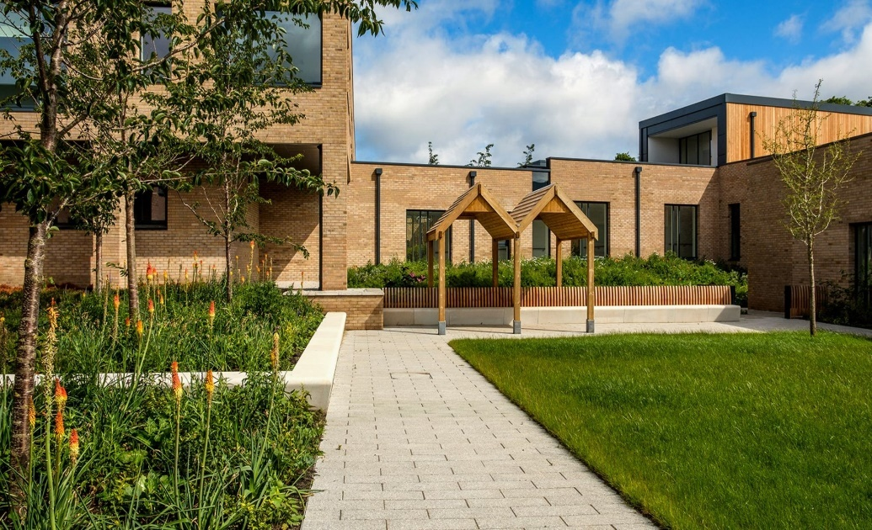

NHS Lothian, in partnership with the Open University, are seeking to recruit 20 trainee Mental Health Nurses to
undertake the BSc (Hons) Mental Health Nursing through the Open University.
This is a unique opportunity to be supported by both organisations
to study to become a Registered Mental Health Nurse whilst employed on a
permanent contract with NHS Lothian.

Due to the nature of the program of study and clinical placements,
you must be willing to work / have clinical placements on both
the Royal Edinburgh Hospital site, Morningside, Edinburgh
and at Specialist Regional Mental Health Units based at St John’s Hospital, Livingston

APPLY at https://apply.scot.job.nhs.uk Ad open from 30th May 2022 until 19th June 2022

INTERVIEWS will be held week beginning Monday 4th July 2022

START WORK as a Band 2 HCSW on 5th September 2022
technology
consulting

