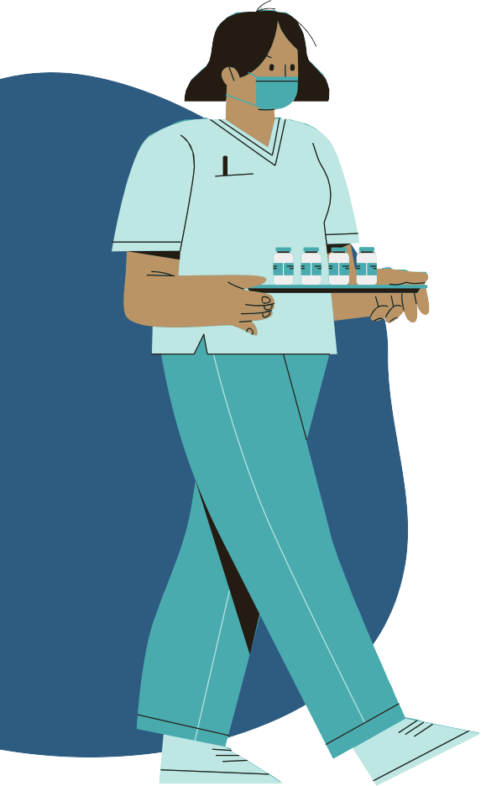
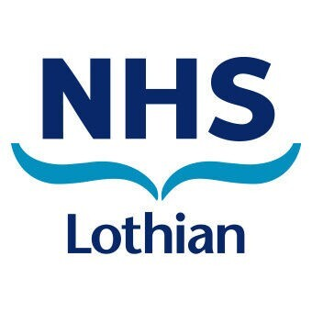
TRAINEE MENTAL

HEALTH NURSES

APPLICATION
PROCESS

1
Advert go live on Monday 30th May https://apply.jobs.scot.nhs.uk
2
Advert closes Sunday 19th June

3
Interviews week beginning Monday 4th July 2022

4
Offers and Pre employment checks July / August

5
Begin in post as a Band 2 HCSW on 5th September 2022

FOR ENQUIRIES EMAIL US AT
genericrecruitment@nhslothian.scot.nhs.uk

