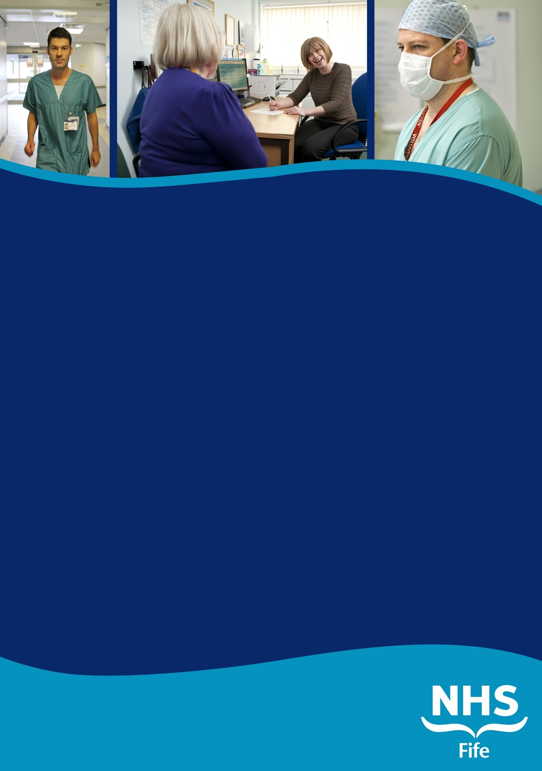
www.medicaljobs.scot.nhs.uk
www.nhsfife.org
CONSULTANT IN
PAEDIATRIC INTENSIVE
CARE

ROYAL HOSPITAL FOR
SICK CHILDREN
INFORMATION PACK

www.medicaljobs.scot.nhs.uk
www.nhsfife.org
CONSULTANT IN
PAEDIATRIC INTENSIVE
CARE

ROYAL HOSPITAL FOR
SICK CHILDREN
INFORMATION PACK

CONSULTANT in Trauma & Orthopaedic Surgery

ACUTE SERVICES DIVISION
NHS FIFE

INFORMATION PACK

REF: 012345A
CLOSING DATE: NOON 7TH FEBRUARY 2014
Information for Candidates

CONTENTS

Page(s)

Post Information

Orthopaedic Surgery, Victoria Hospital, Kirkcaldy

Post Description

Duties & Responsibilities

Job Planning

Person specification

Terms and Conditions of Service

Fife Region
How to Apply

SUMMARY INFORMATION

POST: CONSULTANT IN TRAUMA & ORTHOPAEDIC SURGERY – UPPER LIMB

BASE: VICTORIA HOSPITAL, KIRKCALDY

NHS Fife wishes to appoint a Consultant Trauma and Orthopaedic Surgeon, with a special interest in upper limb trauma. There will be scope to develop an upper limb elective practice to fit in with the needs of the department. The post holder would join our team of 18.5 Consultants and complement the existing subspecialty interests.

Experience in adult and paediatric general trauma is essential with a particular interest in upper limb trauma management. The candidate is expected to take part in the Trauma on-call rota (currently 1:11). The department has a strong record in research with established links to Edinburgh and St Andrews Universities.

NHS Fife serves a catchment area with a population of 380,000 across Fife with the post being based at the Victoria Hospital Kirkcaldy. On occasion you may be required to work at one of the other facilities used by NHS Fife at Queen Margaret Hospital Dunfermline, the Adamson Hospital Cupar, and St Andrews Memorial Hospital. We are currently developing a new elective orthopaedic facility, as part of the National Treatment Centre programme, which will consist of 3 theatres, a 34-bed ward area and outpatient facilities, which is due to open in late 2022.

The Directorate provides out-patient clinics, Trauma and Elective surgery for adult patients’ throughout the Fife area. We also provide general trauma management for paediatric patients. There are currently 6 teams with Consultants providing general Orthopaedic services plus specialist care in major joint replacement and reconstruction, Arthroscopy, Upper and Lower Limb surgery. Interested applicants may obtain further information and/or arrange a visit by contacting either Andy Ballantyne, Clinical Lead, on 01592 643355 ext 29634 or Sarah Mitchell, Trauma Lead, on 01592 643355 ext 28592.

ORTHOPAEDIC SURGERY, VICTORIA HOSPITAL, KIRKCALDY

Acute Care in Fife was centralised in January 2012, with the opening of the new Phase III of the Victoria Hospital, Kirkcaldy. A new Emergency Department opened at this time and saw over 60,000 patients in the first year of operation.
The Orthopaedic Department currently has a dedicated 27-bed (3 side rooms) elective orthopaedic ward in Phase II, which is ring-fenced with a strict infection control protocol. This ward is supported by a team of Nursing ANP’s who support the medical management of the elective patients. There are 2 dedicated, laminar flow orthopaedic theatres in Phase II allowing ~800 TKRs and THR’s to be performed per annum. NHS Fife is currently in the process of building a new elective orthopaedic facility on the Victoria Hospital site, as part of the National Treatment Centre programme. This will provide a 3 theatre complex, a 34 bed inpatient facility with day of surgery admission unit. It will also accommodate an Outpatient area for delivery of MSK services. Completion is due in late 2022. This exciting development will allow delivery of modern orthopaedic services in a custom build facility to meet local needs.

There are two 26-bedded orthopaedic trauma wards (31/33) in Phase III along with a laminar flow trauma theatre (Th6). We have a fragility fracture ward of 26 beds with dedicated MoE support 5 days per week (Daily MoE consultant ward rounds with ANP Fragility nurse support). In Phase III there is access to the Day Intervention Unit for day case procedures and a paediatric ward for paediatric trauma admissions. The department treats ~4500 fractures per year across both sites (VHK and QMH) with outpatient clinics situated on both sites, along with satellite clinics at Cupar and St Andrews. There is a Virtual Fracture Clinic system in operation to streamline outpatient management of patients with fractures. At QMH there is access to the Day Surgery Unit with capacity for overnight stay supervised by an RMO Mon-Fri.

In-Patient Specialty Support On site

On-site support includes Anaesthetics and ICU, Accident and Emergency Medicine, General Medicine (with Medical HDU), Cardiology and CCU, General Surgery (with Surgical HDU), Trauma and Orthopaedics, Maxillofacial Surgery, Paediatrics and Obstetrics & Gynaecology.

ENT is on-site Monday 0800 to Friday 1700.

Emergency Radiology is provided in a dedicated emergency diagnostic suite directly adjacent to the A & E Department. There is 24 hour access to CT scanning. MRI is available on site within office hours.

Emergency laboratory investigations are available 24 hours per day.

There is a stroke thrombolysis service which operates 24/7 either through on-site stroke or emergency physicians or telemedicine support from the regional hub.

MINOR INJURIES UNIT, QUEEN MARGARET HOSPITAL (QMH), DUNFERMLINE

A 24/7 Emergency Nurse Practitioner Minor Injuries Unit runs in the former A & E Department at Queen Margaret Hospital, Dunfermline. Telephone support is provided by the Consultant and middle grade staff at VHK Emergency Department.

Post of Consultant in Trauma & Orthopaedic Surgery, Fife Acute Hospitals
NHS Fife is looking to appoint an enthusiastic, forward thinking consultant orthopaedic surgeon to join a team of 18.5 Consultants in the department. The post has been created to expand the Department in NHS Fife’ Acute Hospitals Operational Division to meet the rising demand for orthopaedic services in Fife, across both Acute and Primary Care.

Definition
You will be expected to provide expertise in general orthopaedic surgery and Upper Limb Trauma. There will be scope to develop an elective upper limb practice that will fit in with the needs of the department. In addition to managing a general trauma workload, there is a commitment to trauma service on-call (currently 1 in 11). This manages both adult and paediatric general trauma and experience in these areas is required. The post will be based in Victoria Hospital, Kirkcaldy, along with input to either Queen Margaret Hospital, or one of the other community hospitals

Staffing
The Department is being expanded to 20.5 surgeons with this post and the department staffing is as follows:

Consultant Staff:
Mr A Akhtar Knee/Lower limb surgery
Mr J Annan Lower Limb Arthroplasty/Revision Knee
Mr A Ballantyne Hip Surgery/Revision Hip
Ms K Bugler Paediatric Orthopaedic Surgery (shared post with RHCYP Edinburgh)
Mr D Chesney Knee Surgery
Mr R Clayton Foot & Ankle Surgery
Mr R Cook Shoulder Surgery/Lower Limb Arthroplasty
Mr J Cowie Lower Limb Arthroplasty/Revision Hip
Mr E Dunstan Hip Surgery/Revision Hip
Mr S Harrison Hand surgery
Ms J McEachan Hand, Wrist & Elbow Surgery
Mr S Middleton Foot & Ankle Surgery
Mrs S Mitchell Knee Surgery
Mr S Sharma Shoulder Surgery
Mr C Tiemessen Lower limb Surgery
Mr P Walmsley Knee Surgery/Revisions
New Post 1 (Appointed w/c Aug 2022) Lower Limb Arthroplasty
New Post 2 (Appointed w/c Sep 2022) Lower Limb Arthroplasty
New Post 3 (Appointed w/c Feb 2023) Lower Limb Arthroplasty
New Post 4 (separate advert) Lower Limb Arthroplasty
Vacant Post (this advert) Upper Limb Surgery

Middle Grades
ST3 – ST6: From SE Scotland rotation 7.0
Specialty Doctors Middle Grade 3.0
Clinical Development Fellow 4.0
4 Junior Doctors 4 FY1/2 4.0
Multi-disciplinary Team

GP with Special Interest (GPwSI) 1 session 0.2
Extended Scope Physiotherapist 1.0
Specialty Doctor (Medicine for the Elderly/Medical Education) 0.6 (Ortho)
2 Consultant (Medicine for the Elderly) 6 sessions/week
10 ANP Nurses across Frailty (hip fracture support)
& Elective (ward 10) 8.0

Support Facilities (Offices/Secretary): Secretarial support will be provided and office space will be shared with 2 other Consultants in the Department.
DUTIES AND RESPONSIBILITIES
The main duties and responsibilities for the posts include the following:

Clinical Duties
Except in emergencies or where otherwise agreed with your clinical manager, you will be responsible for fulfilling the duties and responsibilities and undertaking the programmed activities set out in your new Job Plan in a flexible manner, as reviewed from time to time in line with the provisions below.
The clinical commitments of this post will include responsibility for inpatient and outpatient care at Victoria Hospital Kirkcaldy, and a provision of service to all patients of NHS Fife. The post holder will have access to elective and trauma inpatient beds, located at the Victoria Hospital on Wards 10, 31 & 33. There is a dedicated day-case facility for use at Queen Margaret Hospital Dunfermline. Outpatient clinics will be conducted at both Victoria Hospital Kirkcaldy and Queen Margaret Hospital Dunfermline. This may include evening New Patient clinics. This work pattern has been adopted by a number of current Orthopaedic Consultants within the department. There is a full complement of nursing and paramedical staff.
Associated Duties
The post holder will be responsible for the associated duties set out in Schedule 2 of the Terms and Conditions. These include, amongst other things a requirement to:
    - Establish links with General Practitioners to provide advice to them about the management of patients with orthopaedic conditions.
    - Collaborate with colleagues in primary and secondary care to implement protocols for the management of patients with trauma and elective conditions.
    - Keep him/herself up to date with developments in the speciality. It is expected that active consideration will be given to existing technologies in terms of cost effectiveness. In addition, the use of new techniques where they can be justified clinically will be encouraged.
    - Contribute to post-graduate and continuing medical education. The Board supports the requirement of CME as laid down by the Royal College of Surgeons and is committed to providing time and financial support for these activities.

JOB PLANNING

The Job Plan is provisional and still to be finalised. In particular, you may be asked to consider extra Programmed Activities of direct clinical care. The level of participation in on-call will be agreed at job planning and appropriate PAs agreed (either as extra Programmed Activities or in exchange for other DCC activity). Your job plan will be subject to review once a year by you, your colleagues in Orthopaedics and the Lead Clinician/Clinical Director, as laid out in the terms & conditions of the new Consultant Contract. Opportunities to undertake Extra Programmed activities will be offered if there is service requirement.
In the event of any significant changes in the circumstances affecting this job plan, it is agreed that it will be renegotiated jointly in collaboration with Consultant colleagues
SAMPLE JOB PLAN – for Consultant and SAS Doctors
Name:
Speciality: Trauma & Orthopaedic surgery
Contract: Whole time, 10 PA’s
Part A: Fixed Commitments
Weekly timetable of Fixed Commitments * (i.e. regular scheduled NHS activities in accordance with paragraph 30B of the terms and conditions of service). This is an example of type weekly timetable expected of the post. Days that these activities are delivered may be different. Additional PAs would be considered for management responsibilities as part of professional development
Day | Hospital/Other Location | Type of Work | PA’S
Monday am | Trauma | Trauma list | DCC (4hrs)
Monday pm | Trauma | Trauma list | DCC (4hrs)
Tuesday am | DCC admin |  | DCC (4hrs)
Tuesday pm | SPA |  | SPA (4hrs)
Wednesday am
Wednesday pm | OPD | Outpatients (fracture clinic, alternate weeks) | DCC(2hr)
Thursday am | OPD | Outpatients (review) | DCC(4hrs)
Thursday pm | OPD | Out patients (NP) | DCC (4hrs)
Friday am | Theatre  VHK ph III | Elective theatre | DCC(4hrs)
Friday pm | Theatre  VHK ph III | Elective theatre | DCC (4hours)

* Each fixed session equates to a 4.0 hour Direct Clinical Care Session as defined by the new consultant contract
Out of hours
1 in 11 with prospective cover
2. On-call availability supplement

Agreed on-call rota e.g. 1 in 11 | 1 in 11 with prospective cover

Agreed category : | Level 2

On-call supplement e.g. 5%: | 3%

A split of 9:1 between Direct Clinical Care PAs and Supporting PAs has been agreed for this post. The SPA’s will reflect activity such as appraisal, personal audit and professional development occurring outside study leave time. A second SPA may be included in recognition of activities such as undergraduate and postgraduate medical training which takes place outside direct clinical care, as well as research and/or management. These activities must be specifically and clearly identified and be agreed with the candidate and desired by the Department on commencement of the post.

Cover for Consultant Colleagues

Annual / Study Leave – You will be required to provide emergency cover for Consultant colleagues during annual or study leave. If for any reason such deputising is not practicable, Fife Acute Hospitals Operating Division undertakes to authorise immediate Consultant locum cover.

Managerial

The post holder will be expected to work with local managers and professional colleagues in the efficient running of services and will share with Consultant colleagues in the medical contribution to management. Subject to the provisions of the Terms and Conditions of Service, the post holder is expected to observe agreed policies and procedures drawn up on consultation with the profession on clinical matters and follow the standing orders and financial instructions of NHS Fife. In particular, NHS Fife management are expected to follow the local and national employment and personnel policies and procedures. The Post holder will be expected to ensure that there are adequate arrangements for hospital staff involved in the care of patients to be able to contact him/her when necessary. All medical and dental staff are expected to comply with the NHS Fife Health and Safety Policies.

Teaching

Clinical supervision of trainees has a high profile in the Department and is an important part of the Consultant role. The appointee will take an active role in the training of junior staff. He/she will also be responsible, in collaboration with colleagues, for the supervision and training of a middle grade doctor (Trust Doctor or non-consultant career grade doctor) and Foundation Programme Doctors. He/she will be expected to conduct regular appraisals. There are regular placements for medical students from Edinburgh, Dundee and St Andrews Universities. The appointee may be required, on occasion, to contribute to their teaching. There is an ongoing programme of weekly Departmental teaching sessions for the middle grade doctors (StR’s, Fellow & SD’s) in which the post holders will be expected to participate. STs attend monthly whole day teaching sessions at Edinburgh Royal Infirmary and Fife Consultants may be expected to contribute to this programme. One to one teaching for middle grades, including assessment of their management and non-technical skills, has commenced.

Medical students from St Andrews University attend morning sessions on a Thursday for 2 semesters per year. The Department also takes students from Edinburgh University Medical School for placements in 4th year as part of the musculoskeletal module and in 5th year Selected Study Component (SSC) modules. There may opportunities to develop an interest in medical education or teaching of medical students.

Continuing Medical Education

The Board supports and will require the successful candidate to participate in Continuing Medical Education (CME). You are entitled to 30 days’ paid study leave within any 3-year period, with expenses for the purposes of CME.

Research

Interest in research is welcomed and would be supported by Consultant colleagues. The successful applicant will be encouraged to participate in research on clinical and/or service issues relating to trauma and elective orthopaedic surgery. The Department has an active research programme and good past record with peer-reviewed publications. There would be opportunities to contribute to this. The Department has support from NHS Fife R&D, receiving support from dedicated research nurses and is currently involved in several NIHR and industry sponsored multi-centre trials.

Clinical Governance

There will be annual appraisal arranged by a trained appraiser from within NHS Fife. Clinical Governance requires that all clinical staff accept personal responsibility for knowing what constitutes best practice in their field, defining policies to translate this into practice within their own service and measuring the clinical outcomes of the service. NHS Fife is adopting an approach to Clinical Governance which will draw together its clinical audit programme, complaints and litigation management, risk management, continuing medical education and clinical leadership.

NHS Fife Operational Division is committed to maintaining a high quality of services to patients, with particular regard to patient safety, by continual development of practice in the light of research evidence and by audit based against relevant standards.

Consultant in Trauma & Orthopaedics Surgery Person Specification

Requirements | Essential | Desirable
Qualifications | Primary medical qualification. Full registration with the General Medical Council,  FRCS (Tr&Orth)  Entry on Specialist register or in receipt of CCT or CESR within 6 months | Higher Qualification eg. MSc/MCh/MD/PhD
Clinical Skills and Experience | Specialist Registrar training in Trauma & Orthopaedic Surgery or equivalent.  Full Validated log book summary.  Evidence of appropriate CPD.  ATLS provider  Competency in managing general adult and paediatric orthopaedic trauma | Fellowship training in Upper Limb Trauma
Teaching | Evidence of formal or informal teaching, training and supervision of junior medical staff, medical students and other clinical staff. | Evidence of formal training in teaching.
Audit | Proven experience of clinical audit. | Proven use of audit as a tool to manage change in clinical practice.
Research and Publication | Ability to supervise audit projects.  Understanding of principles of research and audit. Regular attendance at audit meetings | Publications in peer-reviewed journals.  Membership of appropriate societies eg. BOA, BHHS,
Management | Enthusiasm and commitment to the speciality  Awareness of Management issues in the NHS | Desire to develop services for patients.  Experience in initiating change.  Management training/Medical Leadership Qualification
General Attributes | Able to work in a team with colleagues in own and other disciplines.  Able to organize time efficiently and effectively.  Good communication skills.  Commitment to CPD  Enthusiasm to develop service

Additional Information for Candidates

FIFE REGION

The Region of Fife is bounded in the north by the Firth of Tay, in the east by the North Sea and in the south by the Firth of Forth. The Region spans an area of 130,700 hectares and has a population of 380,000. The population served by NHS Fife is currently around 380,000. There is a highly developed agricultural area in east and north-east Fife, and in the west there is an extensive cross-section of highly skilled and scientifically orientated industry. The largest towns are Dunfermline, Kirkcaldy and Glenrothes. The cathedral city of St Andrews is the seat of Scotland’s oldest and the UK’s second oldest university.

Living in Fife offers a good quality of life. Many options are available for rural, coastal or town living and all can be achieved with easy access to the hospitals. Fife has a number of good schools across the region. Current good quality housing is available and is of good value. Opportunities exist for coastal living in one of the many picturesque fishing villages or towns along the Fife coast. Some colleagues live in Edinburgh with an easy commute across the Forth to the Fife hospitals.
Fife is an area of considerable scenic and historical interest. The usual range of sporting facilities are available locally including golf, swimming, fishing, curling, soccer, rugby, cricket, sailing, motor sport and gliding. The Cairngorm Mountains are within easy reach providing access to skiing, mountaineering, orienteering, stalking and salmon fishing. Wide ranges of cultural activities are available in Fife, and in the cultural centres of Edinburgh and Glasgow. The main urban and leisure centres of central Scotland are within easy reach and there are excellent air, rail and motorway links to the rest of the UK. Edinburgh, Dundee & Glasgow Airports are within easy reach by road.

HEALTH CARE IN FIFE

Health care in Fife is provided by an Acute Services Division and three Community Health Partnerships:

Acute Services Division – Acute services for Fife

Three Community Health Partnerships – Community, Learning Disability and Mental Health Services for Fife

Corporate Services are based at the Board’s Headquarters, Hayfield House, adjacent to Victoria Hospital, Kirkcaldy.

HOW TO APPLY:

Prospective applicants wishing to visit the Department or who would like further information should contact:

Mr Andy Ballantyne (Clinical Lead)
Consultant Orthopaedic Surgeon
Victoria Hospital
Hayfield Road
Kirkcaldy
Fife KY2 5AH

Tel: (01592) 643355 ext 29634
E-mail: andy.ballantyne@nhs.scot

or

Mrs Sarah Mitchell (Trauma Lead)
Consultant Orthopaedic Surgeon
Victoria Hospital
Hayfield Road
Kirkcaldy
Fife KY2 5AH

Tel: (01592) 643355 ext 29797
E-mail: sarah.mitchell4@nhs.scot
www.medicaljobs.scot.nhs.uk
www.nhsfife.org

