JOB DESCRIPTION 

1. JOB IDENTIFICATION
Job Title: Undergraduate Medical Education Coordinator

Responsible to: Medical Education Services Manager

Department: Medical Education

Directorate: Medical Director’s

Job Reference:

No of Job Holders: 3

Last Update: 17th May 2022

2. JOB PURPOSE
To coordinate undergraduate medical education. Medical education includes a number of different work streams: routine medical student placements from the Universities of Edinburgh, Dundee, Aberdeen and St Andrews as well as the postgraduate ScotGEM programme; special medical student placements e.g. electives and pre-medical school placements; organising teaching events; coordinating Clinical Assistantships, overseeing quality control; ACT monitoring.

3. DIMENSIONS
- ~ 1600 undergraduate placements
- 4 University Medical Schools (St Andrews, Edinburgh, Dundee, Aberdeen)
- Recent introduction of new Postgraduate Course ScotGEM
- 30 medical and surgical specialties
- 22 consultant lead tutors
- > 150 consultants involved in undergraduate teaching

4. ORGANISATIONAL POSITION
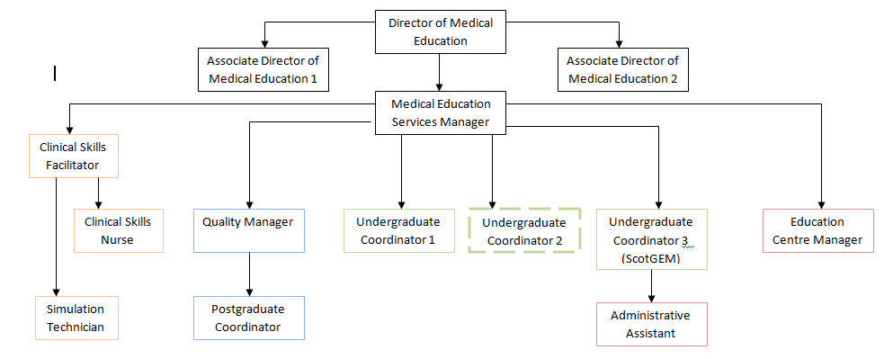

5. ROLE OF DEPARTMENT
The team coordinates the delivery of medical education within NHS Fife for over 800 medical students and around 220 postgraduate doctors in training. Partnership working with the universities of Edinburgh, St Andrews, Dundee and Aberdeen is a key activity as is managing a substantial ACT budget. The annual rotation of doctors in training is also a significant management exercise, undertaken in partnership with the local HR, and NHS Education Scotland.

Medical Education also undertakes rota design and New Deal Contract monitoring. It also manages the delivery of the core teaching programmes of Foundation doctors and GP trainees.

Medical Education partners with SEFCE (the South East Scotland Faculty of Clinical Educators) so help NHS Fife Education Supervisors and Clinical Supervisors to gain GMC recognition and approval.

The department manages two education centres that provide space through which medical education is delivered by clinicians. Within the QMH Education Centre there is now a state of the art Simulation Ward. VHK is the primary centre with QMH used for regional and national events and NHS Fife events requiring half and whole day bookings.

6. KEY RESULT AREAS
- Routine Medical School Placements

- Liaises with medical school and Local Module Leads (LMLs) and quantifies their placement needs over the academic year, in consultation with the Director of Medical Education (DME).

- Liaises with LMLs within NHS Fife to ensure they are aware of the medical school requirements, for which £4m Addition Cost of Teaching (ACT) funding per annum is received. Reminds them ahead of the commencement of placement programmes and provide administrative support if required.

- Lead on the design of new placements within NHS Fife, ensuring high quality placement experience which meets the learning outcomes (LOs) as determined by the university.

- Delegates routine administrative tasks to the Administrative Assistants.

- Manages and updates the Access database that is used to record student throughput and the requests for student accommodation, Digital and Information system access and ID Badges.

- Responsible for ensuring complex education programmes are adjusted and reformulated in line with curriculum changes; vital for post holder to be an expert in this field.

- Special Medical School Placement Programmes

- Organises specific placement initiatives locally, such as the Clinical Assistantships for the University of Edinburgh and the Clinical Consolidation Blocks for St Andrews.

- Liaises with medical school and local module leads and quantifies their placement needs.

- Establishes and maintains relationships with external partners, such as University of St Andrews and Fife Council to widen access to medical education to those from non-typical backgrounds.

- Leads and develops the Work Experience (pre-medicine) programme.

- Delegates routine administrative tasks to the Administrative Assistants, in consultation with the Education Centre Manager and Quality Manager.

- Electives

- Receives requests directly from medical students for electives (or from the DME) via email.

- Uses own judgement on which elective to grant a placement to, based on local criteria, and in consultation with the Medical Education Services Manager (MESM).

- Arranges for clinical supervision and accommodation, if needed.

- Meets and greets elective medical students on arrival and ensure they have all they need during their stay.

- Completes any documentation required by the medical student at the end of their placement.

- Additional Teaching Events

- Facilitates the local delivery of royal college training events such as Royal College of Physicians Edinburgh Evening Medical Updates, RCPE diploma training, O&G PROMPT, etc

- Coordinates Transition Workshops organised locally and through the SEFCE initiative PULSE.

- Facilitates the local delivery of Clinical Educator Programme events.

- Quality Control

- Monitors quality control information collected by the medical schools and investigates underlying causes of poor performance when it is identified.
- Creates action plans to target areas requiring improvement and monitor progress, reporting back to MESM.

- Drafts the annual DME Report to NES in partnership with the Postgraduate Quality Manager, overseen by the DME.

- Facilitates the annual liaison meetings with the medical schools, ensuring the events are publicised and well organised. Create action plans as required.

- ACT monitoring

- Maintains an operational knowledge of ACT and in particular, Measurement of Teaching (MoT)

- Receives MoT data compiled by the ACT Officers and confirms its accuracy.

- Assists in preparing ACT budget bids

- Leads on the production of the ACT Accountability report each year.

- Facilities Management

- Ensures the education centres are open and available for educational use, in partnership with the Education Centre Manager.

- Provides local support for the tutorial booking system TuBS and for any of the technical equipment in the Education Centres at the Victoria and Queen Margaret hospitals.

- Provides absence cover for the Administrative Assistant during holidays and sickness.

- Provides assistance to LMLs for classroom bookings and equipment use during teaching.

7a. EQUIPMENT AND MACHINERY
- Office Equipment: computer, printer, laminator and photocopier.
- Audio Visual Aids: projector, laptop computer, portable projection screens, portable LCD TV screens, Smartboard and clickshare.
- Presentation System: PC , Internet Access, LCD projector and screens, laser pointers, sound system and microphone system.
- Video Conferencing System: National Video-Conferencing System (Cisco), Desktop PC, , LCD Data Projectors,
7b. SYSTEMS
- Microsoft Office 365 including Teams, Outlook, Word, Excel, PowerPoint
- Microsoft Access
- Intranet/Internet and Blink
- TURAS
- Web Room Booking System
- TuBS
- Solas
- Blackboard
- Medblogs

8. ASSIGNMENT AND REVIEW OF WORK
The majority of the quality assurance work undertaken is at the initiative of the post holder in response to direction from DME. The MESM provides operational support.

The post holder will recognise that practices will evolve over time to reflect changes to training and education recommendations from the many governing bodies so must have a flexible working approach.

The post holder will make recommendations to the DME and MESM in relation to decision making and will implement instructions concerning policy and service. The implementation of instructions rests with the post holder, having a high degree of autonomy and will prioritise their own workload.

The post holder will meet on a regular basis with the MESM and also on an annual basis to agree their objectives and personal development plan.

9. DECISIONS AND JUDGEMENTS
The post holder has responsibility for day-to-day decision making relating to their tasks. Only complex decisions are referred to either the DME or MESM.

Problems/issues need to be anticipated, addressed and resolved on a daily basis without being referred to the Line Manager.

10. MOST CHALLENGING/DIFFICULT PARTS OF THE JOB
Gathering valuable feedback from consultants involved in undergraduate teaching in time for report deadlines.

Securing timetables for teaching.

Coordinating a high volume of students at one time.

11. COMMUNICATIONS AND RELATIONSHIPS
- Undergraduate students
- Medical staff
- Education Centre staff
- DME / ADME
- Foundation Programme Directors
- Other NHS staff
- University staff
- South East Scotland Faculty of Clinical Educators
- ACT Officers from Edinburgh, Dundee & St Andrews
- The Deanery
- NHS Education Scotland

12. PHYSICAL, MENTAL, EMOTIONAL AND ENVIRONMENTAL DEMANDS
- Keyboard Skills
- Concentration to work on spreadsheets, reports, etc – frequent interruptions in person and by telephone
- Accuracy and attention to detail in order to correctly coordinate a large number of placements.
- Balancing the placement needs of each programme with departmental capacity.
- Dealing with upset or anxious students
- Movement of Audio-Visual Aid equipment eg TV screens, computer trolleys, etc

13. KNOWLEDGE, TRAINING AND EXPERIENCE REQUIRED
This a professional post, educated to degree, ideally with a relevant postgraduate diploma.

Good organisational and administrative skills to accurately timetable students.

Experience of working in medical education or in coordinating medical student placements, and working within existing Service Level Agreements (SLAs).

Knowledge of the medical student journey from pre-medical school applicants to graduation.

Technical skills e.g. in order to provide video conferencing support to users.

Experience of report writing and having undertaken presentations.

14. JOB DESCRIPTION AGREEMENT
Post holder’s Signature:  Head of Department Signature: | Date:  Date:

