

JOB DESCRIPTION

1. JOB DETAILS
Job Title: | Advanced Specialist Pharmacist (Medicines Homecare & Primary Care)
Immediate Senior Officer/Line Manager | Principal Pharmacist Emergency Planning, Regulatory and Primary Care
Department: | Medicines Team, National Procurement
Division: | Procurement, Commissioning and Facilities Services Strategic Business Unit.
Location: | Edinburgh or Larkhall

2. JOB PURPOSE

The post-holder will lead in the provision of specialist and professional advice to NHS Boards and Scottish Government in one or more areas related to the procurement of medicines and associated services and the medicines supply chain. Key focus area will include medicines homecare and primary care medicines.

They will initiate, lead and/or manage specific complex projects relating to the efficient and effective procurement, purchasing and supply of medicines and associated services and play a key role in both informing and supporting the contracting process within their specialist area.

A key part of the role is stakeholder engagement; working with stakeholders and suppliers to develop and deliver procurement strategies that improve and maintain governance, achieve savings or cost avoidance, and support the national policy direction for optimising pharmaceutical care.

3. DIMENSIONS

This is a national post serving all NHS Boards and Scottish Government. The postholder will provide specialist pharmaceutical advice to NHS Scotland and Scottish Government, support the contracting process and lead projects in their specialist area. The post-holder may act as a budget holder on occasions.

NHSScotland has a supplier base of upwards of 12,000 suppliers. The post involves close engagement with a broad supplier base which includes medicine manufacturers and distributors, wholesalers, homecare & ancillary providers. Approximately 1000 suppliers serve the medicines and related services market. A key part of the role will be horizon scanning of new procurement opportunities for medicines and related services.

The post-holder will oversee the work of staff supporting projects within their specialist area; this may involve line management of staff.

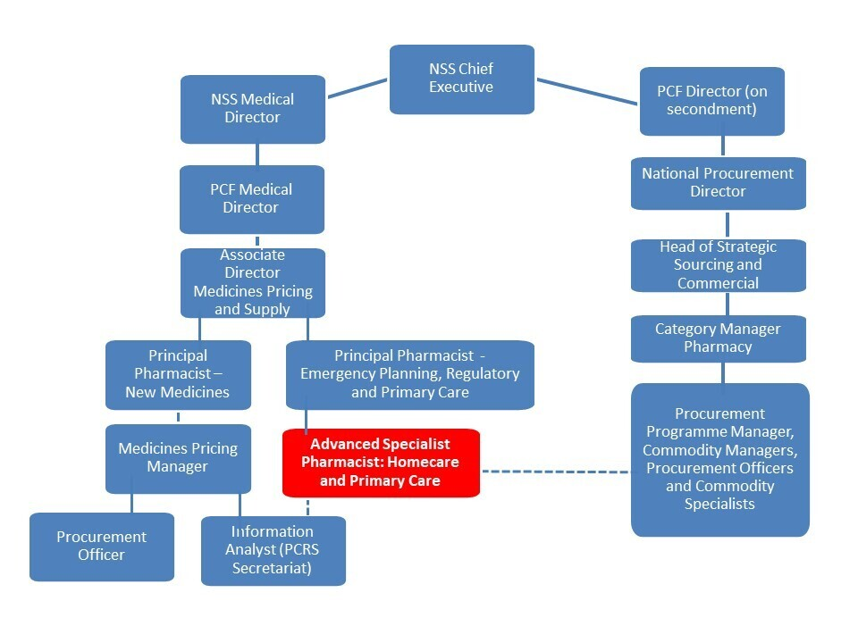
4. ORGANISATION CHART

5. ROLE OF THE DEPARTMENT
NHS National Services Scotland (NSS) is a Non Departmental Public Body. Accountable to the Scottish Government, it provides national strategic support services and expert advice to NHS Scotland. It also plays an active and crucial role in the delivery of effective healthcare to patients and the public. It works closely with all its partner organisations, especially the NHS Boards, in the delivery of its services through its various divisions.

Procurement, Commissioning and Facilities Strategic Business Unit: The PCF SBU provides a complete range of procurement, commissioning and facilities services to a range of stakeholders including Health Boards, Scottish Government and the wider public sector. The SBU provides specific services and expert advice across its portfolio of activity. Outputs include specialist services commissioning, screening, national contracting, logistics, procurement systems, and professional advice and expertise about property, facilities, construction and equipment.

National Procurement: Part of the NSS Procurement, Commissioning and Facilities Strategic Business Unit, National Procurement is in place to provide procurement and supply chain solutions for NHS Scotland. The organisation was established in 2006 out of the McClelland Report on Public Procurement Reform and is now an integral part of this landscape in Health and the wider Public Sector. To achieve its goals NP works closely with its customer Health Boards as well as suppliers, Scottish Government and other Public Sector stakeholders. The main focus of the organisation is to deliver savings through efficient and effective procurement whilst providing the highest levels of customer service in contracting, systems and logistics. In addition NP is tasked with driving ongoing improvement in procurement capability across NHS Scotland.

National Procurement Contracts cover over £750m of the £2bn spent by NHS Scotland on goods and services in financial year 2010-2011. Total savings since NP started exceed £200m with £41m of savings in 2010-2011. The National Distribution Centre is responsible for the delivery of around £120m worth of consumable Medical and Non-medical products to Scotland’s Hospitals annually. The NDC holds over 8000 products delivering on a daily basis to hospital wards and health centres across Scotland achieving service levels in excess of 98%.
National Procurement (NP) has been created to ensure that best practice procurement and supplies management processes are embedded right across the organisation within national, regional and local procurement and supplies communities. NP manages and co-ordinates the ongoing operation and improvement of these processes and practices. NP has primary responsibility for ensuring Procurement delivers best value for its wide customer base and that the savings targets set by Health Minister and the Scottish Government Health Department are met.

The NP Strategic Sourcing function is responsible for effective supplier and contract management, identifying and delivering cost reduction opportunities and delivery and implementation of programmes and projects across all NHSScotland organisations within the NHSS Procurement Reform agenda. The National Procurement Strategic Sourcing team provides comprehensive range of technical programmes and project support as well as a governance function to all programmes and projects; the procurement of medicines at NHS Scotland level are co-ordinated by this team. National Procurement also hosts the Patient Access Scheme Assessment Group (PASAG).

The lead pharmacist for a specialised national service will be employed by National Services Scotland (NSS) and work within the medicines team within the Procurement, Commissioning and Facilities Services Strategic Business Unit. They will work closely and support other teams within NSS.

6. KEY RESULT AREAS

- Provide highly specialised expert advice on professional, pharmaceutical, clinical and non-clinical issues to NHS and non-NHS groups, Scottish Government and other organisations as required. This will include establishing formal links with key players across the UK to share best practice and collaborative working. The post-holder will be required to employ a high level of clinical reasoning and judgement to develop robust and comprehensive pharmaceutical information. There will be a frequent need to effectively communicate highly complex information, negotiate and interpret opinions and viewpoints of senior clinicians, managers and pharmaceutical industry representatives in situations where there may be conflicting opinions and evidence. Provide professional pharmaceutical input and insight into the interpretation of data on prescribing.

- To lead on the contracting strategy for medicines and services within their specialist area, for example identifying, agreeing and supporting implementation of the detailed service requirements for a new medicines homecare service. This involves:

- Engagement with customers across NHSScotland to understand customer needs within their specialist area. This may include co-ordinating relevant national stakeholder groups.

- Identifying sourcing opportunities and working with medicines procurement professionals, key stakeholders and suppliers to develop and deliver commodity strategies. This involves planning and delivering procurement strategies for assigned commodities e.g. optimising the supply chain, market research, exploiting technology and re-engineering processes, using market knowledge and acquired knowledge of supplier product ranges, advising team on tender specifications, the selection of suppliers, negotiation with the suppliers, managing supplier relationships, contract placement.

- Produce implementation strategy plans and supporting materials in consultation with stakeholders, for example supporting the development of prescribing guidelines.

- Work to deliver the agreed rolling annual contract renewal and maintenance programme to maximize efficient use of resources, whilst ensuring contracts meet customers’ needs.

- Through active supplier management and customer engagement during the life cycle of each contract review and revise contracts using specialized product and market knowledge to continually improve customer service and ensure the contracts deliver the range and quality of items required by the customer in a environment of constant change and ensure customers benefit from efficient and cost effective contracts.

- Contribute to the strategic sourcing programme by influencing national procurement strategy and procurement policy within their commodity area and influence key decision makers in Scottish Government and other public sector organisations to set up contracts to meet the national policy requirements.

- Initiate and/or lead and/or manage specific complex projects relating to the efficient and effective procurement, purchasing and supply of medicines and associated services. This will involve working closely with stakeholders across the NHS and Scottish Government. The post-holder will manage the project resources, providing expert advice and guidance to all staff working on the project delivery. Example projects include management of both the NHS Scotland primary care rebate scheme review process and the NHS Scotland manufacturer-commissioned medicines homecare service review process.

- With a particular focus on the procurement, purchasing and supply of medicines, establish relationships with relevant key stakeholders (e.g. senior policy makers, health professionals, NHS managers, trade representatives organisations etc) and participate in national policy forums at both a UK and Scottish level, to ensure that NSS is kept abreast of policy initiatives and to appropriately influence the policy direction. This includes representing Scotland on the National Homecare Medicines Committee (NHMC).

- Develop and implement specialist audit processes to support continuous improvement.

- Co-ordinating the work of internal staff supporting projects within the specialist area; this may involve line management of staff.

- Contribute to the dissemination of results and promotion of the work of NSS through participation in meetings, seminars and through scientific publications and web pages to provide informative insights on a range of topics relevant to the role. The post-holder leads the preparation of, a range of reports, briefing papers and information relative to their specialist area.

7. ASSIGNMENT AND REVIEW OF WORK and DECISIONS AND JUDGEMENTS

Assignment and review of work

Work for the post-holder is generated from a broad framework determined in conjunction with the Principal Pharmacist and Medicines Category Manager. Within the framework the post-holder has autonomy and sets his / her priorities within the national priorities and policies including all legal and professional frameworks governing clinical practice. The post-holder is the expert within their field in NHS Scotland and has freedom to act which demands self-direction, problem solving, self-motivational and innovative skills. The post-holder is expected to anticipate and resolve relevant issues using their own initiative.

Work produced by the post-holder is subject to formal annual review through a process of forward job planning, target setting and performance appraisal. Informal review takes place via discussion with the Principal Pharmacist through regular meetings, published reports and a range of professional meetings. While work may be assigned by the Principal Pharmacist, it will also be generated by direct enquiries from within and out with the host division or organisation.

The post-holder shall develop a personal education and training plan to ensure continuing professional development in line with the host division or organisation’s Personal Development Programme, the requirements to fulfil this specialist national role and the General Pharmaceutical Council’s requirements for CPD. The post-holder shall comply with current legislation, conduct and practice relevant to pharmacy professionals and with the policies and procedures in the host division.

8. COMMUNICATIONS AND RELATIONSHIPS

The post-holder is required to develop and maintain relationships within and out with the organisation. The post-holder will be required to effectively communicate complex issues to groups and individuals of differing professional backgrounds and disciplines locally, nationally and internationally. He or she will be required to negotiate, motivate and persuade individuals and groups who may not always hold similar views and where proposals may have direct consequences on current service provision. The post-holder will adopt a number of different communication techniques including oral, written and formal presentations, as required.

Internal

- Medicines Procurement Team
- NHS National Services Scotland business units e.g., National Procurement, Central Legal Office, Practitioner Services Division).

External

- Manufacturers, homecare providers and medicine distributors (and their representative bodies)
- Homecare leads in other regions of the UK
- NHS Boards and their Operating Divisions (e.g. Directors of Pharmacy, Chief Finance Officers)
- Area Drug and Therapeutics Committees and relevant sub-committees
- Scottish Government
- Scottish Medicines Consortium and Healthcare Improvement Scotland
- Medicines and Health Care products Regulatory Agency (MHRA)
- Care Inspectorate
- Royal Pharmaceutical Society of Great Britain
- Patient Interest Groups
- Community Pharmacy Scotland
- PresQIPP
- DHSC

The audiences to be communicated with are diverse in background and understanding of key principles. The communication strategy of the specialist area will reflect this and be constantly under review. Key elements include attending and presenting at workshops, conferences and meetings; representing NSS on national strategy groups and debating policy and strategy relating to pharmaceutical developments. The post-holder will be expected to chair or facilitate working groups regularly with membership from within and outside NHS Scotland.

9. MOST CHALLENGING PARTS OF THE JOB

The ongoing ability to gain a sufficiently comprehensive understanding of a new medicine/therapy areas including associated pharmacy services, within a short time frame to make complex judgments, the lead pharmacist will constantly build upon his or her knowledge acquired through previous study or clinical experience.

Keeping up to date in a complex and rapidly changing healthcare environment where the needs of different customers may place conflicting demands on the organisation, and to develop innovative solutions that manage customer expectations.

Balancing and prioritising workload to ensure tight deadlines are met.

To convey complex information or concepts in such a way as to be understandable to non-clinical staff.

10. SYSTEMS
The post holder will be required to:
- A working knowledge of Microsoft Office packages and standard keyboard skills are essential. On a daily basis, the post holder is required to use Microsoft Word, PowerPoint, Excel and Teams. The post holder creates spreadsheets (and associated programme formulae) in Excel to facilitate the analysis and comparison of data – this may include medicines cost and prescription data. Write and format educational and report materials for publication.
- Use medicines usage databases (e.g. PRISMS and Rx-Info) to run reports on medicines spend and usage.
- Maintain records to track the progress of a submission through the evaluation and peer review process, as required by the functions of the post. This helps with planning and later for audit.
- Ensure staff work, store and transmit data in accordance with data protection regulations, freedom of information and confidentiality principles. Data may be distributed via email or post to others involved in the evaluation of a submission, to ensure delivery of the completed project by a fixed deadline
- Maintain records of continuing professional development.

11. PHYSICAL, MENTAL, EMOTIONAL EFFORT
Physical
- Frequent requirement for sitting at a keyboard e.g. 2 to 3 hours with appropriate breaks.
- Monthly travel to different sites throughout Scotland; occasional travel within UK.

Mental demands
- Dealing with a number of priorities and demands at the same time. There will be frequent and unpredictable interruptions requiring changes in priorities.
- There is an occasional requirement for prolonged concentration for analysis of data, problem solving, reading and critically appraising highly complex reports and documents from others and writing, reviewing and editing own reports, often under time pressure to meet strict deadlines.
- The post holder will be required to participate in a range of meetings at local and national level, including the requirement to: develop and deliver presentations to a varied audience ranging from students to multidisciplinary groups of healthcare professionals; follow and contribute to debates, which may require consideration of various options to reach consensus decisions; answer questions; interpret comments; and, note revisions to documentation.

Emotional demands
- There can be very tight timelines, for example if information is required by Scottish Government to respond to a parliamentary question. Meeting these tight deadlines can require prolonged concentration and can be emotionally taxing.
- Frequent extensive stakeholder engagement will be required and can be emotionally taxing. The post holder will need to demonstrate an understanding of the often conflicting pressures faced by stakeholders in relation to deliverables.
- The post holder may have to respond occasionally to distressing or emotional issues from persons with challenging behaviour. For example, the post holder may need to advise a pharmaceutical company that their commercial offering is unacceptable.

12. ENVIRONMENTAL/WORKING CONDITIONS & MACHINERY AND EQUIPMENT
The post holder will work in an office or home environment with daily extended routine use of a computer for periods of 2 to 3 hours at a time. Proficiency in Microsoft Word, Excel and PowerPoint will be necessary for writing and formatting educational and report materials for electronic or hard copy publication.

13. KNOWLEDGE, TRAINING AND EXPERIENCE REQUIRED TO DO THE JOB

1. Qualifications and education

Essential
- Masters Degree in Pharmacy.
- Registration with the General Pharmaceutical Council as a pharmacist on the practice register.
- Higher degree or post graduate qualification in a pharmacy related discipline or equivalent experience.
- Evidence of continuing professional development.

2. Experience
Essential
- Significant, demonstrable experience in pharmacy and medicines supply.
- Practical experience in developing systems and processes.
- Practical experience in facilitating change.
- Proven experience in providing an effective professional lead and management to staff

Desirable
- Experience with medicines homecare; pharmacy service development and/or NHS commissioning of services
- Experience of community pharmacy and medicines pricing and supply processes in primary care.
- Experience of formulary decision-making processes.
- Experience with participation in or facilitation of committees.
- Additional experience in procurement or the medicines supply chain; medicines information; NHS finance and administration; pharmaceutical market access.

3. Knowledge
Essential
- Knowledge and understanding of healthcare practices and systems within NHS Scotland.
- Understanding of pharmaceutical law, ethics and legislation relating to pharmacy practice and the use of medicines e.g. the Human Medicines Regulations 2012
- Understanding of the principles of evidence-based healthcare, critical appraisal and the interpretation and synthesis of healthcare research evidence.
- Understanding of principles of public health

Desirable
- Knowledge of the Scottish and English Drug Tariffs.
- Understanding of health economics
- Understanding of statistics used in clinical trials.
- Understanding of sustainability
- Understanding of Cyber Security.
- Detailed understanding of GDPR and Freedom of Information Act.

4. Skills
Essential
- Ability to think, plan strategically, work quickly and accurately and to exercise sound judgement in the face of conflicting pressures.
- Ability to analyse problems of a specialised or professional nature in a particular field/topic area.
- Excellent communication skills, including debating, negotiating and influencing skills and the ability to establish effective working relationships with a range of professionals.
- Ability to work independently to tight deadlines, quickly and accurately under pressure, with at times conflicting demands to meet strict deadlines.
- Excellent oral and written presentation skills
- Word processing and data manipulation skills, e.g. Microsoft word and excel.
- Project and resource management skills.

5. Personal qualities
Essential
- Self-motivated, flexible, pro-active and able to organise and prioritise work.
- Enquiring and persistent in finding answers to unresolved or ambiguous issues despite setbacks.
- Demonstrates personal integrity and is committed to team working, with respect and consideration for the skills of others within a multi-disciplinary group.
- Adaptable to continually changing work procedures and able to critically review these.
- Receptive to constructive critical appraisal and able to provide critical appraisal in a positive manner.
- Actively seeks to deliver solutions that meet the needs of service users/customers.

14. JOB DESCRIPTION AGREEMENT
A separate job description will need to be signed off by each jobholder to whom the job description applies.  Job Holder’s Signature: | Date:
Head of Department Signature: | Date:
HR Department will check job description format and content and then send the job description to the AfC Team  HR Representative’s Signature: | Date:

