JOB IDENTIFICATION

Job Title: Clinical Lead – School Age Service
Highly Specialist Speech and Language Therapist

Department: Speech and Language Therapy for Children & Young People

Job Holder Reference: SLT005cS&LT

No of Job Holders: 1

JOB PURPOSE

- To provide a comprehensive highly specialist speech and language therapy service to children and young people with speech, language and communication needs within a variety of settings across Dumfries and Galloway in line with post specific Job Plan and service needs.

- To provide highly specialist clinical support in area of clinical expertise to other Speech and Language therapists and to facilitate and lead collaborative learning and development with partner agencies contributing to improved health and well being outcomes.

- To be responsible for the co-ordination of speech and language therapy services within clinical area across the localities (Annandale and Eskdale / Wigtown and Stewartry / Nithsdale) liaising with and reporting to the Team Lead on all aspects concerning service delivery and staffing issues.

- To lead on specific quality improvement projects with a key role in the development of evidenced based person centered services within an area of clinical expertise.

- To identify and be actively involved in audit and research activity which will contribute to the development of a defined evidenced based specialist service.

ORGANISATIONAL POSITION

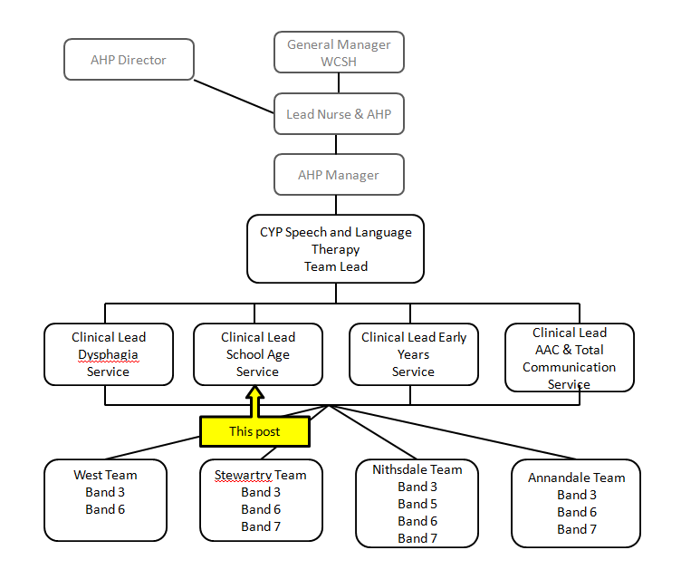

SCOPE AND RANGE

- Experienced therapist with autonomous responsibility for a defined highly specialist clinical caseload across Dumfries and Galloway
- Actively contributes to the planning, co-ordination and evaluation of the service provided to a defined clinical area
- Participates in the development and implementation of local and national guidelines and policies in own area of expertise
- Works proactively within a variety of multi-disciplinary teams providing highly specialist advice to inform clinical decision making Has highly developed areas of special clinical expertise with ability to identify own personal and professional development.
- Provide day to day management, professional supervision and support of other Speech and Language therapists, Support Workers and students.
- Involved with recruitment of staff and induction processes
- Lead in providing highly specialist training in area of clinical expertise to multi-disciplinary teams to build capacity and capability in others.
- Positively promotes the specialist contribution of SLT services to a range of multi-disciplinary forums locally and nationally

MAIN DUTIES / RESPONSIBILITIES
Clinical Practice
- To assess, diagnose, plan, develop and implement highly specialist programmes of intervention to meet the needs of children and young people with speech, language and communication disorders based on best practice.
- To undertake clinical triage and appropriately direct to universal, targeted and specialist interventions
- Work, liaise and negotiate within a multidisciplinary framework with other professionals and agencies as necessary sharing knowledge and expertise to provide the best possible care for children and young people
- Competently deal with complex issues in generating appropriate strategies for caseload management.
- Promote awareness of Speech and Language difficulties and its effect on social, personal and educational development.
- Maintain accurate ,comprehensive case notes, produce highly specialist written reports and attend multi-disciplinary meetings, case-conferences as required regarding individual needs and proposed care plans
- To undertake specialist instrumental clinical evaluations as relevant to post
- To undertake specialist clinics and roles in collaboration with others
- Support and enable CYP and their families to self manage to achieve the best well being outcomes
- Comply with local policies and procedures and work within boundaries
- Comply with RCSLT clinical guidelines and HCPC Professional Standards

Facilitation of Learning
- Plan, develop and co-ordinate training in related areas for other professionals, speech and language therapy students and others as required.
- Demonstrate a commitment to continued professional development.
- Contribute to the development and supervision of speech and language therapy support workers, students and volunteers.
- Facilitate and provide mentoring support to SLT colleagues, support workers and others in specialist area.
- Assist in development of students from other professional groups as appropriate.
- Take the lead in the identification of training needs within the team with regards to specialist area
- Provide highly specialist training in area of clinical expertise.

Leadership
- To act as a highly specialist clinical resource within area of responsibility regarding their specialism to optimize clinical care across the region.
- Use highly specialist knowledge to contribute and participate in the development of services, protocols, clinical pathways. and service redesign
- Advise Team Lead on issues of service delivery with particular focus on specialist clinical area making recommendations for change as appropriate to ensure effective and efficient service delivery
- Lead and develop specialized care pathways
- Take a lead role in the design and development of team objectives or projects to improve clinical practice and service delivery
- Able to respond to and work within a framework that embraces quality and diversity to meet the specific needs of cultural, minority and disability groups

Evidence, Research and Development
- Lead and develop research and audit projects utilizing improvement methodology.
- Develop innovations in areas of risk management, quality standard setting and clinical effectiveness in relation to specific clinical areas.
- Undertake and contribute to research by collating and providing data
- Negotiate with others around service issues, caseload management and assist with dealing and responding to complaints.

SYSTEMS AND EQUIPMENT

- Maintain up to date and accurate casenotes in line with professional standards and local policies.
- Share complex information with others, observing current data protection guidelines.
- Gather activity data accurately and regularly and ensure provision of such information promptly within local Board guidelines.
- Flexibility to use all appropriate information technology software to support clinical practice and activities.
- Highly Specialist knowledge of high technology and low technology alternative and augmentative communication aids and care pathways, as appropriate to client group.
- Care and maintenance of equipment, ensuring standards of infection control and safety are maintained including those loaned to clients.
- Display knowledge of relevant Board procedures and operational systems for data collection, performance management and finance

DECISIONS AND JUDGEMENTS
- Manage highly specialist complex caseload independently.
- Act independently and appropriately on all stages of referral, intervention and discharge in clinical pathway
- Negotiate with CYP, their families and others around individual case management,
- Recognise and pro-actively manage breakdown and conflict when this occurs and use strategies for successful resolution.
- Use highly specialist knowledge to inform sound clinical judgements / decision making for complex case management.
- Able to define a differential diagnosis on the basis of evidence from specialist assessments.
- Responsible for reflecting on own practice and use supervision and performance review processes to identify own strengths and needs
- Accountable for own professional actions, recognizes own professional boundaries and seeks advice and support when necessary
- Able to adapt practice to meet individual client needs.
- Lead and review own highly specialist service delivery and propose changes/developments within specialist area in keeping with local and national policies and guidelines.

COMMUNICATIONS AND RELATIONSHIPS

- Excellent written, verbal and non verbal skills.
- Contribute to multi-disciplinary care plans to ensure a well co-ordinated and integrated approach and positive person centered outcomes.
- Able to communicate complex condition-related information from assessment to CYP and their families, multi-disciplinary team members and other professionals.
- Work closely with CYP and their families and multi-disciplinary team members within a person centered framework .
- Demonstrate empathy with CYP and their families, ensuring most effective communication is achieved overcoming barriers to understanding where they might exist.
- Plan and provide specialist training to both professional and non-professional colleagues including carers and support workers within area of clinical expertise.
- Demonstrate excellent interpersonal skills.
- Demonstrate established negotiation skills and management of conflict.
- Contribute to inter-agency team building and policy development where appropriate.
- Highly developed co-ordination and planning skills
- Advanced goal setting / discharge planning skills.

9. PHYSICAL DEMANDS OF THE JOB
- Keyboard skills.
- Driving – integral to service delivery and associated time management skills.
- Manual handling with both clients and equipment.
- Work within Lifting and Handling guidelines and comply with regulations concerning Health and Safety at work.
- Able to maintain intense concentration in all aspects of patient management.
- Demonstrate highly developed auditory and perceptual skills in the assessment, diagnosis and treatment of clients.

MOST CHALLENGING PARTS OF THE JOB

- Prioritising caseload and time management
- Able to manage the emotional consequences of working with distressing conditions.
- Imparting unwelcome/difficult news to CYP and their families
- Demands of working in a rural area, lone working away from base
- Variety of caseload, locations and personnel.
- Frequently encounters unpleasant / highly unpleasant conditions from time to time related to client contact eg. halitosis, sputum, body fluids, verbal aggression.
- Resilience to conflicting pressures and demands.
- Managing and balancing the expectations of self and others

KNOWLEDGE, TRAINING AND EXPERIENCE REQUIRED TO DO THE JOB

- Degree in Speech and Language Therapy( or recognized equivalent) as regulated by the Health and Care Professions Council, UK
- Current Registration with Health and Care Professions Council.
- Registered member of Royal College of Speech and Language Therapists.
- Comprehensive knowledge of clinical guidelines and standards within specialist area of practice.
- Evidence of a wide range of clinical experience and application of advanced practice skills in area of specialism
- Evidence of advanced specialist knowledge and experience gained through attendance and learning on Specialist courses and advanced training up to Masters level equivalent in particular clinical specialist areas.
- Highly specialist knowledge underpinned by current evidence based practice.
- Knowledge of Child Protection legislation and issues
- Knowledge and experience of leading on quality and service improvements
- Able to identify areas for own personal / professional development evidenced by personal development plan / professional portfolio developed within an appraisal framework including specific objectives relating to clinical specialism
- Active commitment to life-long learning and maintaining up to date professional knowledge base.
- Highly developed knowledge across a range of disorders and client groups underpinned by theory and experience. Further theoretical study plus in-depth experience of legislation and policy relating to health, education, social services and voluntary sector provision.

JOB DESCRIPTION AGREEMENT  A separate job description will need to be signed off by each jobholder to whom the job description applies.  Job Holder's Signature:  Head of Department Signature: | Date:  Date:

NHS Dumfries & Galloway
Speech and Language Therapist - CYP

Highly Specialist Speech and Language Therapist –
Clinical Lead - Band 7

Person Specification

Essential | Desirable
Qualification  - Registered with HCPC  - SLT Degree or equivalent recognized by RCSLT  - Driving Licence | - Evidence of CPD related to specialist area  - Registered member of RCSLT
Knowledge  - Comprehensive knowledge of a range of communication assessments and interventions relevant to CYP  - Highly specialist knowledge of assessments and interventions for in CYP  - In depth knowledge of local and national policies and legislation in relation to the management of CYP  - Knowledge of current national and local education policy, practice and legislation in relation to additional support needs  - Knowledge of improvement methodology and project management Knowledge of relevant IT systems | .  - Knowledge of a broad range of Alternative and Augmentative communication systems
Experience  - Significant relevant experience with specialist client group in a range of educational and health based settings.  - Specialist management of complex cases  - Leading on service improvement and clinical quality initiatives, including audit  - Working collaboratively as part of a multi-disciplinary team to deliver to the health and well being of CYP  - Developing, delivering and evaluating training to others  - Supervision, development and mentoring of others  Skills  - Excellent Communicator  - Able to work on own initiative  - Excellent organisational skills  - Willing to seek and give support  - Able to prioritise demands on time and respond flexibly to a changing work environment  - Able to reflect and evaluate own performance and identify development needs  - Able to embrace and promote collaborative ways of working  - Able to lead and influence others | - .Involvement in a range of specialist professional groups and forums  - Risk assessment and managing risk across the service
Personal Characteristics

- A positive attitude and a commitment to working within, and contributing to the development of health and social care services
- Ability to form positive relationships with a range of people
- Able to value and promote value in others
- Motivated, enthusiastic, constructive outlook
- Resilient, optimistic and self aware

