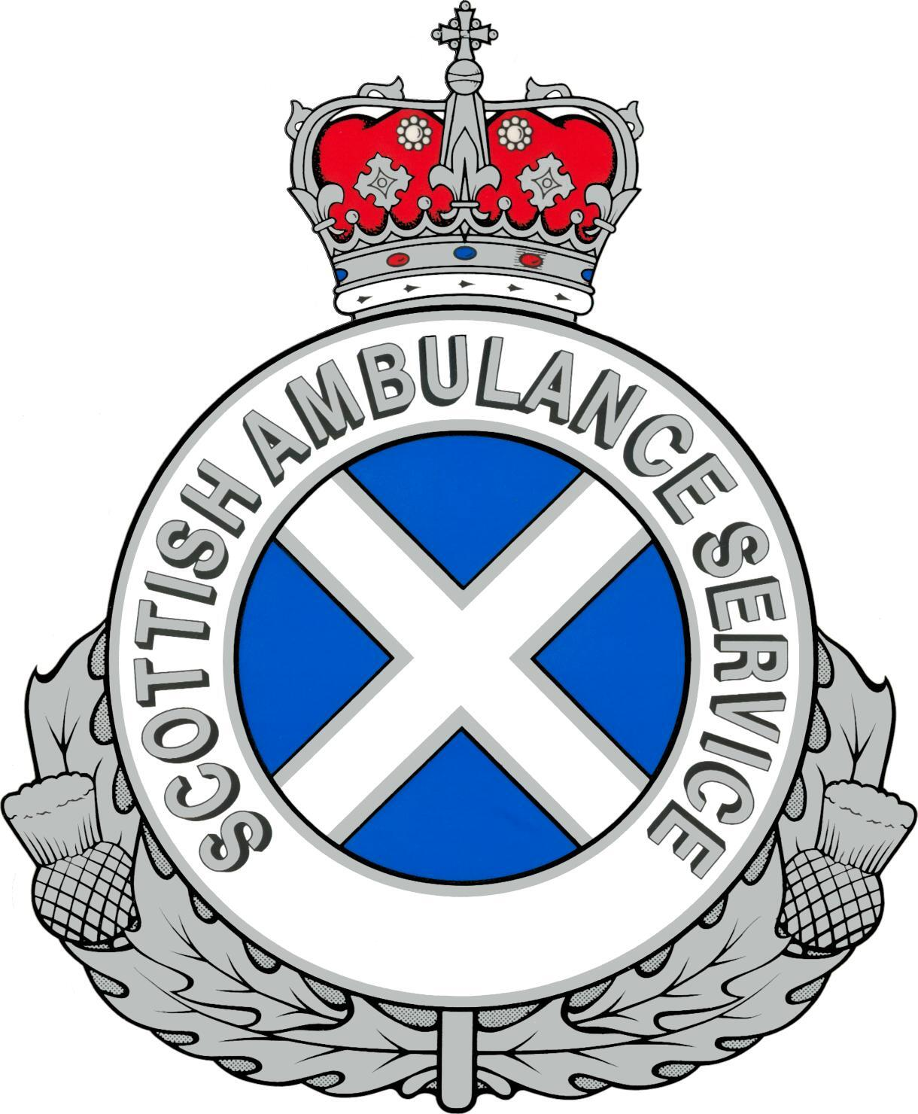 |  | 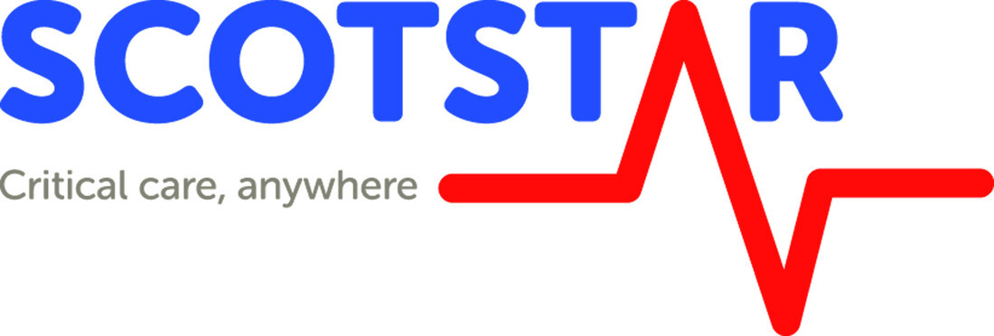

ScotSTAR Emergency Medical Retrieval Service Consultant
Job description

October 2022

Introduction

The Scottish Ambulance Service is commissioned by the Scottish Government Health Department to operate the ScotSTAR (‘Scottish Specialist Transfer and Retrieval’) service for Scotland. ScotSTAR encompasses neonatal, paediatric, and adult retrieval and transfer services as well as advanced pre-hospital and major incident responses. The Emergency Medical Retrieval Service (EMRS) is the adult and pre-hospital component of the service. The EMRS team comprises a West team based in Glasgow, and a North team based in Aberdeen.

The ScotSTAR service has bespoke operational bases located at Glasgow Airport (ScotSTAR West), and Aberdeen Airport (ScotSTAR North). At the ScotSTAR North base the neonatal and adult team are co-located alongside the Scottish Ambulance Service Air Ambulance Division. The base gives the EMRS North team rapid access to rotary and fixed wing aircraft.

The EMRS North team currently employs 12 part time consultants. An opportunity has arisen for one consultant to join the team. Subject to job planning discussions the new consultant will have a minimum of 2.0 direct clinical care (DCC) programmed activity (PA) commitment to the service.

Emergency Medical Retrieval Service

The concept of emergency medical retrieval was trialled in a limited area in rural Argyll and Bute from 2004 to 2008. A formal independent evaluation of a service covering the West of Scotland was undertaken during 2008 and 2009. In 2010 the Scottish Government Health Department made the decision to expand the service to include rural hospitals in the North of Scotland and to provide long term funding. The service became part of the new ScotSTAR service in 2014.

The service enables rural clinicians to request a retrieval consultant to be deployed by air or land to their hospital to resuscitate, stabilise and safely transfer patients with life threatening illnesses and injuries to definitive care. All retrieval consultants come from an Anaesthetic, Emergency Medicine or Intensive Care background. The aim of EMRS is to bring the resuscitation room to the patient, providing more rapid access to critical care interventions and safe transfer of critically ill or injured patients to the most appropriate specialist centre.

The team also provide a pre-hospital critical care service for seriously injured patients. This is provided by both helicopter and fast response car. The team is tasked to these patients by dedicated clinical tasking staff based on the trauma desk in the West of Scotland Ambulance Control Centre. EMRS also provide the pre-hospital major incident response across Scotland, providing Medical Incident Officer (MIO) support and multiple pre-hospital critical care teams who can fulfil other clinical and coordinating roles as needed.

The EMRS works in close co-operation with the Air Ambulance Division of the Scottish Ambulance Service which are co-located at both ScotSTAR bases. Air Ambulance paramedics are seen as an integral part of the EMRS and ScotSTAR teams. The team also works frequently with HM Coastguard Search and Rescue aircraft and crews who support the Ambulance Service emergency response nationally in a variety of circumstances.

The service is supported by doctors on training programmes in emergency medicine and anaesthetics/ intensive care and by a cadre of Retrieval Practitioners (RPs) from both nursing and paramedic backgrounds. Overnight on call room accommodation is available at the base for consultants whose home location precludes a 30 minute out of hours response time.

All consultants are expected to regularly attend the service’s clinical governance and CPD meetings and are also expected to have personal responsibility for a specified area of service operations and development.

The EMRS is part of a clinical network for emergency care in rural health care facilities. Integral to that are rural hospital staff training, liaison, audit, research and telemedicine advice. Retrieval consultants are expected to participate in these roles, necessitating travel to rural areas. Due to the remote location of some hospitals, overnight stays may be necessary.

The service offers telephone advice to rural clinicians, paramedics, advanced paramedics, and ambulance control room staff.

The EMRS operates a comprehensive and robust clinical governance system. Each consultant has a specific role in supporting the governance, operation and development of the service.

Duties of the post

- Advice on patient management and transfer to rural doctors and nurses via telephone and telemedicine.
- Telephone advice to paramedics, advanced retrieval practitioners, advanced paramedics, and ambulance control room staff with regard to clinical decision making, retrieval coordination and prioritisation, and clinical authorisation for tasking of search and rescue aircraft.
- Patient assessment and management in rural hospitals and in pre-hospital situations.
- Safe transfer of patients to definitive care by land or air.
- Contribution to clinical governance structure of the service.
- Contribution to the administration and development of the service.
- Equipment management.
- Contribution to audit and research activities.
- Accurate and comprehensive data recording.
- Providing pre-hospital medical care at the request of the ambulance service and in the event of a major incident. This includes but is not limited to the role of MIO.
- Attending training and clinical governance meetings.
- Attending mandatory major incident training.
- Completion of helicopter underwater escape training.
- Completion and maintenance of medical passenger brieifings for SAS helicopters.
- Visits to rural hospitals for educational and clinical governance purposes.
- Maintaining personal CPD relevant to retrieval duties.
- Liaison roles with allocated rural health care facilities.
- Training paramedics, retrieval practitioners, advanced paramedics, junior doctors and new consultants.
- Gathering follow-up information on patient progress.

It should be recognised that EMRS duties are unpredictable and missions are frequently prolonged beyond programmed duty periods. Flexibility in this respect will be required.

Sessional commitment

The team consultant rota comprises 29 Direct Clinical Care (DCC) sessions distributed among a team of 12 consultants. This post is for a sessional commitment of at least 2.0 PA. Subject to negotiation these sessions may be offered on either substantive or initial locum basis.

Consultants will be paid via their parent Health Board with EMRS sessions cross-charged to SAS. Terms and conditions will be as per the standard NHS Scotland Consultant contract.

A copy of the consultant rota is available on request. This contains details of shift patterns, shift frequency and programmed activities associated with each shift type. The team are resident on base 0800-1800, 7 days a week and on-call from home outside these hours.

The rota is compiled in quarterly blocks by nominating ‘availability’ for a number of shifts greater than the minimum required contribution.

Notice and leave requirements

The employment is subject to three months notice on either side.

The DCC PA commitment is calculated on an annualised basis taking account of annual and study leave, as described in detail in the consultant rota guideline. Other leave such as parental, sickness, or special leave is not accounted for and the required number of shifts will be adjusted on a pro-rata basis in the event of such leave being taken. Any arrangements for such leave must be discussed with and approved by the lead consultant.

Residence requirements

When on-call for EMRS the post holder must be within 30 minutes response time (normal driving) from the Aberdeen Airport Base. Overnight on-call room accommodation is available at the base for consultants whose home location is outside of the required 30-minute out of hours response time.

Medical screening
Candidates will be required to complete a medical assessment by the Occupational health service. Completion of Helicopter Underwater Escape Training (HUET) may require additional medical screening.

Military applicants

The service has had a number of consultants from UK Defence Medical Services contribute to the service, and applicants are therefore welcomed. Expectations of (and appointment criteria for) military incumbents are identical to those for NHS consultants, with the exception that time on military duties, training, or military leave, will be recognised and a pro-rata reduction made in the number of clinical shifts required.

ScotSTAR EMRS Consultant Person specification

 | ESSENTIAL | DESIRABLE
EDUCATION QUALIFICATIONS  & TRAINING | Full GMC registration with Specialist Registration in Intensive Care, Anaesthesia or Emergency Medicine  Life support provider courses completed | Dual CCT in Pre-hospital Emergency Medicine.  Dual CCT in Intensive Care Medicine.  Diploma in Retrieval and Transfer Medicine.  Diploma in Immediate Medical Care.  ATLS, ALS or APLS instructor.  Helicopter underwater escape training completed.
RESEARCH & PUBLICATIONS | Demonstration of active involvement in design and running of relevant clinical audit  Experience of presenting case reports, audit or research results | Evidence of participation in relevant research.  Audit or Research publications
KNOWLEDGE AND SKILLS | Competency in management of acute illness and injury in adults and children.  Good understanding of the principles of clinical governance.  Competence in independent management of the critically ill patient including emergency anaesthesia, lung ventilation, invasive monitoring, and care of such patients for a sustained period. Expert level competence in all practical skills appropriate to this.  Competence in deploying the above skills in both the pre-hospital, remote and rural secondary, and aero-medical environments. | Expert competence in in-hospital critical care including haemodynamic stabilisation, advanced ventilation strategies, treatment-limiting decisions, and end of life care.  Advanced ultrasound skills  Competence in radio communications.
EXPERIENCE | Extensive clinical experience, within a core clinical role, of providing consultant level clinical care to critically ill and injured patients, both at the earliest stage of their presentation and subsequently. | Previous substantial experience of working within an aero-medical primary and rural secondary retrieval service.  Previous substantial experience of pre-hospital care including critical care interventions, preferably as part of a rotary wing aero-medical service.  Extensive experience of technical inter-facility transfers of critically ill patients with multiple-organ dysfunction.
DISPOSITION | Ability to cope with stressful situations, prioritise and delegate tasks, maintain clear communication, and undertake responsibility.  Leadership qualities and skills, able to bring out the best in diverse and multiple teams.  Good communication and organisational skills.  Ability to maintain CPD to a high standard.  Ability to work as part of a multi-disciplinary team in the and pre-hospital and remote and rural environment.  Aptitude for providing empathic clinical, professional, and informal psychological, support to colleagues in diverse contexts and professions.  Commitment to the concept of equity of access to healthcare regardless of a patient’s location. | Knowledge and insight into the service, its ethos, values, and aims, along with evidence of alignment with, and commitment to, each of them.  Understanding of the wider remit of the Scottish Ambulance Service, and willingness to adapt to its organisational culture.
OTHER | Successful applicants must be employed in a NHS consultant post at time of starting post and have discussed their application with their management team.  Applicants must have a clear plan for how part-time EMRS work will integrate with other employments, including commitments to rotas, out of hours, and weekend work.  Evidence of Hepatitis B immune status pre-employment health screening  Willingness to undertake airborne retrieval missions in adverse weather conditions, to complete HUET and to undertake regular visits to rural health care facilities for educational and clinical governance purposes. | Good information technology skills

