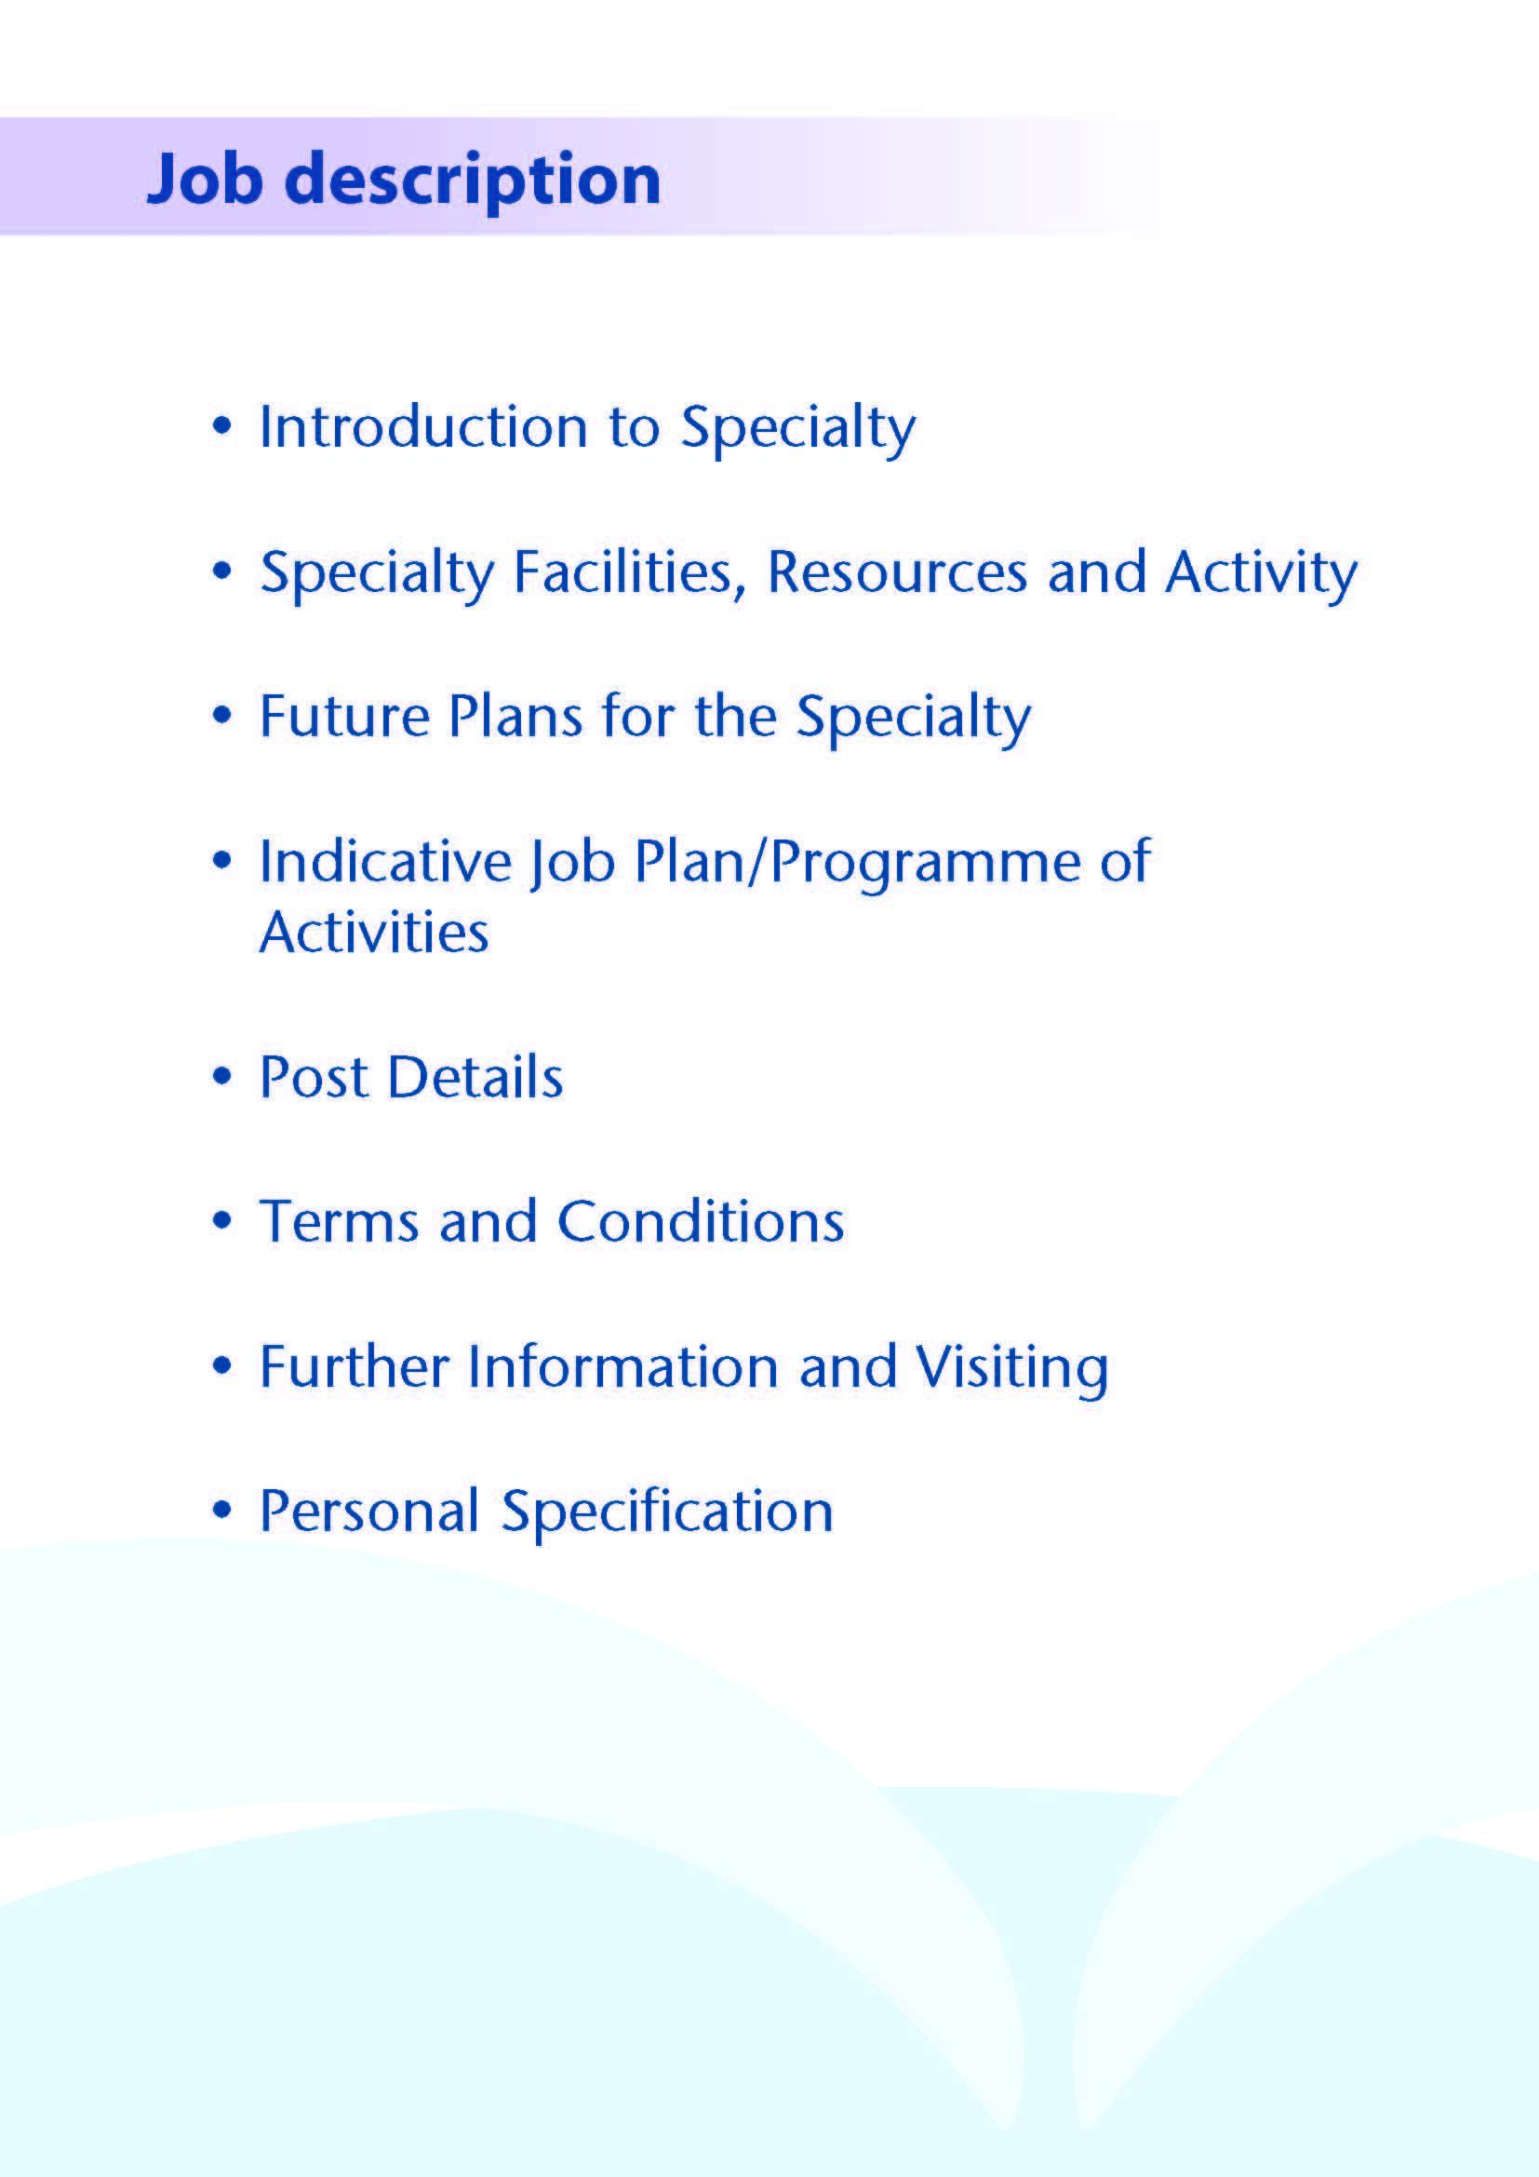



This post will complement the current team of 12 Consultant General Surgeons (with sub-specialty interests), 4 Consultant Breast Surgeons, 5 General Surgery Specialty Trainees, 6 Clinical Fellows, 1 Core Trainee, 1 FY2, 1 Associate Specialist Breast Surgeon and 4 other speciality level doctors in the Department of General Surgery at University Hospital Crosshouse.

University Hospital Crosshouse (539 beds - base population 225,000) was opened in 1982, and has been expanded and upgraded regularly since then. It stands on a green field site just outside Kilmarnock, has excellent trunk road access and free car parking. There is also easy access to rail and air services (Prestwick and Glasgow airports).

Services in the majority of major specialities are provided at the hospital, as well as Ayrshire-wide services in Laboratory Medicine, Renal Medicine, Infectious Diseases, Dermatology, ENT (including the Scottish National Cochlear Implant Centre), Maxillo-Facial Surgery and Obstetrics and Gynaecology. The South West Scotland Breast Screening Unit is based in Ayrshire Central Hospital, but all surgical activity generated is carried out at Crosshouse. The Ayrshire Maternity Unit resides in a state of the art building on the Crosshouse site. Ayrshire and Arran paediatric inpatient and day case services, including the adolescent unit, are also based at the Crosshouse site.

There is a purpose built 3-theatre Day Surgery Unit, plus a 4-procedure room endoscopy suite to complement our 8 theatres in the main theatre complex which have been extensively upgraded and refurbished. In addition, a Combined Assessment Unit has been opened in order to improve the delivery of front door emergency services and a new surgical ambulatory care suite has been developed.



Facilities

The General Surgical Unit at University Hospital Crosshouse provides a comprehensive elective and emergency service to both adults and children, within a catchment population of 225,000.

Inpatient Beds
Emergency and elective inpatient care provided from 54 beds, including 8 monitored post-operative beds and a surgical ambulatory care unit. Within the hospital is a new, combined ITU and HDU facility. In addition there are 4 general surgical paediatric beds in the paediatric department.

Main Theatres
There is a high standard 8 theatre complex. Two of the main theatres are primarily allocated for the use of general surgery with their associated teams of theatre nursing staff. There is a dedicated CEPOD theatre available which is a shared emergency theatre for all surgical specialties and separate trauma theatre facilities.

Day Surgery
A purpose built Day Surgery Unit consists of 3 fully staffed theatres along with an additional treatment room for minor procedures. The unit provides overnight beds for ‘23hr’ patients. Pre-operative assessment is available for all elective surgical patients and a ‘same day admissions unit’ has recently been opened, to improve the service.

Endoscopy
There is a purpose built endoscopy unit, co-located within the Day Surgery Unit. This unit has 4 procedure rooms which are fully equipped and staffed. A 5th room has recently been refurbished for trans-nasal endoscopy. Currently the surgical department performs about 80% of endoscopic procedures in the hospital, the rest being performed by 3 consultant gastroenterologists. In addition, there are 5 nurse endoscopists (4 surgical) and a GP endoscopist.

The full range of upper and lower GI endoscopic procedures are available, including ERCP and laser therapy. C-arm image intensifier is available within the department for procedures requiring screening.

Outpatient Clinics
A range of general and specialist outpatient clinics are held, in the outpatient department. Specialist clinics include a weekly one-stop breast clinic, Colorectal and UGI clinics and paediatric surgical clinics.

Multi disciplinary meetings
At present there are breast cancer, colorectal cancer, and upper GI cancer MDT meetings, all held on a weekly basis. All three of these meetings are linked by teleconferencing to the Ayr Hospital and for the colorectal and upper GI meetings, to the Beatson West of Scotland Cancer Centre in Glasgow. In addition, there is a monthly IBD MDT.

Oncology Services
Within University Hospital Crosshouse, there is an Oncology ward which caters for in and day patients. This is under the management of the medical directorate. Medical oncology support is provided from the Beatson Oncology Centre, Glasgow. Outreach sessions are provided within Ayrshire and Arran.

Access to palliative care is readily available, with consultant sessions from the Ayrshire Hospice.

Nurse Specialists
The surgical department currently has 4 breast care, 2 colorectal and 2 upper GI cancer nurse specialists. There are also 2 stoma therapists and 2 palliative care nurse specialists.

As indicated above, there are 2 experienced nurse endoscopists who carry out upper and lower GI endoscopy. 2 further nurse endoscopists perform OGD.

Diagnostics
Crosshouse has a full supporting diagnostic facility including a spiral CT scanner with 3D reconstruction and an MRI scanner.

Education:
NHS Ayrshire and Arran has excellent education facilities based within the Alexander Fleming Education Centre. This is conveniently sited in the centre of the Hospital, and has a well-stocked library with good electronic facilities, a lecture theatre, meeting rooms and teaching rooms.

The Directorate is fully involved in the teaching of Glasgow University undergraduates.

Medical Staff Resources

Consultant Staff
Subspecialty Interest | Based at University Hospital Crosshouse
Colorectal Surgery | Mr I Felsenstein  Mr E Leung  Mr C Ray  Miss H Koh  Mr D Watt  Ms E Yeap  Mr J Cutajar  Mr V Manda (Locum Consultant)
Upper GI Surgery | Mr K Robertson  Miss C Sharp  Mr D Morran  Mr L Velu
General/ Paediatric Surgery | Mr M Khine
Breast Surgery | Miss S Tovey  Miss S Elgammal  Miss J Reid  Miss L Ewan
Associate Specialist
Breast Surgery | Ms S Pareek
Clinical Director | Mr K Robertson

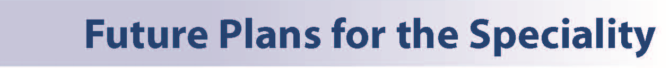

There have been a number of developments in the general surgical department over the past few years.

- Endoscopy services in North Ayrshire are fully comprehensive and cover many of the diagnostic and therapeutic techniques currently available including ERCP, UGI stenting, laser treatment and EMR. Approximately 6,500 procedures are carried out each year with about 80% being performed by members of the surgical department. Recent developments include provision of transnasal endoscopy, development endoscopic submucosal dissection for UGI lesions, anorectal manometery and endoanal ultrasound scan for sphincter assessment and staging.

- In recent years the range of minimal access procedures offered by the Department has continued to expand. Full facilities are available in all of the elective and emergency theatres. In addition to laparoscopic cholecystectomy, the following laparoscopic procedures are carried out regularly in the unit; hiatal surgery, bile duct exploration, benign gastric surgery, colorectal resection, TAMIS, rectopexy, hernia repair (groin and incisional), peritoneal dialysis access, appendicectomy and diagnostic procedures. A business case has recently been submitted for robotic surgery in Ayrshire and Arran with the plan for the robot to be based at Crosshouse Hospital.

- The surgical department is responsible for the assessment and treatment of all patients screened by the breast screening centre based in Irvine. This centre deals with all women in the appropriate age group for the Ayrshire and Arran Health Board area, and those covered by Dumfries and Galloway Health Board area. Magseed techniques are regularly utilised for localising impalpable lesions. More recently the team have introduced the use of Magtrace for sentinel lymph node localisation.

- Over the last 2 years significant refurbishment of the surgical wards has taken place with the elective ward now having 8 monitored beds for elective post-operative patients.

- An area for ‘hot clinic’ / surgical ambulatory care unit for emergency referrals has recently been developed between the two surgical wards. In this area there is also a middle grade doctor’s room with a number of computer stations and is utilised for handovers, administrative work, and education and training purposes.

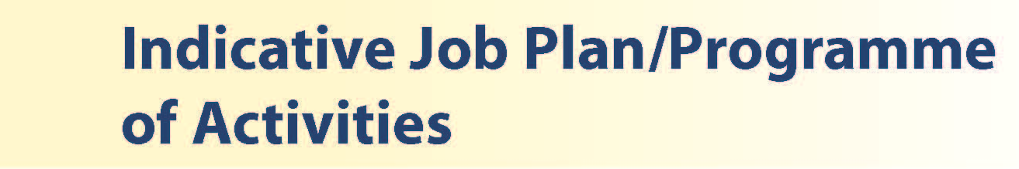

Clinical Activities of the Post

The appointee will engage in all forms of elective and clinical activity taking place in the Department of Surgery. He/she will rotate through the 3 clinical teams (Colorectal, Upper GI and Breast) and therefore gain experience in a wide variety of specialist surgery. Paediatric surgery is also practiced within the Department.

The Colorectal Unit has a major commitment to the management of colorectal neoplasia and this includes a significant contribution to the National Bowel Screening Programme. There is also a specialist commitment to benign colorectal disease, including surgery for inflammatory bowel disease and incontinence. The majority of colonoscopy in University Hospital Crosshouse is practiced by the surgical unit and the teaching of colonoscopy skills receives particular attention.

The Upper GI team has specialist interests in resectional surgery for gastro-oesophageal cancer, laparoscopic hiatal surgery, and ERCP. Endoscopic skills are also well developed for the palliation of advanced upper GI tract malignancy. All ERCP procedures are practiced by the surgical unit in addition to EMR and ESD.

Specialists experience within the Breast Team will be gained in the management of benign and malignant breast pathology, including impalpable screen detected disease. On-site breast reconstruction is practiced and there is additional onco-plastic work carried out with the Canniesburn Unit in Glasgow Royal Infirmary.

As previously mentioned, it is likely that the post will attract an additional 2 programmed activities on top of the core contract of 10 PAs but candidates wishing to restrict themselves to 10PA’s will not be disadvantaged. Whatever contract is agreed 1.5 - 2 PAs will be allocated to recognise the commitment to emergency duty work associated with the participation on the full shift rota on an equal basis with all other rota participants. The rota pattern is illustrated below.

Outwith periods of night shift, elective clinical activities will vary slightly depending on the sub-specialty team allocation but on a 12 PA contract this will approximately equate to the following;

- 6 specialty clinical sessions comprising operating theatre (2-3 sessions), endoscopy (1-2 sessions), outpatient clinics (1-2 sessions)
- 1 clinical administration session
- 1 session for supporting professional activity
- 1.5. sessions for ward clinical duties

A successful appointee who wishes only a 10 PA contract will have the elective sessions reduced on a pro-rata basis

The job plan will be reviewed with the successful candidate no later than 3 months following appointment and where possible discussion may take place in advance of appointment. Job plan review thereafter will be no less frequent than annually.

The agreed job plan will include all the appointee’s professional duties and commitments, including agreed Supporting Professional Activity.

Template work pattern

Wk | Mon | Tue | Wed | Thu | Fri | Sat | Sun
1 | Stnd Day  08:00 17:00 | Stnd Day  08:00 17:00 | Stnd Day  08:00 17:00 | Zero Hours | A: W/E Night  20:30 08:30 | A: W/E Night  20:30 08:30 | A: W/E Night  20:30 08:30
2 | Zero Hours | Zero Hours | Zero hours | Stnd Day  08:00 17:00 | Stnd Day  08:00 17:00
3 | B: Long  08:00 20:45 | C: Half Day  08:00 12:30 | Stnd Day  08:00 17:00 | Stnd Day  08:00 17:00 | Stnd Day  08:00 17:00
4 | D: Night  20:30 08:30 | D: Night  20:30 08:30 | D: Night  20:30 08:30 | D: Night  20:30 08:30 | Zero Hours
5 | Stnd Day  08:00 17:00 | B: Long  08:00 20:45 | C: Half Day  08:00 12:30 | Stnd Day  08:00 17:00 | Zero Hours | G: W/E Long  08:00 20:45 | G: W/E Long  08:00 20:45
6 | Stnd Day  08:00 17:00 | Stnd Day  08:00 17:00 | B: Long  08:00 20:45 | C: Half Day  08:00 12:30 | Stnd Day  08:00 17:00
7 | Stnd Day  08:00 17:00 | Stnd Day  08:00 17:00 | Stnd Day  08:00 17:00 | B: Long  08:00 20:45 | C: Half Day  08:00 12:30
8 | Stnd Day  08:00 17:00 | Stnd Day  08:00 17:00 | Stnd Day  08:00 17:00 | Stnd Day  08:00 17:00 | B: Long  08:00 20:45
9 | Stnd Day  08:00 17:00 | Stnd Day  08:00 17:00 | Stnd Day  08:00 17:00 | Stnd Day  08:00 17:00 | E: Half Day 2  12:30 17:00
10 | Stnd Day  08:00 17:00 | Stnd Day  08:00 17:00 | Stnd Day  08:00 17:00 | Stnd Day  08:00 17:00 | Stnd Day  08:00 17:00
11 | Stnd Day  08:00 17:00 | Stnd Day  08:00 17:00 | Stnd Day  08:00 17:00 | Stnd Day  08:00 17:00 | Stnd Day  08:00 17:00

This rota comprises of 11 doctors:

5 x Specialty Trainees
6 x Specialty Doctors/ Senior CDF

(1:11 on-call rota)

This rota is EWTD compliant over 26 week ref period.

Notes on the Programme

Proposed Weekly Programme

The proposed weekly programme is shown below. Activities with current fixed time commitments will be carried out as detailed in the work programme e.g. clinics. Other DCC and SPA activities are shown with indicative timings within the weekly programme and will be discussed with the appointee.

Notes on the Programme

Patient Administration. This activity covers the management of individual patients including Out Patient administration, results reporting, letters/phone calls to patients, carers, GP’S and members of the wider multidisciplinary team involved in the patients care.

Ward Rounds: The time allocated is indicative and will be discussed with the appointee. Ward work will include teaching ward rounds as required.

Travel: Any travel allocation will be included within the Total Programmed Activities and will be determined by location at which Direct Clinical Care and Supporting Professional activities are carried out.

Emergency Duty Commitments: The appointee will contribute to the emergency out of hours rota along with all the surgical specialty trainees. This is a full-shift EWTD and New Deal compliant rota and is compulsory resident. The rota template is attached.

Supporting Professional Activities: NHS Ayrshire and Arran recognise the important role Job Planning has in ensuring consultants are supported in delivering high quality, safe, sustainable clinical care to patients. It is therefore important to ensure there is an adequate balance between direct clinical care activities and activities which support both the personal and professional development of the consultant workforce and facilitates agreed contribution to activities including:

- Under and post graduate teaching/training
- Clinical Governance
- Quality and Patient Safety
- Research and Innovation
- Service management and planning
- Work with professional bodies
All specialty doctors will have 1 SPA as a minimum to support job planning, appraisal and revalidation. However the final balance of SPA and DCC activity will be agreed between the appointee and clinical manager prior to contracts being agreed.

There may be a requirement to vary the DCC outlined in the indicative timetable at section 4 when the final balance of DCC and SPA is subsequently agreed.


Duties and Responsibilities

The main duties and responsibilities of the post include:

- Carrying out teaching as required, and for contributing to undergraduate and postgraduate medical education. The post holder will be expected to comply with College recommendations on Continuing Medical Education.
- The post holder will be required to comply with NHS Ayrshire and Arran’s Policies on Clinical Governance.
- The successful applicant will be encouraged to participate in research and to develop a relevant subspecialty interest, subject to resources and local priorities.
- Requirements to participate in medical audit and in continuing medical
education.
- Managerial responsibilities (where appropriate).

You shall integrate with other middle grade staff in the day-to-day service and commitments of the department. Accordingly, the duties would be flexible depending on which surgical team he/she was attached to.

You shall work with a team of Consultants, and rotate through the sub-specialties.

All members of the department participate in monthly meetings which may combine audit review or case discussions with our radiological and pathological colleagues.

You will be accountable to the Clinical Director who will agree the weekly timetable.

Annual Appraisal

You shall be required to participate in annual appraisal and agree a personal development plan.



Are those determined by the Terms and Conditions of the New Specialty Doctor grade (Scotland) as amended from time to time. The distance that a specialty doctor can reside from the principal base hospital, where travel time is seen as more important than mileage, is subject to the agreement of the Medical Director.

Applicants wishing further information about the post are invited to contact Miss C Sharp, Consultant Surgeon or Mr K Robertson with whom visiting arrangements can also be made.



Post of: Specialty Doctor in General Surgery
Location: University Hospital Crosshouse

Qualifications:
Essential | Desirable

MBChB/MBBS or equivalent medical qualification

Successful completion of MRCS or equivalent
- Full GMC Registration with a Licence to Practice at time of appointment
- Evidence of achievement of Foundation competences by time of appointment in line with GMC standards/ Good Medical Practice including:
  - Good clinical care
  - Maintaining good medical practice
  - Good relationships and communication with patients
  - Good working relationships with colleagues
  - Good teaching and training
  - Professional behaviour and probity
  - Delivery of good acute clinical care

- Completion of a minimum of 4 years full-time postgraduate training (or equivalent) with evidence of achievement of at least 2 years’ experience in competences relevant to general surgery at time of appointment

- Eligibility to work in the UK

Skills/Knowledge/Competence
Requirements | Essential | Desirable
General Experience:  - Expertise in generalist field | - Knowledge of and skill relevant to the management of general surgical patients.  - Ability to communicate effectively with all levels of staff and patients  - Ability to work efficiently and timeously  - IT literacy | - Ability to develop and maintain a database of clinical practice
Team Working | - Effective Team Player
Development | - Evidence of relevant Continuing Professional Development  Ability to provide a complete employment history  - Evidence of satisfactory career progression  - No unexplained career breaks  - Maximum one year repetition of core surgical training at ST1 or ST2 level relevant to general surgery  - At least 24 months’ experience (at ST1/ST2 level) in surgery (not including Foundation modules) by start of appointment, of which:  - At least one year’s experience is in general surgery  - One further year is in specialties relevant to general surgery (including cardiothoracic surgery, ENT surgery, general surgery, maxillofacial surgery, neurosurgery, paediatric surgery, plastic surgery, trauma & orthopaedic surgery, urology and up to 6 months ICU)
Teaching & Training | - Proven ability to deliver high quality teaching
Research & Publications |  | - Evidence of publications.
Clinical Audit | - Evidence of participation in audit
Management and Administration | - Proven organisational skills  All applicants to have demonstrable skills in written and spoken English adequate to enable effective communication about medical topics with patients and colleagues demonstrated by one of the following:  - a) that applicants have undertaken undergraduate medical training in English; or  - b) have the following scores in the academic lnternational English Language Testing System (IELTS) – Overall 7, Speaking 7, Listening 6, Reading 6, Writing 6.  - If applicants believe they have adequate communication skills but do not fit into one of these examples they must provide supporting evidence | - Understanding of resource management and quality assurance.
Personal and Interpersonal Skills | - A willingness to accept flexibility to meet the changing needs of the NHS in Scotland  - Effective communicator  - A willingness to develop special interests which conform to the needs of NHS Ayrshire and Arran  - Ability to function at different levels  - Open and non-confrontational | - Knowledge of recent changes in the NHS in Scotland

