 | JOB IDENTIFICATION
 | Job Title:  Responsible to:  Grade:  Department(s): | Out of Hours (OOH) Operational Business Manager  GP OOHs Service Manager  Band 7  GP OOH
 | JOB PURPOSE
The post holder will have a key role within NHS Greater Glasgow and Clyde (GGC) GP OOHs Service, working closely with heads of service, senior managers and service teams; both clinical and non-clinical, to seek out new opportunities for service development and improvement.

The post holder will facilitate and promote a positive organisational culture which supports the objectives of the OOH service and will model positive leadership behaviours and will maintain positive working relationships at all times.

 | ROLE OF DEPARTMENT
 | NHS Greater Glasgow and Clyde (GGC) GP OOH Service is an urgent care service delivered from various locations across GGC including patients home or homely settings. GP OOHs main base is Caledonia House, alongside the Home Visiting service.
 | ORGANISATIONAL POSITION
 | 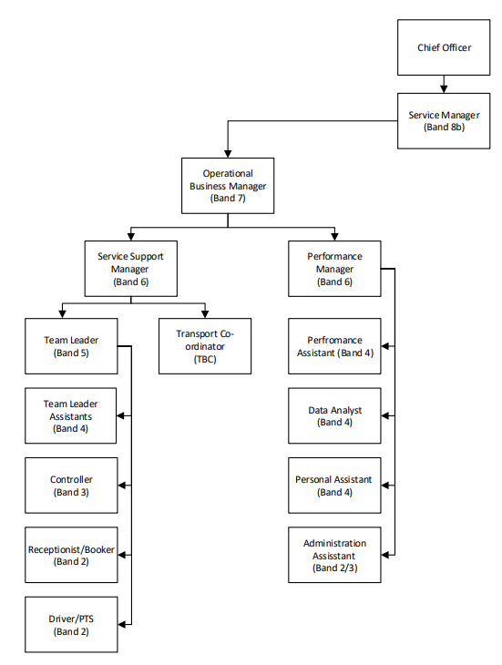
 | SCOPE AND RANGE
The GP OOH Service provides urgent care during the out-of-hours period; Monday – Friday 18:00 – 08:00hrs and 24 hours at weekends and Bank Holidays. Service users access the service via NHS 24. NHS 24 assess the patient and if clinically appropriate will refer the patient to the OOH service. Patients may receive a remote consultation by telephone or video or a face to face consultation, either by appointment at one of Primary Care Centres or in their home or homely setting.

The GP OOHs HUB at Caledonia House provides a single point of access for an integrated, appropriate response. This includes collaborative working with Scottish Ambulance Service, NHS GGC Laboratory’s and Community Pharmacies in NHS GGC.

The post holder will be responsible for the development and implementation of robust systems and processes to support programme activities and ensuring that required outputs are delivered within defined timescales across a range of projects/work streams. Ensuring implementation of NHS systems, to maintain effective support to all staff within the service, senior management team and clinicians, thereby facilitating the delivery of effective patient care.

 | MAIN TASKS, DUTIES AND RESPONSIBILITIES
- Participate in the development of operational and strategic planning working closely with the Service Manager and other members of the Senior Management Team. Taking responsibility for the implementation of specific initiatives and service developments within the service.
- Provide leadership, motivation and vision in operational developments and improvements, by acting as a change agent and innovator, planning, instigating and evaluating change.
- The post holder will have the autonomy to make decisions on complex situations where there is a requirement to analyse, interpret and compare a range of options to determine the correct course of action and ensure that the service continues to operate effectively and efficiently.
- Lead by example to shape the Organisations culture by demonstrating and exemplifying positive behaviours and attitudes that represent the organisation’s agreed values and behaviours.
- Responsible for the delivery of high quality, patient centred, safe and effective care and ensuring arrangements are in place to meet all requirements of Clinical Governance. This includes providing direct support to senior clinical staff with adverse incidents/reviews, action planning and monitoring and recording of improvement.
- Report on the monitoring of quality outcomes, and if necessary, support required changes to the service as recommended and ensure resource for implementation of any remedial action to bring back on target.
- Accountable for the management and control of the delegated budget within standing financial instructions and for staff who have delegated budget responsibility.
- Work in partnership with the HSCP service managers and clinical leads and Senior Management Team, where appropriate.
- Assist the Service Manager, Chief Officer and HSCP clinical and service leads in the evaluation of specific services and ensure the views of service users are encouraged and acted upon.
- Assist with investigation of complaints for the OOH clinical managed services, both formal and informal, and where appropriate respond, in line with GGC Complaints Procedure.
- Maintain and develop communication links with GP OOH, HSCPs, Scottish Government representatives and other external agencies, identify key personnel and ensure appropriate and timely dissemination of information.
- Provide/present reports to groups and nominated individuals within the GP OOHs Senior Management Team, to the Board and Scottish Government both as required to a prescribed timetable, and on an ad hoc basis as determined by events.
- Monitoring, maintaining and development of the Business Continuity Plans. In the event of an emergency situation, implement and co-ordinate the Business Continuity Pan to ensure the service has the ability to provide the minimum service required.
- Ensure the team is line managed in accordance with HR policies and procedures ensuring that good practice in recruitment, appraisal, performance management and other policy areas are maintained.
- Support the Senior Management Team in the delivery of key corporate, financial, clinical and staff performance targets.
- Development of induction and training programmes for directly managed staff. Whilst taking cognisance of service change and required competencies.
- Maintain adherence to the relevant GGC Health Board and national clinical guidelines.
- Represent the Service on relevant local, board and national groups.

7a. | EQUIPMENT AND MACHINERY
- PC/laptop
- Printer
- Photocopier
- Telephone

7b. | SYSTEMS
The following are examples of systems which will be used when undertaking the role;
- HR Information System – eESS, SSTS
- Rota Management - RotaMaster
- Financial and Procurement Systems – Budget reporting, supplies and ordering (PECOS) /
- eExpenses – primary authoriser for multiple staff groups, staff bank requests and authorisations.
- Personal Development Planning & Review Process – TURAS
- Patient Administration Systems – TrakCare, ADASTRA.
- Business Objects
- Incident reporting – DATIX
- Internet and Intranet
- Electronic data storage e.g. Word, Access, Excel, PowerPoint, other local databases

Note: New systems may be introduced as the organisation and technology develops; full training will be provided.

 | DECISIONS AND JUDGEMENTS
The post holder will be expected to deliver project/delivery plans to ensure the projects are completed within agreed timescales ensuring that staff are fully supported during periods of change.

The planning of the projects and service changes, including utilisation of the facilities, resources and systems required to support these will be at the discretion of the post holder. Importantly, the post holder will be required to exercise initiative and judgement when unforeseen circumstances arise e.g. staff absence, responding quickly to invoke measures which will minimise impact on service users and performance standards.

 | ASSIGNMENT AND REVIEW OF WORK
The post holder will exercise a high degree of autonomy in the management of their workload and as such will have autonomy and self-direction in relation to prioritising their workload. Much of the activity will be self-generated or from within the service e.g. in the anticipation of events, and proactively managing service demands within agreed timescales and negotiated budget.

The post holder will meet on a monthly basis with the Service Manager, providing updates on developments and improvements in relation to the service changes and projects.

 | COMMUNICATIONS AND RELATIONSHIPS
Communication will be both verbal and written and will include presentation of facts and figures around the programmes of work, service developments and budgetary requirements. Tact and diplomacy will be required when responding to queries about the services, especially if these are of a controversial or sensitive nature.
Internal:
- GP OOHs Senior Management Team
- Medical Staff
- Nursing and Midwifery staff
- Technical staff
- Corporate Support functions; Human Resources, Finance, Procurement, eHealth, Estates.
- Complaints department
- Payroll
- Contracts
- Trade Unions and Professional Organisations
External:
- Patients/Carers; verbal and written
- Public Health Scotland
- NES
- SAS
- NHS 24
- Scottish Government
 | PHYSICAL, MENTAL, EMOTIONAL AND ENVIRONMENTAL DEMANDS OF THE JOB
Physical Skills
- A combination of sitting, standing and walking.
- Frequent VDU work, advanced keyboard skills required for report writing, manipulation and analysis of complex data in spreadsheet formats.
- Extended hours on occasions as role requires.
Mental
- Interruptions relating to Service/staff issues which require immediate action.
- Balancing multiple and often conflicting requirements.
- Frequent extended periods of concentration required.
- Concentration required when chairing or participating in meetings.
- Retention and communication of knowledge and information.
- Responding to an unpredictable workload and competing demands from the multidisciplinary team across the service at all levels and across multiple locations.
- Maintenance and management of precise and accurate records.
Occasional shorter periods of concentration required for following; presentations, audit, payroll and rota management
Emotional
- Deals with a range of complex service issues.
- Frequently facilitates potentially emotive meetings.
- Deals with sensitive staff problems and patient complaints involving direct contact with patients.
- Provide support through organisational change within the working environment when there are barriers to understanding and acceptance.
Environmental
- Requirement to work operationally in the Hub, including during OOH period.
- Daily VDU usage.

 | MOST CHALLENGING/DIFFICULT PARTS OF THE JOB
Planning, co-ordinating and evaluating high profile transformational changes within the service, considering multiple factors; time frames, staffing levels across multi-disciplinary teams, volume of planned and emergency activity, capacity planning and maintenance of minimum acceptable performance standards.
Working within a multidisciplinary team, negotiating and influencing decisions both strategic and operational in nature, around change programmes, service developments and changes to policies and procedures.

Maintaining and developing good communication across all staff groups and stakeholders, ensuring that the information shared is appropriate and relevant.

Supporting the senior management team, at a time of significant change, whilst maintaining morale and motivation in the delivery of high quality services.

 | KNOWLEDGE, TRAINING AND EXPERIENCE REQUIRED TO DO THE JOB
 | Selection Criteria |  | Essential | Desirable
 | Qualifications and Training  Experience of working at a senior level for a minimum of 5 years within the NHS  Educated to degree level  Evidence of CPD  Management Experience  Project and Change management  Staff management  Budget management  Service management  Information management  Knowledge Skills and Abilities  Understanding of Acute and Primary Care Services and organisation  Demonstrable communication and negotiation skills  Project planning  Understanding the relationship between primary and secondary care services  Proven track record in effective leadership  Report Writing/Presentation skills  Excellent IT and analysis skills  Ability to work on own initiative  Problem Solving  Personal Qualities  Ability to work on broad and varied agenda  Able to engage with clinicians, managers and staff at all levels in NHS GGC  Ability to meet deadlines  Other Requirements  Car Driver / Full drivers licence |  | *  *  *  *  *  *  *  *  *  *  *  *  *  *  *  *  *  *  * | *
 | JOB DESCRIPTION AGREEMENT
 | A separate job description will need to be signed off by each jobholder to whom the job description applies.
 | Job Holder’s Signature: | Date:
 | Head of Department Signature: | Date:

