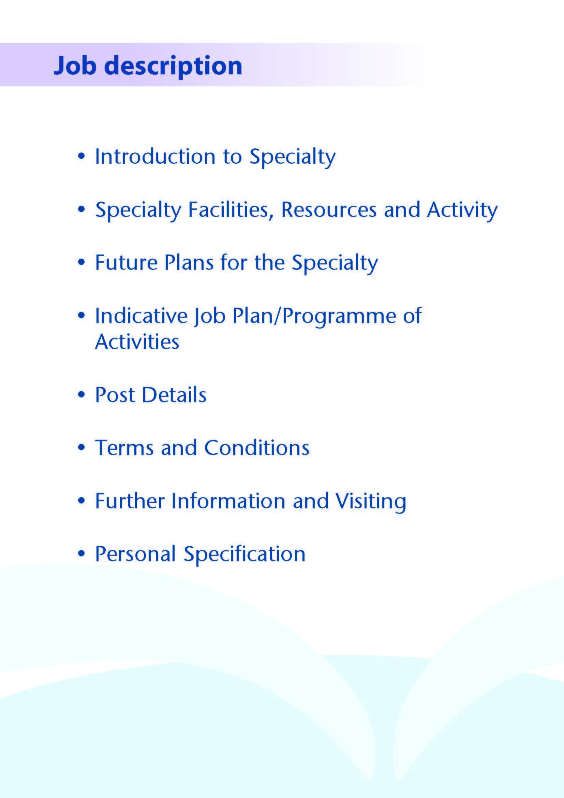



This Speciality Doctor post is available to support the Oral and Maxillofacial Team within NHS Ayrshire & Arran.

NHS Ayrshire & Arran has two large District General Hospitals; University Hospital Crosshouse and University Hospital Ayr. The Oral and Maxillofacial Department forms part of the Head & Neck Directorate, along with ENT, Orthodontics, Maxillofacial Laboratory and Restorative Dentistry services.

Oral and Maxillofacial services are provided to the Ayrshire & Arran catchment population of 388,000 residents.

The main base for this post is University Hospital Crosshouse where Oral and Maxillofacial in-patient and daycase services are located. Outpatient Clinics are provided at both University Hospital Crosshouse and University Hospital Ayr.

The scope of the service within Ayrshire is: -

- Dento-alveolar surgery.

This still constitutes the majority of the work carried out by the unit, which is mainly dealt with by the Speciality Doctor(s) and Trainees under supervision. The Consultants also undertake dento-alveolar surgery in the day surgery unit. This new post would allow for greater Consultant involvement in this aspect of service delivery.

2. Orthognathic surgery.
A complete facial deformity service is provided, treating both acquired and congenital deformities in conjunction with the orthodontists, developments include a 3D Printer and funding for a Cone Beam CT Scanner.

3. Trauma.
Hard and soft tissue trauma of the face, jaws and neck is dealt with on an on-call basis by NHS Ayrshire and Arran consultants between Monday and Thursday. The regional consultant on-call service, which the applicant would contribute too, is in place to deal with calls between 5 o’clock on Friday evening and 8 o’clock on Monday morning.

- Head and Neck Oncology and Reconstructive Surgery.
The department has undergone sub-specialisation with one consultant taking responsibility for the maxillofacial input to the head and neck oncology and reconstruction service. The ENT consultants provide the otolaryngology input. The major cases will have had their microvascular surgery in Greater Glasgow and Clyde since 2013. There is cross referral and joint operating on patients. The head and neck oncology managed clinical network supports this service.

- Facial cancer.
There are --- consultant dermatologists within NHS Ayrshire and Arran. The Oral and Maxillofacial department, works closely with all the dermatology team. A Treatment Theatre is available within the OMFS department. There is a well-established fortnightly local Skin MDT with links to the weekly Regional MDT and Skin Cancer managed clinical network

TMJ Disease
All temporomandibular joint problems, but not currently including joint reconstruction, are dealt with by the Consultant team. There are already in place established relationships with the radiology department for the provision of MRI and CT scanning

Implantology
Implantology, both Intra and Extra Oral is available for the rehabilitation of both cancer and the congenital and acquired deformity patients. The Consultant in Restorative Dentistry carries out the restorative aspects of treatment.

Cleft Lip and Palate
After reorganisation a team approach exists with three surgeons two OMFS and a Plastic Surgeon undertaking the Surgical Cleft service at RHC, Glasgow. There is a clinic held in Crosshouse.

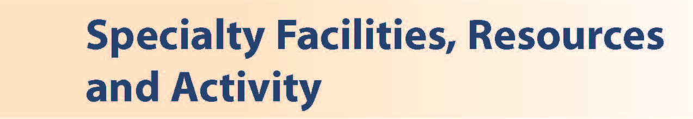

Inpatient Beds
The Head and Neck Directorate operate primarily from one inpatient ward of 12 beds at University Hospital Crosshouse which includes a well-equipped treatment room and a counselling room. There is a suite of Oral and Maxillofacial offices located at University Hospital, Crosshouse. The postholder would have shared office accommodation. There are currently 4 medical secretaries within the Oral and Maxillofacial department to help with any administrative duties at University Hospital Crosshouse.

Clinics
At University Hospital Crosshouse the main outpatient department comprises some 50 consulting rooms. There is also a dedicated clinic area for the Oral and Maxillofacial and Orthodontic Departments.

At University Hospital Ayr outpatient services are provided from both a dedicated area and some rooms shared with other specialties.

Theatres and Day Surgery
Theatre services supporting the Oral and Maxillofacial department are provided at Crosshouse Hospital. There are 8 main theatres in the theatre complex and 3 day surgery theatres together with one treatment room. There are 12 overnight beds for 23-hour cases.

Diagnostics
Crosshouse also has a full supporting diagnostic facility including a spiral CT scanner with 3D reconstruction and a new MRI scanner. Cone Beam CT scanning is also available within University Hospital Crosshouse.

Oral and Facial Laboratory
There is a fully equipped oral and facial laboratory, including 3D printer, this is led by a Consultant Maxillofacial Prosthetist and Technologist. Both intraoral and craniofacial prostheses are made at University Hospital Crosshouse.

Education Facilities
Both hospitals have extensive facilities for educational support. The MacDonald Education Centre at University Hospital Ayr and the Alexander Fleming Centre at University Hospital Crosshouse have an auditorium, tutorial rooms and up-to-date audio-visual facilities.

Both Education Centres house well stocked libraries which include good IT facilities offering access to Medline and the Internet.

Medical Staff Resources

The staffing of the Head & Neck Directorate is as follows:

Consultant Staff | Base | Specialist Interest
Mr Roger Currie | Crosshouse | Oral and Maxillofacial /Skin Cancer/Associate Medical Director, Surgery
Ms Deborah Boyd | Crosshouse | Oral and Maxillofacial /Orthognathic/Facial Deformity/ Trauma; Clinical Director for Head & Neck
Mr Ewen Thomson | Crosshouse | Oral and Maxillofacial /Head and Neck Oncology
Vacancy | Crosshouse | Oral and Maxillofacial /Orthognathic/Facial Deformity/Trauma
Mr Andrew Whymark | Crosshouse | General ENT/Rhinology
Mr Richard Townsley | Crosshouse | General ENT/Head & Neck Oncology
Ms Lyndsay Fraser | Crosshouse | General ENT/Paediatrics & Cochlear Implant
Mr Peter Wardrop | Crosshouse | General ENT/Cochlear Implant
Ms Natasha Grimmond | Crosshouse | General ENT/Cochlear Implant
Ms Lorna Langstaff | Crosshouse | General ENT/Head & Neck Oncology
Vacancy | Crosshouse | Orthodontics
Ms Lorna Murphy | Crosshouse | Orthodontics
Mr Ryan Higgins | Crosshouse | Restorative Dentistry (visiting)
Mr Andrew McInnes | Crosshouse | Restorative Dentistry (visiting)

Speciality Doctor | Base | Specialist Interest
Ms Louisa McCaffrey | Crosshouse | Oral and Maxillofacial (P/T)
Ms J Cross | Crosshouse | Oral and Maxillofacial (P/T)
Ms A Murray | Crosshouse | Oral and Maxillofacial (P/T)
Vacancy (this post) | Crosshouse | Oral and Maxillofacial (P/T)

The department is supported by junior staff as part of the Pan Scotland StR Training Programme 1 Dual qualified StR on rotation. Four DCT2’s, one DCT1, and one part time Specialty Doctor to support the on call rota

Activity (average per annum):

 | In-patient Admissions | Day Case Admissions | New Out-patient Appointments | Out-patient Treatments
Maxillofacial Department | 513 | 458 | 3187 | 927
ENT Department | 1681 | 604 | 6597 | 409
Orthodontics | 0 | 0 | 826 | 4770



The OMFS department is very forward thinking and has been at the forefront of many innovations. Any contribution by this new post would be welcome in terms of the department’s development. As this is a new post the successful candidate will be supported to develop a complementary interest to the current consultants and expand the opportunities for team working across the West of Scotland Region.

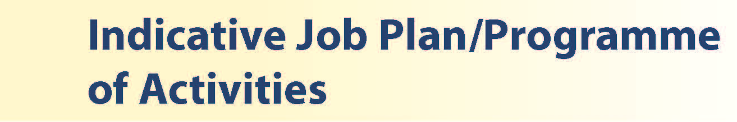

You will be responsible to the OMFS Clinical Lead who will delegate a mentor in your career development. You will be a member of the OMFS team, supporting both elective and emergency care, support consultants in theatre and out-patient programmed activities.

You will be encouraged to develop and provide independent OMFS service in outpatients, day surgery and theatre.

There will be time for Continued Professional Development / Personal Study / Audit (one programmed activity a week).

It is important to note, that the current practice is for a variable timetable in order to maintain skills and cover. You will have to be flexible in your timetable.

The requirements of this post will change through time in line with clinical advances and developments in services provided by the NHS Ayrshire & Arran.

Criteria for the Post

• Minimum of 2 year’s post-registration experience in OMFS
• Full General Dental Council Registration
• MFDS qualification
• Evidence of quality improvement/audit work
• Appropriate practical and diagnostic skills
• Competence in minor oral surgery
• Excellent communication skills, both written and oral
• Ability to work well within a team
• Demonstrable organisation and time management skills
• A genuine interest in the specialty

PROPOSED WEEKLY PROGRAMME
DAY | HOSPITAL/ LOCATION | ACTIVITY | HOURS PER ACTIVITY INC TRAVEL
FROM / TO | HOSPITAL/ LOCATION | ACTIVITY | HOURS PER ACTIVITY INC TRAVEL
Monday
am | UHC | Theatre | 4
pm | UHC | Theatre | 4
Tuesday
am | UHC | Local anaesthetic list | 4
pm | UHC | Local anaesthetic list | 4
Wednesday
am | UHC | SPA | 4
pm | UHC | Clinic | 4
Thursday
am | UHC | Wound management | 4
pm | UHC | Wound management | 4
Friday
am | UHC | Local anaesthetic list/Treatment Theatre | 4
pm | UHC | SPA | 4
Saturday
Sunday
Total |  |  | 40 hours



Job Plan

The post holder is required to agree a detailed job plan which will be reviewed at least annually. Efforts will be made to complete job planning prior to the date of commencement in post, or, if this is not possible, as soon as possible following this date. The detail of fixed sessions, including any special interest, will be finalised following appointment of the successful applicant. It is expected initially that 9 programmed activities per week will be devoted to direct clinical care, with 1 programmed activity allocated for supporting professional activities Attendance at multi-disciplinary team meetings, pre-procedure consultations, are included within the 9 programmed activities of direct clinical care and will be appropriately timetabled. Subject to completion of job planning, the proposed weekly timetable will follow a rolling pattern and will be linked to a consultant pairing. The work will include elective and trauma theatres and out-patient clinics

Contracted activities for this appointment will be defined and agreed with the post holder and the Lead Clinician for OMFS. The post holder will be professionally responsible to the Associate Medical Director and managerially responsible to the General Manager Surgical Services.

This post is available on a full-time basis and part time basis but the Board welcomes applications from individuals who are unable to undertake a full time commitment and who may wish to work on either a part-time or job share basis.

The successful candidate will be expected to be registered for CPD with the General Dental Council and to fulfil requirements for annual certification and for appropriate revalidation. Annual leave entitlement is 5 weeks per year, rising to 6 weeks per year after having completed 2 years’ service in the specialty doctor grade and/or equivalent grades with additional statutory holiday entitlement.



The terms and conditions of service applicable to this appointment are the Specialty Doctor Terms and Conditions of Service (Scotland) 2008 as amended from time to time. NHS Ayrshire & Arran will require the post holder to agree with the Lead Clinician and General Manager, a job plan of fixed and other commitments, which will be reviewed on an annual basis and revised as necessary to meet the requirements of the local and national service issues.

Specialty Doctors will be required to participate in an annual appraisal. Formal appointment to this post will be conditional upon satisfactory completion of all pre-employment checks, including satisfactory medical screening.

On commencement of employment, salary will be determined in accordance with Schedule 14 of the terms and conditions of service. This appointment will be superannuable under the NHS Superannuation Scheme. New employees will automatically be enrolled in the scheme unless they opt out. For further information, please contact the Scottish Public Pensions Agency (SPPA) on 01896 893100 or visit www.sppa.gov.uk.

The employment is subject to three calendar months’ notice on either side.

Applicants wishing further information about the post are invited to contact Ms Debbie Boyd, Consultant in Oral and Maxillofacial Surgery, Tel: (01563) 827293, with whom visiting arrangements can also be made.



Post of: Speciality Doctor in Oral & Maxillofacial Surgery

Location: University Hospital Crosshouse

QUALIFICATIONS:
REQUIREMENTS | ESSENTIAL | DESIRABLE
Qualifications | Fellowship/Membership of the Royal College of Surgeons or equivalent Full GDC registration, with licence to practise at time of appointment | Higher degree e.g. MSc, MD or PhD higher degree MBA or other relevant diploma

SKILLS/KNOWLEDGE/COMPETENCE
REQUIREMENTS | ESSENTIAL | DESIRABLE
Knowledge & Skills | Ability to take clinical responsibility for independent management of patients as agreed with the Consultant Good written and oral communication skills Demonstrated ability to manage time effectively Experience of working in a multidisciplinary team Good information technology and administrative skills
General Experience: | Minimum of 2 years post-registration work which will have been in a specialty training programme in a relevant specialty or as a fixed term specialty trainee in a relevant specialty; or shall have equivalent experience
Development | Committed to formal and informal teaching and training of junior doctors/dentists, medical students and other clinical staff Commitment to learning & continuous professional development and audit
Personal and Interpersonal Skills | Effective communicator  Ability to work flexibly according to the needs of the service, and contribute to team and skills development | Knowledge of recent changes in the NHS in Scotland

