NHS Lothian – Leith Community Treatment Centre
Exciting opportunities are available to join Edinburgh Health and social care Partnership within Leith Community Treatment Centre, in the Outpatient and Endoscopy Department. We have various positions for registered and unregistered nursing staff. We are looking for passionate, caring, motivated people to join our highly skilled nursing teams.
We offer the opportunity to work with exceptionally talented teams in a friendly and welcoming environment and impact positively on the lives of thousands of patients and their families.

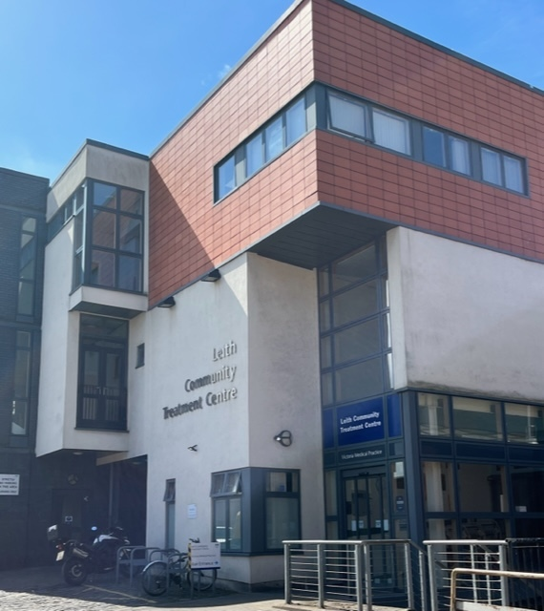

What We Can Offer You
The Outpatient department supports a variety of Adult and Paediatric clinics including, Endoscopy, Minor Surgery, Cryotherapy, Respiratory, Diabetic, Paediatric surgical, Medicine of the Elderly and Chronic Pain - providing you with the opportunity to gain a breadth of knowledge and exposure to multiple specialties.
Roles
- Nursing Assistants (Band 3 salary (£25,468 - £27,468)) pro rata per annum
- Staff Nurses (Band 5 salary (£30,229 - £37,6644)) pro rata per annum

Benefits
- A minimum of five weeks annual leave increasing with length of service
- A range of supportive employment policies including Flexible Working
- A range of hours considered
- We provide an extensive induction programme and excellent professional training and development opportunities.
- Access to the NHS Pension Scheme and Staff Benefits
- Monday – Friday working

