11.
NHS NATIONAL SERVICES SCOTLAND

JOB DESCRIPTION
1. JOB DETAILS
Job Title |  | Finance Improvement Manager
Immediate Senior Officer/ Line Manager |  | Head of Projects and Service Improvement
Department |  | Finance
SBU |  | Finance
Location |  | Gyle Square, Edinburgh
CAJE Reference |  | NPFINS603
2. JOB PURPOSE
Provide an independent, objective assurance to internal finance processes and controls. Managing the service improvement function to bring a systematic, disciplined approach to evaluate and improve the effectiveness of risk management, control and governance processes.

To lead, plan and deliver a programme of service improvements for the Finance department which support effective service delivery through maximising qualitative, quantitative and customer focussed benefits
across all areas of the business.
3. DIMENSIONS
NHS National Services Scotland (NSS) is the working name of the Common Services Agency and as a non-departmental public Body (NDPB) is designed and enabled to provide a range of support services to Health Boards, Health and Social Care Integrated Joint Boards and across the wider Scottish Public Sector.
NSS is committed to helping its customers achieve financial benefits from working with us, and Finance
plays a key role in ensuring that NSS has appropriate systems of financial control, and is able to identify opportunities to drive financial savings and to support the management and delivery of these savings, both internally and for our customers.
Specifically, the post holder will be responsible for:
- Direct Line Management of the Service Support Officer who provides direct support for the
Service improvement, Performance Management and Customer Engagement Frameworks across the SBU;
- Performing internal process reviews and audit reports to identify deficiencies and underlying root causes in Finance processes, providing recommendations to mitigate/address deficiencies;
- Development and implementation of the Finance Service Improvement Programme and Quality and Performance Management Framework;
- Key to achievement of successful redesign of services to ensure the effective and efficient delivery
of customer focussed services;
- Monitoring service improvement progress (against expected timelines, scope etc) and project manage to completion, escalating where required in a timely manner;
- Assisting with the production of timely management information and KPI reporting;

4. ORGANISATIONAL CHART
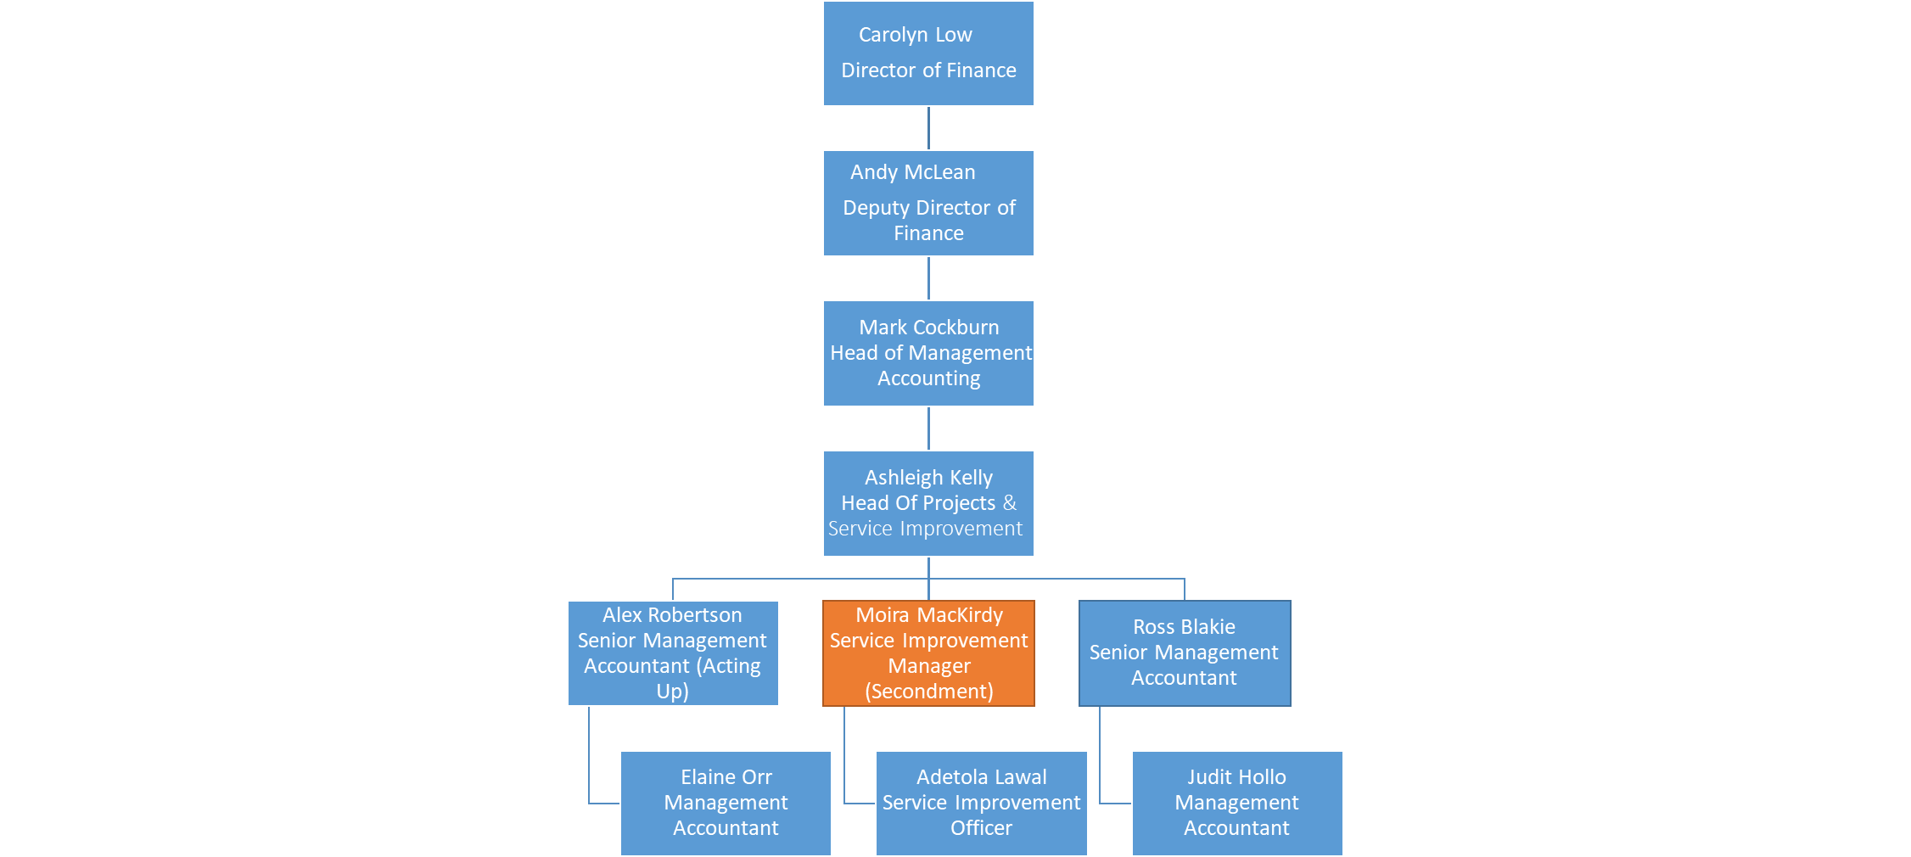

5. ROLE OF THE DEPARTMENT
The role of Finance function is to support the NSS staff; Budget Holders; Line Managers; SBU management teams; NSS Board; and wider NHS Scotland through the provision of comprehensive financial services and influencing the delivery of financial sustainability and value in support of direct patient care, public health
and related activities.
- Business Finance includes Management Accounts, Business Controllers and Business Partners.
- Finance Operations provides Accounts Payable, Accounts Receivable, Payroll, Car leasing and
Treasury
6. KEY RESULT AREAS
- Provide expert advice on the application of improvement approaches and methods to support
Finance colleagues in delivering innovative, effective and value add systems and process improvements. This includes identifying and delivering opportunities for process efficiencies and savings across Finance, the wider NSS, and beyond utilising digital and system solutions,
so Finance continue to transform the way we deliver our services.

- Collect, analyse and interpret system data, to ensure the success of process improvement,
digitisation and automation initiatives are monitored, evaluated and evidenced based.

- Working closely with Finance Leads, co-ordinate the development of Service Level Agreements with customer Boards ensuring the team deliver within these agreements, assure service compliance through regular monitoring and taking remedial action where compliance falls below the agreed standard required. This will also include responsibility for appropriate management of stakeholder relationships within a project and service environment, including suppliers and staff ensuring a collaborative approach at all times.

- Work closely with Finance Leads and wider stakeholders to develop, implement and deliver the
5 year Finance Roadmap in order to continue to transform how we deliver our services across Finance, NSS and our Shared Service customers.

- Manage, monitor and review Finance Audit actions coming out of external audits, ensuring action updates are provided, are achievable and are ultimately delivered. This will include identifying opportunities and implementing solutions from Audit outcomes for system or process improvement.

- Lead on designated strategic work streams designed to improve service quality, reduce costs and increase the effectiveness both of the team and of the wider SBU. This includes identifying and taking the lead on opportunities to synergise system processes and workflows as they relate to the functional teams and continually monitoring, reviewing and refining the quality and efficiency of processes and systems to meet customer requirements.

- Embed a culture of continuous improvement across the Finance SBU supporting and promoting cycles of design/redesign activity from initiation through to embedding and evaluating. Ensuring that the opportunities, requirements and benefits of process improvement are well defined, championed and communicated across the function, working closely with colleagues in CEaD.

- Work collaboratively with Digital and Security and the NSI Team to ensure that opportunities to apply a digital first design principle are identified and embedded in all system and process improvement plans to increase the effectiveness of both teams and the wider SBU.
7. ASSIGNMENT AND REVIEW OF WORK
The post-holder will establish their own detailed priorities within annually agreed objectives and allocation of workload from the Head of Management Accounting. The post holder is required to prioritise, plan and delegate workloads as appropriate to meet planned and ad-hoc demands. Work will also emanate from the Director and other members of the wider finance team including the Deputy Director of Finance and Associate Director – Finance Operations.
The post-holder will adjust priorities to meet changing customer demands and will review these, self managing any conflicting demands, seeking advice from the Line Manager only when necessary.
The post holder will be expected to exercise independent judgment and make decisions based on information gathered in order to reach optimal process improvement recommendations.
Post holder will be required to provide expert analysis - interpreting and comparing a range of performance and other data from a range of sources across operational areas which will be used to inform process improvement.
Formal line management reporting for the post-holder will be to the Head of Management Accounting
Participates in the formal objectives setting and performance appraisal process within Finance.
Takes a pro-active approach in the formulation of a personal development plan.
8. COMMUNICATIONS AND WORKING RELATIONSHIPS
The post holder will be required to communicate verbally, face to face, by telephone, in writing and through presentations with a number of stakeholders, to support the service improvement and quality and performance management agendas. There will be formal meetings, written communications and informal opportunities for discussion in order to ensure efficient systems of working and timely outputs.
Communicates information at all levels concerning issues that can be highly complex, sensitive and confidential such as performance review, service redesign resulting in organisational change, information required for reports to the Board. Applies well developed motivational skills through interactions with Directors, managers and staff.
The post holder is required to use a wide range of skills such as negotiation, mediation, persuasion and tact when communicating with contacts both internal and external.
Must be able to negotiate with senior stakeholders on difficult issues and present highly complex and sensitive information to large and influential groups.
Negotiating on difficult and controversial issues including performance and change.
Represent the SBU on NSS working groups and steering groups. Establish relationships with relevant key stakeholders across NSS, including other SBU service improvement and performance leads and
NSS Leads for example on process improvement, DST.
The post holder will be required to communicate both verbally and in writing with a number of internal and external stakeholders, in the design and consultation of service and process development and implementation:
Internal
- Close working relationships with Director of Finance and Finance SMT/OMT colleagues on an informal and formal basis using collaborative verbal and written methods of engagement and communication.
- Negotiates with senior stakeholders on difficult and controversial issues and presents highly complex
and sensitive information to large and influential groups. Often the need to convey highly contentious information in an atmosphere where change is proposed.
- Regular meetings with Finance staff, Staff Side and across other SBUs to ensure effective service improvement and any associated change management that relies on contributions from other areas of NSS.
External
- The postholder is expected to utilise effective partnership working through establishment and maintenance of good working relationships with key internal and external stakeholders in line with operational requirements;
- Effective customer engagement where service improvement requires liaison with external customers/clients. These may include other Health Boards;
- These relationships are essential to ensure that existing services are meeting customer and stakeholder requirements, and that proposals for new work or service changes are fully explored;
- Internal/External auditors for the purpose of agreed audit recommendations to improve processes and systems.
9. MOST CHALLENGING PART OF THE JOB
Create a service improvement culture across all areas of Finance where quality, process improvement and performance management are embedded and service redesign is a key part of business as usual to effectively support service delivery and the maximisation of qualitative, quantitative and customer focussed benefits.
Challenging existing ways of doing things and breaking down barriers while staying close and sensitive to stakeholder and staff needs. Managing constant and often conflicting demands through mature negotiation and prioritisation of workload and resources.
Ability to analyse complex facts and situations and develop a range of options where there is no obvious solution. This requires investigating potential solutions and reporting back to enable a final decision.
10. Systems
Required to work closely with the Senior Managers and Heads of Service within Finance to ensure that service delivery and improvement plans are meeting requirements and that the SBU has systems in place to accurately monitor performance.
The post requires the use of a PC and advance knowledge and practical application of the Microsoft Office package – for communications via e-mail, drafting regular reports, associated papers, correspondence, compiling spreadsheets, drafting Powerpoint presentations, accessing internet.
The postholder uses a variety of systems available which include Service Now, DST, Business Objects, others (such as SSTS, eESS etc).
11. WORKING ENVIRONMENT AND EFFORT
Physical Effort
The post holder will be expected to work at a desk with a computer and regularly move to different locations to meet with stakeholders. This may require the carriage of documents and lap top computers.
Mental Effort
Being required to work within different operational areas and departments on unfamiliar subjects will require the post holder to concentrate for protracted periods to learn new topics quickly in order to add value. This will require the postholder to support more than one area at a time and so will need to be able to switch focus between conflicting priorities as the work requires.
Strong element of unpredictability in working day. The ability to make sound judgements, deal with unpredictable interruptions and meet deadlines, using own initiative. Requirement to change from one
task to another, prioritising effectively and adjusting plans.
Substantial mental effort required for problem solving, juggling demands and negotiating and influencing stakeholders to meet competing priorities and to understand complex methodologies linked to o process development.
Sustained concentration, 2-3 hours at a time required to create and review complex analysis, reports and outputs, this will often be to tight deadlines and may require very quick decision making.
Ability to sustain mental effort and attention in order to effectively lead meetings and discussions or working groups, ensuring good participation and effective end results.
Ability to quickly assess customer requirements and mentally associate these with current or emerging technical or operational trends.
Emotional Effort
Required to maintain emotional resilience through work programmes, changes and challenges and see
these through to completion.

Required to handle and resolve conflict and challenging behaviour during meetings or discussions and through other channels, especially where these are related to service improvement or service redesign.
This could include exposure to strongly held, conflicting stakeholder viewpoints and resistance to change.
Required to deal with these with skill and diplomacy to build rapport, gain cooperation and compliance and demonstrate strong competence.
Line management responsibilities for the performance of team members – this may result in disciplinary or change in duties. Managing the team through changes to roles and processes.
12. ENVIRONMENTAL / WORKING CONDITIONS & MACHINERY AND EQUIPMENT
The postholder works in an open plan office which can lead to frequent interruptions and there can also be considerable background noise.
There is a requirement to use VDU equipment daily and standard office equipment e.g. telephone,
computer, photocopier, printer and projector and needs to keep a tidy and organised workstation due to clear desk policy and health and safety reasons.

Standard keyboard skills.
13. QUALIFICATIONS AND/OR EXPERIENCE SPECIFIED FOR THE POST
Qualification
Educated to degree level with evidence of holding or working towards postgraduate training such as accountancy/ project management qualification
Experience
Management experience within a large complex organisation preferably within the NHS or wider public sector.
Significant demonstrable experience in a number of key areas, ideally including:
- Performing process walkthroughs to build a strong understanding of key processes and identify key risks and controls;
- Project management of key service improvement programmes;
- Performance management and quality,
- Data analysis and reporting;
- Development and delivery of training programmes;
- Developing and maintaining effective customer relationships and working in an environment where customer engagement is a key focus.
Knowledge & Skills
Excellent communication, facilitation and negotiation skills, including the ability to simplify and communicate complexity, and the maturity to operate at all levels within NSS, and potentially NHS Scotland and the wider public sector.
Highly effective at building collaborative working relationships.
14. JOB DESCRIPTION AGREEMENT
A separate job description will need to be signed off by each postholder to whom the job description applies.

Postholder Signature: |  |  | Date:
Postholder Print:
Manager Signature: |  |  | Date:
Manager Print:
Manager Title:

