

NHS LothianWard 54, WGH
Exciting opportunities have arisen to join our fantastic team in Ward 54 at the Western General Hospital,NHS Lothian. We have multiple Band 2 positions available for Health Care Support Workers (HCSW) and we are looking for passionate, caring, motivated people to join our highly skilled nursing team.
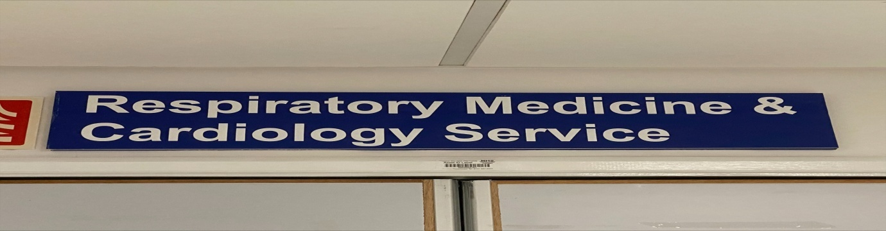
We offer the opportunity to work alongside talented team players within a multidisciplinary environment, impacting positively on the lives of thousands of patients and their families.

What We Can Offer You

Ward 54 is located on the 1st floor of the Anne Ferguson Building within the WGH, NHS Lothian. We specialise in caring for patients with Respiratory, Cardiology and Cystic Fibrosis illnesses. We have a range of specialist nurses amongst our team who are located within the ward to assist with specialised care requirements for our patients. The ward is a 35 bedded unit and is often very busy with lots of learning opportunities.

We pride ourselves in staff development and ensure that all new and existing staff are well supported. Effective teamwork within our environment is essential and we welcome you with open arms to our highly dynamic team. If you feel like this opportunity is for you, please see below, and don’t hesitate to get in touch.

We look forward to welcoming you to Ward 54…

Roles
- Band 2 Health Care Support Worker
Salary
- Band 2 Range £23,362 - £25,368 (pro rata) per annum

Benefits
- A minimum of five weeks annual leave increasing with length of service
- A range of supportive employment policies including Flexible Working
- Full or part time hours considered
- Access to the NHS Pension Scheme and Staff Benefits

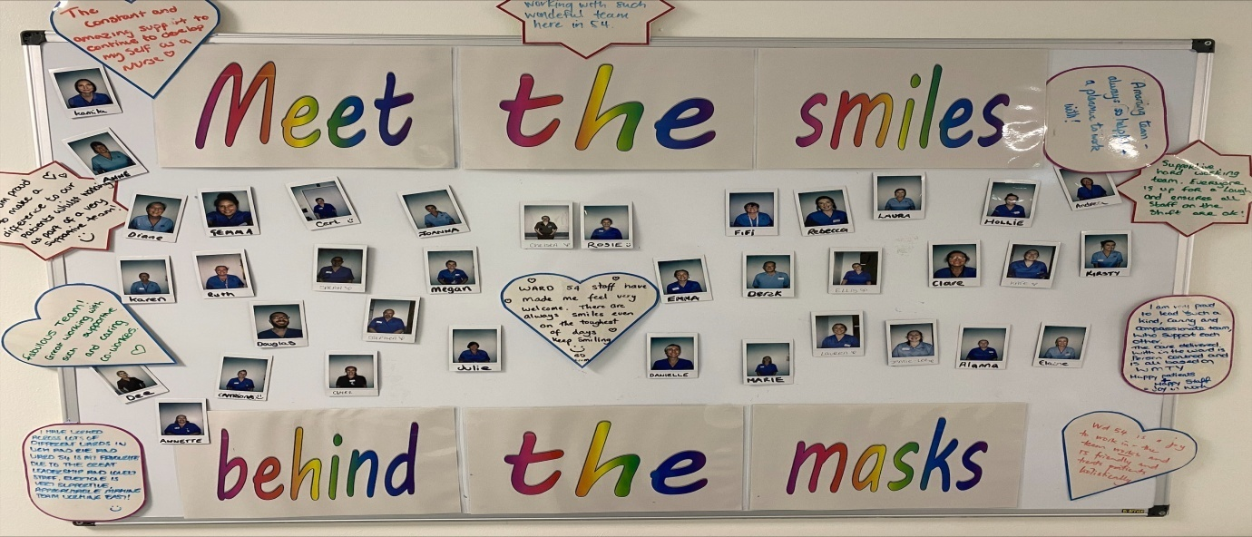

We would love to meet you and invite you for a walk round of the ward to answer any questions you may have.

For further information please contact –

Senior Charge Nurse –
Chelsea Smith
Chelsea.Smith@nhslothian.scot.nhs.uk

Deputy Charge Nurses –
Sharon Walsh
Sharon.Walsh@nhslothian.scot.nhs.uk
Sarah Duncan
Sarah.D.Duncan@nhslothian.scot.nhs.uk
CatrionaDowney
Catriona.Downey@nhslothian.scot.nhs.uk
Blas Berral- Perez
Blas.Berral-Perez@nhslothian.scot.nhs.uk

Or call Ward 54 01315373554



