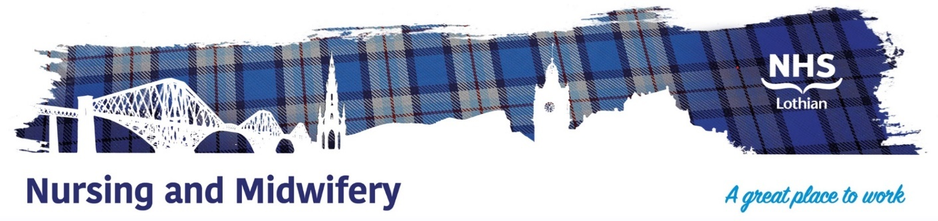

NHS Lothian : The Robert Fergusson Unit
Exciting opportunities are available to join The Robert Fergusson Unit (RFU) Team. The RFU is based in Edinburgh and is the Scottish National inpatient unit for treatment of the Neuropsychiatric Sequelae of Acquired Brain Injury.
Are you passionate, caring, motivated come join our highly skilled teams.

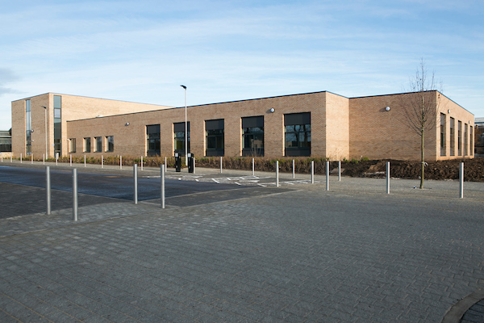

What We Can Offer You
You will be joining an ambitious, innovative, and dynamic team. You will learn and develop skills that are transferable into a range of different roles and tasks, gaining a breadth of knowledge through exposure to multiple specialties within a specialist national service.
Salary
- Healthcare Support Workers Band 3 £25,468-£27,486 (pro rata) per annum
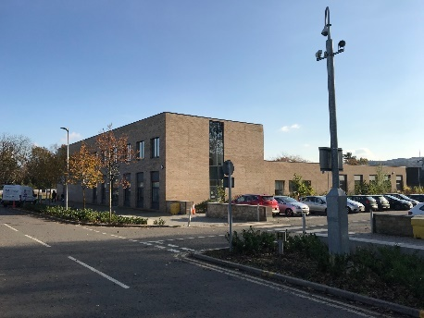
Benefits
- A minimum of five weeks annual leave increasing with length of service.
- A range of supportive employment policies including Flexible Working.
- Full or part time hours considered.
- Being a part of a supportive and enthusiastic team.
- Being part of a national behavioural rehabilitation service.
- Access to the NHS Pension Scheme and Staff Benefits.


