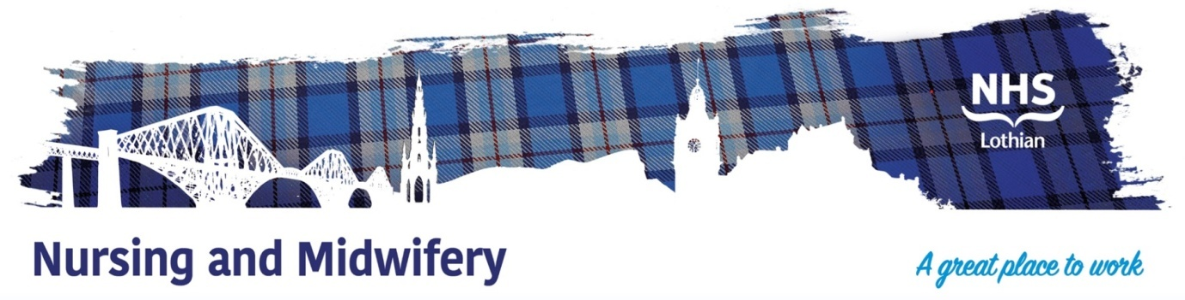

NHS Lothian Baillie Ward, Tippethill Hospital
Exciting opportunities are available to join Baillie Ward within Tippethill Community Hospital, West Lothian. Baillie Ward is a mixed gender ward which provides care for older people, specialising in Hospital Based Complex Clinical Care (HBCCC), Intermediate Care / Rehabilitation and End of Life Care.
We have multiple Band 5 positions available for Registered Nurses and we are looking for passionate, caring, motivated people to join our highly skilled nursing team. If you are passionate about high quality person-centred nursing for older people then we would love to hear from you.
We offer the opportunity to work with talented teams within multidisciplinary environments and impact positively on the lives of thousands of patients and their families.
Find out what our staff say about working in NHS Lothian at https://careers.nhslothian.scot/acute-specialist-nurses/who-we-are/



What We Can Offer You
We have a range of vacancies for experienced and newly qualified nurses to join our innovative and dynamic team – providing you with the opportunity to gain a breadth of knowledge and experience working in a community setting.
Baillie Ward are passionate about staff development and career progression and we support education and training for all staff, for example – skills boost programme, modern apprenticeship, SVQ/NPA, HNC and Open University Nursing. We have link workers to support excellence and quality improvement and you will be supported to develop your skills in your area of interest. We support post-registration learning for example extended role clinical skills and modules such as clinical assessment and decision making and palliative care.
Roles
- Health Care Support Worker (band 3)
- Registered Nurse (band 5)

Salary
- Band 5 Range £30,229 – £37,664 (pro rata) per annum

Benefits
- A minimum of five weeks annual leave increasing with length of service
- A range of supportive employment policies including Flexible Working
- Full or part time hours considered
- We provide an extensive induction programme and excellent professional training and development opportunities.
- Access to the NHS Pension Scheme and Staff Benefits

