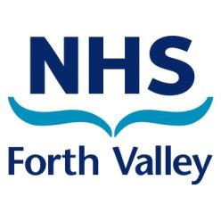
Introduction to NHS Forth Valley

Thank you for your interest in applying to work within NHS Forth Valley. As an organisation, we are responsible for providing health services and improving the health for the population of Forth Valley.
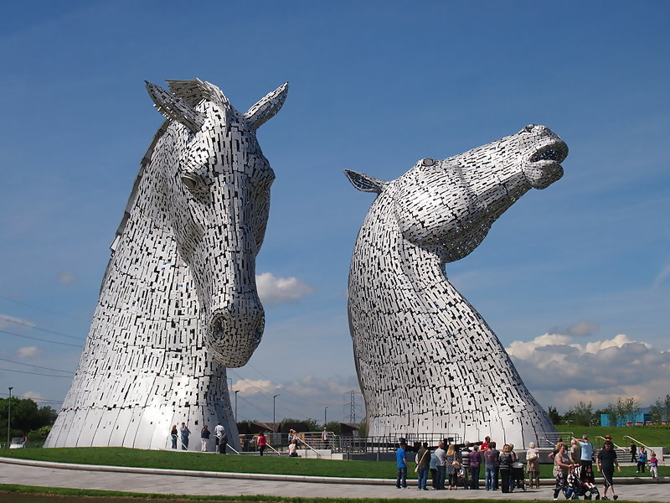
Forth Valley is in the heart of Scotland and covers a wide and varied geographical area from Killin and Tyndrum in the North, Strathblane in the West and Bo’ness in the South.
It is an exciting place to live and work. Its diverse and rich cultural history includes the ancient city of Stirling, once the country’s capital, Falkirk, home of the world’s only rotating boat lift and Clackmannanshire, in the shadow of the Ochil Hills.

It embraces world-class crowd-pullers, like Stirling Castle, and Scotland’s first National Park which takes in Loch Lomond and the Trossachs. Add to this great shopping, leisure and arts facilities and cinemas, plus a healthy dose of fresh air with plenty of opportunities for hillwalking, golf, cycling and even paragliding!
Transport links are second to none with excellent rail services to all major cities and a motorway network which accesses Edinburgh and Glasgow within an hour and brings stunning scenery within easy reach. The area is also noted for excellent schools, both state and independent, and for the friendliness of its people.
Further information about NHS Forth Valley and the services we provide can be found at our website: nhsforthvalley.com

RESISTERED MENTAL HEALTH NURSE (current UK NMC pin required)

FULL & PART TIME / BAND 5 / PERMANENT / ACROSS A VARIETY OF CLINICAL SETTINGS (SEE BELOW)

We are delighted to announce that there are some exciting opportunities available within the mental health services in NHS Forth Valley
We are looking for applicants who have an interest to work within:
- IPCU & Adult Inpatient admission wards, Forth Valley Royal Hospital (FVRH)
- Inpatient admission dementia specialist & Older Adult Admissions ward, Forth Valley Royal Hospital (FVRH)
- Male low secure ward, Bellsdyke site, Larbert
- Rehabilitation wards, Bellsdyke site, Larbert

Applications are invited from enthusiastic suitably qualified first level registered mental health nurses, who are keen to enhance/develop clinical skills, to work within these settings. The post holder will work as part of a multidisciplinary team and should possess good interpersonal and communication skills (both written and verbal). The successful candidate should be committed to the provision of high quality, patient focused care; have a flexible approach to service needs and a genuine interest in working with patients within a mental health setting.

NHS Forth Valley is committed to providing excellent patient care. Wards 2 & 3 are both AIMS accredited, by the Royal College of Psychiatrists. Ward 4 recently won the “Top Team Award” at the Scottish Health Awards.

NHS Forth Valley is committed to supporting staff with a work-life balance and we are in the process of reviewing our shift patterns for our mental health wards. If you would like to discuss this further then please get in touch.

We encourage and support staff to gain a wide range of experiences, and support this through staff personal development plans.

This advert is for registered mental health nurses who have a current UK NMC pin. If you are due to qualify in 2024, our Newly Qualified advert will be out around Easter 2024.

The duties of this post require the successful candidate to be a member of the Protecting Vulnerable Groups (PVG) Scheme. More information on this scheme can be found at www.disclosurescotland.co.uk

For informal enquiries please contact:
Katherine Roseweir, Lead Nurse, Adult Mental Health on 07814 138983
Please note that the majority of correspondence is sent by e-mail, therefore please check your e-mail regularly (including junk folders) and your Jobtrain account for updates.
NHS Forth Valley is positive about disabled people and is committed to offering an interview to disabled people who meet the minimum criteria for the job. Please contact the Recruitment Office on 0330 041 4694 if there are any reasonable adjustments we can make to assist you with your application and/or interview.

