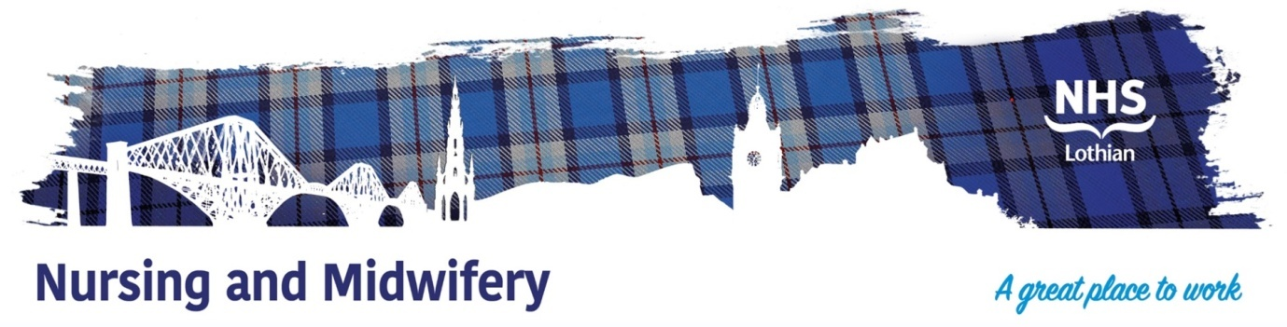

Newly Qualifying Nurses Awareness Session
Midlothian Community Hospital, Midlothian Health & Social Care Partnership – Wednesday 6th March 2024
10am – 2pm
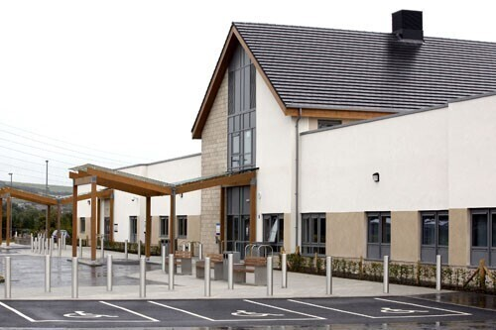
Midlothian Community Hospital, 70 Eskbank Road, Bonnyrigg, Dalkeith, EH22 3ND
Upon arrival, please report to the main reception. Representatives from the following areas will be in attendance to provide information, and answer any questions that you may have:
Midlothian Community Hospital
- Medicine Of The Elderly - Rehabilitation
- Palliative Care
- Mental Health Services
Midlothian Community Nursing
- District Nursing
- Hospital at Home
- Adult Mental Health Community
- Substance Use
Site tours will commence at the following times should you wish to attend:
Site Tours
Guide - TBC
Guide - TBC
Guide - TBC

