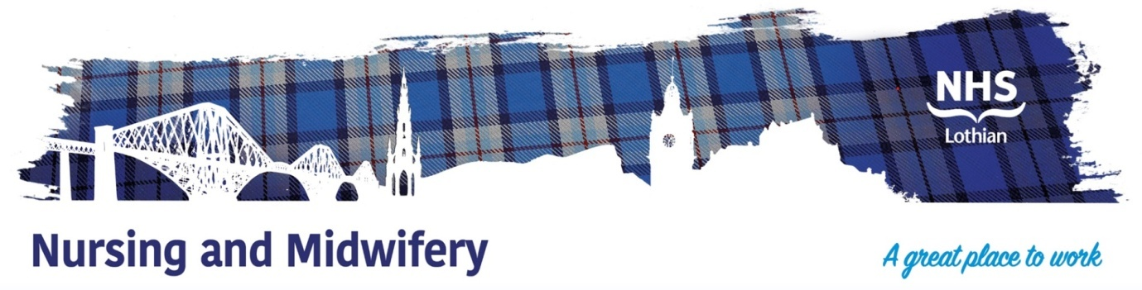
NHS Lothian Meadows Ward – Royal Edinburgh Hospital
Exciting opportunities are available to join Meadows Ward within the Royal Edinburgh Hospital. We have multiple Band 3 positions available for healthcare support workers and we are looking for passionate, caring, motivated people to join our highly skilled nursing teams.
Meadows Ward is a 16 bedded female acute mental health admissions ward comprising all single en-suite rooms.
We offer the opportunity to work with talented teams within multidisciplinary environments and impact positively on the lives of thousands of patients and their families.
Find out what our staff say about working in NHS Lothian at https://careers.nhslothian.scot/acute-specialist-nurses/who-we-are/
The clinical team comprises:
- Consultant psychiatrists Dr N Nuttall, Dr L Donnelly and Dr D Nelson who share responsibility of patients according to community based sectors
- Mon-Fri medical cover is provided by speciality doctor Lorenzo Bandieri who is ward based and supported by junior medical staff.
- The ward is supported by psychologist Dr E.Dalziel
- The nursing team is headed by Senior Charge Nurse Lindsay Fox and Deputy Charge Nurses Jim Hewat and Katie Flockhart.
- There is access to further members of the MDT, OT, PT, SW and discharge coordinators. There is also specialist nurses, SLT, dieticians and other allied health professionals can be made on an as required basis
Ward purpose:
- Meadows ward is responsible for admissions from the South Sectors of Edinburgh
- The age range is 18-65 however at times we may care for people out with this range if required to deliver person centred care
- We offer care and treatment based on both a medical and trauma informed model
- Therapeutic activities and groups are on offer during inpatient stay including decider skills delivery, recreational activity, occupational therapy, music and art therapy, relaxation and self care, sensory based sessions (both on one to one and group basis)
- We offer a safe and supportive environment for those in times of crisis
- During inpatient stay the MDT will ensure medication compliance and can provide services such as clozapine escalation, commencement or reinstatement of depot therapy
- We can support self administration of medications to ensure ongoing compliance upon discharge
Ward philosophy
- Strength based, person centred, individualised care
- Honesty and respect for all
- Social inclusion
- Ownership of rights and opinions
- Heard as an individual
- Prioritisation of personal choice
- Carers support and involvement
- Promotion of a recovery based model

What We Can Offer You
We have a range of vacancies for experienced and newly qualified nurses to join our innovative and dynamic teams across NHS Lothian – providing you with the opportunity to gain a breadth of knowledge and exposure to multiple specialties.
Roles
- Healthcare Support Worker

Salary
- Band 3 Range £25,468 – £27,486 (pro rata) per annum

Benefits
- A minimum of five weeks annual leave increasing with length of service
- A range of supportive employment policies including Flexible Working
- Full or part time hours considered
- We provide an extensive induction programme and excellent professional training and development opportunities.
- Access to the NHS Pension Scheme and Staff Benefits

We prioritise staff development and ensure that individuals are respected, valued and empowered to further their career and own personal development.




