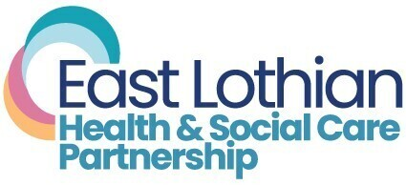
Our Hospital to Home team is expanding, and we’re looking for someone just like you!

Are you caring, compassionate, and motivated to support people in East Lothian to live independent and healthy lives? Are you willing to support people in their own home, to enable them to be discharged earlier from hospital? Then you are who we are looking for!

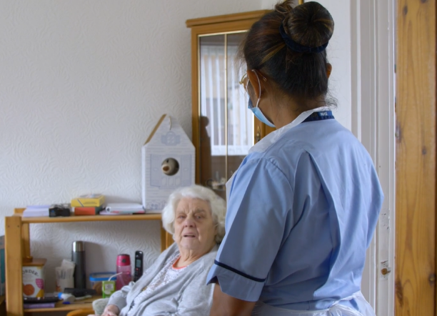
Hospital to Home Team
As part of a new initiative, we are creating a new dedicated team of Health Care Support Workers within our Hospital to Home service.
The East Lothian Hospital to Home team, works in partnership with the Health and Social Care Partnership locality teams in collaboration with East Lothian Council, NHS Primary Care, Voluntary and Third Sector services to support people to stay longer at home.
Your role will involve assessing, planning, providing, managing, monitoring, and evaluating nursing care, following best practice to meet the requirements of people with nursing needs in a community setting. Your responsibilities will include assistance with activities of daily living, medication, meal prep, end of life care and palliative care.

Why East Lothian?
East Lothian prides itself on being a county of opportunity, where our people are our greatest asset, and you will be recognised for the vital part you play.
We will support and encourage your growth and development, providing you with training, coaching and mentorship opportunities for career progression.
East Lothian is one of the most picturesque and popular parts of Scotland to live and work with friendly welcoming towns, some of Scotland’s most beautiful beaches, rolling countryside and the city of Edinburgh on our doorstep.
East Lothian Health and Social Care Partnership is small enough to feel like you belong, and yet big enough to provide a wealth of wide range of career developing opportunities.

What are we looking for?
Qualifications  - Basic literacy skills  - Good basic education  - A level of English language competency and communication skills necessary to perform this role safely and effectively. | Personal Specifications  - Good general health  - Reliable  - Good observation skills  - Able to use own initiative  - Team worker  - Enthusiasm for working with the elderly  - Supportive references  - Physical health. No restrictions which would affect ability to carry out the duties of the post.
Driving Licence
- Candidates interested in this role must hold a full driving license. East Lothian’s Hospital to Home Team have a fleet of cars for staff to use.

Salary and Benefits
Our Health Care Support Workers are employed by NHS Lothian at Band 3 Level, which has a salary scale of £25,468 – £27,486 per annum (pro rata).
Being part of the wider East Lothian Health and Social Care Partnership Team you will be able to enjoy a range of benefits including:
- Opportunity to make a positive impact on the people you support
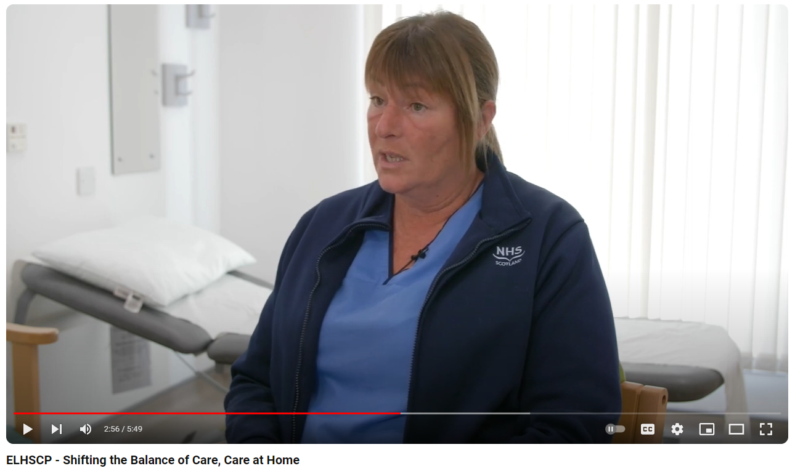Hear from your future
Hospital to Home Colleagues
- An extensive induction programme and excellent professional training and development opportunities.
- Full or part time hours considered
- A range of supportive employment policies including Flexible Working
- A minimum of five weeks annual leave increasing with length of service
- Access to the NHS Pension Scheme
- Access to a range of NHS Staff Benefits schemes
- Opportunity to be part of a multi-disciplinary team
- Career progression opportunities available

Interested?
For further information or to ask any questions about the vacancies please contact
Susan Burton - ICAT Service Manager at Susan.Burton@nhslothian.scot.nhs.uk
All applications should be made though the NHS Scotland Online Job Portal
APPLY NOW

