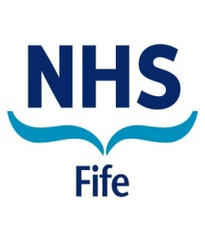

WORKING IN NHS FIFE

Consultant in Addictions/ Consultant in Addictions Clinical Lead


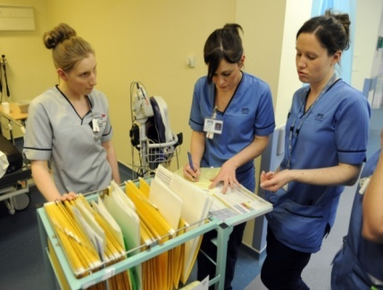

Contents

Section | Page
Section 1: Introduction to Appointment | 3
Section 2: Departmental and Directorate Information | 3
Section 3: Main Duties and Responsibilities | 8
Section 4: Job Plan | 12
Section 5: Person Specification | 14
Section 6: Contact Information | 15
Section 7: Working for NHS Fife | 15
Section 8: Terms and Conditions of Employment | 17
Section 9: General Information for Candidates | 18

This post requires the post holder to have a PVG Scheme membership/record. If the successful applicant is not a current PVG member for the required regulatory group i.e. child and/or adult) then an application will need to be made to Disclosure Scotland and deemed satisfactory before the successful post holder can commence work.

Section 1. Introduction to Appointment

Job Title: CONSULTANT IN ADDICTIONS
Department: FIFE WIDE
Base: LYNEBANK HOSPITAL, DUNFERMLINE

This is a replacement post.

Section 2. Departmental and Directorate Information

FIFE ADDICTION SERVICES
NHS Fife Addiction Services is the NHS organisation that provides a Fife wide treatment service to individuals with drug and alcohol related problems. These services work in close co-operation with others statutory and non-statutory services (known as recovery services) commissioned by the Fife Alcohol and Drug Partnership (ADP). The service is located within the Mental Health Service. NHS Fife Addiction Services receives approximately 100 referrals per month and has an active caseload of about 1800 treatment seeking individuals.
FIFE MENTAL HEALTH DIRECTORATE
NHS Fife Addiction Services is part of Fife Mental Health Service.
The NHS Fife Mental Health Service is a Fife wide service delivering the full range of inpatient and community care and treatment for patients of all ages experiencing mental illness and a range of mental health problems, including alcohol and drug dependency. The service operates as a distinct, Fife wide service managed and governed within and by Fife Wide Division of Fife Health & Social Care Partnership.
It is a large and complex service organised into operational and functional service units in order to provide secondary, tertiary and specialist services, and to link with primary care and the Acute Division. The service is geographically organised to provide inpatient and community general adult and elderly psychiatric care, and functionally organised to provide general and specialist community services for children and young people, and those with addiction problems.
The Adult Psychiatric Service in Fife is divided into three sectors, with inpatient and outpatient care being delivered by a nominated sector consultant. –
Central Fife (population 147,370)
Kirkcaldy & Levenmouth Sectors Based in Whyteman’s Brae Hospital, Kirkcaldy
Glenrothes Sector In-patients based in Stratheden Hospital, Cupar
Day Hospital based in Whyteman’s Brae Hospital, Kirkcaldy
North East Sector (population 74,180) Based in Stratheden Hospital, Cupar
West Sector (population 126,840) Based in Queen Margaret Hospital, Dunfermline

In-patient services
In-patient services are at Whyteman’s Brae Hospital, Kirkcaldy, Queen Margaret Hospital, Dunfermline and at Stratheden Hospital, Cupar. There are three general adult acute wards, one on each site. Ravenscraig Ward in Whyteman’s Brae Hospital, Kirkcaldy has 29 beds, Ward 1 at Queen Margaret hospital, Dunfermline has 30 beds, Lomond Ward in Stratheden Hospital Cupar has a further 30 beds.
Supporting Adult Mental Health Services:
- Community Mental Health Teasm- multidisciplinary teams are located in catchment areas (2 teams in West Fife, 3 in Central and 2 teams in North East Fife). In addition, there are two community rehabilitation teams, one is the east and one in the west, with inpatietn rehabilitation beds based at Stratheden Hsopital.

- There are three day hospitals, one for each site, Dunnikier Day Hospital at Whyteman’s Brae, Hillview at Queen Margaret and Weston Day Hospital in Cupar, offering a range of nurse delivered psychological therapies, both individual and group based, in addition to running Clozapine clinics.

- Department of Clinical Psychology led by the Area Head of Psychology Services based at Lynebank Hospital and Stratheden Hospital.

- Social Work Department (Fife Council). Currently the Social Work Service is being reorganised but we relate at present mainly to the mental health team and community care team. The Social Work Department commissions supporting people care from a number of providers.

- Specialist Pharmacy Services. Specialist mental health pharmacy managers work closely with clinicians, provide information to patients and carers and work on local protocols.

Specialist Services
Unscheduled Care Assessment Team  Old Age Psychiatry | This is a 24 hour nurse lead team with medical input from trainee doctors within hours (consultant supervision within sectors) and on call medical psychiatric doctors out of hours. It is a Fife wide service and is based at Whyteman’s Brae Hospital. It provides urgent assessments, management and signposting for unscheduled presentations including A&E at the Victoria Hospital Kirkcaldy and has close links with the sector teams.  Whyteman’s Brae Hospital (Day Hospital only), Kirkcaldy  Stratheden Hospital, Cupar  Queen Margaret Hospital, Dunfermline
Rehabilitation | Stratheden Hospital,Cupar (Fife wide)
Intensive Psychiatric Care Unit | Stratheden Hospital, Cupar (Fife wide)
Addictions * | Cameron Hospital, Windygates, Leven  Whyteman’s Brae Hospital, Kirkcaldy  Lynebank Hospital, Dunfermline
Child and Adolescent | Playfield House, Stratheden Hospital, Cupar (Fife wide)
Learning Disabilities | Lynebank hospital, Dunfermline (Fife wide)
Forensic | Forensic Community Mental Health Team, Lynebank Hospital, Dunfermline  Radernie Low Secure Unit, Stratheden Hospital, Cupar

ORGANISATIONAL POSITION
Director Fife Health & Social Care Partnership
Clinical Services Manager in Addictions
Consultant in Addictions
Clinical Lead in
Addictions

All other Addiction Clinical and Admin Staff

General Manager
Fife Wide Services
Health & social Care Partnership
Seniorl Manager Mental Health Service

Fife Wide Services
Clinical Director
Associate Medical Director
Health & Social Care Partnership
NHS Fife Medical Director
Line management accountability
Professional accountability
Professional accountability
SOUTH EAST SCOTLAND PSYCHIATRIC TRAINING SCHEME
Fife is part of the South East of Scotland Psychiatric Training scheme. Trainees rotate throughout the whole region, between Lothian, The Borders and Fife. Trainees spend one half day each week during the academic year attending the MRCPsych course in Edinburgh and an additional half day of postgraduate training in Fife. They also attend psychotherapy training. There are GPST’s and FY2’s on rotation with the service also. In total, there are 19 trainee doctor posts.
ARRANGMENTS FOR MEDICAL REPRESENTATION
There is an active Local Negotiating Committee with Primary Care Division representation.
All consultants are members of Fife Division of Psychiatry.
Section 3: Main Duties and Responsibilities
The successful applicant will provide clinical leadership, support, advice and supervision to NHS Fife Addiction Services in order to deliver care and promote a multi-disciplinary/multi-agency approach.
This post helps support the delivery and ongoing development of an effective and safe NHS Fife Addiction Service within the Health and Social Care Partnership in Fife. The postholder will take responsibility for the clinical care of individuals referred to the service within a designated area. The appointment will be on a whole time or maximum part time basis.
There are two opportunities for appointment: Consultant in Addictions or Consultant in Addictions Clinical Lead.
This post will complement the medical workforce within a multidisciplinary service that provides an evidence based and clinically governed approach to individual and population level interventions to meet the needs of substance dependent individuals in Fife. The successful applicant will be involved in the delivery of a recovery oriented approach to complex and multi-morbidity cases using a consultancy model.
Definition

The post holder will join a team of four additional medical staff comprising 0.6WTE Consultant in Addictions, 2WTE Specialty Doctors and 0.4WTE Addiction GP Specialist.

The post holder will be expected to participate in the current duty work schedule of 1:20, (non-resident and on the Consultant out of hours on call rota).
The post is a 10PA job, to be worked over five days. This will comprise 8 DCC and 2 SPA with 0.5 PA in lieu of OOH and flexibility to be subtracted from the DCC’s .

Members of Multi-disciplinary Team
NHS Addiction Services comprises Addiction Nurses and Senior Addiction Nurses working in community alcohol and drug teams covering specific geographical areas. The staff are supported by Addiction Support Workers and an administration team.
Support Facilities (Offices/Secretary):
The Consultant will have an office of his/her own with personal computer and secretarial support.

DUTIES AND RESPONSIBILITIES
- Clinical

- To provide clinical leadership to the care of individual patients as well as the care of patients within the assigned clinical patch.

- To give expert advice on clinical issues relating to substance misuse to the clinical teams within Addiction Services and Mental Health.

- To assess, treat and arrange appropriate care for people with substance misuse problems on an outpatient basis and to provide such care as part of a multi-disciplinary team.

- To undertake psychiatric, medical and risk assessments, and treatment planning in conjunction with the multi-disciplinary team.

- To coordinate complex multiple morbidity clinical scenarios

- Managerial

- To assist with successful achievement of set targets such as the HEAT A:11 waiting time to treatment target.

- To take a special interest lead, the nature of which is to be agreed.

- Provide opportunities in the future to take on the role of clinical lead in addictions.

- Clinical Audit, Data Management and Clinical Governance

- To work with GPs and other clinicians and support staff to develop Fife wide policies for the assessment and management of drug and alcohol users.

- To liaise with the existing geographically based Psychiatry and other medical specialties’ services to develop protocols for the care of patients with multiple morbidities.

- To develop, in partnership with other agencies, alternatives to hospital admission for detoxification and/or rehabilitation.

- To set up substitute prescribing clinics across Fife, working closely with the Health and Social Care Partnerships and Fife Alcohol and Drug Partenership (ADP)

- To work closely with a wide range of statutory and voluntary agencies active within Fife to ensure a multi-agency approach in the provision of services for people with substance misuse problems and associated multiple morbidities.

- To work closely with Primary and Secondary Care services in the provision of a timely and effective treatment plan.

- On-Call Commitment

- To participate in the Psychiatry on-call rota approximately 1:20, non-resident. There will be 0.5DCC in acknowledgement and 3% responsibility allowance.

- Leave

- Annual leave allowances and public holidays are combined 40 days per annum for a full time appointment.

- Research

- Research and audit will be encouraged. Honorary Senior Clinical Teacher and/or Honorary Senior Lectureship status may be available to an appropriately qualified applicant with St Andrews University Medical School. NHS Fife Addiction Services is active within the NHS Fife Research and Development Programme of research activities. NHS Fife also participates in the teaching and research activities organised by Universities of Dundee, St Andrews and Edinburgh.

- To uphold, support and/or initiate research and innovation related activities

- Teaching

- To participate in the training and development of junior medical staff and medical students, including individual and educational supervision.

- To lead on and coordinate with addiction related placements for Universities of Edinburgh, Dundee and St Andrews undergraduate medical training

- Continuous professional development

- To engage actively in local and national Continuing Professional Development

WORK PROGRAMME

Job Plan Review
The Job Plan is provisional and still to be finalised. In particular, you may be asked to consider extra programmed activities of direct clinical care. Your job plan will be subject to review once a year by you, your CSM in Addiction Services and the Clinical Lead/Clinical Director, as laid out in the terms & conditions of the new consultant contract.
In the event of any significant changes in the circumstances affecting this job plan, it is agreed that it will be renegotiated jointly in collaboration with consultant colleagues.

Cover for Consultant Colleagues
Annual/Study Leave - You will be required to provide emergency cover for consultant colleagues during absence on annual or study leave.
GENERAL PROVISIONS
You will be expected to work with local managers and professional colleagues in the efficient running of services and will share with Consultant and other colleagues in the medical contribution to management. Subject to the provision of the Terms and Conditions, you are expected to observe the Directorate’s agreed policies and procedures, drawn up in consultation with the profession on clinical matters, and to follow the standing orders and financial instruction of NHS Fife. In particular, where you manage employees, you will be expected to follow the local and national employment and HR policies and procedures. You will be expected to make sure that there are adequate arrangements for hospital staff involved in the care of your patients to be able to contact you when necessary.
All medical and dental staff employed by NHS Fife are expected to comply with all Hospital Health and Safety Policies within the Division.

Section 4: Job Plan
Proposed Job Plan
Day | Hospital/Other Location | Type of Work | PA’S
Monday am | Lynebank Hospital | Clinically related meetings | DCC (4hrs)
Monday pm | LBH | Mental Health Assessments | DCC (4hrs)
Tuesday am | Various | Fife wide psychiatric education session/training/ Journal Club/ CPD  Supervision | SPA (4hrs)
Tuesday pm | WBH | Case supervision | DCC (4hrs)
Wednesday am | Cameron Hospital | Clinical work | DCC (4hrs)
Wednesday pm | Flexible clinical time | Clinical work | DCC (4hrs)
Thursday am | LBH | Clinical time | DCC (4hrs)
Thursday pm | LBH | Clinical discussions | DCC (4hrs)
Friday am | WBH | Cliical time | DCC (4hrs)
Friday pm | Various | Case supervision / prescription signing | SPA (4hrs)

* Each fixed session equates to a 4.0 hour Direct Clinical Care Session as defined by the new consultant contract
The above job plan is draft only with the final job plan being agreed with the appointee. The precise timetable will be discussed to take into account departmental needs and interest/experience of appointee, especially if successful candidate wishes to take on Clinical Lead role.
1 SPA will be available for the Clinical Lead role.

Weekly timetable of Fixed Commitments * (i.e. regular scheduled NHS activities in accordance with paragraph 30B of the terms and conditions of service).
Your duties and responsibilities will be defined in your job plan,which is subject to review on an annual or interim basis. The provisions relating to job planning are as setr out in section 3 of the Terms and Conditions of service. Consultants may be required to undertake scheduled work during out of hours periods. This will be part of the regular job plan and will be renumerated in line with nationally agreed terms and conditions of service , or your PAs reduced from 4 to 3 hours, in line with the 2004 Consultant contract.

Section 5 – Person Specification
REQUIREMENTS | ESSENTIAL | DESIRABLE
Qualifications and Training | GMC registered medical practitioner.  Licence to practice  Applicants must be on the GMC Specialist Register for General Psychiatry or within 6 months of the anticipated award of a CCT or CESR in General Adult Psychiatry at the time of interview for the post  OR  Applicant must show that he / she has undergone CCST equivalent training in Addictions Medicine | Additional post-graduate qualifications, e.g. MD/ PhD/MSc  Eligible for recognition as Approved Medical Practitioner under the MH (C&T)(S) Act 2003
Experience | Wide experience in psychiatry and/or other fields of medicine.  Working in community settings | Evidence of leading team meetings and other examples of clinical leadership.
Ability | Ability to take full responsibility for independent management of patients.  Ability to communicate effectively and clearly with patients and team members | Evidence of complex case management that are recovery focused.
Academic Achievements | Supportive of research activity | Evidence of research and publications in peer reviewed journal
Teaching and Audit | Evidence of commitment to clinical audit  Formal and informal teaching and training of trainee doctors, medical students and other clinical staff.  Learning and continuing professional development | Experience of designing audits  Evidence of training in clinical and / or educational supervision  Completed audit leading to change in practice
Motivation | Evidence of commitment to:patient-focused care  Continuous professional development and life-long learning  Effective and efficient use of resources | Experience of involvement in service development projects  Clear commitment to developing role in relation to community services
Team Working | Ability to work in a team with colleagues in own and other disciplines  Ability to organise time efficiently and effectively  Reliability | Ability to motivate colleagues  Leadership training  Good liaison and negotiation skills
Section 6 - Contact Information

Informal enquiries and visits are welcome and should initially be made to: Mrs Debbie Christensen tel 01592 643355 or e-mail debbie.christensen@nhs.scot
Section 7 - Working in Fife

Working in Fife
Great education, superb transport links, a growing economy and a wide range of leisure and housing choices, Fife has it all!
Fife lies on the east coast of Scotland, between Edinburgh and Dundee, and is one of Scotland's fastest growing regions. We are going from strength to strength offering competitive employment opportunities coupled with quality alternatives to big city living and everything you would need for a healthy work life balance. As Edinburgh is in easy reach, Fife residents can also benefit from the amenities of Scotland’s capital city.
As well as great golf (St Andrews is home to the game after all) and leisure facilities, our countryside, wildlife and award winning beaches attract over a quarter of a million visitors every year.
Fife is also rich in history; it's the birthplace of Adam Smith and Andrew Carnegie, as well as being the historic seat of Scottish Kings. If you are interested in culture, we have award winning community cultural festivals, theatres, libraries, museums and galleries.
The Kingdom of Fife is a place of contrast and opportunities, packed with potential.
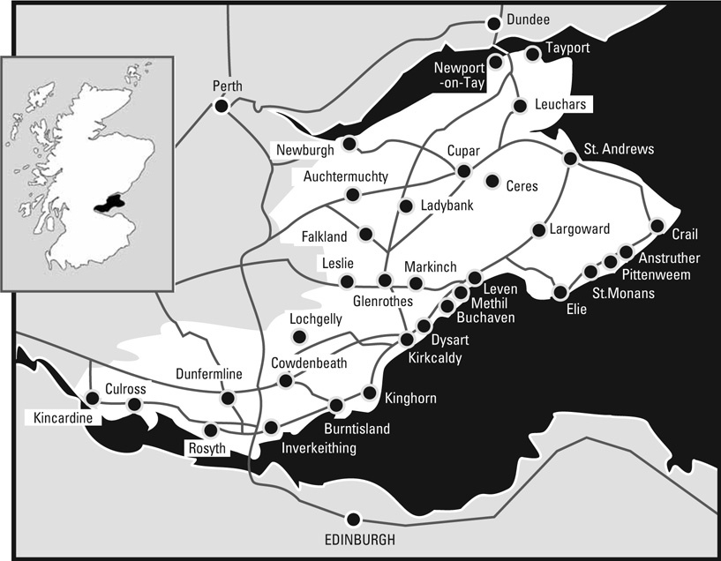

Living in Fife
Property in Fife spans all the options. From picturesque fishing villages in the East Neuk, to medieval streets in St Andrews and new housing across Fife, there's a home to suit every taste. Fife offers excellent properties, easy commutes and fresh air on your doorstep.
184 schools offer the Curriculum for Excellence to learners from 3 to 18, helping 50,000 children and young people develop the knowledge, skills and attributes they will need to flourish in life.
Fife is home to one of Scotland’s most famous universities, St Andrews. Fife College offers qualifications and provides opportunities for learning at home or in the community across Fife. The college works with local employers to help meet their employment needs.

Leisure
Leisure comes naturally in Fife, from modern sports facilities to some of Scotland’s most beautiful parks, gardens, countryside and coastal paths and a packed events programme. Cycling is an ideal way of taking in the Fife landscape with over 300 miles of dedicated cycle routes (www.fife-cycleways.co.uk). Award winning blue flag beaches offer miles of clean white sand and protected wildlife, so good that we welcome over a quarter of a million visitors every year. Of course Fife is also the home of golf and has 5-star courses.

Travel & Location
The Fife transport infrastructure is excellent and accessible so you should find travelling throughout Fife simple. We experience few of the commuting pressures of major cities thanks to the first-class road and railway network.
By rail, the local Fife Circle Network connects major towns and villages with 19 stations, and the main east coast line from London to Aberdeen provides fast and regular links to the cities. By car, Fife is next to Scotland’s major motorway network. From south Fife, Edinburgh is just 30 minutes away, Glasgow just 45 minutes and Perth 30 minutes. The Ferrytoll Park and Ride at Inverkeithing provides an alternative to car journeys into Edinburgh from the north. Dundee is also just a short journey across the river Tay.
Both Glasgow and Edinburgh airports can be reached in under an hour.

Business & Jobs
Fife is redefining its economic landscape with high-tech industries, tourism and renewable energy. Once home to ship-building, mining and heavy manufacturing, Fife is a place that encourages innovation and entrepreneurship. Commitment to education, workforce training, life-long learning and skills development helps to attract and retain talent, develop a knowledge economy and promote a culture of enterprise.
For more about Fife see www.welcometofife.com

Section 8 - Terms and Conditions of Employment

For an overview of the terms and conditions visit http://www.msg.scot.nhs.uk/pay/medical.
Employment Details
The post is available on a full time basis (10 programmed activities) and will be based at Lynebank Hospital, Dunfermline.
Hours of work are as per the agreed job plan which will be reviewed annually.
All NHS Fife appointments are subject to a satisfactory medical report and this post will require enhanced disclosure from PVG scheme.
The salary scale will be that appropriate to a full time consultant i.e. £82,669 to £109,849 (exclusive of any distinction and service awards payable). Part time appointments will be calculated on a pro rata basis. The starting salary and other terms and conditions are subject to the nationally agreed Consultant Grade terms and conditions.
The appointment is superannuable, unless you opt out of the NHS Superannuation Scheme. Staff who choose not to be in the scheme will automatically contribute to the State Earnings Related Pension Scheme (SERPS) unless they are excluded from doing so or have arranged a Personal Pension Plan.
The annual holiday entitlement for staff will be 6 weeks, in addition to public holidays and statutory days.
In addition to the duties outlined above, you may occasionally be required to undertake other duties for limited periods.
Employment is subject to three months' notice on either side, but is subject to the provisions for appeal agreed between NHS Fife and the BMA Local Negotiating Committee.
You are required to be fully registered with the General Medical Council.
Your residence shall be maintained in contact with the public telephone service with appropriate reimbursement for place of residence in accordance with terms and conditions of service.
The post is non-resident.
The terms and conditions of service relating to your employment are those of NHS Fife and for the time being are set out in the Terms and Conditions of Hospital Medical & Dental Staff (Scotland) and the General Whitley Council Conditions of Service, as amended from time to time. Copies of these may be seen at the Headquarters of the Operating Division or at any of Fife Primary Care's Locality Personnel Departments. NHS Fife may from time to time amend these conditions following negotiating and consultation with the BMA, represented by the Local Negotiating Committee.

Section 9 – General information for candidates

Training
The post holder is expected to keep their CPD up to standard.
A programme of Postgraduate lectures and journal club presentations is held on Tuesday mornings and rotates each term between sites (Dunfermline, Stratheden and Kirkcaldy).
The Trust encourages consultants to participate in CPD and to join a peer group. The annual budget for funding for CPD activities is flexible. There are some courses available locally for IT training.

Research
Research is encouraged and the successful candidate may be offered an honorary Senior Lectureship within the local universities

Audit
The post holder is expected to take part in Audit activities. NHS Fife Addictions Services together with Recovery Services have several audits ongoing e.g. Drug Death Monitoring.

Lines of Clinical Responsibility
The post holder will be professionally responsible to the Clinical Director and the Medical Director.

Resources
The consultant will have an office of his/her own with personal computer and secretarial support.
Management Role/Management arrangements
NHS Fife currently has a directorate structure. The Director of Mental Health Services has responsibility for the management of the Mental Health Service. The post holder will be managerially responsible to the Clinical Services Manager for NHS Fife Addiction Service on a day to day basis.

Data Protection Act 1988
Please note that any personal information obtained from you throughout the recruitment process will be collected, stored and used in line with the Data Protection Act 1998. Information will be available to the recruiting manager and to Human Resources staff.

References
All jobs are only offered following receipt of three satisfactory written references. At least one reference must be from your current/most recent employer or your course tutor if you are currently a trainee. If you have not been employed or have been out of employment for a considerable period of time, you may give the name of someone who knows you well enough to confirm information given and to comment on your ability to do the job.

Disclosure Scotland
Where a Disclosure or Protection of Vulnerable Groups Check is deemed necessary for a post, the successful candidate will be required to undergo an appropriate check. Further details on the Recruitment of Ex-Offenders are available from the recruitment centre.

Work Visa
If you require a Work Visa, please seek further guidance on current immigration rules, which can be found on the Home Office website www.ind.homeoffice.gov.uk

ADDICTION RECOVERY SERVICES
Rehabilitation services
Family Support
Mutual aid groups

Psychosocial counselling

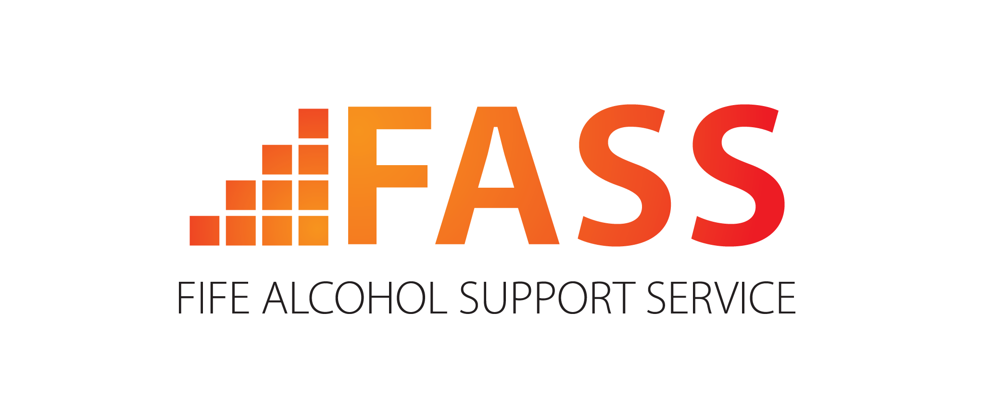

FASS offers a range of Motivational Enhancement & Cognitive-Behavioural counselling methods to individuals and support for relatives and friends.

DAPL offers one to one counselling, support, information and advice to individuals and families across Fife.


“Self Management and Recovery Training”
Helping people develop the tools and skills they need to gain control over their addictive behaviours.
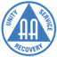
Alcoholics Anonymous
National 24-hour helpline 0845 769 7555
Local 24-hour helpline 0131 225 2727
www.aa-gb.org.uk/eastscotland/fife
AA is concerned with the personal recovery and continued sobriety of individual alcoholics who turn to the Fellowship for help. There are more than 40 meetings in 16 different towns across Fife.
Fife Alcohol Support Service
17 Tollbooth St, KIRKCALDY
KY1 1RW
01592 206200
www.fassaction.org.uk
Drug & Alcohol Project Limited
2 Parkdale, Park Drive
Leven, KY8 5AO
01333 422277
www.dapl.net
Fife Intensive Rehabilitation & Substance Misuse Team
3 Fergus Place, KIRKCALDY KY1 1YA
01592 585960
www.firstforfife.co.uk
Meetings held across Fife: Phone 01333 422277 or 01592 585960 for details. www.smartrecovery.org
FIRST provides a Fife-wide rehabilitation service to individuals via one to one sessions, group work and volunteer support

Al-Anon Family Groups provide support to anyone whose life is, or has been, affected by someone else’s drinking.
Groups currently meet in Cupar, Dunfermline, Glenrothes and Kirkcaldy
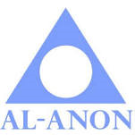
Al-Anon
National helpline 020 7403 0888
www.al-anonuk.org.uk


Barnardo’s
Westbridge Mill, Bridge St, KIRKCALDY, KY1 1TE
01592 265294
www.barnardos.org.uk

A family intervention service for children affected by parental substance use.

Harm Reduction Service across Fife

Harm Reduction Services
Addaction
8 Hanover Court, Glenrothes, KY7 5SB

