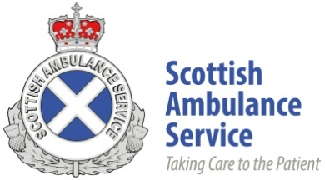

PERSON SPECIFICATION

JOB TITLE: | EPDD Driver Training Officer (DTO)

Listed below are the key requirements needed to perform this job, candidates will be assessed against these criteria throughout the selection process. NB – Any criteria in the “Essential” box must apply to all candidates. You must stipulate at which stage of the selection criteria will be assessed, i.e. Application Form (AF) or Selection Process (SP)

 | Essential Criteria |  | Desirable Criteria
 | Criteria | AF / SP | Criteria | AF / SP
Qualifications | Level 4 Diploma Emergency Response Ambulance Driving Instructor | AF | Current DVSA Approved Driving Instructor (ADI) registration | AF
 | Level 3 Certificate in Emergency Response Ambulance Driving | AF | level 4 Award in the Internal Quality Assurance of Assessment Processes and Practice | AF
 | Level 4 Certificate in Education & Training (QCF) or equivalent | AF | Level 4 Award for Preparing for the Mentoring Role | AF
 | Level 3 Certificate in Assessing Vocational Achievement (CAVA) or equivalent | AF
Experience | Delivered a CERAD course within the last 6 months, as per FQ qualifications specification | AF | 2 Years Level 4 Diploma Emergency Response Ambulance Driving Instructor experience teaching CERAD / DERADI / APCSAD | SP
 |  |  | Previous shift working experience. | SP
 |  |  | Previous NHS experience. | SP
Skills and Knowledge | Able to communicate effectively verbally and in writing | AF | Ability to remain calm while working under pressure. | SP
 |  |  | Planning and decision making skills | SP
Personal Attributes | Ability to work unsupervised for long periods.  Ability to work to tight deadlines, with frequent interruptions and ability to mange workload and respond to changing workload | SP | Team Player | SP
Other Requirements | Full B, C1 driving licence, valid in the UK and no more than 3 penalty points | AF | Evidence of self-development CPD / Portfolio. | SP
 | First Aid or equivalent Qualification | AF |  | SP
 | Flexibility (may be required to work in locations across Scotland) | SP

