

**NHS Lothian Main Theatres WGH**

Exciting opportunities are available to join Main Theatres at the Western General. We have Band 5 positions available for Registered Nurses, Operating Department Practitioners and Anaesthetic Practitioners. We are looking for passionate, caring, motivated people to join our highly skilled multidisciplinary theatre team.

We offer the opportunity to work with talented teams within multidisciplinary environments and impact positively on the lives of thousands of patients and their families.

Find out what our staff say about working in NHS Lothian at https://careers.nhslothian.scot/acute-specialist-nurses/who-we-are/

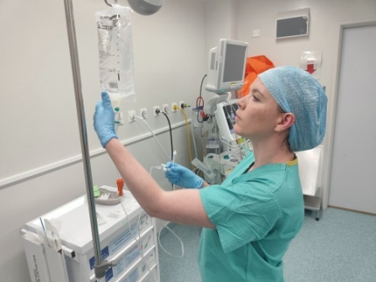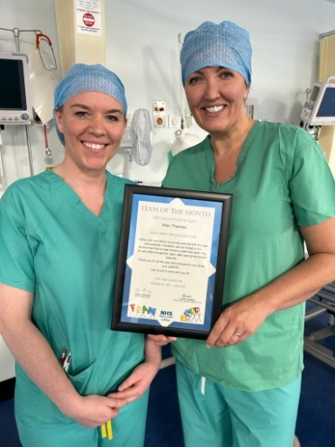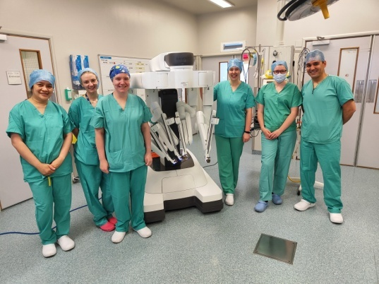

**What We Can Offer You**

We have a range of vacancies for experienced and newly qualified nurses to join our innovative and dynamic teams across NHS Lothian – providing you with the opportunity to gain a breadth of knowledge and exposure to multiple specialties.

We welcome you to apply to join our amazing team here at Main Theatres in the Western General Hospital. The WGH is a rewarding place to work, which is centrally located in the beautiful capital city of Edinburgh, boasting excellent transport links.

Main Theatre offers an excellent opportunity to both new and experienced theatre nurses and Anaesthetic practitioners/ODPs. We support our new staff with a three month induction programme, guided by our education team. Furthermore, there are excellent development opportunities within the department. We offer a theatre specific course for all scrub practitioners, and we also have NES anaesthetic competency programme to further develop your skills.

Our department contains five theatres, which cover both Urology and Colorectal specialties, with a focus on major and complex surgeries. Working at the cutting edge of technology, we have a very active robotic service utilising both the DaVinci and Versius systems. We also have a bustling emergency theatre which is available 24/7.

We work seven days a week, and our shift pattern involves dayshifts (0800-1800), Twilights (1400-Midnight followed by on call to 0800), and long days (0800-2030). Totalling four shifts per week when full time.

Should you wish to discuss opportunities within our department, or have any further questions please contact-

Katherine Galliard, Clinical Lead at Katherine.galliard@nhslothian.scot.nhs.uk

Derek McCabe, Clinical Lead at Derek.mccabe@nhslothian.scot.nhs.uk

Or call us at Main Theatres on 0131 537 1656

We look forward to hearing from you!

### Roles

**Band 3 Perioperative Support Workers**

**Band 5 Registered Nurses- Scrub and Anaesthetics**

**Band 5 Operating Department Practitioners**

**Band 5 Anaesthetic Practitioners**

**Salary**

* Band 3 Range £25,468 – £27,486 (pro rata) per annum
* Band 5 Range £30,229 – £37,664 (pro rata) per annum

**Benefits**

* A minimum of five weeks annual leave increasing with length of service
* A range of supportive employment policies including Flexible Working
* Full or part time hours considered
* We provide an extensive induction programme and excellent professional training and development opportunities.
* Access to the NHS Pension Scheme and Staff Benefits

  