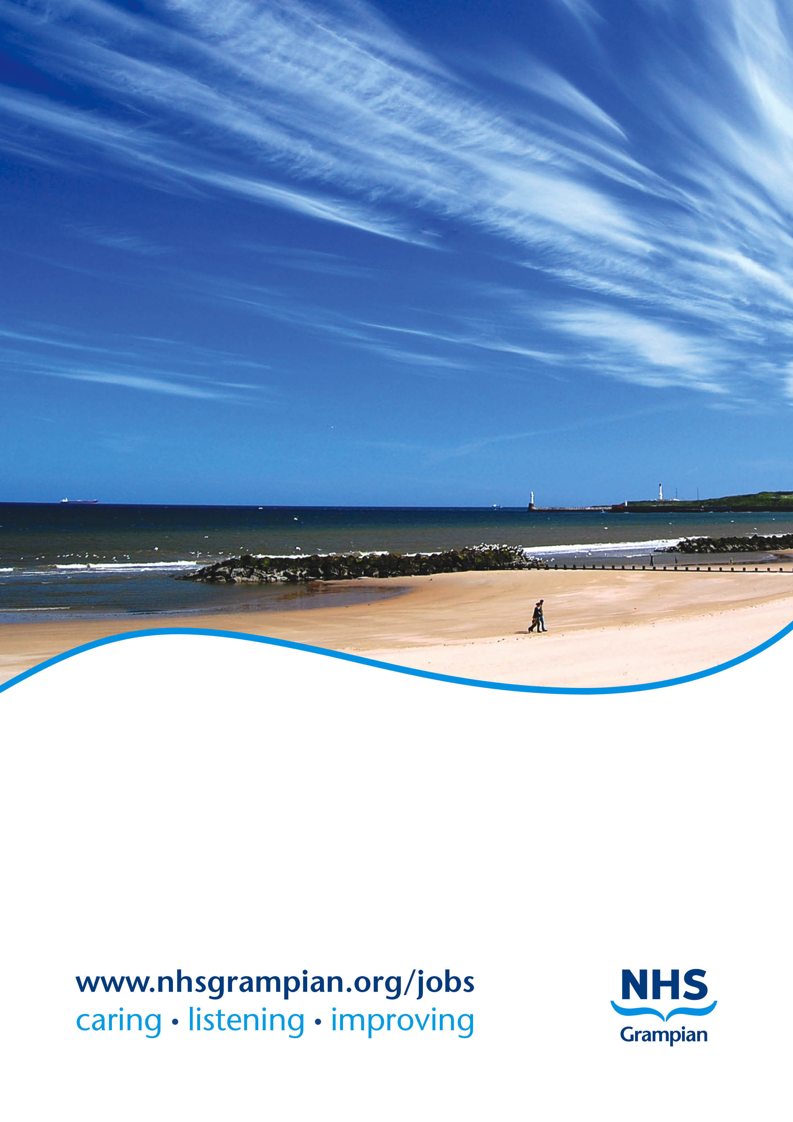

**Job Title: Consultant Physician in Medicine for the Elderly**

**Location: Aberdeen Royal Infirmary/Rosewell House and Community areas**

**Ref No: IR121453**

**Closing Date: Sunday, 8 January 2023**

**NHS GRAMPIAN**

**JOB DESCRIPTION**

**CONSULTANT PHYSICIAN IN MEDICINE FOR THE ELDERLY**

**REF: IR121453**

**LOCATION**

Aberdeen is Scotland’s 3rd largest city and is found in the North-East of Scotland with a population of approximately 230,000 within the city and a further 260,000 within Aberdeenshire. The city stands between the Rivers Dee and Don and is surrounded by coastline. This historic city has many architectural splendours and the use of its sparkling local granite has earned Aberdeen the name of the Silver City. Recognised as the oil capital of Europe it retains its old-fashioned charm and character making it an attractive place in which to live.

The city and the surrounding countryside provide a variety of urban, sea-side and country pursuits. Aberdeen has first class amenities including His Majesty's Theatre, Music Hall, Art Gallery, the Aberdeen Exhibition Centre, Museums, Aberdeen Sports Village and Beach Leisure centre. Within a short distance beach pursuits and mountains can be found making a range of outdoor pursuits possible. The city and the surrounding countryside are repeatedly given high ratings for quality of life in surveys. Many picturesque villages and towns lie within easy commute to the hospital.

Aberdeen is particularly strong in the field of education with a large number of excellent state schools which consistently rank very highly in national league tables. Additionally, there are three fee–paying schools.As well as having excellent schooling, Aberdeen is a university town and is home to two of the UK’s oldest and most successful universities.

The University of Aberdeen - The School of Medicine, Medical Sciences and Nutrition

The Medical School is located on the Foresterhill site along with the majority of NHS Grampians’ clinical services. The majority of lectures, tutorials, and clinical skills teaching take place at the Suttie Centre which is a joint University and NHS Grampian centre for postgraduate and undergraduate education, opened in 2009. Our medical programme is consistently ranked in the top 10 in the UK (2nd in the UK according to the Guardian league tables 2021).

The Institute of Medical Sciences (IMS) is adjacent to the Suttie Centre and brings together medical scientists and clinicians in a fully integrated research facility. The institute has the mission to become an acknowledged centre of excellence in Medical Science Research. The University believes this can only be achieved by the optimal integration of both medical and scientific research.

Robert Gordon University

The Robert Gordon University has earned wide recognition for its pragmatic approach to higher education both in Scotland and internationally. Courses offered include pharmacy, nursing and allied health professionals.

The University is actively involved in applied research in a variety of fields and many short course programmes are being formulated to meet the growing needs of the community.

**HEALTH SERVICE IN GRAMPIAN**

**DESCRIPTION OF HOSPITALS**

**The Foresterhill campus**

This large hospital campus includes the Royal Aberdeen Children’s Hospital, Maternity hospital, Medical school, and Aberdeen Royal Infirmary. The close location of all these services and medical school on the one campus allows easy integration of undergraduate and postgraduate studies whilst providing access to specialist investigations and opinions.

**Aberdeen Royal Infirmary**

This is the principal acute hospital of the Grampian Area providing a complete range of medical and surgical specialities.

The Emergency CareCentre is a modern purpose built facilityincorporating out of hours GP,NHS24, Emergency Department and Acute Medical Initial Assessment (AMIA) together with acute medical wards/specialties including Geriatric Medicine in the floors above.

**Woodend Hospital**

Situated two miles west of Aberdeen Royal Infirmary and includes Medicine for the Elderly, Rehabilitation Medicine and Elective Orthopaedics. It consists of:

* Geriatric and Vascular Rehabilitation – The Links Unit – 22 beds
* Continuing Care Morningfield house – 20 beds
* Stroke Rehabilitation Unit – 28 beds
* Neurological Rehabilitation Unit– 12 beds
* Orthopaedic Rehabilitation Unit – 18 beds
* Elective Orthopaedic Surgery

**Rosewell House**

60 bedded single room facility near to Woodend Hospital with 40 sub-acute beds under care of Medicine for the Elderly and 20 rehabilitation beds run by GP’s. 24hour medical cover.

**Community hospitals – Aberdeenshire wide**

There are currently 9 GP run community hospitals throughout Aberdeenshire. Each hospital has mainly older people with frailty as inpatients with the care being led by local GP’s. GP’s admit directly here or patients step down from Aberdeen Royal Infirmary. Local community teams work in the wards allowing integration between hospital and home. Each hospital has a Geriatrician aligned to them.

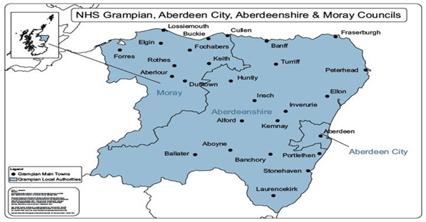

**TITLE OF POST – CONSULTANT PHYSICIAN IN MEDICINE FOR THE ELDERLY, ABERDEEN CITY AND ABERDEENSHIRE.**

One, Full Time (10PA) Consultant post with split of 8 DCC and 2 SPA sessions.

**CLINICAL SERVICES – DEPARTMENT OF MEDICINE FOR THE ELDERLY (DOME)**

We looking to recruit an enthusiastic and forward-thinking Consultant in Geriatric Medicine to develop and deliver high quality care for older people living with frailty in NHS Grampian to work with us in Aberdeen City and Aberdeenshire with the acute base in Aberdeen.

This is a community facing service focused on ‘home first’ principles. Each post would rotate through our 25 bedded Geriatric Assessment Unit in the Emergency Care Centre of Aberdeen Royal Infirmary one week out of 4. The performance of this unit has been recognised nationally in the Scottish Care of Older People (SCoOP) Acute Hospital Outcomes report.

There are well-established community services. There are longstanding relationships between GP practices and Community Hospitals using a linked-geriatrician alignment model, in Aberdeen City and Aberdeenshire. There is an established Hospital at Home service, which has been Consultant-led since March 2021, with plans to develop Hospital at Home throughout Aberdeenshire with a “discharge to assess” initial model. The development of the “Frailty Pathway” within NHS Grampian over the last year has allowed us to focus more on streamlined care with our 2 aligned health and social care partnerships within Aberdeen City and Aberdeenshire. Video-conferencing has allowed us to become part of the multi-disciplinary teams throughout Aberdeen city and Aberdeenshire in areas we previously would have not been able to visit regularly. A key part of this post will be to become embedded within community working.

Our sub-acute inpatient beds have moved from Woodend Hospital to Rosewell House intermediate care unit as part of the Frailty Pathway changes allowing us to provide joined up care in a homely setting with full multi-disciplinary team input.

**Hospital at home**

The team has been growing and developing for over 3 years, and became a fully consultant-led Hospital at Home team for Aberdeen City in March 2021. Based in the former Day Hospital at Woodend Hospital, the multidisciplinary team provide hospital level care in patient's own homes as an alternative to hospital admission or to support active recovery on discharge from hospital. The team provide a 7 day service with twice daily multidisciplinary team meetings.

**Rosewell House**

This is an intermediate care facility 1 mile from Aberdeen Royal Infirmary which is all single rooms. There are 40 NHS beds under the care of Geriatric Medicine with 24hour medical cover. Medically stable patients are stepped down from Aberdeen Royal Infirmary to here.

**Ward 102**

This is an admissions and assessment unit providing early comprehensive geriatric assessment. Ward 102 is based within the purpose-built Emergency Care Centre at Aberdeen Royal Infirmary, enabling rapid access to diagnostics and other specialties. There are 17 single rooms, two 4-bedded rooms, and therapy rooms including an occupational therapy assessment kitchen. There is 7-day multidisciplinary cover with daily multidisciplinary meetings and huddles.

**Aberdeen City community teams**

Four Geriatricians are linked to the GP practices within Aberdeen city, with proactive practice-based liaison including multidisciplinary models to support GPs in managing older people with frailty in both community (via the award winning Silver City model) and care home settings. The new frailty pathway offers exciting opportunities for progress via the new Enhanced Community Support teams.

**Aberdeenshire community teams**

Four Geriatricians and 2 Specialty Registrar’s are currently aligned to the 6 different localities within Aberdeenshire. Each locality has at least one community hospital where GP’s lead the care of patients within these units supported by the multi-disciplinary team which we are part of. Monthly clinics run in our community hospitals for general geriatric clinics and Parkinson’s clinics. Many practices run “virtual wards” which we link in to for advice and review where needed.

**OPAL (Older People Assessment and Liaison team)**

In-patients within ARI are referred for assessment by the team either for advice about ongoing management or for referral for rehabilitation. We work together with the OPAL nurse to see these referrals.

**Teaching**

We are actively involved in the clinical based teaching of our senior medical students in year 4 and year 5. There are ample opportunities to become more involved in medical education with teaching of medical students and Physician Associate students.

**Research**

NHS Grampian aims to maintain the tradition of clinical excellence and research activities. Clinical staff are encouraged to exchange ideas within the national and international research community. We work in an environment where people are looking to innovate and are aware of, and contribute to, developments within their specialties. NHS Grampian has a research and Development Directorate to prioritise and stimulate research and development within its fields of interest, complementing the research strategies of the Universities and Research Institutes in the area.

Our research programme delivered by Ageing Clinical & Experimental Research (ACER) team is led by Professor Phyo Myint, Clinical Chair in Old Age Medicine. We carry out interdisciplinary research into ageing and have extensive network of national and international collaborators. The team consists of a Professor, an Honorary Reader, an Honorary Senior Lecturer, two SCREDS Clinical Lecturers, six PhD candidates, 11 clinical and non-clinical affiliated research staff and associates, and two post-doctoral visiting international fellows. Further details about the research programme can be found at https://www.abdn.ac.uk/iahs/research/acer/index.php

Candidates should contact Prof P K Myint,Tel: 01224 556313(Sec), to discuss research in their particular area of interest.

**On Call –** average 1 in 12 weekdays and weekend.

**STAFFING WITHIN THE DEPARTMENT OF MEDICINE FOR THE ELDERLY**

**Management Staff:**

The Head of Service for Specialist Older Adults and Rehabilitation Services (which included Elderly Medicine) is Jason Nicol, the Service Manager is Vicky Smith and the Medical Lead is Dr Sarah Alder. Dr Santanu Sarkar is the Medical Lead for Rehabilitation Medicine.

**Clinical Staff:**

|  |  |
| --- | --- |
| **Consultants:**  Dr S Alder | **Special Interests**  Clinical Lead, Community |
| Dr S Rochow | Parkinson’s, Community Geriatrics |
| Professor P Myint | Research |
| Dr C Bostock | Hospital at home |
| Dr C Butchart | Hospital at home, Community Geriatrics |
| Dr R Caslake | Parkinson’s, Community Geriatrics |
| Dr Z Muir | Parkinson’s, Community Geriatrics |
| Dr M Grieg | Community Geriatrics |
| Dr M Slater | Associate Postgraduate Dean |
| Dr J Lowrie  Dr L Shields | Community Geriatrics, Orthogeriatrics  Parkinson’s, Community Geriatrics |
|  |  |
|  |  |
| **Non-consultant Career Grade Staff** | |
| Dr R Setty | Specialty Doctor |
| Dr J Otakoro | Specialty Doctor |
| Dr N Jalib | Specialty Doctor |
| Dr V Sonanis | Specialty Doctor |
| Dr L Whiteside  Dr M Khor | Specialty Doctor  Specialty Doctor |
|  |  |
|  | |
|  | |
|  | |
| **Trainees:** | |
|  | |
| 9 Specialty Registrars (including 2 SCREDS Clinical Lecturers) | |
| 12 FY2/ IMT/ GPST staff in Training Posts, 1 FY2 in community geriatrics based with Hospital at home | |
| 10 Pre-registration FY1 Doctors | |

SAMPLE JOB PLAN

**Specialty: Geriatric Medicine   
Principal Place of Work: ARI/Woodend**

**Contract:** Whole Time Permanent

**Programmed Activities: 10. Indicative PA Split: DCC 8 SPA 2 EPAs**

**Availability Supplement**: Level 1

**Premium Rate Payment Received:** 3 **%**

**Managerially Accountable to:** Medical Lead – Dr Sarah Alder and Head of Service – Jason Nicol

**Sample week plan**

**Week 1: Acute Consultant of the Week (currently 1 in 4 weeks)**

|  |  |  |
| --- | --- | --- |
| **DAY** | **HOSPITAL/ LOCATION** | **TYPE OF WORK** |
| **Monday** | am – 102 ARI  pm – Rosewell House | Acute assessment reviews-teaching ward round, MDT  Ward round and relatives – 10 bedded unit |
| **Tuesday** | am –102ARI  pm - SPA | Acute assessment reviews-teaching ward round, MDT  Unit radiology meeting, teaching meeting and senior staff meeting. |
| **Wed** | am – 102 ARI  pm - Off | Acute assessment reviews-teaching ward round, MDT |
| **Thursday** | am – 102 ARI  pm – Rosewell House | Acute assessment reviews-teaching ward round, MDT  Ward round |
| **Friday** | am – 102 ARI  pm - SPA | Acute assessment reviews-teaching ward round, MDT  CPD/Audit; Trainee supervision |
| **Saturday** | am/pm – ARI 9-6 | On-call 1 in 12 Level 1 OOH included in jobplan |
| **Sunday** | Am/pm – ARI 9-6 | On-call 1 in 12 Level 1 OOH included in jobplan |

**Weeks 2-4 sample week**

|  |  |  |
| --- | --- | --- |
| Day | Hospital/Location | Type of work |
| Monday | Am – Rosewell House  Pm - Community | Ward round and MDT  GP/community meetings |
| Tuesday | Am – outpatient clinic  Pm - SPA | New and return patients  Departmental meetings, trainee supervision |
| Wednesday | Am – Patient administration  Pm - off | Inpatient and outpatient administration |
| Thursday | Am – Rosewell House  Pm – ARI 102 or community | Ward round and MDT, family meetings  On call ( 1 in 3 weeks ) on site 1-7pm  Home visits/GP meetings |
| Friday | Am – admin and teaching  Pm - SPA | Vetting referrals, liaison community teams, medical student teaching  CPD/Quality improvement |
| Saturday | 1 in 12 ARI 9-6 |  |
| Sunday | 1 in 12 ARI 9-6 |  |

***NB: The detailed Job Plan will be agreed with the successful candidate at the time of the appointment, taking account of the experience, skills and interests of the candidate and how they can best be used within the Consultant team.***

**NHS Grampian**

**Person Specification Form**

Post of Consultant Physician Medicine for the Elderly

|  |  |  |  |
| --- | --- | --- | --- |
|  | **REQUIREMENTS** | **ESSENTIAL** | **DESIRABLE** |
| **A.** | **Qualifications and specialist skills** | MB ChB or equivalent  MRCP (UK) or equivalent  GMC registered with licence to practice | Additional qualifications eg  PhD, MD  Holds valid driving licence. |
| **B.** | **Experience and skills** | Acquired full training in Geriatric Medicine with GMC Registration on Specialist Register or within six months of obtaining CCT.  Evidence of commitment to Geriatric medicine | Experience of service re-design.  Experience in a hospital at home service delivery model |
| **C.** | **Ability** | Extensive specialist knowledge in the care of frail older adults with decompensated frailty syndromes  Able to independently conduct a specialist Comprehensive Geriatric Medicine Assessment and lead the multi-disciplinary team. | Evidence of having implemented change in practice as part of service re-design.  Additional sub-specialty interest. |
| **D.** | **Personal attributes** | Enjoys working in a multidisciplinary environment.  Must have good communication skills.  Flexible approach to service delivery.  Commitment to personal development  Motivated to develop service |  |
| **E.** | **Audit/Quality improvement** | Experience in performing and teaching quality improvement projects | Experience working at national level in quality improvement or national audit. |
| **F.** | **Research** | Knowledge of basic research methods and ability to guide junior doctors to conduct their research projects | Evidence of publications in peer reviewed journals |
| **G.** | **Management Ability** | Involvement in project management.  Working Knowledge of NHS management system and current developments.  An understanding of clinical governance | Previous experience of leadership role within geriatric medicine |
| **H.** | **Teaching and supervision** | Interest in teaching and supervising both undergraduate and postgraduate trainees. | Postgraduate qualification in medical education.  Evidence of having organised seminars or educational meetings. Evidence of supervision or mentorship of other team members. |

**ANNUAL LEAVE**

The appointee is entitled to 6 weeks, in addition to statutory holidays.

**STUDY LEAVE**

A practitioner appointed to the grade is entitled to continuing education, subject to the Conditions of Service. The Trust Study Leave Policy is 30 days Study Leave in each fixed three year period. Full details are available from the Assistant Human Resources Manager Clinical Services A, Woodend Hospital, Eday Road, Aberdeen.

**NOTES TO CANDIDATES**

Canvassing in connection with appointments is not permitted but this does not debar candidates who wish from visiting the hospitals concerned.

Further information can be obtained and an appointment to view the Department arranged by contacting Mr Jason Nicol, Specialist Older Adults and Rehabilitation Services, Woodend Hospital, Contact Number 01224 556660*.*

Dr C Howarth Dr N Fluck

Clinical Director – Aberdeen HSCP Medical Director

Peterculter Medical Practice NHS Grampian

Contact: 01224 733535 Summerfield House

Eday Road, Aberdeen

Lyndsay Cassie

Personal Assistant

Direct Line: 01224 558577