

JOB DESCRIPTION

JOB IDENTIFICATION
Job Title: Clinical Pharmacist – Rotational (Acute and Specialist Services)

Responsible to: Lead Pharmacist – Acute and Specialist Services

Department: Pharmacy and Prescribing

Directorate: Community Health and Social care

Last Update: May 2024

2. JOB PURPOSE
- To deliver patient-focused clinical pharmacy services as a member of the multidisciplinary team to patients in both Primary and Secondary Care.
- To assist in the co-ordination and development of pharmaceutical services to meet the needs of patients in NHS Shetland in accordance with the identified local and national priorities, under the direction of the appropriate Advanced/Specialist Pharmacist.
- This rotational post is a development role: A key function of the post is to support the work of the Acute and Specialist service pharmacy service by developing as a clinical pharmacist by developing knowledge, skill, values and behaviours appropriate to the role and as an independent prescriber.
- To undertake & complete training to achieve the competencies defined in the NHS Education Scotland Post-registration Foundation Training to gain accreditation to work in any sector of pharmacy practice.

- DIMENSIONS (Job Facts and Figures)
The post holder will work in the acute sector primarily with the possibility of follow up of specific patients in primary care. The Gilbert Bain Hospital (GBH) has 60 beds across the following wards: medical, surgical and maternity. There is also a busy Accident and Emergency, Outpatient department and provision of services by Allied Health Professionals. The Pharmacy supplies all pharmaceutical products within GBH as well as vaccines and a small range of other products to the 10 primary care health centres situated throughout Shetland. The integrated pharmacy team is composed of 3 specialist clinical pharmacists working in secondary care and 4 Advanced and Core Clinical Pharmacists working in primary care, supported by a team of 6 technicians.

4. ORGANISATIONAL POSITION
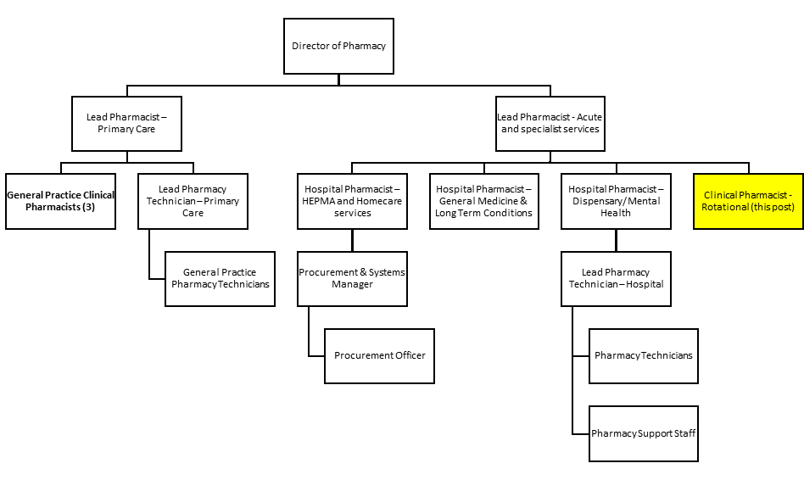

5. ROLE OF DEPARTMENT
- Ensure that patients derive maximum benefit and minimum harm from their medicines
- Provide an integrated approach to pharmacy and prescribing policy issues, including between systems within pharmacy and prescribing support functions
- Support clinicians in provision of high quality, effective and efficient pharmaceutical care to individual patients at point of need in the healthcare journey
- Provide prescribers and managers with high quality, timely information, analysis and advice to assist them to deliver effective prescribing management
- Ensure that medicines are purchased, stored, dispensed and prescribed as cost effectively as possible.

6. KEY RESULT AREAS
- Provide a patient-focused clinical pharmacy service through provision of pharmaceutical care in order to maximise benefit and minimise risk to patients from their medicines and assure smooth transition of care between care settings.
- Critically evaluate and provide medicines information and therapeutic advice to all members of the health care team in order to optimise patient care, maximise benefit and minimise risk to their patients from their medicines.
- Undertake training and provide evidence to enable completion of the NHS Education Scotland Post-Registration Foundation Training.

Within the above the following principal activities are performed on a daily basis:

- Provision of pharmaceutical care for individual patients including ensuring safe use, handling and administration of medicines (for example identifying drug interactions or medication errors), assessing effectiveness/response to therapy, monitoring of unwanted effects, discharge planning and provision of patient/carer education. Ensure patient care is provided in a planned manner, and in response to immediate, unpredictable pharmaceutical needs.
- Pharmaceutical assessment of in-patients on admission including ascertaining reason for admission, medical history, drug history including allergies, assessment of any patient’s own medication or compliance devices, ability to self-administer medication and compliance with medication.
- Facilitation of supply of medicines for individual patients including resolving of procurement or distribution issues.
- Maintenance of a record of patient issues identified, specific to the patient, including action taken and patient outcomes known as a “Pharmaceutical Care Plan”.
- Contribution to the discharge planning process and checking of discharge prescriptions for appropriateness, safety and accuracy both before and after discharge.
- Provide accurate dispensing, professional and technical checking of all types of medicine request (discharge prescriptions, out-patient prescriptions, one-stop dispensing for inpatients, controlled drugs, unlicensed and extemporaneous medicine) and resolve problems associated with these
- Perform complex calculations when required, for example in order to check the accuracy of complex doses and check the accuracy of products prepared.
- Participate in ward and pharmacy stock checks of controlled drugs and safely destroy controlled drugs when appropriate.
- Provide expertise in accessing medicine information databases to answer medicines related queries.
- Undertaking independent prescriber training and on completion undertaking a prescribing role appropriate to experience.
Some of this expertise may include opportunities to work in neighbouring health boards to gain experience not readily available in Shetland in particular in Medicine Information and aseptic.

Activities appropriate to all sectors of pharmacy practice
- Encourage adherence by medical and non-medical prescribers and other healthcare professionals to local prescribing policy and guidelines, for example the Grampian Formulary
- Anticipation of potential pharmaceutical issues and prevention of these, for example the reduction in medication errors through risk management processes.
- Assist other members of the team in monitoring medicines expenditure and analysis of prescribing trends.
- Participate in the implementation and development of services by the pharmacy department through evidence based medicine, inter-disciplinary audit and development of standard operating procedures.
- Participate in formal or informal interdisciplinary and multidisciplinary education and training including pharmacy staff, in particular EL students, Foundation pharmacists and technical staff. Participate in teaching of undergraduate medical students and medical staff. Participate in education and training of nursing staff and other healthcare staff as required to meet service needs.
- Contribute to the development and delivery of pharmaceutical components of clinical governance within the relevant areas and actively contribute to the wider clinical governance agenda by adherence to legal and professional requirements and standards to assure the development and implementation of best practice.
- Provide cover for colleagues for example on study leave, annual leave and meetings.

Participate in the out of hours rota and public holidays as required by the needs of the service, and at these times have delegated responsibility for the pharmacy service provided. Hours of work are 37 over a 7 day period or pro-rata equivalent. The post-holder can be contactable in the event of a major incident at any time.

7a. EQUIPMENT AND MACHINERY
Responsible for appropriate use, maintenance, repair and documentation of equipment by self and others
Equipment used within this job:
IT equipment, Laptop, Desktop PC and Printers
Photocopier, Scanner and telephone
7b. SYSTEMS
Systems used within this job:
- Microsoft Office, Excel, Word, PowerPoint. Used extensively in the production, analysis, interpretation and presentation of prescribing information.
- Hospital Electronic Prescribing and Medicines Administration (HEPMA)
- Pharmacy stock control and labelling system
- SCI store
- ECS
- Chemocare
- MI databases via Knowledge network

The post holder will be required to handle and analyse various types of data and good numeracy skills are required
The post holder will be required to formally present information requiring audio-visual and computer links
Knowledge and familiarity on the use of clinical pharmacy documentation and patient’s notes is essential to communication and ensuring a high quality of patient care.
Knowledge and familiarity with dispensary systems and procedures is essential in ensuring the safe and effective provision of dispensing services.
Knowledge, familiarity and use of departmental procedures are required.

8. ASSIGNMENT AND REVIEW OF WORK
The post holder reports to the Lead Clinical Pharmacist – Acute and Specialist Services but will have, as competency develops, an increasing degree of autonomy to deliver their agreed personal objectives, managing their own workload, with continued access to support and supervision as necessary.

The post holder will participate in an annual development review in line with KSF, objective setting and the production of a Personal Development Plan.

The post holder will develop a work plan with the pharmacist assigned as tutor for the NHS Education Scotland Post-registration Foundation Training programme in order to gain experience in all areas where competencies must be met. The post holder will be responsible to complete the ePortfolio required as part of this training and this will be reviewed on a monthly basis along with the tutor.

The post holder is required to adhere to NHS Shetland organisational policy and procedure.

9. DECISIONS AND JUDGEMENTS
The post holder is expected to use their initiative to act decisively and autonomously in their professional capacity, being accountable for their actions, under guidance from the Lead Clinical Pharmacist or Specialist Pharmacist. They will have to recommend and implement care plans or medicine reviews for individual patients guided by local policies and procedures. Typical decisions include clinical decisions regarding medication for individual patients, using evidence based medicine including local and national guidelines.

Work is generally assigned on a daily basis with the post holder responsible for the organisation of their workload and their time management under guidance from the appropriate trainer (Lead Clinical Pharmacist or Specialist Pharmacist). During normal working hours the post holder can seek advice from the Lead Clinical Pharmacist/Specialist Pharmacist or other senior colleagues.

The post holder is expected to participate in the development and delivery of pharmacy and NHS Shetland policies, under guidance from the Lead Clinical Pharmacist/Specialist Pharmacist.

The post holder is expected to interpret clinical data from clinical trials, published papers and other sources. They are expected to present the information in an appropriate manner to the relevant healthcare professional(s) under guidance from the Lead Clinical Pharmacist/Specialist Pharmacist.
The postholder is expected to make professional judgements that they may have to defend to their peers and/or the General Pharmaceutical Council.

A training plan is jointly agreed with the appropriate Supervisor (Lead Clinical Pharmacist/Specialist pharmacist) and the post holder in accordance with the competencies defined in the NHS Education Scotland Post-Registration Foundation Training scheme. Progress review and appraisal of performance is undertaken with the assigned supervisor on a monthly basis.

10. MOST CHALLENGING/DIFFICULT PARTS OF THE JOB
- Prioritisation of workload (individually and with others). The need for high levels of concentration through constant interruptions
- Communicating at appropriate levels with a broad range of people (various levels of staff and patients) in order to convey complex information.
- Successful completing of the NHS Education Scotland Post-Registration Foundation Training Programme, including gaining of an Independent Prescriber qualification.
- Influencing and encouraging appropriate prescribing in an effective way
- When working in extended/out of hours periods with reduced access to support from colleagues and have delegated responsibility for the pharmacy service provided and departmental security.
- Effectively contribute to multidisciplinary working, including to managed Clinical Networks.

11. COMMUNICATIONS AND RELATIONSHIPS
The need for good interpersonal and communication skills is essential including written, electronic, verbal and presentation skills both formal and informal.

The post holder will be required to influence prescribing in medical and non-medical prescribers.

The post holder must communicate effectively and have the ability to adapt communication skills to meet the needs of the patient and their representatives (e.g. family and carers), some of whom may have barriers to understanding or communication (e.g. learning difficulties, language barriers, sensory impairment, confused, elderly and frail patients).Diplomacy, tact and empathy need to be used as well as an ability to convey complex and sensitive information. For example. When providing counselling on medication in sensitive situations.

The post holder will be required to instruct, reassure, encourage and guide patients/carers and other healthcare staff in the prescribed treatment e.g. educating patients/carers in the use of their medicines, inhalers and other medication delivery devices. The post holder will seek to gain concordance with the patient on their medicines use.
The post holder will document recommendations/interventions made on medicines use/treatment plans appropriately in the patient’s “Pharmaceutical Care Plan” and in the patient’s medical notes.

The post holder will be required to negotiate with their colleagues, and other healthcare professionals.
The post holder should be confident in providing advice regarding medicines use.

Internal
To continue the seamless care of patients, communication with pharmacists, pharmacy staff and members of the multidisciplinary team is essential.

External
To ensure continuity of care when patients are transferred between different areas of the healthcare system. Interaction is required with pharmacists in other areas of practice including community pharmacy, general practitioners, community and practice nursing staff, social care staff, relatives/carers and other relevant professionals.

12. PHYSICAL, MENTAL, EMOTIONAL AND ENVIRONMENTAL DEMANDS OF THE JOB
Physical Effort
The post holder is required to stand for long periods while performing prescription and medicine checks.

The post holder is also required to meet deadlines for collection of prescriptions/orders on a daily basis and is therefore subject to time pressures throughout the day.

Mental Effort
Intense concentration for short periods of around 15 minutes at a time over a period of 3-4 hours is required, for example while providing dispensing services. This includes checking medication and drug dose calculations including surface area dose calculations.

The post holder is required to concentrate for periods of 3-4 hours while producing reports, performing literature searches, analysing and reporting data.

The post holder must be capable of effective problem solving in order to offer practical solutions to often difficult and unique problems/situations.

The workload is subject to constant interruption. Work is not always predictable as priorities change at very short notice according to the needs of the service/management. Requests for formal/informal advice are frequent by email, pager and in person. Workload has to be prioritised constantly throughout the day.

Emotional effort
There is a need for empathy and composure when dealing with complex individual patient needs, carers and other staff members. There is the possibility of exposure to occasional aggression.
- Frequent (daily) need to educate and counsel patients, carers and relatives on medicines and medication regimes. These people may frequently be confused, have short term memory problems, be terminally ill, and have other communication problems e.g. blind, deaf.
- Frequent (daily) need to have the ability to negotiate, reassure, empathise, understand and motivate patients to maximise patient compliance with medication regimes and health promotion measures e.g. healthy diet, smoking cessation.
- Negotiating with prescribers to change current prescribing/clinical practice in areas where available information and/or personal professional views may differ and can be conflicting.

13. KNOWLEDGE, TRAINING AND EXPERIENCE REQUIRED TO DO THE JOB
Registered Pharmacist of General Pharmaceutical Council (GPhC), requiring a first degree of MPharm or equivalent and 1 year Foundation training with successful completion.

The post holder will complete the NHS Education Scotland Post-Registration Foundation Training Programme during their employment, in order to progress towards advanced pharmacy practice and undertake further education to expand their knowledge in the relevant clinical areas.

The post holder must meet the demands for Continuing Professional Development set out by the General Pharmaceutical Council.

14. JOB DESCRIPTION AGREEMENT
A separate job description will need to be signed off by each jobholder to whom the job description applies.  Job Holder’s Signature:  Head of Department Signature: | Date:  Date:

Person Specification

Job Title: Clinical Pharmacist (Rotational) – Acute and Specialist Services
Department: Pharmacy and Prescribing
Location: Based at Gilbert Bain Hospital, Lerwick, Shetland

Criteria | Essential | Desirable
Qualifications & Training | - MPharm  - Successful completion of Foundation year training and examination  - Registration with General Pharmaceutical Council  - Commitment to Continuous Professional Development as per directions of General Pharmaceutical Council
Experience | - Foundation training in community or acute care
Knowledge & Skills | - Excellent understanding of the pharmacology and therapeutic use of medicine  - An understanding of the importance of medicines management within the primary and secondary care settings  - Excellent oral and written communication skills and report writing  - Good problem solving skills with an ability to analyse and scrutinise data  - Detailed knowledge and understanding of pharmacy legislation  - Good IT skills | - A working understanding of NHS policies, processes, structures, systems and clinical practices within primary and secondary care  - Knowledge of the community pharmacy contract.
Personal qualities/other | - A good team worker with the ability to work independently when necessary  - Self-motivated  - Excellent interpersonal skills and diplomacy  - Ability to prioritise and work within tight deadlines. | - Driving licence

