

**NHS Lothian Critical Care Team St John’s Combined ITU/HDU**

Exciting opportunities are available to join the combined Critical Care ITU/HDU at St John’s Hospital, Livingston. We have multiple Band 5 positions available for Registered Nurses and we are looking for passionate, caring, motivated people to join our highly skilled nursing teams.

We offer the opportunity to work with talented teams within multidisciplinary environments and impact positively on the lives of thousands of patients and their families.

Find out what our staff say about working in NHS Lothian at https://careers.nhslothian.scot/acute-specialist-nurses/who-we-are/

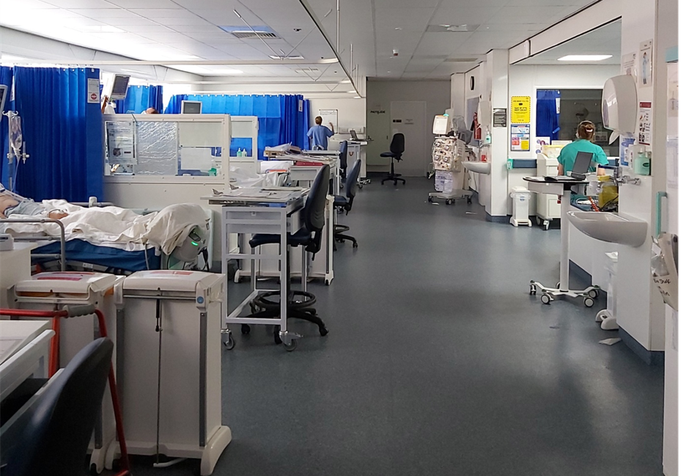

**What We Can Offer You**

We have a range of vacancies for experienced and newly qualified nurses to join our innovative and dynamic staff within SJH Critical Care Team – providing you with the opportunity to gain a breadth of knowledge and exposure to multiple specialties.

**Roles**

* Critical Care Nurse Band 5
* Band 3 Senior HCSW
* Band 2 HCSW

**Salary**

* Band 5 Range £30,229 to £37,664 (pro rata) per annum
* Band 3 Range £ 25,468 to £27,486 (pro rata) per annum
* Band 2 range £23,362 - £25,368 (pro rata) per annum

**Benefits**

* A minimum of five weeks annual leave increasing with length of service
* A range of supportive employment policies including Flexible Working
* Full or part time hours considered
* We provide an extensive induction programme and excellent professional training and development opportunities.
* Access to the NHS Pension Scheme and Staff Benefits

The Critical Care Unit at St John’s Hospital, currently has 5 admitting beds (although it is planned to increase this to 7 in the near future). It is a combined Intensive Care and High Dependency Unit that looks after patients requiring enhanced care that the ward areas are unable to provide. It offers Level 1 and 2 care for those requiring HDU care and Level 3 care for patients requiring sedation, ventilation and requiring multi-organ support. The specialities that are admitted include Medical, Plastics, Max Fax, Burns, ENT, Obstetric and occasionalyl Paediatric cases for stabilisation prior to transfer. Patients may be admitted electively following surgery or as an emergency through ED or from the wards following deterioration.

The nursing team comprises of 2 SCN’s, 7 Band 6’s and a team of B5’s. We also have 5 CSW’s and a Ward Clerk to support the nursing team. There is a close working relationship with the Anaesthetic Doctors and many members of the multi-professional team, including Physiotherapists, Pharmacists and Dieticians.

The Unit provides many learning opportunities and is keen to support education and development of all staff. There is close cross site working with the other Critical Care areas within NHSL and on site support given as able. Pre registration nursing students are supervised on placement.

The Unit is a supportive, caring and friendly place to work, providing a flexible and nurturing environment for staff, patients and their relatives. There are daily challenges but as a close working team, all options are considered and solutions are found.

For further information please contact:

SCN Eileen Miller, 01506 524066 eileen.miller@nhslothian.scot.nhs.uk

SCN Elsa Jardine, 01506 524066 elsa.jardine@nhslothian.scot.nhs.uk

Nurse in Charge ITU/HDU St John’s 01506 524063