

**NHS Lothian Day Surgery Centre**

Exciting Band 5 opportunities are available to join the Day Surgery Team within St John’s Hospital, Livingston. We are looking for passionate, caring, motivated people to join our highly skilled nursing team.

We offer the opportunity to work with talented teams within a multidisciplinary environment and impact positively on the lives of thousands of patients and their families.

Find out what our staff say about working in NHS Lothian at https://careers.nhslothian.scot/acute-specialist-nurses/who-we-are/

**What We Can Offer You**

We have vacancies for experienced and newly qualified nurses to join our innovative and dynamic team in NHS Lothian – providing you with the opportunity to gain a breadth of knowledge and exposure to many specialities.

**Roles**

* Staff Nurse (Band 5)

**Salary**

* Band 5 Range £30,229 to £37,664 (pro rata) per annum

**Benefits**

* We are open 24 hours from Monday to Friday
* A minimum of five weeks annual leave increasing with length of service
* Full or part time hours considered
* We provide an extensive induction programme and excellent professional training and development opportunities.
* Access to the NHS Pension Scheme and Staff Benefits

The Day Surgery Centre (SJH) provides a range of elective procedures from a variety of specialities including ENT, Gynaecology, Urology, Colo-rectal, Orthopaedic, Plastics, Maxillofacial, Hands and General Surgery. The range of surgical specialities provides the unique opportunity to enhance professional knowledge and learn highly desirable skills.

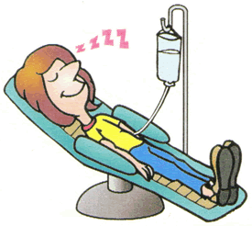

Our friendly, caring and approachable team take pride in providing excellent standards of pre and post operative care to our patients while nurturing our team member’s professional development in a supportive learning and clinical environment.

Day Surgery can be an intense fast-paced environment with a team working ethos being at the heart of the services we provide. If you enjoy a challenge and would like to join our busy but friendly unit this might just be the post for you and we would look forward to welcome you into our team.

**Informal enquiries can be made to Mhairi Sutherland (Senior Charge Nurse) on 01506 524105**

  