

**Working for NHS Lanarkshire**

**Clinical Fellow in Old Age Psychiatry**

**NHS Lanarkshire**

**Recruitment Pack**

**Application Closing Date: 28/05/2024**

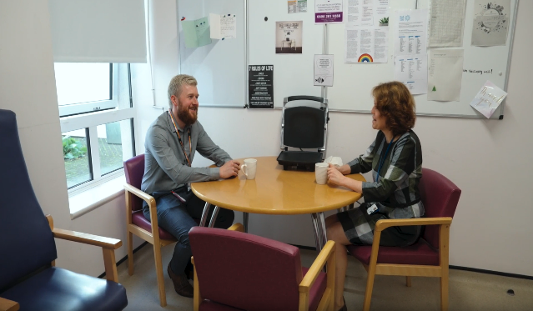 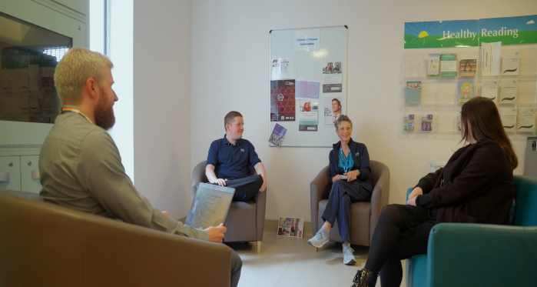

HR Medical & Dental

Law House

Airdrie Road

Carluke

ML8 5EP





|  |
| --- |
| **Contents** |

|  |  |  |
| --- | --- | --- |
| **Section** |  | **Page** |
| Section 1: | How to Apply | 3 |
| Section 2: | Contact Information | 4 |
| Section 3: | Person Specification | 5 |
| Section 4: | The Post | 8 |
| Section 5: | Department Resources | 9 |
| Section 6: | Working for Lanarkshire | 10 |
| Section 7: | Terms and Conditions of Employment | 10 |

|  |
| --- |
| **This post requires the post holder to have a PVG Scheme membership/record. If the successful applicant is not a current PVG member for the required regulatory group i.e. child and/or adult, then an application will need to be made to Disclosure Scotland and deemed satisfactory before the successful post holder can commence work.** |

|  |
| --- |
| **Section 1: HOW TO APPLY** |

**In order to apply:**

Applicants are required to complete an Application Form via the following link: https://apply.jobs.scot.nhs.uk/vacancies.aspx. Please note that you can upload your CV, however this will only be used to pre-populate part of the application form. CV`s are **not** accepted instead of a completed Application Form. Your CV **will not** be visible to the panel.

**Please complete applications by MIDNIGHT ON THE CLOSING DATE.**

**You will receive an email acknowledging receipt of your application once submitted.**

To find out more about the role and our recruitment process please visit NHS Scotland Recruitment Portal

Recruitment | NHS Lanarkshire (scot.nhs.uk)

**Application Process:**

The first part of the process is to complete the gateway questions applicable to the role you are applying for. Should you meet the requirements of the gateway questions you will then have the opportunity to complete the full application form, which asks you to complete your top three preferences of location and specialty.

**It is important that you demonstrate you meet the eligibility criteria detailed in the person specification on your application.**

**Shortlisting Process:**

**Stage 1**

Applications will be longlisted in line with the person specification for the job. If you are successful, you will receive an email from Jobtrain advising you have been successful. Successful candidates from longlisting will be emailed a Clinical Situation and asked to provide feedback on this in the form of a one-page document. If you are successful after this stage you will receive an invite to interview email.

**Stage 2**

Interview and Competency Assessment.

|  |
| --- |
| **Section 2: Contact Information** |

**Programme / Post Queries**

Prospective applicants are encouraged to make contact with:

Dr S Munishankar

Consultant / Clinical Director

(Email: Sowmya.Munishankar@lanarkshire.scot.nhs.uk)

**Application Queries**

If you have any queries regarding the application process please email Isabel Rankin at medical.dentalrecruitment@lanarkshire.scot.nhs.uk

**NHS Lanarkshire is committed to working towards equal opportunities for all.**

|  |
| --- |
| **Section 3: Person Specification** |

|  |  |  |  |  |
| --- | --- | --- | --- | --- |
| **PERSON PROFILE** | | | | |
| Attributes | **Essential** | | | **Desirable** |
| Qualifications | MBChB or equivalent.  Successful completion of UK Foundation Programme **OR CREST FORM** | | | Additional related qualifications, e.g. intercalated degree, BSc or equivalent |
| Training | Evidence of achievement of foundation competences from a UKFPO- affiliated foundation Programme or equivalent.  Training in research and/or audit. | | | Experience within UK training establishments  Human Factors Training.  Further life support qualifications, eg PALS, ATLS etc |
| Experience | **At least six months’ experience in Psychiatry or Medicine for the Elderly**.  Eligible for full registration with the GMC at time of application and hold a current licence to practice * (\***Overseas Registration and Qualifications -**  NHS Lanarkshire will check you have the necessary professional registration and qualifications for this role. You are required to provide an official translation of qualifications notarized by a solicitor of your overseas qualifications to be checked by the recruiting panel. Please ensure that this is available before applying for the post. | | | Administrative / Management experience. |
| Audit/Research | Understanding of the principles of medical audit.  Evidence of a consistent engagement and contribution to audit or quality improvement. Minimum of annual local involvement.  Awareness of principles of research with an ability to critically analyse medical literature. | | | Experience and interest in Audit of Psychiatry practice and experience in the design of audit(s)  Research within Psychiatry  Involved in design of research relevant to Psychiatry |
| Publications | Presentations relevant to the practice of Psychiatry or acute emergency management of medical or surgical issues. | | | Previous publications relevant to the practice of Psychiatry  Presentations at national meetings relevant to the practice of Psychiatry |
| Teaching | Previous contribution to a teaching programme. | | | Interest in and commitment to teaching and training.  Experience of providing problem-based teaching.  Experience of organising teaching programmes.  Formal training in educational/clinical supervision. |
| Knowledge and  Skills | Broad based knowledge and skills in diagnosis and clinical management within the Specialty and encompassing most sub-disciplines. | | | Further educational certificates, diploma’s, etc  Good IT skills. |
| Disposition | Committed to Quality Patient Care.  Able to be understanding of and sensitive to the needs of patients.  Excellent communication skills (verbal and written)  Ability to work under pressure.  Ability to work effectively in a multidisciplinary team.  Responsive to change and innovation, promoting a culture for organisational development.  A flexible approach to duties, which satisfies the needs of the Service in a changing environment.  Ability to demonstrate reflective practice with evidence of regular appraisal with clear Personal Development Plan relating to Continuing Professional and Personal Development.  Good time management and organisation.  Demonstrates commitment and enthusiasm to service delivery. | | | Problem solver/diplomat/counsellor.  A natural leader. |
| Managerial | Knowledge of service provision at a local level.  Awareness of the principles and core practices involved in service management, project management and effective meetings. | | | Involvement in service re-design.  Involvement in project delivery.  Formal leadership qualifications.  Evidence of leadership resulting in positive transformation of patient care. |
| Leadership | Awareness of the principles of team leadership and effective people management.  Commitment to the Values of NHS Lanarkshire:- Fairness, Respect, Quality, Working Together. | | | Evidence of role as leader within groups. |
| Other | Satisfactory medical clearance by NHS Lanarkshire Occupational Health Service.  Satisfactory PVG Check.  Fluent in medical English and evidence of ability to communicate in stressful situations. | | | Preference to work in a District General Hospital. |
| If there is any reason why a disabled person should not be considered suitable for this post, please provide details: | | | **The post requires physical dexterity. Uncorrected visual or hearing defect would be incompatible with the nature of the work**. | |
|  | | **Prepared By:-** | | **Approved By:-** |
| Name | |  | |  |
| Designation | |  | |  |
| Date | |  | |  |

|  |
| --- |
| **Section 4: The Post** |

**ROLE SUMMARY:**

The job is offered as a full-time post on 40 hours per week basis in Old Age Psychiatry (No On-calls). The job will be primarily based within the Old Age Psychiatry inpatient units in either Udston Hospital, Hamilton; Ward 24, University Hospital Monklands or Ward 3, University Hospital Wishaw.

There will be additional opportunity to gain community or liaison Psychiatry experience under supervision of experienced Psychiatrists. We would support interested candidates in gaining adequate knowledge and skills to apply for specialty training in future.

There is no On–call commitment attached to these posts.

**Clinical/Other Duties:**

Regular duties include:

* assistance with the admission and discharge process.
* provision of day-to-day physical healthcare
* attendance at weekly multi-disciplinary team and family meetings for the continued care of inpatients

There will be the opportunity to develop skills in the assessment and management of acute mental illness, in addition to Mental Health Act work.

There will be a nominally allocated Clinical Supervisor who will provide weekly supervision.

**Teaching/Continuing Professional Development:**

NHS Lanarkshire has excellent post-graduate libraries and IT facilities The Board has a well-established, bespoke Medical Education and Training Centre with simulation facilities and is developing a faculty for Human Factors training. Active post-graduate educational programmes are in place, including dedicated protected teaching sessions for junior doctors. The post holder will be able to attend internal Psychiatry teaching and attend Balint groups for case-based discussions when conducted remotely. If the applicant wishes to apply for Core training, there is local advice and support from Dr Hegde and Dr Donaldson.

**Quality Improvement/Audit/Research:**

NHS Lanarkshire is supportive of applications from individuals with well-developed ideas for improving services, who are able to demonstrate a commitment to quality improvement, patient safety (including human factors training), medical education and research & development.

We have a strong commitment to patient safety and quality improvement with an increasing number of consultants who are trained Patient Safety Fellows. We have a pan-Lanarkshire Clinical Quality (CQ) Service to support the development of such projects. Every ward has a ward clinical governance group, with opportunity to engage in their quality improvement schedule where appropriate.

NHS Lanarkshire is supportive of applications from individuals with well-developed ideas for improving services who are able to demonstrate a commitment to quality improvement, patient safety (including human factors training), Medical Education and Research & Development.

|  |
| --- |
| **Section 5: Department Resources** |

|  |  |  |
| --- | --- | --- |
| **Consultants** | **Special Interest** | |
| Dr Sowmya Munishankar | Young onset Dementia, Management | |
| Dr Rajdeep Routh | Deanery | |
| Dr Susan Telfer | Community psychiatry | |
| Dr Damian Lynch | Management | |
| Dr Martin Carlin | Education and training | |
| Dr Gillian Docherty | Complex needs | |
| Dr Christine Carswell | Forensic | |
| Dr Alison Gordon | Movement Disorders | |
| Dr Andrew Donaldson | HBCCC/Clinical Gov/Research/Training | |
| Dr Sujatha Maiya | ECT/HBCCC | |
| Dr Stuart Gibson | Sleep Disorders | |
| Dr Adam Daly | Management | |
| Dr Rekha Hegde | Liaison/Deanery | |
| Dr Joanna Franz | Community Psychiatry/BMA | |
| Dr Karli Dempsey | Liaison Consultant/Education | |
| Dr Craig Patrick | Community Psychiatry/HBCCC/Care Home | |
| Dr Catriona Ingram | Community psychiatry | |
|  | | |
| **Specialty Doctors (inc. Clinical Fellow)** | | 7 |
| Specialist Registrars on rotation from the West of Scotland Training Scheme | | 2 |
| STRs/FY’s | | 8 |
| **Secretarial Support:** | |  |
| WTE Secretaries (shared with other staff within the teams) | | 1 |
| All sites are supported by consultants and fellow Specialty and Associate Specialist Doctors along with participants in the Psychiatric Training Rota.  Full secretarial support is available along with various multi-disciplinary functions associated to both the in-patient and out-patient services. | | |

|  |
| --- |
| **Section 6: Working for NHS Lanarkshire** |

For more information on the role please visit **NHS Lanarkshire Careers Website**

|  |
| --- |
| **Section 7: Terms and Conditions of Employment** |

|  |  |
| --- | --- |
| **TYPE OF CONTRACT** | Fixed Term (12 months) |
| **GRADE AND SALARY** | Clinical Fellow  £40,995 to £64,461 per annum (pro rata) |
| **HOURS OF WORK** | Full Time – 40 hours per week |
| **SUPERANNUATION** | New entrants to NHS Lanarkshire who are aged sixteen but under seventy five will be enrolled automatically into membership of the NHS Pension Scheme. Should you choose to "opt out" arrangements can be made to do this via: www.sppa.gov.uk |
| **REMOVAL EXPENSES** | Assistance with removal and associated expenses may be awarded |
| **EXPENSES OF CANDIDATES FOR APPOINTMENT** | NHS candidates who are requested to attend an interview will be given assistance with appropriate travelling expenses. Re-imbursement shall not normally be made to employees who withdraw their application, refuse an offer of appointment. Non NHS employees are not normally awarded travel expenses. |
| **DISCLOSURE SCOTLAND** | This post is considered to be in the category of “Regulated Work” and therefore requires a Disclosure Scotland Protection of Vulnerable Groups Scheme (PVG) Membership. |
| **CONFIRMATION OF ELIGIBILITY TO WORK IN THE UK** | NHS Lanarkshire are required to check the entitlement to work in the UK of all prospective employees, regardless of nationality or job category. UK Visas & Immigration rules are available at www.bia.homeoffice.gov.uk. Prospective applicants are encouraged to check eligibility in advance of applying for vacancies in NHS Lanarkshire. |
| **MEDICAL NEGLIGENCE** | In terms of NHS Circular 1989 (PCS) 32 dealing with Medical Negligence the Health Board does not require you to subscribe to a Medical Defence Organisation. Health Board indemnity will cover only Health Board responsibilities. It may, however, be in your interest to subscribe to a defence organisation in order to ensure you are covered for any work, which does not fall within the scope of the indemnity scheme. |
| **NOTICE** | Employment is subject to one month notice on either side. |
| **PRINCIPAL BASE OF WORK** | You may be required to work at any of NHS Lanarkshire sites as part of your role. Your base will be clarified for expenses purposes. |
| **REFERENCES** | All jobs are only offered subject to receiving two satisfactory references. At least one reference must be from your current/most recent employer or your course tutor if you are currently a student. If you have not been employed or have been out of employment for a considerable period of time, you may give the name of someone who knows you well enough to confirm information given and to comment on your ability to do the job. |