JOB DESCRIPTION

JOB IDENTIFICATION
Job Title: Specialist Clinical Pharmacist Medicine of the Elderly (Band 7)

Responsible to: Lead Pharmacist Medicine of the Elderly

Department(s): Pharmacy NHS Lothian

Directorate: Pharmacy

Operating Division: Corporate

Job Reference: 162479

No of Job Holders: 1.4

2. JOB PURPOSE
To deliver a specialist clinical pharmacy service within the agreed standard of pharmaceutical care for the identified patient population, safely, effectively and within the defined limits of responsibility, resources, and activity.

To provide prescribing and professional advice to medical, nursing, and other healthcare staff and contribute to good clinical governance in the use of medicines
3. DIMENSIONS
The Department of Pharmacy provides services to primary and secondary centres throughout Lothian. Services include dispensing, aseptic, clinical, radio pharmacy, procurement and distribution, medicines information, medicines management and quality assurance. These services are currently delivered from 7 sites: the Western General Hospital (WGH), the Royal Infirmary of Edinburgh (RIE), the Royal Hospital for Children and Young People (RHCYP), St John’s Hospital (SJH), Royal Edinburgh Hospital (REH), Roodlands General Hospital (RGH) and Liberton Hospital (LIB).

The Department of Pharmacy dispenses over 543,000 prescription items, 686,000 pre-packs, 9300 total parenteral nutrition bags, 34,000 intravenous additives, 38,000 cytotoxic products, 900 intrathecal products, 11,000 radiopharmaceutical products and processes 55,000 Controlled Drug orders per annum. The department has approximately 327 WTE staff.

The combined drug budget for NHS Lothian hospital services is £96.6 million per annum. The budget is not held by the pharmacy service but expenditure against this is monitored and reported on to senior management.

The average monthly stockholding across the pharmacy services is £7.15 million with monthly stock value issues of £6.2 million. Approximately 152,000 lines are ordered, and 995,000 lines are supplied per annum. 492 locations across Lothian are supplied on a weekly basis.

Staffing responsibilities:
Day to day supervision of Clinical Pharmacists and Pharmacy Technical staff within the specialist area. This role will include specified human resource functions e.g., participation in recruitment and selection, personal development, and performance review.

Financial/Budgetary responsibilities:
Responsible for the provision of specialist advice on medicine use and formulary management within the specialist service and provides written financial reports to the relevant Management Team contributing to the control of the medicine budget.

The postholder is employed within NHS Lothian and there may be a requirement to work flexibly across Lothian to meet service demands.

4. ORGANISATIONAL POSITION
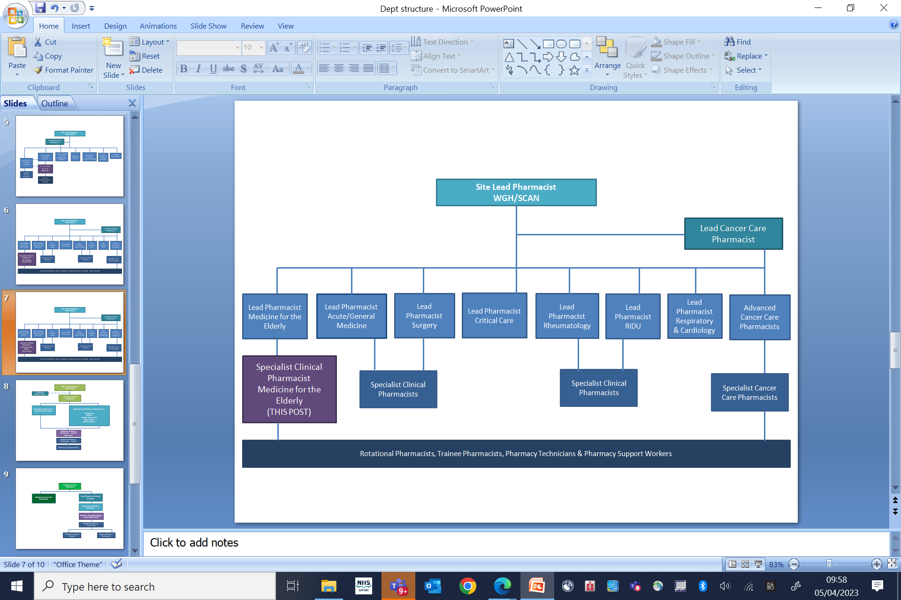

5. ROLE OF DEPARTMENT
The Department of Pharmacy provides services to primary and secondary centres throughout Lothian. Services include dispensing, aseptic, clinical, radio pharmacy, procurement and distribution, medicines information, medicines management and quality assurance. These services are currently delivered across 4 Health and Social Care Partnerships and 7 hospital sites: the Western General Hospital (WGH), the Royal Infirmary of Edinburgh (RIE), the Royal Hospital for Children and Young People (RHCYP), St John’s Hospital (SJH), Royal Edinburgh Hospital (REH), East Lothian Community Hospital (ELCH) and Liberton Hospital (LIB).

The Department of Pharmacy dispenses over 543,000 prescription items. The combined drug budget for NHS Lothian hospital services is £96.6m per annum and c.£160m per annum across the 4x HSCP prescribing budgets. The budget is not held by the pharmacy service but expenditure against this is monitored and reported on to senior management.

The average monthly stockholding across the pharmacy services is £11 million with monthly stock value issues of £8 million.

The Pharmacy and Medicines Service employs 526WTE staff including Pharmacists, Pharmacy Technicians, Pharmacy Support Workers, Business Managers and Administrative staff, including 177 WTE Clinical Pharmacists and Pharmacy Technicians working in GP practices supporting delivery of the General Medical Services Pharmacotherapy Services.

Last year, across the network of 182 Community Pharmacies in Lothian, 9.5 million prescription items were dispensed, 280k Pharmacy First consultations took place and over 20k flu vaccinations administered.

6. KEY RESULT AREAS
Clinical

- To undertake clinical pharmacy activities when delivering a specialist pharmacy service, including, establishing and resolving individual patient pharmaceutical care issues and providing specialist pharmacy advice with the aim of ensuring safe and effective use of medicines e.g.

Systematic approach to individual patient care: - Take account of patient and medication risk factors when assessing the patient to confirm pharmaceutical needs, and to identify, assess and prioritise pharmaceutical care issues. Medication history taking, medicines reconciliation, prescription monitoring, consulting case notes and liaising with patients, carers and other healthcare professionals will all contribute to the process of assessment.

- Therapeutic drug monitoring (TDM): - For patients prescribed medicines with a narrow therapeutic index assess their individual dosage needs and monitor treatment. Advise on dosage adjustment when required.

- Adverse drug reactions (ADR): - Monitor patients for adverse reactions or unexpected events related to their medication. Investigate and report suspected adverse effects to the MHRA. Ensure that details of any ADR and hypersensitivity reactions are documented under the hypersensitivity section of the case notes, the prescription and administration record and immediate discharge letter. Discuss the findings of the investigation and any necessary future avoidance with the patient.

- To participate in discharge planning by reviewing patients prior to discharge for pharmaceutical care related issues. Promoting efficient patient flow within the specialist area. Factors to be considered include patient education, adherence to medication regimen; seamless care; discharge prescription checking; review of patients own medicines for return to patient or destruction; named patient medication.

- Through participation in multidisciplinary working groups develop and implement protocols, guidelines, patient group directions and train relevant staff in their use.

- May initiate medication prescribing and management in line with independent prescribing competencies if required for the post

Re Resource Management

- To be responsible for the provision of specialist advice on medicine use and formulary management within the specialist area, including adherence to local prescribing policies and medicines governance framework and provides written financial reports to the relevant members of the multidisciplinary team every month, contributing to the control of the medicine budget and promote economic use of medicines.

- To lead on the introduction of new medicines into NHS Lothian in the specialist area by participating in the agreed medicines governance processes (e.g. Unlicensed Medicine policy, non-Formulary policy).

- Contribute to the identification and delivery of LRP schemes on prescribing efficiencies with medicines.

- To undertake effective medicines management, conducting regular ward stock list reviews, 3 monthly controlled drug checks and promoting the use of patients’ own drugs, where appropriate.

- As part of the multi-disciplinary team be aware of and report on any changes/developments to strategic and operational plans within specialist areas and their impact on the pharmacy service and escalate issues as appropriate to senior management.

Supervise staff on a day-to-day basis, including workload allocation to ensure delivery of the clinical pharmacy service within the specialist area in line with national standards and the service specification.

Education and Research

- To undertake and support research and audit within clinical speciality and report on findings both at a local and national level.

- To educate medical and nursing staff at ward level through the provision of specialist pharmacy advice.

- To contribute to the education and training of healthcare staff and students in a formal setting, including workshops / teaching sessions.

- To undertake continuing professional development to identify and address learning needs.

- To support NHS Lothian’s values of quality, teamwork, care and compassion, dignity and respect, and openness, honesty and responsibility through the application of appropriate behaviours and attitudes.

7a. EQUIPMENT AND MACHINERY
The following are examples of equipment which will be used when undertaking the role.

- PC, telephone, pager, scanner, photocopier
- Isolators, laminar airflow cabinets, syringes and transfer devices

Note: New equipment may be introduced as the organisation and technology develops, however training will be provided.
7b. SYSTEMS
The following are examples of systems which will be used when undertaking the role:

- Software systems: Pharmacy stock control and dispensing system
- Pharmacy management information reporting system
- Microsoft Office for word processing, spreadsheets, e-mail, internet access
- Medicines Information database
- Patient administration system
- Incident management system
- eKSF personal development and review system
- Paper based systems: patient medical records, pharmaceutical care plans, workload collection data, medicine information records.
- Pharmacy Quality System (BS EN ISO 9001:2008)

Note: New systems may be introduced as the organisation and technology develops, however training will be provided.

8. ASSIGNMENT AND REVIEW OF WORK
Responsible for the provision of the specialist clinical pharmacy service and accountable for own professional actions guided by local policies and procedures, and professional code of practice.

Workload is generated by the needs of the patient / service area and the postholder is responsible for planning and organising own workload to meet agreed objectives.

Agrees objectives with relevant advanced or lead clinical pharmacist in line with NHS Lothian and departmental objectives on an annual basis.

9. DECISIONS AND JUDGEMENTS
Interprets and analyses information about medicines and individual patients to advise on and promote the safe and effective use of medicines.

Interprets and analyses clinical evidence about medicines to advise on and promote the safe and effective use of medicines within the specialist area.

If required for the post, interpret clinical evidence and individual patient information and then prescribe medicines as a supplementary and/or independent prescriber against a clinical management plan for identified patients.

Manage and reconcile conflicting opinions of professionals to optimise use of medicines.

Uses financial data and critical appraisal skills to promote the use of safe and cost-effective evidence-based therapies.

Identify possible service developments, assessing impact and determine when to escalate to the relevant advanced or lead pharmacist.

10. MOST CHALLENGING/DIFFICULT PARTS OF THE JOB
Developing and delivery of the specialist service within limited resources, and to effectively prioritise the workload to meet the needs of the customers (patients / other multi-disciplinary professionals / managers).

Ensuring that the delivery of individualised patient care is safe, effective and efficient.

Continually updating knowledge in a complex and varied patient group.
11. COMMUNICATIONS AND RELATIONSHIPS
Liaises and communicates with other senior pharmacy and non-pharmacy staff to ensure that an effective service is provided. Communication is either on a one-to-one basis or in a group setting, with identified patients, relatives / carers and associated healthcare staff in order to identify and address pharmaceutical issues. Communication, either verbal or written, takes.
place between community pharmacists, GPs, Consultants and other healthcare professionals as appropriate to ensure continuity of care and resolution of identified pharmaceutical care issues.

Communicates with other members of the profession to facilitate both service and professional development, to ensure best possible pharmaceutical care for their patients.

Educate patients on any aspect of their medication that requires explanation, or discussion of the relative risks and benefits of treatment options. Written information may be required to supplement verbal instructions and empathy, re-assurance, persuasion, and motivational skills may be needed to optimise patient concordance.

Present research and audit both informally and formally to other pharmacists, multidisciplinary team and at relevant conferences.

12. PHYSICAL, MENTAL, EMOTIONAL AND ENVIRONMENTAL DEMANDS OF THE JOB
Physical
Standard keyboard skills.
Validated aseptic manipulation skills e.g. manipulate needles syringes and transfer devices to reconstitute and measure doses of aseptically prepared medicines.
Light physical effort when undertaking pharmacy duties.

Mental
Requires a high level of concentration to check, dispense and prepare medicines accurately, to meet deadlines, and subject to interruptions.
Clinical work requires a high level of concentration, characterised by assessment of information, sometimes conflicting, from a variety of sources and forming a clinical opinion. Such work is often conducted under time pressure and subject to frequent interruptions.

Emotional
Provides advice and guidance to patients on medication regimens that require explanation and reassurance.
Frequent daily contact with patients and relative which can be emotionally demanding.
Performance appraisal for staff within managerial responsibility

Environmental
Risk of occasional exposure to violence and aggression.
Occasional exposure to cytotoxic agents and ionising radiation within a controlled aseptic environment.

13. KNOWLEDGE, TRAINING AND EXPERIENCE REQUIRED TO DO THE JOB
Qualifications and Knowledge
Master’s degree in pharmacy or equivalent
Membership of the General Pharmaceutical Council of Great Britain
Post-registration hospital clinical pharmacy practice experience
Completion of the Scottish Hospital Pharmacists Vocational Training (stage II) or documented evidence of equivalent competency
Annotated as a supplementary and/or independent prescriber on the General Pharmaceutical Council register if required for the post.

Skills and Experience
Good interpersonal skills
Good communication skills including verbal, written and formal presentations.
Good numeracy skills
Standard keyboard skills and knowledge of Microsoft office packages
Staff management
Experience of planning, delivery and reporting audit and research projects
Experience of planning delivering and assessing teaching

14. JOB DESCRIPTION AGREEMENT
A separate job description will need to be signed off by each jobholder to whom the job description applies.  Job Holder’s Signature:  Head of Department Signature: | Date:  Date:

