NHS GRAMPIAN

JOB DESCRIPTION

1. JOB IDENTIFICATION

Job title: Domestic Assistant

Department(s): Domestic Services Department

Hours: 12.5 hours per week

Location: Glen o Dee Hospital

Grade: Band 2

Salary: £18,383 - £20,015 pro rata per annum

Contract: Permanent

Job reference: CE008099

- JOB PURPOSE

Provide a high standard of domestic service to patients, staff and visitors within Clinical/Non Clinical Departments and Theatres

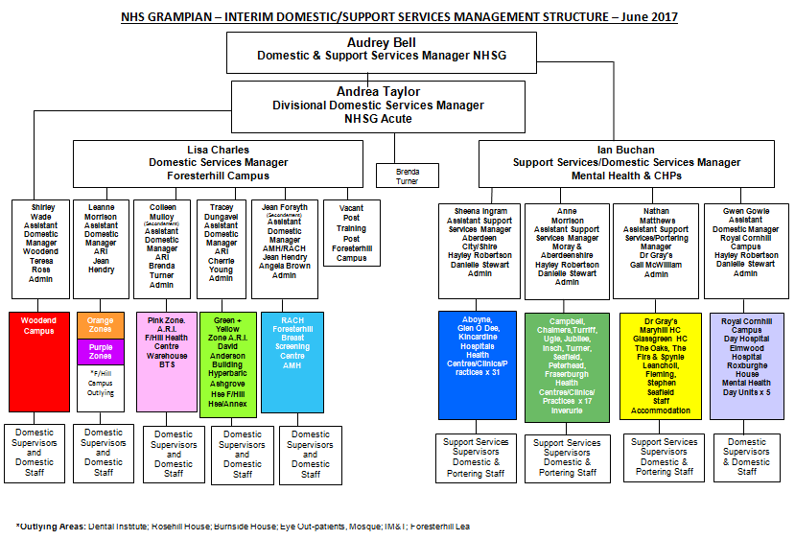

- SCOPE & RANGE

Provision of a Cleaning Service within Wards and Departments in a Hospital/Healthcare setting, whilst working closely with ward/department staff to ensure high quality service provision.

- MAIN DUTIES/RESPONSIBILITIES

- Responsible for cleaning all the floors, furniture, fixtures, fittings, glassware, high and low level surfaces, sanitary areas within Clinical and Non –Clinical Areas. These duties will be carried out inline with NHS Grampian Policies and local operational procedures and Work Schedules.
- Responsible for ensuring the safe disposal/packaging of waste as per NHS Grampian policy for example Clinical Waste, Household Waste.
- Within Residential Accomodation responsible for changing and making up of beds on residents departure, including medical staff on call rooms.
- Movement of bulky/awkward Furniture/Equipment is subject to Risk Assessment by Supervisor, thereafter if appropriate, domestic assistant will be required to move some items (with help if appropriate) to enable effective access for daily, weekly and periodic cleaning.
- Reporting details of faults and failures of electrical equipment/fabric of the building to Supervisor or Ward Manager.
- Responsible for maintaining adequate stocks of cleaning materials and consumables at ward level , based on predetermined stock levels. Top up supplies are requested on a weekly basis from supervisor.
- Responsible for ensuring basic building security measures are undertaken for example locking doors, securing windows.
- Responsible for the completion of records, for example personal signing in/out sheets and key register.
- Responsible for safe/secure/hygienic storage of various stocks at department level e.g cleaning chemicals, consumables, dry/refridgerated foodstuffs and equipment.
- Responsible, where applicable for the changing of curtains/bed screens
- Responsible for the routine and basic cleaning maintenance of all domestic equipment, (e.g. bag change, filter, visual check of cable and plug).

- SYSTEMS AND EQUIPMENT

The postholder will be required to operate the following equipment.

- Procedures as detailed in the Domestic Services Operational Procedures Manual
(Yellow book)
- Tub or cylinder vacuum
- Scrubbing Machine
- Carpet Shampooer
- Dishwashing equipment
- Toaster All equipment to be used in
- Wet Pick up Suction Drying Machine accordance with
e.g. Removal of spillages, water. manufacturer’s instructions
- Microwave and as stated in Domestic
- Hot water boilers/kettles Procedures Manual
- Floor Mopping equipment
- Food Trolleys
- Safety Steps
- Scrubber/Dryer machines
- Janitorial trolley
- Steam cleaner machines

This list is not exhaustive but indicative of the equipment in use.

- DECISIONS AND JUDGEMENTS

- The postholder will be expected to follow domestic services procedures in accordance with those set down in the Domestic Procedures Manual and Work Schedules
- A supervisor will be contactable and available at all times, by phone and bleep.
- The postholder can liaise with Senior Ward Staff/Supervisors or Domestic manager at any time.
- Work Schedules prepared by the Manager based on National Cleaning Services Specifiction will be adhered to as far as possible.
- The postholder can make decisions as to the order of work at their own discretion to fit in with department procedures, priorities and patient needs.

The postholder is expected to alert the supervisor of any ad hoc requirements for additional equipment, supplies etc.

- COMMUNICATIONS AND RELATIONSHIPS

- The postholder will be in contact with patients, clinical, non-clinical staff, colleagues members of the public, and Supervisor /Domestic Manager on a daily basis. Face to Face or telephone/pager system.
- Domestic Assistants will be expected to work alongside and support new staff on cleaning tasks further to the initial training carried out by Supervisor.

- PHYSICAL DEMANDS OF THE JOB

The postholder must be physically fit and able to undertake the physical duties of the post. The post involves manual handling duties and constant movement and standing for duration of shift e.g. twisting, stretching, bending, kneeling, lifting, pushing and pulling.

- Use and movement of cleaning equipment.
- Physically moving furniture whilst cleaning areas e.g. Desks, chairs.
- Physical movement of stores e.g. Cleaninig chemicals, paper disposals by use of cages and trolleys.
- Physical movement of waste e.g. Household waste and Clinical waste by use of cages and trolleys.

- MOST CHALLENGING/DIFFICULT PARTS OF THE JOB

- Accessing areas for cleaning purposes and completing duties within time-scales whilst maintaining an unobtrusive service. Having to work around patient needs and clinical service provision.
- Regularly working in obnoxious smelling environment e.g. urine, vomit, excrement..
- On a daily basis the post holder is required to deal with body fluids during routine cleaning of toilet/sanitary areas.
- Occassionally removing, handling and reporting discarded sharps e.g. Used needles in public areas.

11. KNOWLEDGE , TRAINING AND EXPERIENCE REQUIRED TO DO THE JOB

Knowledge

Basic Communication skills.
Knowledge of basic cleaning.

Experience

Previous experience desirable.

Training

Able to undertake essential induction training and ongoing training as provided by the organization e.g. Elementary Food Hygiene, Fire Awareness Training, Moving & Handling. Infection Prevention and Control Precautions, Hand Hygiene. Health and Safety Procedures. Working knowledge of HAI/HEI procedures.

PERSON SPECIFICATION
POST/GRADE: DOMESTIC ASSISTANT/ BAND 2

LOCATION: GLEN O DEE HOSPITAL

The Person Specification should meet the demands of the job and comply with current legislation. Setting unnecessary standards may, for example, unfairly discriminate against one sex, the disabled or minority racial groups. Applicants should be assessed in relation to their ability to meet the real requirements of the job as laid down in the job description. With the exceptions relating to displaced and disabled candidates noted in Sections 5.3 and 5.4 of this policy, shortlisted candidates must possess all the essential components as detailed below.
Requirements of Post
 | ESSENTIAL | DESIRABLE
Qualifications: | - Basic General Education.  - Literate and numerate – able to complete simple log sheets | - Elementary Certificate in Food Hygiene  - Basic qualification relating to cleaning processes, Health and Safety , Hygiene or Infection Control  - Completion of NHS Scotland Healthcare Support Workers workbook.
Experience: | - Experience of undertaking cleaning tasks  - Experience of working with others | - Cleaning experience in a healthcare setting
Knowledge | - Knowledge of cleaning tasks, preferably in a hospital/healthcare environment  - Basic awareness of health and safety issues associated with cleaning in a healthcare setting | - Sound awareness of health & safety issues and Infection Prevention and Control issues relating to cleaning in a Healthcare setting
Interpersonal Skills | - Good command of the English language – must fully understand written and verbal instructions  - Ability to carry out tasks in a methodical manner  - Be able to listen and communicate information effectively
Technical Skills | - Have some knowledge of cleaning operations and methods | - Training in safe methods of operating cleaning machinery
Physical Requirements | - Must be suitably fit, and be able to undertake a full range of domestic/portering (where applicable) duties in safe and competent manner. This will include walking and standing for most of the shift, bending, stretching, pushing, pulling and lifting, using appropriate aids  - Clean and tidy appearance | - Safe Moving & Handling procedures.  - Elementary Certificate in Food Hygiene  - In certain community hospitals there is an element of catering & Portering related duties. The operation of cook/chill practices and procedures

