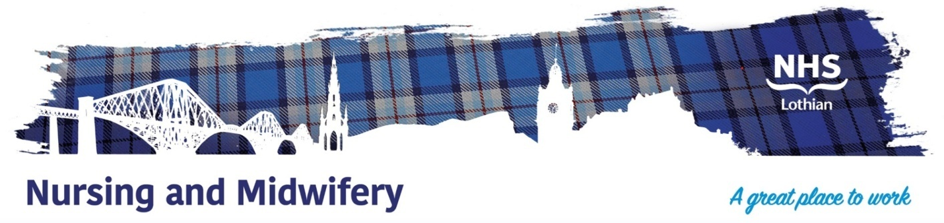

**Liberton Community Hospital Ward 4**

Exciting opportunities are available to join Intermediate Care within Liberton Hospital. We have positions available for Registered Nurses. We are looking for passionate, caring, motivated people to join our highly skilled nursing teams.

We offer the opportunity to work with talented teams within multidisciplinary environments and impact positively on the lives of thousands of patients and their families.

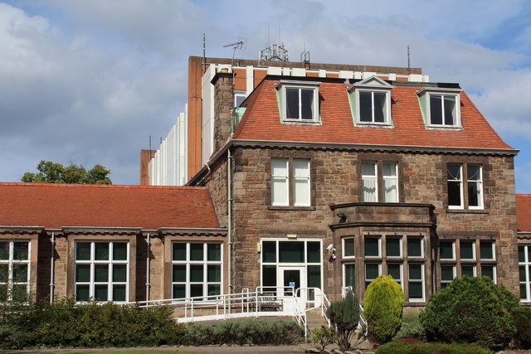

**What We Can Offer You**

We have a range of vacancies for experienced and newly qualified nurses to join our innovative and dynamic teams across NHS Lothian – providing you with the opportunity to gain a breadth of knowledge and exposure to multiple specialties.

Liberton Hospital currently has 3 In-patient wards which provide assessment for the older person usually above the age of 65 with low or stable medical needs that prevent them going directly home from an acute site. After a period of illness or injury, patients are transferred from RIE/WGH and would benefit from a period of inpatient recovery with rehabilitation and re-enablement to facilitate them to return home, alongside complex discharge planning. The wards provide care for patients who have a wide range of chronic health conditions, or are recovering post surgery.

We have consultant ward rounds weekly; rotating FY2 Doctors Monday to Friday and visiting community based Advanced Nurse Practitioners.

We have an extensive AHP team comprising of Occupational Therapists and Physiotherapists and their respective assistants. Liberton Hospital also houses the Hospital at Home Team and Day hospital.

**Roles**

Liberton Hospital offers a variety of learning opportunities. You will be orientated to the unit on your first day and allocated a “support Buddy”. The patient group have varying levels of communication, health care needs and dependence and this will provide you with an opportunity to gain knowledge in the assessment of individual needs and formulating patient centred care plans.

  