- JOB IDENTIFICATION

Job Title: Research Radiographer – Band 6
Responsible to: Deputy Lead Research Radiographer/ CRIF Manager
Department: Clinical Research Imaging Facility, QEUH
Directorate: Corporate
Contract: Permanent
Last review: May 2024
- JOB PURPOSE
The post holder will be an integral part of the highly skilled Clinical Research Imaging Facility team (CRIF) where cutting edge research imaging modalities, including 7Tand 3T Siemens MRI and Canon Aquilion Prime CT. We also have access to DEXA at Royal Hospital for Children.

We support researchers, clinicians and academics for both commercial clinical drug trials and academic studies. We have an active MR development programme to enable quick and dedicated access to gather pilot data, allowing refinement of study protocols to support grant applications and assessment of C2Ps and WIPs. CRIF is an important part of the advancement and testing of new RF coil technologies which are developed and built on site. We are a central partner in the UKRI Strength in Places funded Living Lab workstreams with the University of Glasgow

Our current research interests are primarily advanced cardiovascular i.e. multi-parametric CMR and CTCA, and neurological studies including fMRI and spectroscopy, and CT perfusion but could include other areas of interest depending on which research projects are being supported by the facility at the time i.e. renal, MSK, oncology, hepatology.

MRI and CT scanning of research subjects and support of research scanning projects will be central to this role however there will be significant non-scanning responsibilities. The post holder will act as part of the core team within the imaging research facility taking on responsibilities with other facility activities e.g. NHS support work.

The post holder is tasked with ensuring this data is uploaded and transferred confidentially to the appropriate server for post processing and to update and maintain all records and documentation accurately, in accordance with approved study processes and Good Clinical Practice. Image trial data management and image analysis are also potential areas of study support work for this role.

SCOPE AND RANGE
The Clinical Research Imaging Facility (CRIF) is an integral part of a multifaceted team which facilitates academic and commercial Research and Innovation projects locally, throughout Scotland and beyond to an international audience. The research group consists of a team of radiographers, HCSW, radiologists, physicians, physicists, data scientists, administrators, IT staff, research fellows and students form the NHS and University of Glasgow.

A Siemens 3T Prisma scanner is fully featured with capabilities for complex cardiac imaging, complex neuro imaging, advanced parallel imaging and acceleration techniques, multi-nuclear spectroscopy and access to work in progress sequences to trial and review alongside a comprehensive selection of coils.

The 7T system, Siemens Terra, is a joint venture with the University of Glasgow, and is currently neuro focused, developing both advanced healthy volunteer and patient studies. A coil lab with expert engineers is also based at this site.

The CT scanner is highly specified and capable of many advanced techniques and technologies e.g. single rotation cardiac imaging, perfusion imaging and adaptive dose reduction with a huge post processing capability including subtraction angiography, iodine mapping and perfusion.

CRIF is required to produce consistent, robust data through imaging, applying cutting edge technologies appropriately and precisely to each and every examination thereby allowing these techniques to move forward into everyday clinical use and enhancement of patient care.

Service provision covers core hours with potential to work flexibly.

- ORGANISATIONAL POSITION
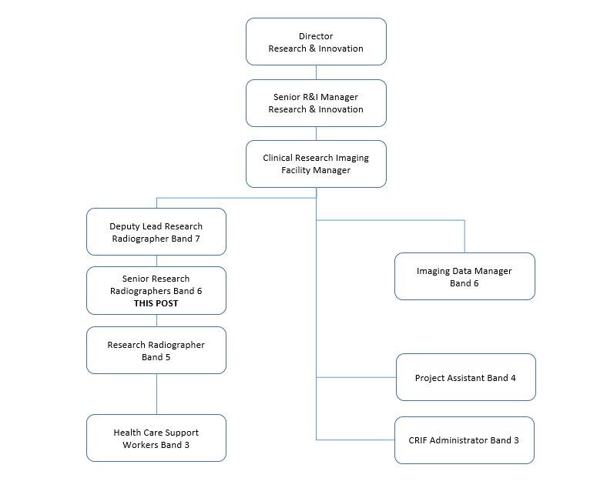

- MAIN TASKS, DUTIES AND RESPONSIBILITIES
- Provide a high quality imaging service. This involves scanning to a consistently high level in accordance with study protocols, and clinical research and patient governance guidance.
- To be accountable for own professional actions at all times.
- Be responsible for the safety of the patient, subject, staff and equipment in the research imaging facility. This involves maintaining a clean and safe working environment, and ensuring safe transfer of patients/participants and equipment used in the department using manual handling guidelines, infection control and risk assessments.
- Undertake IV cannulation and use of pressure injector and infusion pump when training and competencies are completed. Be aware of safety issues in relation to the pressure injectors used in CT and MRI and infusion pump in MRI.
- Update completely and accurately all records pertaining to research scanning and subject records with particular focus on safe and correct anonymisation of participant data.
- This also involves some administration activity and booking/monitoring of scanning appointments.
- As part of the core team, fulfilling core tasks and roles as directed by the management team e.g. Quality Assurance processes, Audits, SOP authoring and monitoring, Health and Safety monitoring, updating policies and procedures as necessary.
- Participate in clinical and professional development, staff meetings and multidisciplinary meetings by keeping up to date with current trends and developments in MRI imaging and sharing of knowledge acquired at study meetings.
- Take part in producing and suggesting changes in departmental procedures and policies to reflect changes in working practises over time and to ensure their effectiveness at all times.
- Participate in the implementation of new protocols and the updating of protocols already in use in accordance with trial guidelines with supervision.
- The Radiography team work at the “front line” of research therefore will often have to work along with the Investigators and research teams to resolve problems encountered on the job, i.e. during research scanning. Radiographers therefore need to be able to manage the expectations of the researchers during such problems and help them understand that research scanning often presents unforeseen problems that need to be worked through calmly and efficiently.
- Liaise and communicate effectively with colleagues, fellow healthcare professionals and clinicians to ensure the provision of a high quality and effective service.
- After examination is completed, ensure the patient knows the procedure for receiving results and is well enough to leave the department.
- Communicate any concerns, either clinical or professional, to the managers
- Assist with resource management, monitoring levels of non-stock consumables and contrast media.
- Assist with the supervision of HCSW, research fellows and students.

Workflow:
- Prioritise scheduled workload to accommodate for unplanned/urgent cases.
- Anticipate and prepare for delays or extended examinations, taking appropriate action.
- Delegate appropriate tasks to HCSW, supervising or assisting where appropriate to provide the highest quality of care for all patients/volunteers.
- Assist in training Consultants, Research fellows, students and visitors with the safe working practices of MRI.
- Documentation, reporting and first line troubleshooting of all equipment errors and faults.

Education:
- Participate in GG&C mandatory training
- Attend Good Clinical Practice and ILS training
- Actively pursue CPD and keep an up to date record
- Actively update knowledge of technological advances infield of speciality
- Actively update an in depth knowledge of specialist equipment used.
- Actively search for journals and papers which might explain and assist with furthering knowledge and improving techniques in imaging

- EQUIPMENT AND SYSTEMS
Equipment:
- Siemens 3T Prisma and 7T Terra MR scanners
- Toshiba Aquilion One Vision 320 CT scanner
- MRI post processing workstations – Siemens and stand alone
- CT post processing workstations – Toshiba
- High pressure injectors for CT and MRI
- Infusion pump for MRI
- DEXA
- MR safe patient monitoring system
- Various none MR safe patient monitoring equipment
- Personal computers/scanners/printers
- MR safe trolley and wheelchair plus manual handling equipment

Systems:
- Remote workstations are available for viewing and manipulating images prior to being archived allowing strict checks and anonymization to be completed.
- Research databases: used for accurately recording data e.g. XNAT
- Clinical systems: PACS/ CRIS/Clinical Portal/ Trakcare:
- EDGE: to track and record patient activity.
- Paper documentation: to be completed accurately for many research studies, stored in specific files safely and neatly.
- Software programmes such as Microsoft Office to create documents, tables and spreadsheets.
- Access to internet to enable secure upload of study data CT raw data sever

- DECISIONS AND JUDGEMENTS
- Determine whether a patient/subject/volunteer is suitable and safe to be scanned, and accompanying staff or relations are safe to enter the MR controlled areas.
- Understand a wide variety of clinical information from a variety of clinical disciplines and be prepared to update knowledge as required.
- Prioritise workload based on clinical situation.
- Exercise personal responsibility making confident decisions in complex circumstances during research imaging e.g. alteration of parameters to ensure the subject completes the scan while maintaining protocol adherence.
- Assess quality of examination and recognise need for improvement/assistance within the scope of the study protocol
- Assess mental, physical and emotional condition of a patient prior to commencement of examination in order to implement best methods to ensure a complete, comfortable and safe examination.
- Assess the patient after contrast agent/ stress agent administration and make sure there is no adverse reaction.
- An awareness of how quickly stable situations can change and become an emergency and have the ability to notice these changes and react accordingly.
- Can recognise abnormalities on an image and confidently discuss findings with an appropriate clinician/radiologist. Can clinically evaluate images produced, assess quality and decide on a need for further imaging.
- Monitoring scanner performance and reporting aberrant function immediately to responsible physicist and core management team.
- Participation in the delegation of tasks and supervise staff as required.
- Participate in the assessment of the abilities and competencies of new staff joining the team.
- Identify Health and Safety issues and document and report as appropriate

- COMMUNICATIONS AND RELATIONSHIPS
Patients/ volunteers:
- Understand the importance of time spent with volunteers and patients, providing complex information by explanation of procedures, listening to their concerns and requirements.
- Ensure a positive experience for participants attending research imaging to facilitate a high rate for follow-up imaging.
- Employment of counselling and communication skills in case of anxious, claustrophobic participants to help alleviate fears and hopefully achieve a successful exam.
- Be able to ascertain whether a subject is safe for imaging.
- Providing and receiving highly complex and sensitive information.

Relatives/carers:
- Ask and instruct relatives/ carers for assistance with methods of transfer and immobilisation.
- Highly developed communication skills are required to provide reassurance and understand complex and sensitive information.
- Provide information using tact and diplomacy adhering to the regulations governing the Data Protection Act and the Freedom of Information Act.

Research staff:
- Impart technical information to research fellows/ students/other radiographers regarding specialist equipment, imaging protocols and post processing techniques.
- Effective communication to enable correct dose of contrast agents and controlled drugs in accordance with each individual study protocol; record and verify in accordance with departmental protocol.
- Pass on relevant information when transferring participant care to colleagues.
- Liaising with physicists/ medics/ nursing staff/ HCSW/ clerical staff on a daily basis.
- Training of research fellows and PhD students providing advice and support as part of the assessment process.

Medical staff/ other health care professionals:
- Relaying sensitive patient information and discussing this with referring clinicians.
- Diplomatic skills are required during discussion with referrers.
- Liaise with appropriate staff to ensure effective workflow of examinations.
- Provide advice on the acquired and post processed images.
- Supervise and train all staff with regard to MR safety.
- Provide clinical/professional information to this professional group.

Visitors:
- Participate in providing a brief and insightful demonstration including image presentation, to a wide variety of visitors including academics, charity representatives, students, politicians, the media and potential users of research imaging.
- Effectively communicate the safety requirements for visitors to the facility.

Non-NHS staff:
- Effectively relaying correct information to engineers, sales representatives, and company support staff.

PHYSICAL, MENTAL, EMOTIONAL AND ENVIRONMENTAL DEMANDS OF THE JOB
Physical skills:
- Expertise and knowledge to operate highly specialised equipment accurately using specialised techniques.
- Highly developed hand to eye co-ordination to accurately prescribe and manipulate MR sequences and images and complete post processing tasks.
- Competently perform IV cannulations.
- Possess significant keyboard skills to enable accurate data entry.
- Possess Intermediate Life Support skills.

Physical demands:
- Frequent light lifting and occasional moderate lifting during clinical duties such as carrying QA phantoms and MRI Coils, assisting patients on and off the table.
- Frequently moving in-room equipment such as contrast injectors and infusion pumps.
- The majority of the working day is spent sitting at a VDU, standing and walking to position participants and between the two modalities.
- Cleaning of equipment regularly.
- Occasional transfer of participants from trolleys and wheelchairs onto scanner tables.

Mental demands:
- Frequent requirement for prolonged intense concentration and accuracy while operating Imaging equipment, inputting patient data, archiving, reviewing and post processing image data for reporting processes.
- Require ability to know how to use different operating systems and workstations for both acquiring and manipulating image data.
- Possess diplomatic skills to ensure smooth running of lists in pressured situations
- Training, supervising and assessing other staff members while maintaining participant care.

Emotional demands:
- Occasional exposure to highly distressing circumstances such as an unexpected deterioration of a subject’s condition, death of a subject
- Perform serial examinations on terminally ill participants.
- Care and understanding is required when dealing with subjects who may be anxious, claustrophobic, distressed or terminally ill.

Working conditions:
- Occasional exposure to unpleasant working conditions, can come in contact with blood, faeces, urine, unpleasant smells and unclean patients.
- Occasional exposure to verbal and physical abuse.
- Potential risk of serious injury to persons whilst working with high field MRI
- Working constantly in artificial lighting with little or no natural daylight.
- Long periods of time spent in front of VDUs.
- Working with equipment with a constant low level noise.

- MOST CHALLENGING/DIFFICULT PARTS OF THE JOB
- On a daily basis multitask one highly specialist task and another with frequent interruptions.
- Be able to manage any unpredictable workflow effectively and interacts successfully with fellow health care professionals.
- Understanding varying research protocols and processes, ensuring they are performed to strict and most current standards.
- Combining training in new techniques or newly procured highly complex equipment with normal research imaging workload.
- Monitoring scanning procedures are keeping within those agreed for specific studies and alerting the administration to any deviation from agreed procedures.
- Awareness of how quickly a stable and controlled situation can escalate to become emergency, life-threatening conditions.
- Provide supervision and assistance to trainee staff when performing examinations as well as being actively involved oneself.
- Dealing with participants who may become emotional and/or aggressive.
- Balancing mental and physical speed and accuracy ensuring that the service to the participants is never compromised.
- Cope with the mental and physical demands of working independently

- KNOWLEDGE, TRAINING AND EXPERIENCE REQUIRED TO DO THE JOB
Essential:
- BSc(Hons) Diagnostic Radiography or equivalent
- HCPC registration
- Evidence of experience in CT and MRI
- Excellent communication skills
- Team worker
- Excellent IT skills
- Evidence of CPD
- Flexible approach to type and hours of work
- Ability to use initiative and problem solve
- Effective organisational and interpersonal skills

Desirable:
- IV cannulation
- Evidence of attendance of post graduate training including training courses and study days
- Previous research experience
- Previous cardiac CT and MR experience
- Experience with databases and spreadsheets

