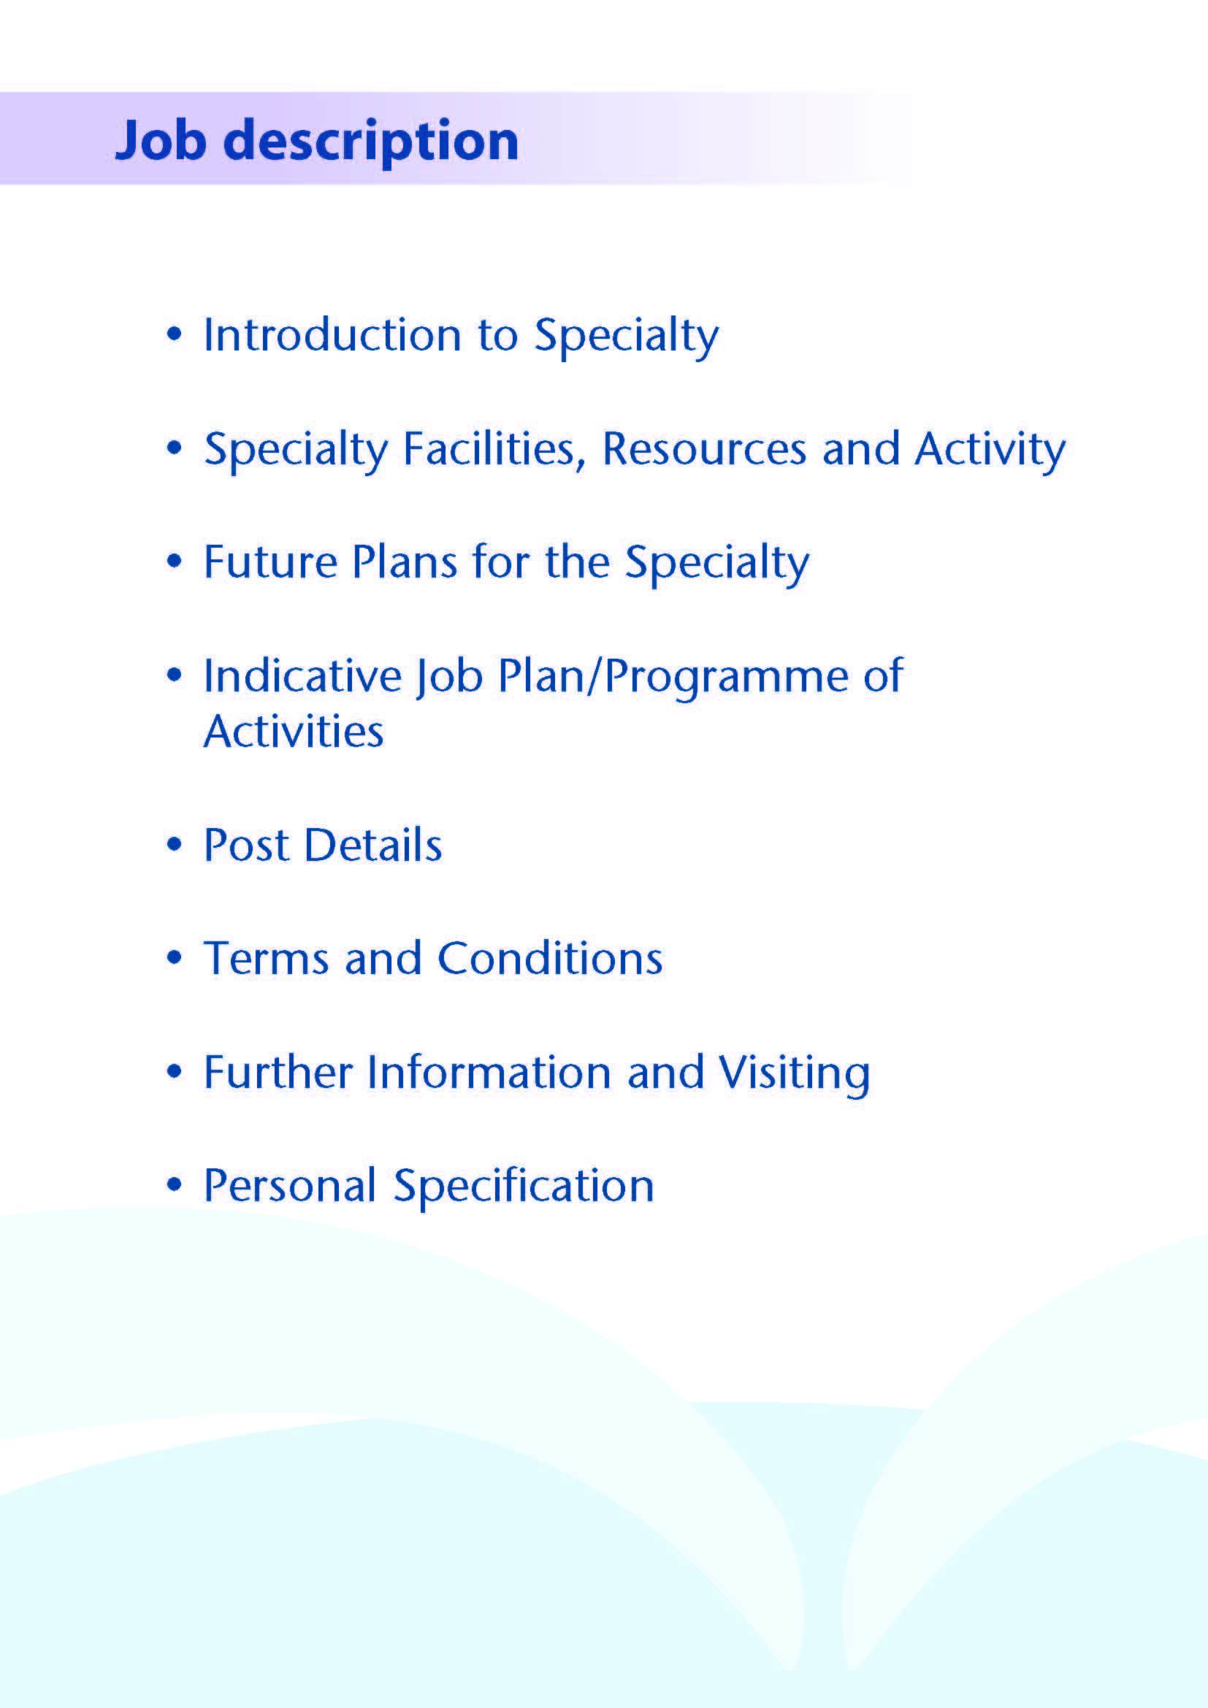



Applications are invited for a Consultant General Surgeon to join the team in Ayrshire and Arran (NHSAA) with on call commitments at University Hospital Ayr (UHA). Applications are welcomed from candidates with a sub-specialty interest in Bariatric Surgery.

The two main hospital sites within the health board are UHA and University Hospital Crosshouse (UHC), located in the picturesque West Coast of Scotland. Together they serve a population of 366,000.

Clinical sessions may be worked across both sites. The successful applicant will join a team of 20 consultant general surgeons, with subspecialist interests, across both sites and will contribute to the emergency general surgery on call rota.

UHA is a 343-bedded general hospital located to the south east of Ayr town and provides several area-wide services for NHSAA including Urology and elective Orthopaedic surgery. UHA is a referral center for Bariatric Surgery within NHSAA, has a comprehensive MDT and receives referrals from other parts of Scotland for revision and primary surgery (NHS Highland, NHS Dumfries and Galloway).

UHC has 539 beds, was opened in 1982 and has been expanded and upgraded regularly since then. Services in the majority of major specialties are provided at the hospital, in addition to Ayrshire-wide services in Intensive Care Medicine, Trauma, Robotic Surgery, ENT, Maxillo-Facial Surgery, Paediatrics, and Gynaecology. The Ayrshire Maternity Unit resides in a state of the art building on the Crosshouse site.

Both Hospitals are easily accessed by road, with the M77 providing rapid access to Glasgow (30 minutes from UHC, 45 minutes from UHA). Rail services also link both Kilmarnock and Ayr to Glasgow and other surrounding towns. Prestwick International Airport lies midway between both hospitals, approximately a 15 minute drive to each. All clinical sites in NHSAA provide free parking.



.

* UHA is one of the main referral centres in Scotland for Bariatric Surgery. Having been established in 2008, referrals are accepted in line with the agreed referral criteria. A multi-disciplinary group meets on a monthly basis to triage the referrals and discuss patients at various stages through the pre-op programme. A tier 3 weight management service is also available within NHSAA. A range of procedures are offered including sleeve gastrectomy, gastric bypass, intragastric balloon and revision surgery. This exciting opportunity has arisen for a new and enthusiastic general and bariatric surgeon to join the team. It is expected that, after integration into the team, the successful candidate will lead the service, bringing to it the added benefit of their own experience.
* A variety of benign and malignant UGI operations are performed in NHSAA including hiatal repair, cardiomyotomy and biliary surgery. Utilisation of ‘Spyglass’ for biliary surgery and ERCP is currently being assessed. UGI cancer resections are also performed.
* UHC has seen the recent addition of a DaVinci robot. This is currently being utilised by the colorectal, urology and gynaecology teams, but one might expect that the range of procedures performed will expand over time.
* General Surgical units at UHA and UHC have recently moved under the leadership of a single Clinical Director. In the future the units will deliver a single General Surgical service for NHSAA across the two sites with the expectation that clinicians will increasingly deliver clinical commitments on a cross-site basis.



**MULTIDISCIPLINARY TEAM STRUCTURE**

The Multidisciplinary team for bariatric surgery meets monthly with tele-link to Dumfries and Galloway. There is a comprehensive MDT including full time specialist nurse and dietitian. There is support from clinical psychology and a physician with an interest in obesity/ metabolic medicine (currently based in Dumfries and Galloway). Established referral pathways are in place for cardiology and respiratory support, in addition to an anaesthetist with a special interest.

Area-wide multidisciplinary teams for colorectal, upper GI and breast cancer meet weekly with tele-linking between NHSAA’s two acute hospitals and the Beatson Oncology Centre in Glasgow. Teams are supported by clinical oncologists, medical oncologists, specialist nurses, palliative care specialists, MDT coordinators and dedicated audit staff. NHSAA Cancer MDTs play a major role in the West of Scotland Managed Clinical Networks for Cancer. The Surgical Directorate provides breast and bowel screening services for NHSAA and NHS Dumfries and Galloway.

**NURSE SPECIALIST SERVICES**

NHSAA has been very proactive in developing enhanced nursing roles.

The organisation has nurse specialists in bariatric surgery, cancer care, stoma therapy and endoscopy. In addition there are Advanced Nurse Practitioners who are Ward based and UHA has a Nurse Practitioner who undertakes minor surgery. UHA has a trained Theatre Practitioner who can act as First Assistant in theatre.

**THEATRE / ENDOSCOPY FACILITIES**

The theatre facilities in NHSAA are equipped to a high level. There are designated CEPOD theatres available daily.

UHA is equipped with state of the art laparoscopic/ endoscopic 4K theatre with educational package linked to the education suite and the lecture hall.

NHSAA continues to invest in the purchase of up to date theatre equipment and has a well-established programme for the ongoing replacement of existing equipment.

The endoscopy suites provide a range of diagnostic and therapeutic procedures including, OGD, colonoscopy, ERCP, stenting, endoanal ultrasound, laser endoscopy and transnasal endoscopy. Currently the surgical department performs about 80% of endoscopic procedures, the rest being performed by 4 consultant gastroenterologists. In addition, there are 5 nurse endoscopists (4 surgical) and a GP endoscopist in UHC and a further 4 nurse endoscopists in UHA.

|  |  |  |
| --- | --- | --- |
| **No. of Facilities** | **UHA** | **UHC** |
| Main Theatres | 6 | 8 |
| Robotic Theatre | - | 1 |
| Integrated 4k theatre | 1 | - |
| Interventional Theatres | 1 | - |
| Day Surgery Theatres | 3 | 3 |
| DSU Treatment Room | 2 (diagnostic rooms) | 1 |
| Endoscopy Procedure Rooms | 4 | 4 |

**IMAGING**

An extensive range of imaging facilities are available including spiral CT with 3D reconstruction, MRI, MRA, nuclear medicine and digital subtraction angiography.

Interventional radiology is available at UHA.

**EMERGENCY DEPARTMENT**

Both UHC and UHA provide Emergency Departments with care led by consultants in Emergency Medicine.

**CRITICAL CARE**

Critical Care units are available at both UHA and UHC, however all ICU level 3 care is provided at UHC where there are 12 level 3 and 6 level 2 beds under the management of consultants in Intensive Care Medicine. There is an 8 bed level 2 critical care unit at UHA. This area is managed by the ICM team Monday to Friday, 9am -5pm. Outwith these times patients are cared for by their parent specialty (i.e. general surgery, urology, orthopaedics, medicine) with input from the anaesthetic team. A dedicated transfer rota is in place for those patients requiring transfer to UHC for level 3 care on an emergency basis.

**EDUCATION CENTRES**

Excellent post-graduate facilities are provided at both hospitals, with the MacDonald Education Centre based at UHA and the Alexander Fleming Education Centre based at UHC. Both centres include a full size lecture theatre, classrooms and a number of tutorial rooms. The facilities are supported with modern audio visual and information technology, including teleconferencing facilities and both centres incorporate an excellent up-to-date library with a resident librarian.

**MEDICAL STAFF RESOURCES**

**CONSULTANT SURGEONS**

|  |  |
| --- | --- |
| Subspecialty Interest |  |
| Colorectal Surgery | Mr S Alishahi  Mr R Muir (Deputy Clinical Director UHA)  Mr T Kallachil  Mr E Leung  Mr C Ray  Ms E Yeap  Ms H Koh  Mr I Felsenstein |
| UGI | Mr K Robertson (Clinical Director)  Ms C Sharp (Deputy Clinical Director UHC)  Mr D Morran  Mr L Velu  Mr A Hussain  Mr LJ Fon  Vacancy (this post) |
| General/ Paediatric | Mr M Khine |
| General / Breast Surgery | Mr S Bhattachayra |
| General Surgery | Mr S Rajeev (Locum)  Mr V Manda (Locum)  Mr N Wickramesekara (Locum) |
| Breast Surgery | Ms S Elgammal  Ms S Tovey  Ms J Reid  Ms L Ewan |

**SUPPORTING MEDICAL STAFF**

|  |  |  |
| --- | --- | --- |
|  | UHA | UHC |
| Staff Grade / Specialty Doctor | 6 | 6 |
| Specialty Trainee | 2 | 5 |
| Clinical Development Fellow | 2 | 3 |
| Clinical Teaching Fellow | 1 | 2 |
| FY2 | 0 | 1 |
| FY1 | 9 | 10 |



This programme is based upon a core job plan of 10 programmed activities however opportunities may exist for Extra Programmed Activities to be undertaken subject to service requirements and in accordance with national terms and conditions of service.

|  |  |  |  |  |  |  |  |  |  |  |  |  |
| --- | --- | --- | --- | --- | --- | --- | --- | --- | --- | --- | --- | --- |
|  | | **Direct Clinical Care (hours)** | | |  |  | **Supporting Professional Activities (hours)** | | |  |  |  |
|  | Description | Theatre | OPC | Admin | Ward  Work | **Total** | Teaching | Audit | CPD | Research | Other | **Total** |
| Mon a.m. | Ward Work / Admin |  |  | 2 | 2 | **4** |  |  |  |  |  |  |
| Mon p.m. | Ward / Admin |  |  | 2 | 2 | **4** |  |  |  |  |  |  |
| Tues a.m. | SPA | 4 |  |  |  | **4** | 1 |  | 2 |  | 1 | **4** |
| Tues p.m. |  |  |  |  |  |  |  |  |  |  |  |  |
| Wed a.m. | Theatre | 4 |  |  |  | **4** |  |  |  |  |  |  |
| Wed p.m. | Theatre | 4 |  |  | ` | **4** |  |  |  |  |  |  |
| Thurs a.m. | SPA |  |  |  |  |  |  | 1 | 2 |  | 1 | **4** |
| Thurs p.m. | Endoscopy | 4 |  |  |  | **4** |  |  |  |  |  |  |
| Fri a.m. | Clinic |  | 4 |  |  | **4** |  |  |  |  |  |  |
| Fri p.m. | Clinic |  | 4 |  |  | **4** |  |  |  |  |  |  |
| **TOTALS** |  | 16 | 8 | 4 | 4 | **32** |  | 1 | 2 |  | 1 | **4** |
| **On Call** |  |  |  |  |  | **4** |  |  |  |  |  |  |
| **Total Hours** |  |  |  |  |  | **36** |  |  |  |  |  | **4** |

**The above job plan is a typical working week. All teams have been delivering sessions more flexibly following**

**remobilisation after the pausing of working during the pandemic. The actual days of delivery of each session**

**may therefore change.**

**PROPOSED WEEKLY PROGRAMME**

The core proposed weekly programme is shown at Section 4. Activities with current fixed time commitments will be carried out as detailed in the work programme e.g. clinics.

This timetable will be reviewed three months following appointment and should therefore be regarded as an interim programme.

The programme may be adjusted with appropriate recognition for Extra Programmed Activities depending on the needs of the department. Any change to the programme would be by mutual agreement between the post holder and Clinical Director.

**NOTES ON THE PROGRAMME**

**Patient Administration**. This activity covers the management of individual patients including Out Patient administration, results reporting, letters/phone calls to patients, carers, GP’s and members of the wider multidisciplinary team involved in the patients care.

**Ward Rounds**: the time allocated is indicative and will be discussed with the appointee. Ward work will include teaching ward rounds as required.

**Travel:** Any travel allocation will be included within the Total Programmed Activities and will be determined by location at which Direct Clinical Care and Supporting Professional activities are carried out.

**ON CALL ARRANGEMENTS**: On Call is on a 1:8 basis initially.

**Supporting Professional Activities**: The agreed job plan will include all of the consultant’s professional duties and commitments, including agreed supporting professional activities (SPA). It will be requested that SPA is delivered at the normal place of work, unless there are mutual advantages to it being performed elsewhere. The exact timing and location of SPA, and flexibility around these, will be agreed during the 1:1 and included in the prospective job plan.

**Research:** The unit is supported by an active Research and Development Committee. The appointee will be encouraged to develop research interests.

**Teaching**: The post holder will be responsible for the training and supervision of post-graduates and under-graduates and will be expected as part of their SPA allocation to devote time to this activity on a regular basis. In addition he/she will be expected to ensure that Junior Staff and medical students receive adequate support and advice and may act as a contact as the person responsible for overseeing their training and as an initial source of advice.



The post holder will be responsible for the provision of inpatient, day case and outpatient surgical care. Specific to the subspecialty interest the post holder will also be expected to:

* Work with colleagues to further develop services across NHSAA.
* Support West of Scotland Managed Clinical Network activity regionally.
* Provide training and support to Foundation Doctors and Specialist Trainees.
* Support multidisciplinary team delivery of care.

The post holder will be accountable to the Clinical Director for General Surgery who will agree the Job Plan.

He/she will work with local managers and professional colleagues in the efficient running of services and will share with Consultant colleagues in the medical contribution to management.

Subject to the provisions of the Terms and Conditions of Service, he/she is expected to observe the Organisation’s agreed policies and procedures, drawn up in consultation with the profession on clinical matters, and to follow the standing orders and financial instructions of NHSAA. Where they formally manage employees on behalf of NHAA, the post holder will be expected to follow the Local and National Employment and Personnel Policies and Procedures.

It is expected that the post holder will make sure that there are adequate arrangements for hospital staff involved in the care of patients to be able to make contact with the post holder when necessary.

The post holder is required to comply with the Organisational Health and Safety Policies.

The post holder will be responsible for the training and supervision of Junior Medical Staff who work with the post holder and will be expected to devote time to this activity on a regular basis.

In addition, they should foster a supportive environment for colleagues and help ensure Junior Staff have access to advice and counselling. If appropriate, the post holder will be named in the Contracts of Doctors in training grades as the person responsible for overseeing their training, and as the initial source of advice to such Doctors on their career.

**RESOURCES**

The staff resources of the Directorate are listed elsewhere. The post holder will have access to such general administrative support as is required for the discharge of his/her duties and responsibilities.

This will include the provision of adequate secretarial and clerical support and the availability of accommodation, equipment etc.

The post holder will receive support from such other professional staff as are employed within the Division and are deployed to his/her area of patient care.

**DUTIES AND RESPONSIBILITIES**

The main duties and responsibilities of the post include:

* Responsibility for day case, inpatient and outpatient care at the UHA and other sites throughout NHSAA as agreed within the Job Plan.
* Provision of cover for consultant colleagues during periods of annual and study leave.
* Professional supervision and management of Junior Medical Staff.
* Responsibilities for carrying out teaching, accreditation and examination duties as required, and for contributing to undergraduate andpostgraduate medical education. The post holder will be expected to comply with College recommendations on Continuing Medical Education.
* The post holder will be required to comply with Organisation’s Policies on Clinical Governance.
* The successful applicant will be encouraged to participate in research and to develop a subspecialty interest to complement the department, subject to resources and local priorities.
* Requirements to participate in medical audit and in continuing medical education.
* The successful applicant will participate in the Managed Clinical Network as appropriate within Ayrshire and Arran and other hospitals in the West of Scotland.
* Managerial, including budgetary, responsibilities (where appropriate).

**ANNUAL APPRAISAL AND JOB PLANNING**

You shall also be required to participate in annual appraisal. Job planning is linked closely with, but is separate to, the agreed appraisal scheme for consultants. The job plan review will take into account the outcome of the appraisal discussion and reflect the agreed personal development plan.



Are those determined by the Terms and Conditions of the New Consultant Grade (Scotland) as amended from time to time. The distance that a consultant can reside from the principal base hospital, where travel time is seen as more important than mileage, is subject to the agreement of the Medical Director.



Applicants wishing further information about the post, or to arrange a site visit, are invited to contact:

Potential candidates may also wish to contact Mr Kevin Robertson, CD for General Surgery, Mr Robbie Muir, Site CD for General Surgery UHA or Mr Cameron Sharkey, Divisional General Manager, 01292 616899/ Cameron.Sharkey@aapct.scot.nhs.uk



**PERSONAL SPECIFICATION** 

**POST OF**: CONSULTANT GENERAL/ BARIATRIC SURGEON

**LOCATION**: UNIVERSITY HOSPITAL AYR, WITH COMMITMENTS ACROSS NHSAA

***QUALIFICATIONS:***

|  |  |
| --- | --- |
| **ESSENTIAL** | **DESIRABLE** |
| * Full GMC Registration * Inclusion on the GMC Specialist Register for General Surgery | * Royal College Membership/Fellowship |

**SKILLS/KNOWLEDGE/COMPETENCE**

|  |  |  |
| --- | --- | --- |
| **REQUIREMENTS** | **ESSENTIAL** | **DESIRABLE** |
| **General Experience/ Training:** | * Specialist training in the diagnosis and management of patients presenting to the general surgical department. * Knowledge of and skill relevant to the management of patients. * Ability to communicate effectively with all levels of staff and patients * Ability to work efficiently and timeously * IT literacy * Experience and training in Bariatric surgery. | * Laparoscopic Hernia Surgery * Laparoscopic benign biliary surgery * UGI endoscopy skills |
| **Team Working** | * Effective Team Player |  |
| **Development** | * Evidence of service development and quality improvement. |  |
| **Teaching & Training** | * Proven ability to deliver high quality teaching | * Interest in and knowledge of advances in medical education and training. |
| **Research & Publications** |  | * Evidence of publications of a high standard relating to specialty |
| **Clinical Audit** | * Evidence of previous audit relating to surgical services | * Peer reviewed publications and presentations |
| **Management and Administration** | * Commitment to effective departmental management and management of a multidisciplinary group | * Proven ability to lead a clinical team * Proven management experience * Understanding of resource management and quality assurance. * Proven organisational skills |
| **Personal and Interpersonal Skills** | * Effective communicator and negotiator * Demonstrate effective leadership * A willingness to develop special interests which conform to the needs of NHS Ayrshire and Arran * Ability to operate on a variety of different levels | * Knowledge of recent changes in the NHS in Scotland * A willingness to accept flexibility to meet the changing needs of the NHS in Scotland |

# 