

JOB DESCRIPTION

- JOB IDENTIFICATION
Job Title: | Business Intelligence Solution Developer
Responsible to  (insert job title): | Analytical & BI Team Lead
Department(s): | Information & Business Intelligence Services, Education Centre (currently working from home)
Directorate: | BI Services
Clinical Board: | Corporate Services
JD Reference: | 7194
No of Job Holders:

Last Update (insert date): | July 2023

- JOB PURPOSE

This post is Business Intelligence Solution Developer within the NHS Borders Business Intelligence Team. The post holder will develop custom Business Intelligence solutions and data visualisation products, such as reports and dashboards, built in Business Objects, Power BI and other leading Business Intelligence tools.

Reporting to the BI Team Lead, the role is responsible for developing innovative, custom solutions by constantly striving to push the boundaries of how data can support better healthcare. You will act as the Board’s specialist and provide consultancy and advice on the development of new and existing Business Intelligence solutions. You will act as a translator, taking requirements from end-users and designing and developing these into technical solutions that enable the organisation to respond to the challenges of the evolving framework of national initiatives and targets.

You will work with data from the NHS Borders Data Warehouse and raw data from other systems to build custom solutions mostly without any form of schema documentation to refer back to. The post holder must document the technical and design solutions, develop testing plans, provide results and complete change control requests. They are also responsible for the secure deployment of Business Intelligence solutions. You will also be required to develop data indicators which contribute towards the enrichment of the Data Warehouse.

The post holder must be able to demonstrate complex information to people with little knowledge of the specialist area in a way that is easily understood.

- ORGANISATIONAL POSITION

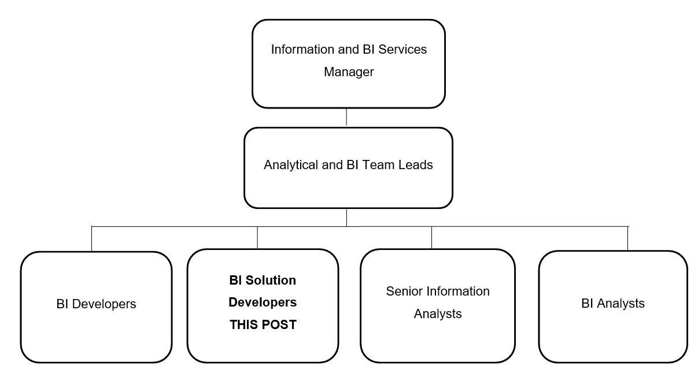

4. SCOPE AND RANGE

The role of the Information and BI Services Team is to manage information processes, reporting and analysis to support delivery, and decision making process for the delivery, of NHS Borders and the Health and Social Care Partnership’s services.

The post holder will be required to gather and document data requirements. They will design and develop complex custom Business Intelligence solutions that may incorporate data from multiple systems and data sources from the NHS Borders Data Warehouse. There may also be the need to design custom datasets to meet the reporting needs that are not met from the Data Warehouse.

The post holder is responsible for the delivery of these solutions to provide data and information to all departments, Operational Units, Corporate Services, National Services Scotland and the Scottish Government.

The post holder will be required to work with third party contractors.
5. MAIN DUTIES/RESPONSIBILITIES

- Develop complex datasets from multiple data sources within the Data Warehouse for subsequent reporting and analysis across the organisation.
- Develop and maintain indicators and standard calculations (both locally and nationally) in the Data Warehouse for others to use in reporting and analysis.
- Provide guidance and recommendations to co-ordinate the integration of NHS Borders systems and data sources into the Data Warehouse. This should include NHS Borders standard definitions and reference tables. Develop and ensure compliance with standards for data extraction, loading and transformation in accordance with current methodologies.
- Complete development of data extractions for national submissions and returns. This should include the programming of SQL scripts. Design the returns in such a way that they can be automatically uploaded to Scottish Government data collection websites and data marts.
- Develop and support data requirements across the organisation, providing interactive access to near real-time data, which can be used to analyse, manage, plan and monitor performance across the organisation. This will involve the use of specialist reporting and dashboard software applications including Business Objects Data Integrator, Business Objects and Power BI.
- Be proficient in application of statistical methods such as run charts and SPC charts and be able to implement these, as necessary, as part of performance management.
- Ensure robust testing processes are in place to ensure validity of data and information reported within and out with the organisation.
- Act as lead source of expertise to the organisation in relation to Business Intelligence, providing expert advice and guidance.
- Ensure robust processes and standards are met for all new and existing developments.
- Actively remain abreast of latest technologies and software available to Business Intelligence and advise on the possibilities and benefits of implementing such new technologies.
- Develop relationships with other board areas to collaborate on existing and new developments, sharing knowledge and skills where possible.
- Deliver presentations to senior management across the organisation to advise and demonstrate the latest developments and implementations of Business Intelligence dashboards and reporting suites.
- Publish patient and non-patient identifiable reports to NHS Borders. Set, develop and maintain meta data for reports to be found ensuring patient confidentiality is maintained at all times.
- Liaising with subject matter experts across the organisation to design, build, test and launch new data quality indicators.
- Maintaining and developing the existing library of data quality indicators.
- Leading development of regular performance reports that include trajectories for improvement.
- Promoting the use of on-demand analytics via Business Intelligence tools.
- Work with other teams outside of Business Intelligence, such as the Clinical Governance & Quality Team and the PMO to deliver custom Business Intelligence solutions for clinical systems across the organisation. This will contribute to the accuracy of mandatory national returns and the data used to support decision making throughout the organisation.
- Support the on-going development of the NHS Borders dashboards.
- Work in partnership with other teams to ensure standardised and efficient data collection
- Analyse, investigate and interpret highly complex datasets and KPIs through the application of informatics knowledge and be able to communicate implications to technical and non-technical staff.
- SYSTEMS AND EQUIPMENT

The post requires advanced use of computers and software including highly developed knowledge of data capture, analysis, business intelligence, and business support packages and products, including the development of BI solutions. Systems include:

Patient Management and Clinical Systems: Trakcare, EMIS Community Web, Nexus Theatres, Soliton Radiology + Information System

BI tools such as SQL Server, Business Objects, Business Objects Data Integrator, national reporting and information repositories provided by Public Health Scotland, Health Information Scotland etc.

The post holder must be proficient in Microsoft applications at an advanced level for report writing,
data manipulation and analysis (Excel, PowerPoint, Word, and Office 365 tools, such as Power BI); and other software applications as used by the Health Board.

7. DECISIONS AND JUDGEMENTS

As a specialist in their field, the post holder will be required to make decisions for which there is no former precedent and where other leading opinions may conflict. Business Intelligence is a fast- evolving discipline and, as such, the post holder is expected to remain abreast with the latest applications and tools, assessing and delivering solutions that utilise the latest technologies for the benefit of the organisation. The post holder is expected to formulate solutions to the unique requirements of NHS Highland.

The post holder has significant discretion to work within a set of defined parameters and is expected to perform the duties of the post, managing their own time and using initiative and judgement in meeting all areas within the post’s remit.

The post holder will be expected to use their judgement as to what issues should be escalated to the BI Team Lead and the appropriate time to escalate.

- The post holder will be given objectives by the Analytical & BI Team Lead
- The post holder is responsible for the delivery of agreed objectives, within guidelines provided but they will frequently be required to determine how this is best achieved.
- The nature of the post requires the post holder to react to a significant proportion of day-to-day requirements by managing their own workload within previously agreed parameters.
- The post holder is frequently required to work within broad professional policies and regulations, which may require to be interpreted for local implementation.
- Much will be expected of the post holder in terms of initiative and drive to ensure Business Intelligence solutions are designed and delivered to meet the expectation and needs of the stakeholders.
- The post holder, being a lead specialist in their field, will have the freedom to initiate action within broad policies, seeking advice as necessary. They will be expected to advise the Analytical & BI Team Lead on all matters in relation to Business Intelligence.
- The post holder is expected to manage their own time, using initiative and judgement in meeting all areas of the position’s remit.
- The post holder must be proactive in identifying and implementing improvements within and beyond their key result areas, anticipating future internal and external customer requirements and in formal planning.
- Review of performance is undertaken through the agreement of performance objectives and individual appraisal by the BI Team Lead. Formal review will be agreed with the BI Team Lead at least annually.
- The post holder will mentor other team members in order to develop their skills and abilities concerning Business Intelligence development and knowledge of the business and other resources of information.
- The post holder will also continually review their own performance to ensure high standards are maintained.
- The post holder will review their development needs in line with the e-KSF process.

8. COMMUNICATIONS AND RELATIONSHIPS

The post holder is required to regularly communicate with a wide range of senior clinical and non- clinical staff across NHS Borders, the wider NHS in Scotland and the Scottish Government. Methods of communication involve face-to-face, group meetings, Microsoft Teams, video conference, email, written correspondence and telephone. There will also be a requirement to deliver presentations to large groups of people at local and national events, so the post holder must have excellent presentation and delivery skills.

The post holder must be able to communicate highly technical issues to other team members and senior management within NHS Borders in a non-technical manner in order convey the complexities of Business Intelligence.

There is potential to collaborate Business Intelligence solutions across NHS Scotland boards and so the post holder will be required to develop relationships with peers and promote and participate in the sharing of knowledge, skills and experience to inform local developments based on best practice.

The post holder will be required to potentially collaborate and deliver Business Intelligence solutions to the following key contacts:

Internal:

- NHS Borders clinical and non-clinical staff at all levels
- Senior Management
- Planning and Performance
- Clinical Governance & Quality
- Project Management Office

External:

- Scottish Government, National Services Scotland, Public Health Scotland
- Systems suppliers
- External consultants
- Counterparts from other NHS Boards

9. PHYSICAL/ MENTAL DEMANDS OF THE JOB

Physical Skills:

- There is the need for travel across NHS Borders and Scotland, therefore, the post holder should be able to drive.
- Highly developed keyboard skills are required.

Mental Effort:

- There is a frequent requirement for long periods of concentration when interviewing stakeholders, analysing complex information and writing detailed reports.
- The post holder will be expected to deal with frequent, unplanned interruptions and is expected to be able to multi-task, changing from one activity to another when dealing with urgent issues and requests.
- There will be a requirement to make decisions for which no previous precedent has been set.

Emotional Effort:

- The post holder is expected to communicate with staff members at all levels.
- Working to challenging deadlines where no precedent has been set before.
- Meeting deadlines whilst operating in a dynamic, constantly changing environment.
- Ability to cope with unexpected problems and to take responsibility.
- Ability to cope with pressure.

Working Conditions:

- The post holder is required to use a keyboard extensively for prolonged periods.

11. KNOWLEDGE, TRAINING AND EXPERIENCE REQUIRED TO DO THE JOB

Qualifications:

- Relevant degree
- Relevant post graduate qualification or equivalent experience

Experience:

- Extensive knowledge and expertise in Business Intelligence tools and concepts
- Extensive knowledge and expertise in requirements gathering – translating non-technical requirements into technical solutions
- Experience in Data Warehousing tools and concepts
- Experience in the development and implementation of a Data Warehouse
- Experience and knowledge of healthcare data
- Experience of complex data analysis using a variety of different reporting tools
- Experience in testing and data validation

