Physiotherapy Job Description: Additional Specialism Information
Specialism: Neuro Out-patients, North Ayrshire Grade: Band 6
Job description linked to: Band 6 Specialist Physiotherapist
Organisational position (including chart) | 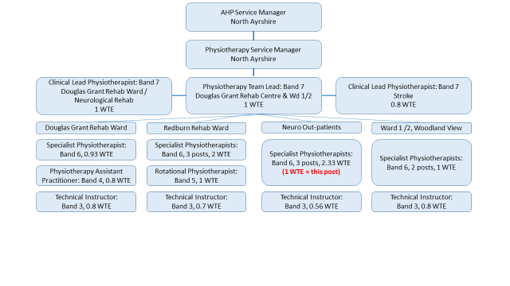  - The Physiotherapy Neuro out-patient service delivers physiotherapy to adults living with neurological conditions across North Ayrshire. This service also provides pan-Ayrshire physiotherapy services for those living with MND and MS. This is supported by other neuro outpatient services in the South and East HSCPs.  - This post is one of 3 Specialist Physiotherapist posts within the Neuro out-patients team, which is part of the wider Douglas Grant Rehabilitaiton Centre and Ward 1 team.
Job Purpose | - Act as a Specialist Physiotherapist in the Neuro Rehab out-patient team demonstrating specialist knowledge of evidence-based practice and clinical skills in the field of neurological physiotherapy and rehabilitation.  - Assess and treat adults with diagnosed or suspected neurological conditions from a variety of referral sources including GP, Consultant, other AHPs, Nurse Specilialists, Community and Tertiary setting.  - Undertake a lead role in the assessment, treatment, management and discharge planning of patients with a variety of neurological conditions, often with complex presentations.  - Treatments will include, but are not limited to, neurofacilitation techniques; gait re-education; balance and proprioceptive re-education; upper limb rehabilitation; provision of walking aids; assessment for and use of orthoses; use of manual handling equipment e.g. hoists and standing and walking aids such as Encore ® / Taurus ® / Stedy ® / tilt table; use of functional electrical stimulation; upper and lower limb strengthening.  - Participate in home and community visits, including working with others from MDT, community services and 3rd sector.  - Establish shared goals with patients who may have complex physical, communication, psychological, social, cultural and emotional needs, while considering widely differing understandings and expectations of disease status and outcome.  - Respiratory conditions treated include, but are not limited to, patients with acute and chronic respiratory conditions including pre-existing conditions such as COPD and bronchiectasis or acute conditions such as pneumonia and aspiration pneumonia.  - Respiratory treatments will include, but are not limited to, chest clearance and airway recruitment techniques for sputum retention, increased work of breathing and loss of lung volume such as Autogenic drainage; Active Cycle of Breathing Technique; Forced Expiratory Technique; positioning; mobilisation.  - Attend MDT meetings and contribute to goal setting, discharge planning & case conferences  - Lead, and participate in, local service improvement projects.  - Engage at a local and national level with relevant clinical interest, policy development and service development groups relating to Neuro rehab/Stroke services, pathways and guidelines.
Key Result Areas | - Treat adults with complex rehabilitation needs using specialist neuro-physiotherapy skills and knowledge.  - Use highly skilled verbal and non-verbal communication to communicate effectively with patients with complex communication impairments.  - Promote a rehabilitation ethos within Neuro rehab as part of the MDT.  - Empower and support individuals to be as active and independent as possible, maximising self-management where possible.  - Contribute to MDT discharge planning and goal setting.  - Make onward referrals to other services and teams as required to ensure ongoing rehab needs are met.
Other relevant information | - Nil

