1. JOB DETAILS
Job Holder

Job Title: | Medical Director (Digital)
Reports To: | Deputy Executive Medical Director
Location | Glasgow or Edinburgh / Hybrid

2. JOB PURPOSE

National Services Scotland plays an important role providing wide-ranging clinical leadership, advice and assurance, for our work as a national Board and our role in essential services to NHS Scotland, which include digital delivery of key NHS systems; procurement; commissioning and delivery of specialist health services, the Scottish Blood Transfusion Service and assisting the Scottish Government to develop and implement policy and provide resilience (e.g. assisting pandemic response).

The Clinical Directorate provides senior clinical leadership and expertise in a team of diverse specialists bringing knowledge and skills in complex decision making; clinical governance, risk and assurance; clinical leadership of change and quality improvement; investigation, reviews and solution-finding in response to adverse events; management of clinicians; senior responsible officer role in major national programmes; partnership working with territorial Health Boards and national professional bodies; engagement with emerging research and innovation assessing challenges and value based health care potential for the NHS.

Medical Directors are professionally accountable, and provide support, to the NSS Executive Medical Director through contributing to the development and positioning of the overall strategic direction of NSS by leading and/or participating in specific programmes to support NSS in the discharge of its governance responsibilities and the delivery of NSS business.

The Medical Director (Digital)
The post holder will provide clinical leadership and strategic direction for digital transformation in NHS Scotland and NSS. Working collaboratively with the NSS Digital and Security Directorate (DaS) to design, implement and support the clinical and patient users of digital solutions and improvements, the post holder will work across all major digital programmes and support a range of clinical and non-clinical digital experts to ensure strategic direction and strong partnership working across the whole organisation and across NHS Scotland.
NSS Digital and Security (DaS) Directorate designs, develops, maintains and procures digital solutions for NHS Scotland as a key partner in delivering Scottish Government’s digital health and care agenda. The Digital and Security Directorate senior team comprises the Chief Data Officer, Information Governance & Cyber Security; Cloud Engineering & Operations; Software Engineering & Applications Management. The Medical Director (Digital) will ensure alignment with the DaS SMT strategy and assist in the directorate’s work to provide services, products and advice to stakeholders, internally and externally, across its portfolio, for key programmes of work involving clinicians in primary and acute care across NHS Scotland.

- DIMENSIONS OF THE POST

The Medical Director (Digital) will be professionally and operationally line managed within the Clinical Directorate of NSS. They will be the senior medical post-holder working collaboratively across the DaS Directorate and responsible for ensuring high quality clinical contribution to integrated, effective and efficient operation of DaS, as a member of the DaS Senior Management Team and reporting to the Director of DaS

The Medical Director, as a clinical advisor to the DaS Senior Management Team, will achieve outcomes in the following key result areas:

- Provide clinical leadership expertise across the spectrum of clinical care, underpinned by a broad and deep knowledge of eHealth/Digital and IT systems in the health sector.
- Provide clinical leadership support to professionals providing guidance on the design, development and ongoing operation of safe, effective and efficient clinical health information systems to support and improve health & care delivery.
- Ensure clinical safety and oversight of the development of Clinical Safety Cases, consulting with clinical stakeholders to assess clinical risk and appropriate solutions and mitigations.
- Take responsibility for clinical governance, clinical risk management and assurance activity across the DaS Directorate, including at the early stages of healthcare software design, implementation and on-going monitoring and management.
- Ensure the principles of value-based health care underpin digital design, development and delivery.
- Ensure that the clinical functions within the DaS Directorate are aiming to meet the highest possible professional standards and any required regulations or legislation.
- Provide clinical leadership, and engagement with heath and care professionals, developing and maintaining relationships and communications to ensure the focus is on understanding and meeting user needs of digital programmes and innovations.
- Develop and maintain a strong working relationship with NHS Board Medical Directors, E-Health lead clinicians, their deputes, and with senior clinical colleagues in Scottish Government and other National Health Boards.

- ORGANISATION CHART (see appendix for full Clinical Directorate chart)

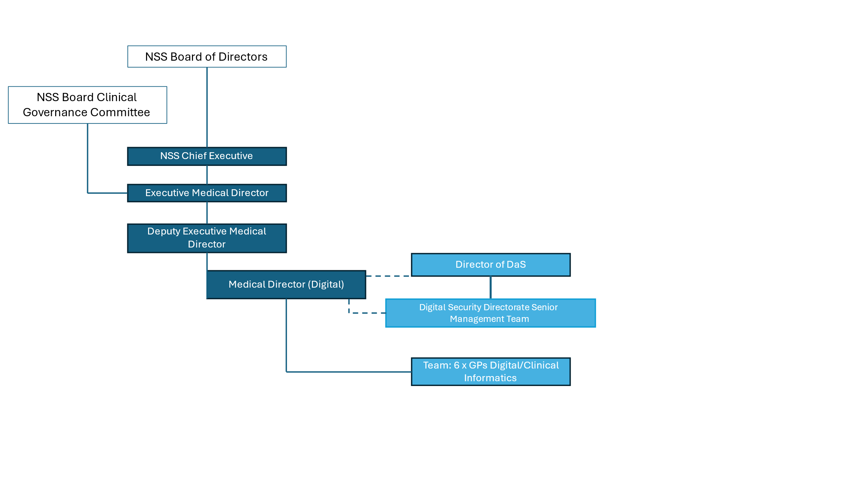
- ROLE OF THE CLINICAL DIRECTORATE

The Clinical Directorate’s function is to provide corporate professional support and expertise across all Directorates of NSS. It is crucial in assuring the Chief Executive and Board of Directors that all our service delivery is safe, effective, efficient and providing best value for patients, the public, NHS Scotland and Scottish Government.

As a national Health Board, NSS plays an important role in assisting and enabling other Health Boards and providing underpinning national infrastructure and services. The Clinical Directorate provides leadership and assurance for this role, applying its expertise flexibly to meet a demanding and diverse portfolio of work.

The Clinical Directorate represents NSS in national forums, professional bodies and leadership groups, relied upon for advice and expertise, and to ensure NSS partnerships and stakeholders’ views and experiences inform our work.

Medical Director (Digital)

The post holder will be professionally based within the Clinical Directorate and provide their professional expertise to the DaS Directorate, taking responsibility for all clinical elements of the Directorate’s work

As a member of the DaS Directorate Senior Management team the Medical Director will contribute to the planning and delivery of the organisation’s strategic objectives and planning processes, embedding a ‘Clinical by design’ approach. The Medical Director will provide strong and inspirational professional clinical leadership to all the DaS Directorate ensuring a highly motivated and clinically aware workforce.

The Medical Director for Digital will collaborate across DaS to provide clinical leadership in annually agreed objectives which will require:

- Contributing to the digital direction and strategy for NSS and NHSS;

- Provide leadership and expertise on the development of ongoing operation of safe, effective and efficient clinical health information systems to support and improve health and care delivery;

- Provide clinical leadership and direction to teams developing and delivering clinical informatics and innovation across the DaS Directorate and wider NSS organisation;

- Ensuring National Digital Solutions and systems developed or supported by NSS, meet both quality and regulatory standards and assurance of clinical safety through oversight, advice and managing the development of clinical safety cases when required;

- Maintain oversight of clinical risk in DaS, assessing, reporting and advising on risk and contributing to mitigations and solutions;

- NSS-wide and DaS understanding, interpretation and application of software as a medical device (SaMD) and AI as a medical device (AIaMD) regulations and standards.

- Supporting and leading the team developing digital platforms and services to Primary Care.

- Support DaS to connect to relevant external stakeholders and parties such as professional bodies, NHSS, eDRIS and the Public Benefit Privacy Panel, and provide their services as required.

- Support colleagues involved with development and delivery of digital services to embed these within NHSS systems moving forward; contributing to communications and stakeholder engagement with relevant clinical specialities to ensure adoption.

7. KEY RESULT AREAS

7.1 Leadership

- Understand the key clinical and care challenges in Scotland, and work to ensure DaS Services are designed to address these, where appropriate;
- Line manages the General Practitioners within the Primary Care Informatics team to support their delivery.
- Provide leadership and expertise on the development on ongoing operation of safe, effective and efficient clinical health information systems to support and improve health and care delivery.
- Lead in the development and delivery of clinical digital systems and innovation across the DaS Directorate and wider NSS organisation.
- Lead, drive and promote effective multi-disciplinary and cross boundary working within DaS and in programmes of work with external partners.
- Represent NSS, reflecting its purpose, mission, objectives and values to NHS Scotland and the wider public sector, the Scottish Government, and stakeholders.

7.2 Clinical Governance, Information Governance, Clinical Risk Management responsibilities

- Provide clinical governance leadership through involvement in analysing and supporting adverse events that have clinical impact. Provide specialist clinical expertise, to identify risks or issues to be resolved. Ensure there is effective clinical risk management undertaken consistently across both NSS and NHSS.

Lead in the effective application of all aspects of Clinical Governance and confidentiality to support the Executive Medical Director in their role as Executive Lead for Clinical Governance.
- Ensure all aspects of clinical governance are understood and effectively implemented in line with NSS policies and procedures, supported by the Clinical Directorate clinical governance team.
- Lead periodic clinical risk management reviews/inspections.
- Ensure development and delivery is compliant with all regulatory requirements, and enable preparation for new regulatory requirements, standards or policies as these develop.

7.3 Expert Advice

- Provide expert advice on health and care professional and, more broadly, NHS structure, organisation and service delivery issues.
- Ensure authoritative, coherent and relevant clinical professional advice and direction on strategic change within the organisation as indicated by national policy/strategic direction and on the planning, provision and development of services for the Directorate and on broad-based knowledge, networking and understanding of the operation of the NHS in Scotland.

Develop and utilise a broad-based network and understanding of the operations of the NHS in Scotland to be able, when required, to draw upon the specialist knowledge of appropriate staff in other NSS Directorates, NHS Boards and Scottish Government.

7.4 Professional Standards

- Ensure that appropriate mechanisms are in place for, and contribute to the implementation of, continuing clinical professional development of medical staff.
- Provide senior clinical professional input to necessary for advisory and mentoring processes.
- Promote and ensure an evidence-based approach to clinical practice and support research and development as integral elements of clinical/professional practice.

7.5 Links

- Work closely and in partnership with the clinical professionals across NSS, ensuring clinicians directly lead by the post holder work collaboratively across the organisation, share and maintain awareness of clinical issues in all directorates.
- Lead and facilitate appropriate engagement with and participation of clinical professionals and users in the work of the DaS Directorate, ensuring their needs are understood and met.
- Communicate the role and value provided by NHS NSS across Scotland, with clinicians and other clinical leaders.
- Proactively develop and maintain close links with NHS Boards, customers, agencies and regulatory bodies.
- Represent NHS Scotland as required and engage with colleagues in other UK administrations and health and care organisations.
- Represent NSS on Scottish Association of Medical Directors and other national bodies as required by the Executive Medical Director

7. ASSIGNMENT AND REVIEW OF WORK

The Medical Director for Digital will be accountable to the Deputy Executive Medical Director. They will report to the NSS Director of Digital & Security on annually agreed objectives and work as part of DaS Senior Management Team.

- PROFESSIONAL ACCOUNTABILITY

The Medical Director for Digital will be professionally accountable to the Executive Medical Director and must be in good standing with the GMC.

9. COMMUNICATIONS AND WORKING RELATIONSHIPS

Internal:
- Establish and maintain effective working relationships with senior colleagues, managerial and professional, across NSS.
- Oversee and manage medical professionals working in and for the DaS Directorate.
- Provide clinical advice to the diverse range services offered across the DaS Directorate.
External:
- Maintain and strengthen links with other organisations including Territorial and National Health Board Medical Directors and Directors of Public Health, national, regional and local regulatory and advisory bodies, patient groups, Royal Colleges and Universities. Contact will be both formal and informal.
- Take cognisance of developments in clinical practice and the organisation of health care delivery within Scotland, across the United Kingdom and internationally and ensure that the DaS Directorate is appropriately informed on relevant developments in health care.

10. Most Challenging Part of the Job

The most challenging part of the role will be delivering against a portfolio of complex and diverse services in a way that ensures health, patient safety and financial impact is maximised, and the highest standards or organisational performance and clinical governance is achieved.

11. CLINICAL COMMITMENT

The post is for 8 sessions per week (7 plus 1 SPA).The post attracts a managerial supplement.

Due to the nature of the role, it is envisaged that the appointee will maintain their clinical professional standing and work no more than 12 sessions per week.

The Medical Director for Digitalmay not hold any substantive appointments outside the NHS e.g. company consultancy or medical advisory role, without the written approval of the NSS Executive Medical Director.

12. QUALIFICATIONS AND/OR EXPERIENCE SPECIFIED FOR THE POST

Applicants must be constantly registered with the General Medical Council, have a licence to practice, and should:

- Demonstrate senior leadership ability at a senior level in a multi-disciplinary environment over several years. This should include experience in organisations of considerable scale and complexity
- Have broad experience of and strong understanding of the operations of the NHS and understanding of electronic health information systems within the Health and Care environment
- Adept at change management with evidence of managing and delivering improvement across a portfolio of challenging and high-profile services
- Able to demonstrate experienced in clinical governance and risk management, with awareness of clinical safety regarding digital systems used in healthcare.

Significant understanding of the wider strategic policy, planning and workforce agendas across NHS Scotland

- Be able to demonstrate the ability to think and act strategically and assist in the development of an organisational strategy,
- Have experience of chairing and facilitating meetings, seminars and training across all levels of staff within health delivery services,
- Demonstratable experience of stakeholder engagement and building effective relationships networks,
- Experience of working across multi-professional disciplines e.g. primary care, secondary care, community care, private sector, clinical informatics, local and national NHSS management,
- A strong and effective communicator including management of conflict and ability to deal with the media if required.

12. ENVIRONMENTAL/WORKING CONDITIONS & MACHINERY AND EQUIPMENT

- Exposure to unpleasant working conditions is rare.
- Standard office equipment is provided (laptop, mobile phone, screen).
- Office accommodation, when used, is in a shared open plan environment within NSS offices, by advance booking.
- Home-working environments are the responsibility of the employees and expected to comply with standard health and safety requirements for home working.
- Advanced keyboard skills are required, with frequent need for accuracy.
- The post holder may be required to travel across NHS Scotland as well as attending meetings across the wider UK to represent NHS Scotland if required.

13. JOB DESCRIPTION AGREEMENT  Job Holder’s Signature | Date
Senior Officer/Head of Department:

Signature | Date
Title

